[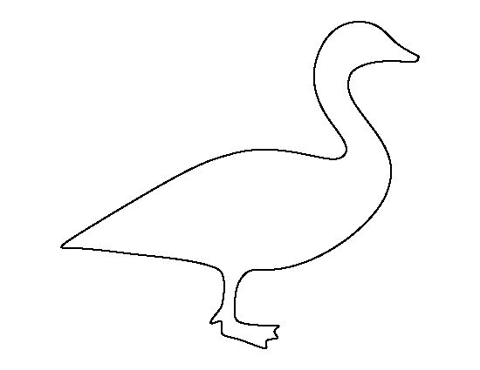](https://www.google.ca/url?sa=i&rct=j&q=&esrc=s&source=images&cd=&cad=rja&uact=8&ved=0ahUKEwiE7u6AlP3RAhVn7IMKHY4eCw4QjRwIBw&url=https://www.pinterest.com/pin/325455510550052944/&psig=AFQjCNFZ3xcSFSrigxssOpuNs3ApdAcAGg&ust=1486528391397009)

[](https://www.google.ca/url?sa=i&rct=j&q=&esrc=s&source=images&cd=&cad=rja&uact=8&ved=0ahUKEwjlrYqPlP3RAhVr0YMKHX4OC_wQjRwIBw&url=https://www.pinterest.com/pin/78531587227808551/&psig=AFQjCNFZ3xcSFSrigxssOpuNs3ApdAcAGg&ust=1486528391397009)

[](https://www.google.ca/url?sa=i&rct=j&q=&esrc=s&source=images&cd=&cad=rja&uact=8&ved=0ahUKEwjOteSVlP3RAhXq6IMKHaoxAfwQjRwIBw&url=https://www.pinterest.com/jezcreations/illustrations-silhouettes/&psig=AFQjCNFZ3xcSFSrigxssOpuNs3ApdAcAGg&ust=1486528391397009)

[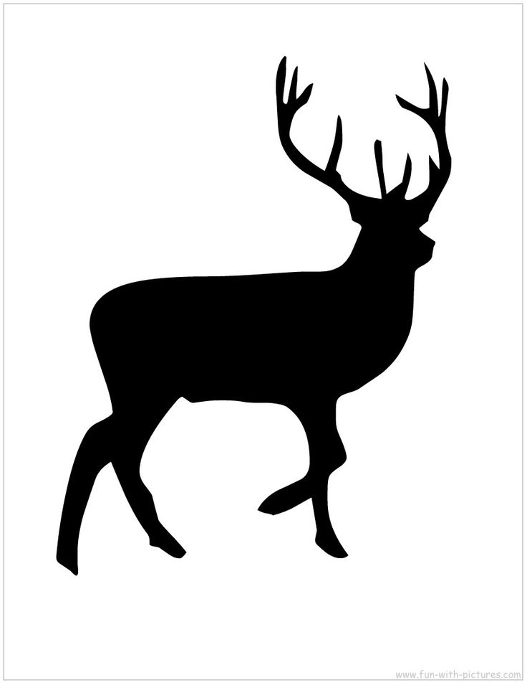](https://www.google.ca/url?sa=i&rct=j&q=&esrc=s&source=images&cd=&cad=rja&uact=8&ved=0ahUKEwj6ks-5lP3RAhUryoMKHfCZDikQjRwIBw&url=https://uk.pinterest.com/explore/fox-silhouette/&psig=AFQjCNFZ3xcSFSrigxssOpuNs3ApdAcAGg&ust=1486528391397009)

[](http://www.google.ca/url?sa=i&rct=j&q=&esrc=s&source=images&cd=&cad=rja&uact=8&ved=0ahUKEwj81OmBlf3RAhUM84MKHUPGCNkQjRwIBw&url=http://www.clipartbest.com/wolf-stencil&bvm=bv.146094739,d.amc&psig=AFQjCNHy8OScXjnIUgL2L_Vo2zIzfLSsIw&ust=1486528625755890)

[](http://www.google.ca/url?sa=i&rct=j&q=&esrc=s&source=images&cd=&cad=rja&uact=8&ved=0ahUKEwidlL6Rlf3RAhWh7oMKHfkGDNAQjRwIBw&url=http://www.sawyoo.com/post_wolf-cut-out-patterns_93608/&bvm=bv.146094739,d.amc&psig=AFQjCNHy8OScXjnIUgL2L_Vo2zIzfLSsIw&ust=1486528625755890)

[](http://www.google.ca/url?sa=i&rct=j&q=&esrc=s&source=images&cd=&cad=rja&uact=8&ved=0ahUKEwjy2oajlf3RAhXp24MKHXH4CUIQjRwIBw&url=http://recedingrules.blogspot.com/2011_05_01_archive.html&bvm=bv.146094739,d.amc&psig=AFQjCNG7IsSCGyYbYSMqbV-A-fcFec00iQ&ust=1486528733232961)

[](https://www.google.ca/url?sa=i&rct=j&q=&esrc=s&source=images&cd=&cad=rja&uact=8&ved=0ahUKEwiil5Wrlf3RAhUk74MKHWOvB-QQjRwIBw&url=https://www.pinterest.com/rynne123/moose/&bvm=bv.146094739,d.amc&psig=AFQjCNES0iU7ypFZMkjaVosK8PDw--G-8w&ust=1486528766663139)

[](http://www.google.ca/url?sa=i&rct=j&q=&esrc=s&source=images&cd=&cad=rja&uact=8&ved=0ahUKEwj2zoi7lf3RAhUMxoMKHUnPBXIQjRwIBw&url=http://www.spstencils.com/shop/animals/eagle2-stencil/&bvm=bv.146094739,d.amc&psig=AFQjCNEbPQZSeZA_G3jqT2UmRBoEgqC4aA&ust=1486528791622015)

[](https://www.google.ca/url?sa=i&rct=j&q=&esrc=s&source=images&cd=&cad=rja&uact=8&ved=0ahUKEwiY2-fblf3RAhUm54MKHY6SDCIQjRwIBw&url=https://www.pinterest.com/pin/451274825132752801/&bvm=bv.146094739,d.amc&psig=AFQjCNFzmlYyfjt5k4yvR3FjXcPFvdH2-w&ust=1486528866918530)

[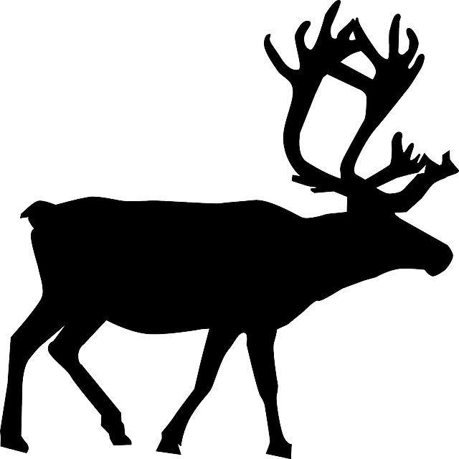](https://www.google.ca/url?sa=i&rct=j&q=&esrc=s&source=images&cd=&cad=rja&uact=8&ved=0ahUKEwjhheP2lf3RAhWnz4MKHX-TDuwQjRwIBw&url=https://www.pinterest.com/dorisdoris73/stencils/&bvm=bv.146094739,d.amc&psig=AFQjCNGur1dqFvtNy0HXvA-iNx2RkZVutA&ust=1486528923872947)

[](http://frontporchmercantile.com/paint-deer-silhouette/)

[](http://www.google.ca/url?sa=i&rct=j&q=&esrc=s&source=images&cd=&cad=rja&uact=8&ved=0ahUKEwi-6NuVlv3RAhUM04MKHcK0D9YQjRwIBw&url=http://www.stencil-library.co.uk/animalandbird-budget-stencils/002465-ANB0291-5/goosestencil.html&bvm=bv.146094739,d.amc&psig=AFQjCNGPe0K-2A1vTMmKuzb06hcM1LbWMg&ust=1486528975941310)

[](http://www.google.ca/url?sa=i&rct=j&q=&esrc=s&source=images&cd=&cad=rja&uact=8&ved=0ahUKEwiUx_jOlv3RAhWH7YMKHf4UBtsQjRwIBw&url=http://www.timvandevall.com/templates/butterfly-stencil/&bvm=bv.146094739,d.amc&psig=AFQjCNEV2uVnRZWldVRqJN6ImdoHvJ6jCg&ust=1486529049686710)

[](https://www.google.ca/url?sa=i&rct=j&q=&esrc=s&source=images&cd=&cad=rja&uact=8&ved=0ahUKEwicoYjilv3RAhVqxoMKHdRoC0cQjRwIBw&url=https://www.pinterest.com/pin/471189179734809602/&bvm=bv.146094739,d.amc&psig=AFQjCNFFzzqZ_asBw9AjOGFLuPLdX6NfeA&ust=1486529149931664)

[](http://www.google.ca/url?sa=i&rct=j&q=&esrc=s&source=images&cd=&cad=rja&uact=8&ved=0ahUKEwimjNf-lv3RAhXI6oMKHUbxDrsQjRwIBw&url=http://animalsclipart.com/gallery/beavers/&bvm=bv.146094739,d.amc&psig=AFQjCNFT_NWNnHD0T0mpNPo-DVmSXP4-Tw&ust=1486529205617159)

[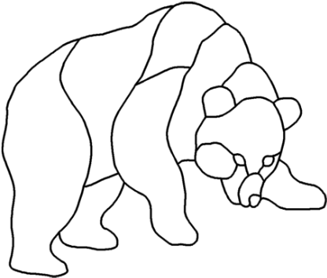](http://www.google.ca/url?sa=i&rct=j&q=&esrc=s&source=images&cd=&cad=rja&uact=8&ved=0ahUKEwiA5LLvnP3RAhWd2YMKHR8wCqEQjRwIBw&url=http://online.rapidresizer.com/&bvm=bv.146094739,d.amc&psig=AFQjCNGPXVpkkhrsokBPrzrYJsD5q6C7KQ&ust=1486530773914193)