Environmental
Art
A Guide to Eco Artists

By: Cynthia Cousineau

Eco Art
Definition:
- A term used for forms of art dealing with ecological issues.
Purpose:
- To help improve our relationship with the natural world.
- To create an understanding of nature and its processes & current environmental issues.
- Allows us to be concerned with the environmental forces and materials we can use to create artworks.
- To help us rethink our relationship with nature and consider some solutions on how we can better co-exist with it.
- To restore ecosystems in artistic and aesthetic ways.

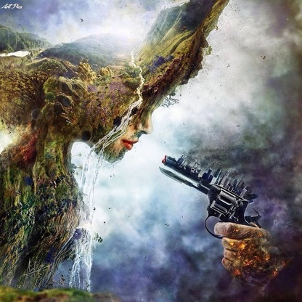
"Betrayal" by Spanish artist Mario S. Nevado

Brief History:
- An artistic movement that began in the 1960s.
- Several artists began sculpting with natural materials.
- Most of these works are temporary & exist nor only on photographs.
- Often these works are filled with messages: environmental or ontological (concerned with the nature of being).

Types of Eco Art:

  - Landscape Manipulation (using nature to create art)
2) Important Message (Environmental, social, or political)
3) Using recycled materials
4) Digital Art
5) Street Art

Examples of Eco Artists
"Land Manipulation"
Robert Smithson:
- An American artist famous for his use of photography in relation to sculpture and land art.
- He manipulated the natural environment by using rocks and stones to form huge spirals.
His Spiral Jetty Artworks
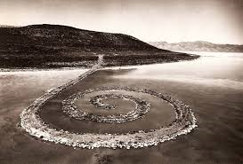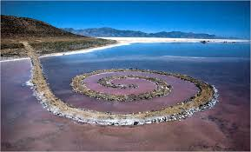
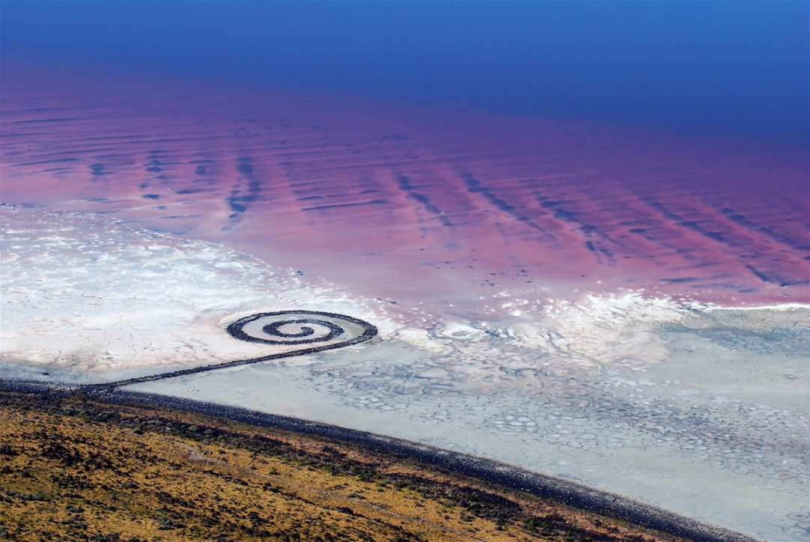

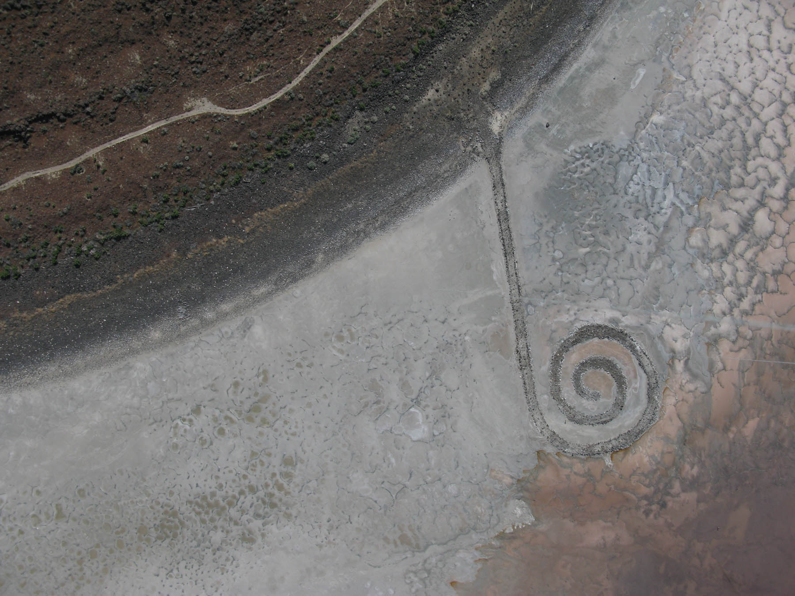
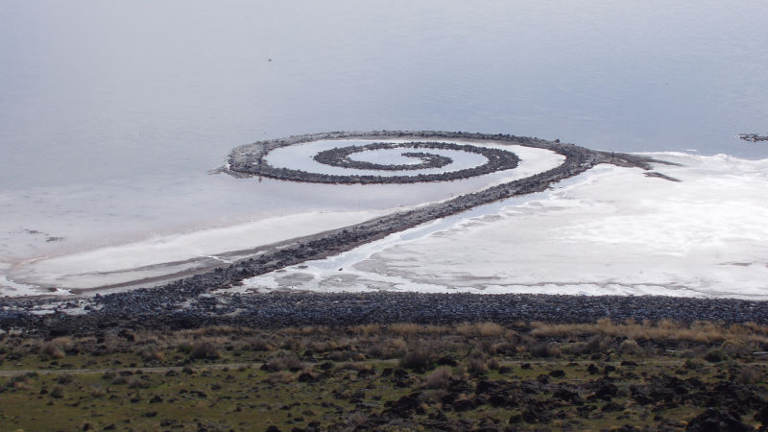
Spiral Jetty, Utah, USA (April 2005)

Andy Goldsworthy:
- A British Artist who created outdoor sculptures using natural materials like: pedals, leaves, snow, ice, rocks and twigs.
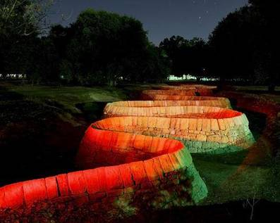
“Stone River” by Andy Goldsworthy
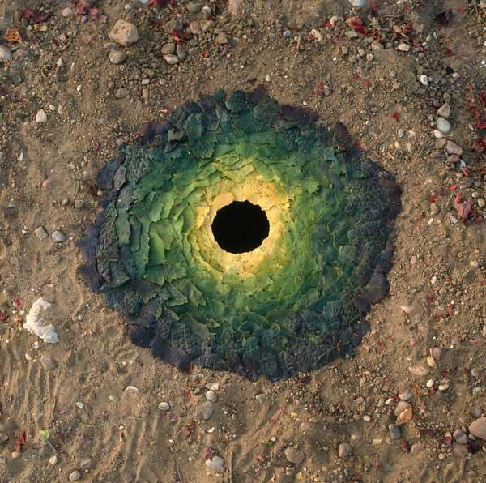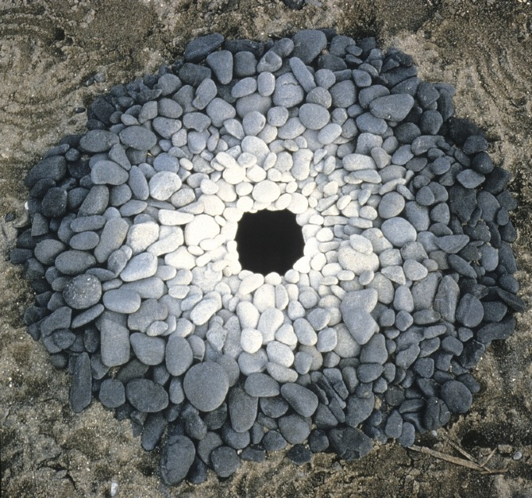

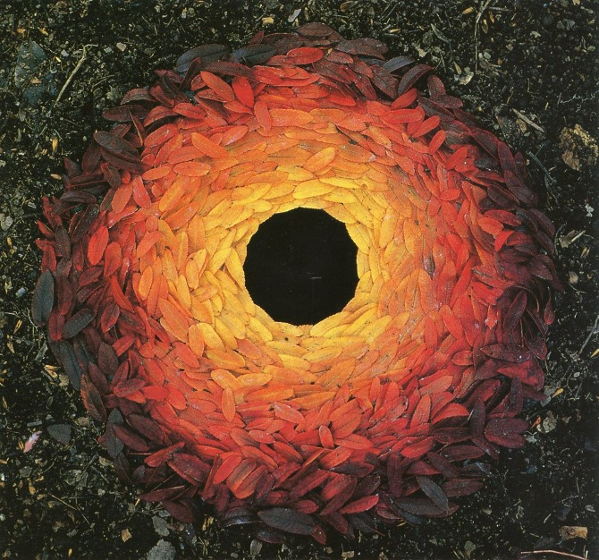
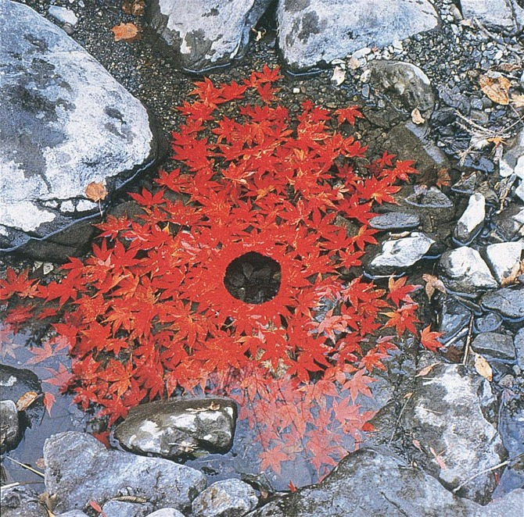

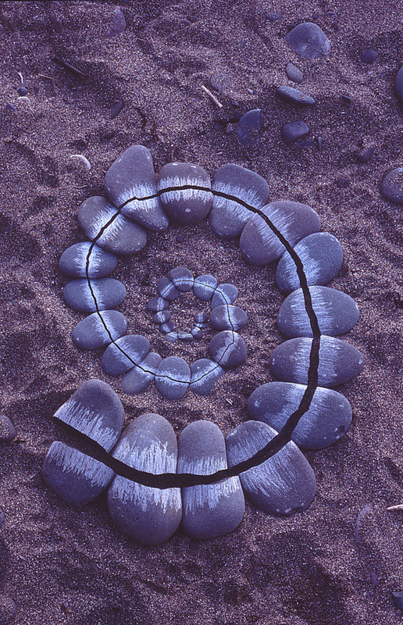
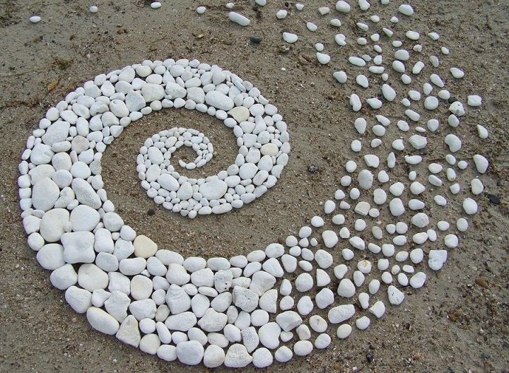

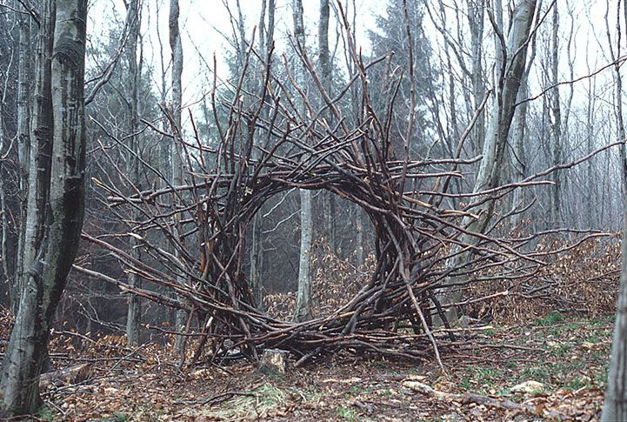
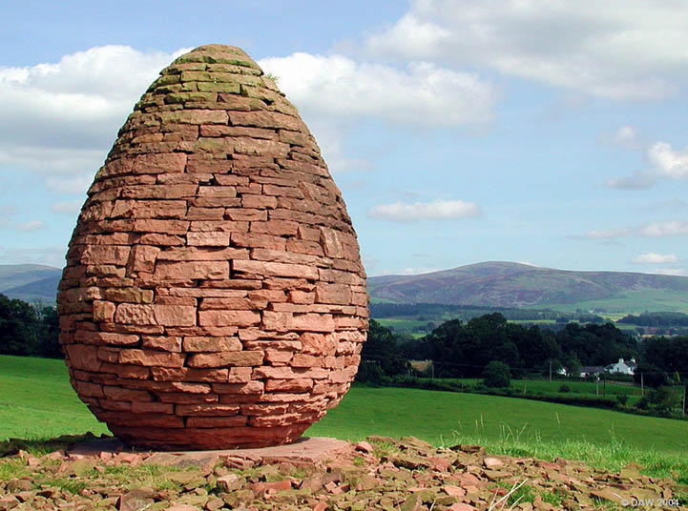

Andres Amador:
- An artist who creates unconventional art with his incredible sand paintings.
- Using the beach as his own enormous canvas and rakes as his brushes, he creates massive, eye-catching murals feathering geometric and floral patterns.
- The sand artist uses his whole body to navigate his tools across the grains, transforming his chosen coastline into one of his giant Earthscapes paintings.

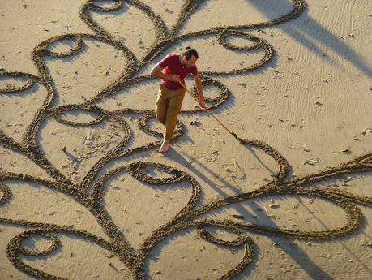

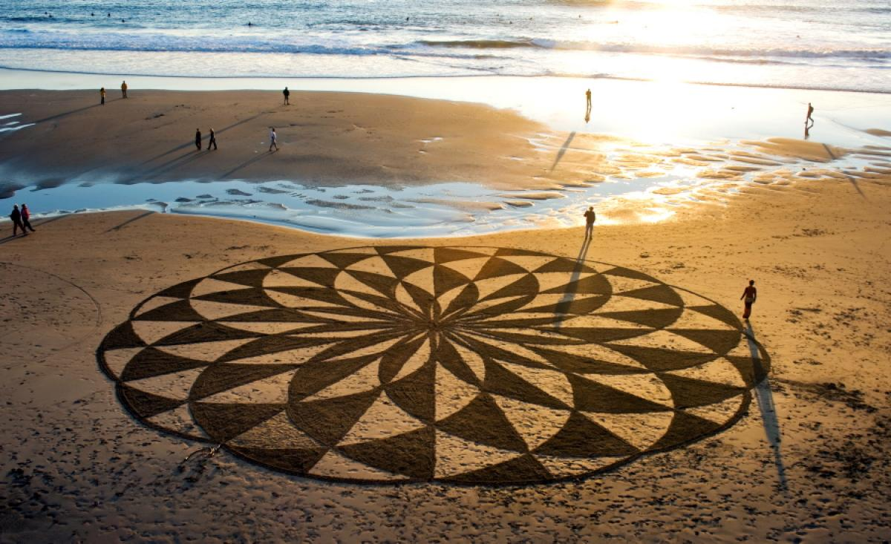
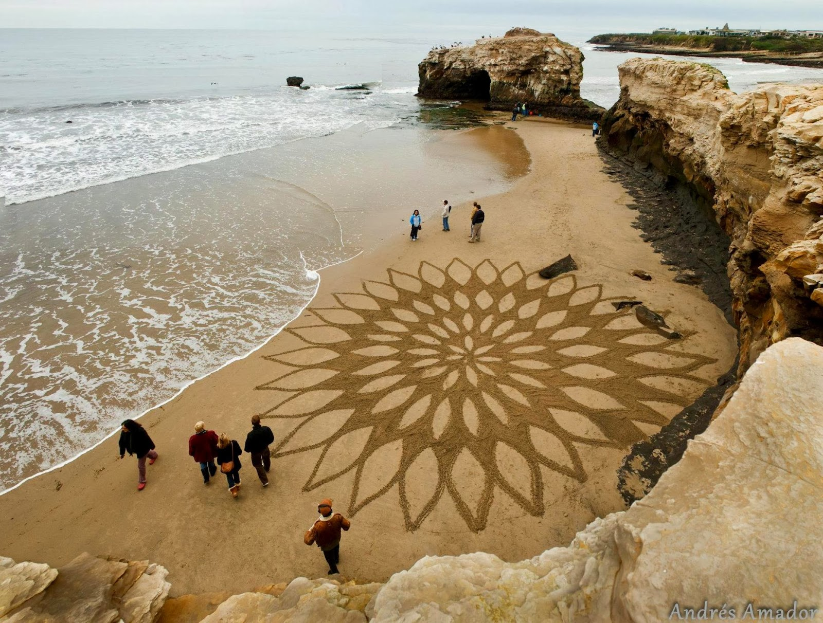

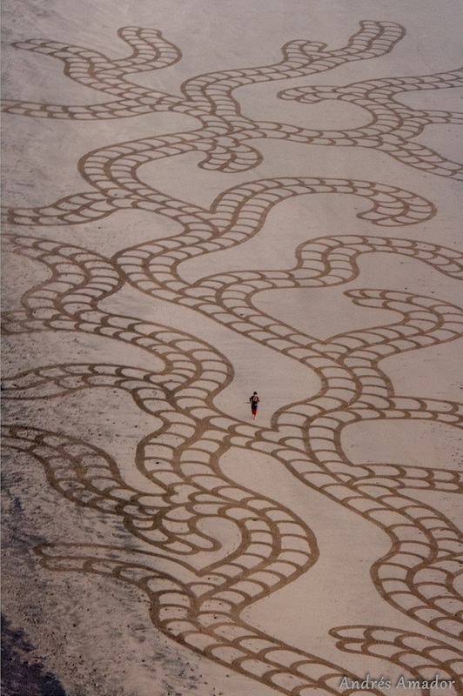

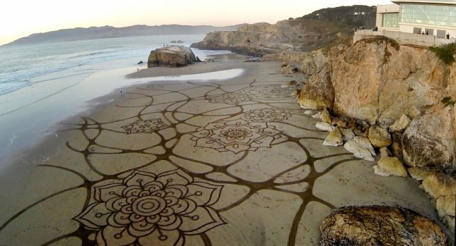
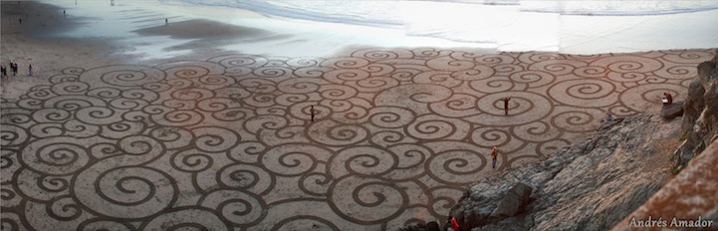
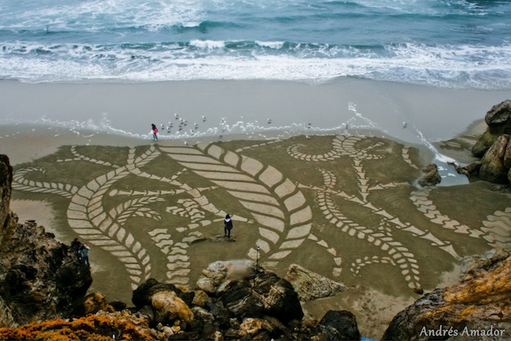

Examples of Eco Artists
"Important Messages"
Christo & Jeanne-Claude :
- A Bulgarian American and his American Wife.
- This couple was interested in provoking their audience to think about the immediate world.
- In 1972-1976 they created “Running Fence”, which consists of cloth attached to street poles. A veiled fence of 24.5 miles crossing the private property of 59 ranchesers to reach the Pacific Ocean. Inspired after the Continental Divide.
- Aimed to create a new way of seeing familiar landscape.
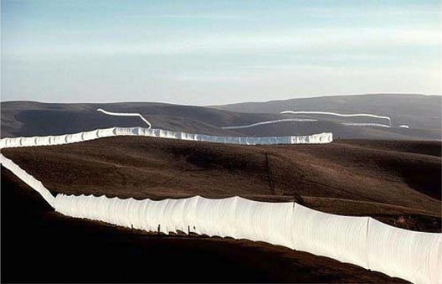
Chisto & Jeanne-Claude's Running Fence (1976)

Jeff Hong:
- A New York animation artist who imagined some of Disney’s popular characters facing the grim conditions associated with the reality of climate change and pollution.
- He states that if “we do not safeguard our planet, these fairytales most certainly won’t have a happy ending”.
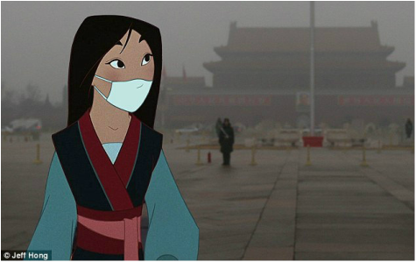
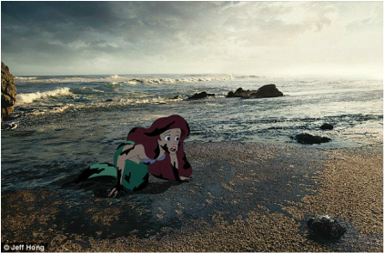

Paulo Grangeon:
- French sculptor used an unlikely medium to illuminate the reality of animal endangerment across the world. His traveling exhibit, “Pandas on Tour,” he created 1,600 papier-mâché bears meant to represent the actual number of pandas left on the planet
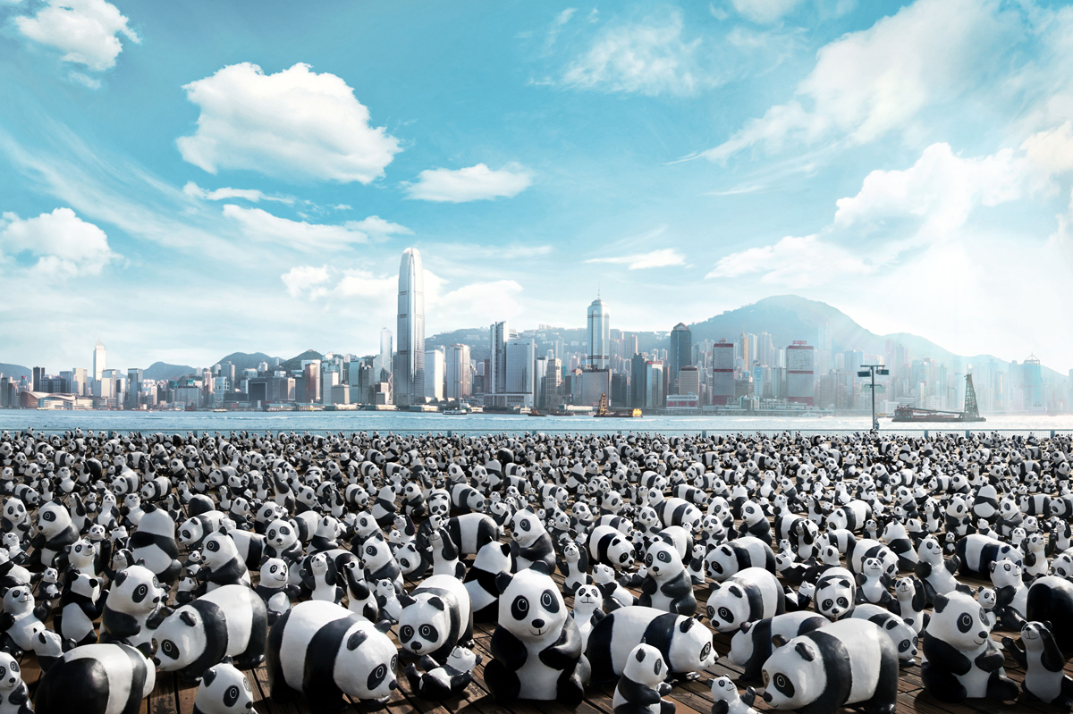

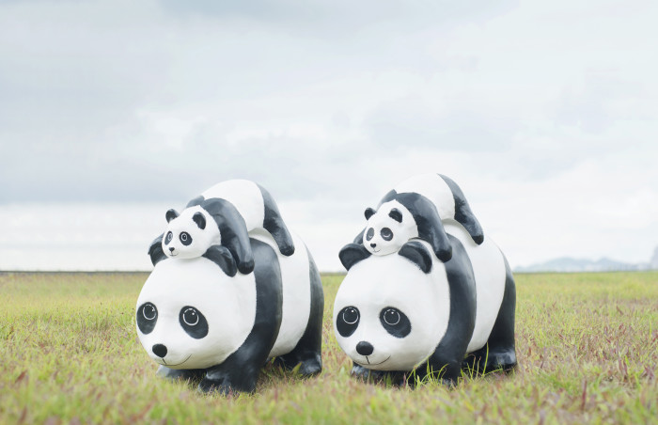

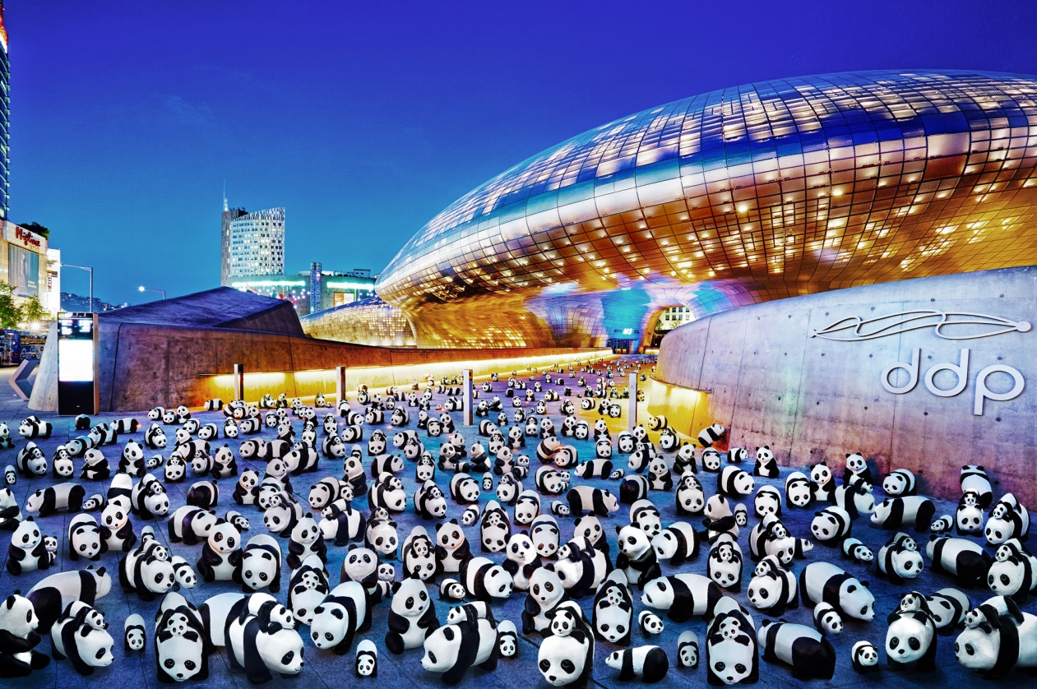
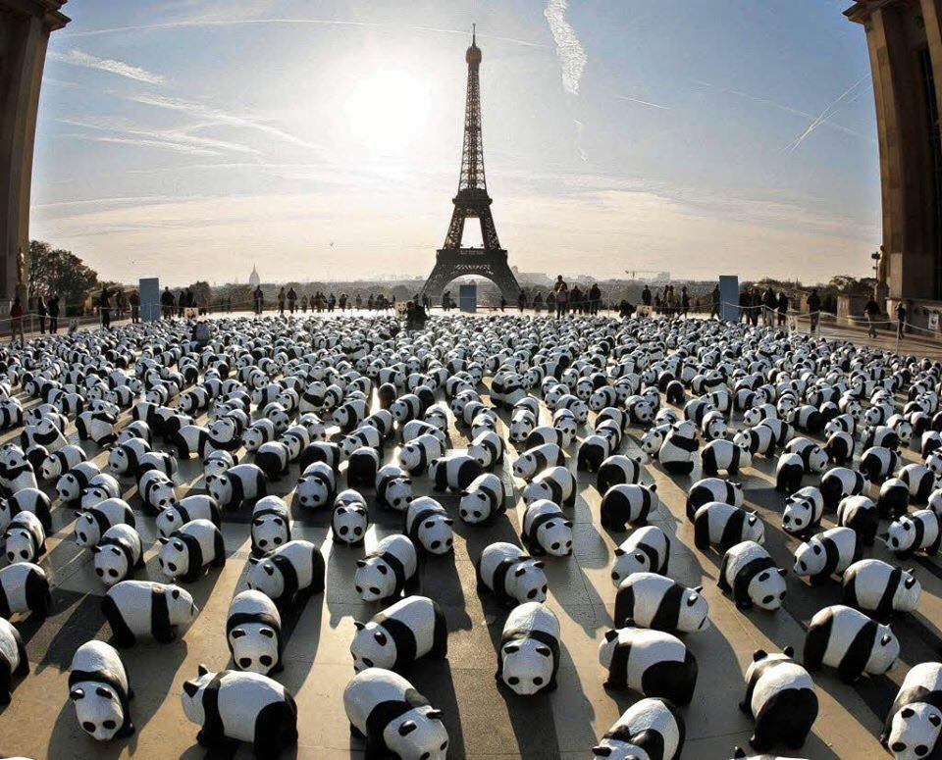

Examples of Eco Artists
"Using Recycled Materials"
Bernard Pras:
- A French artist who used anamorphosis (sticking objects on a canvas to give more volume).
- He Turned trash into treasure.

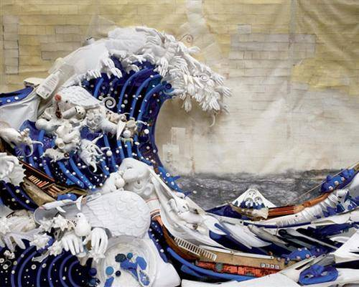

“The Great Wave" by Bernard Pras

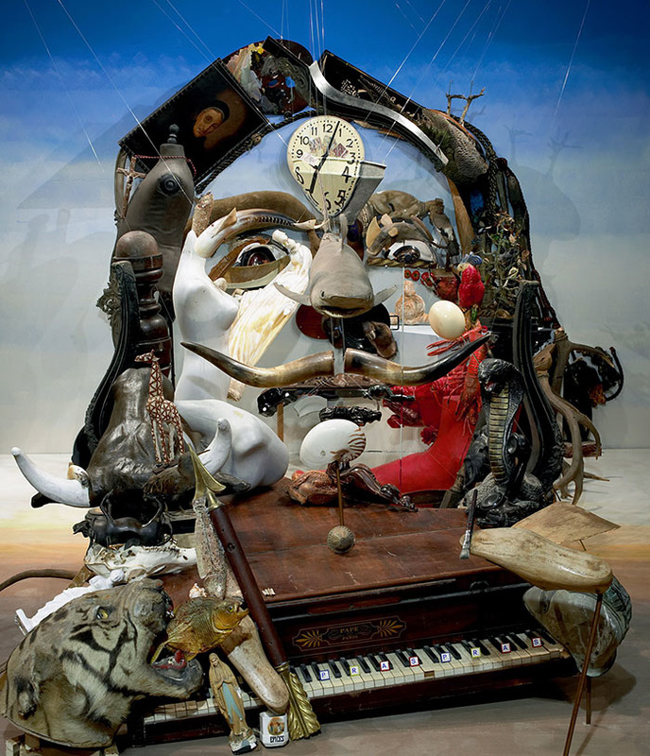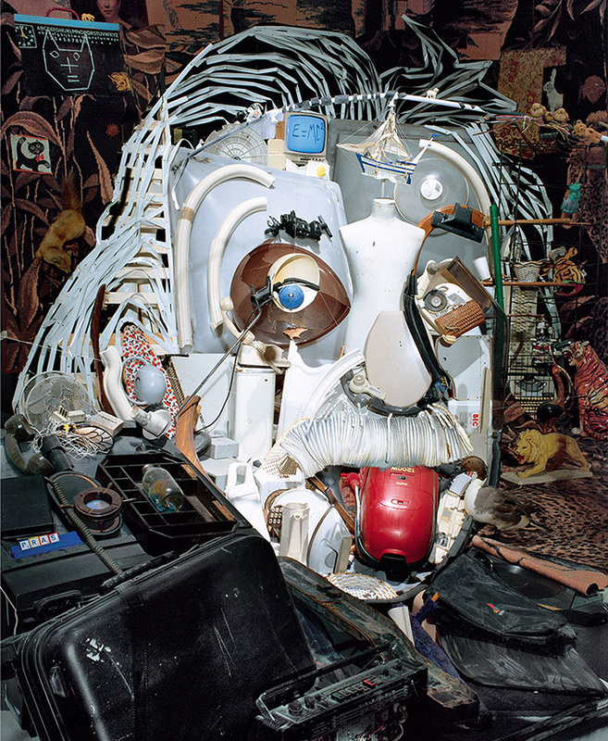
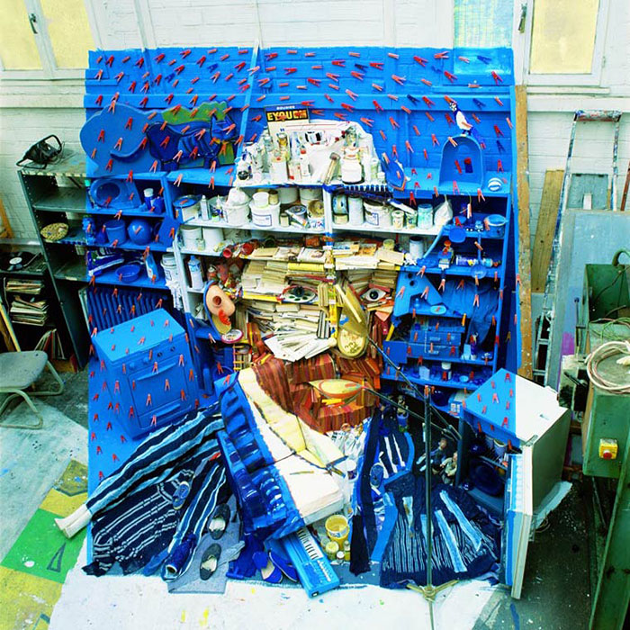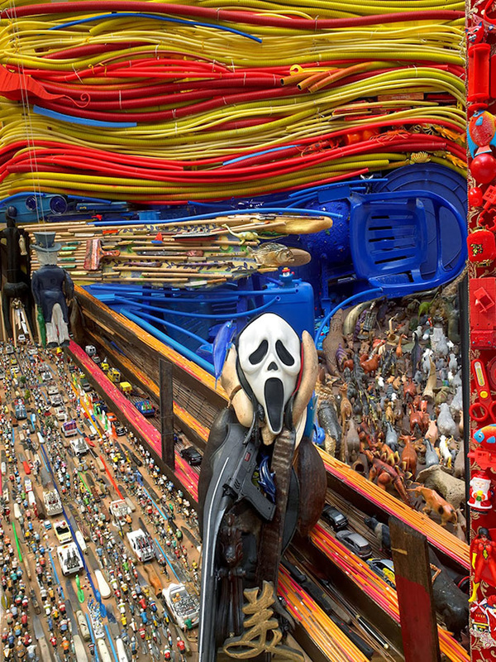

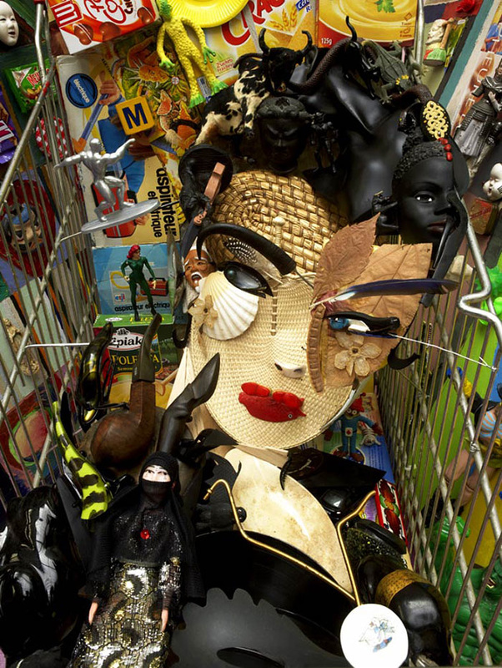

Sayaka Ganz:
- Inspired by the Japanese belief that “all objects have spirits” and those thrown away weep in the trash brings at night.
- She creates animals, to bring live again to these discarded objects.

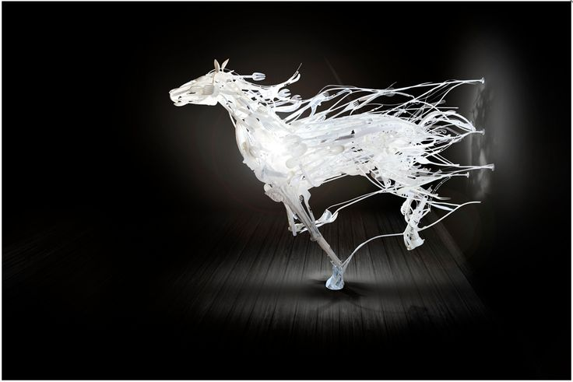

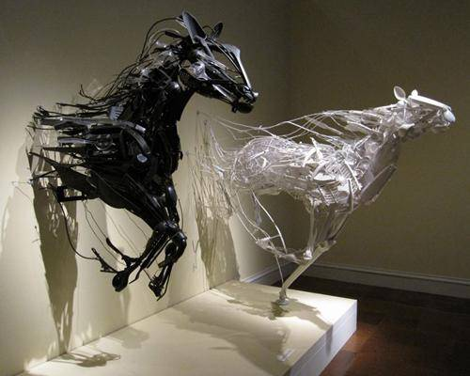

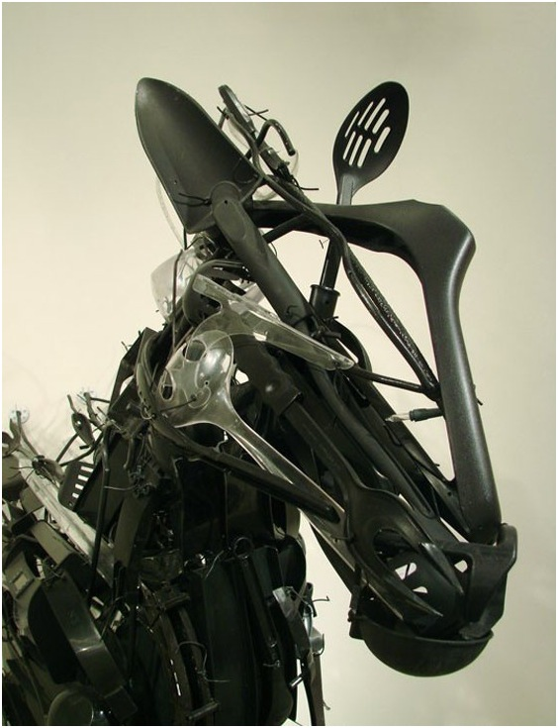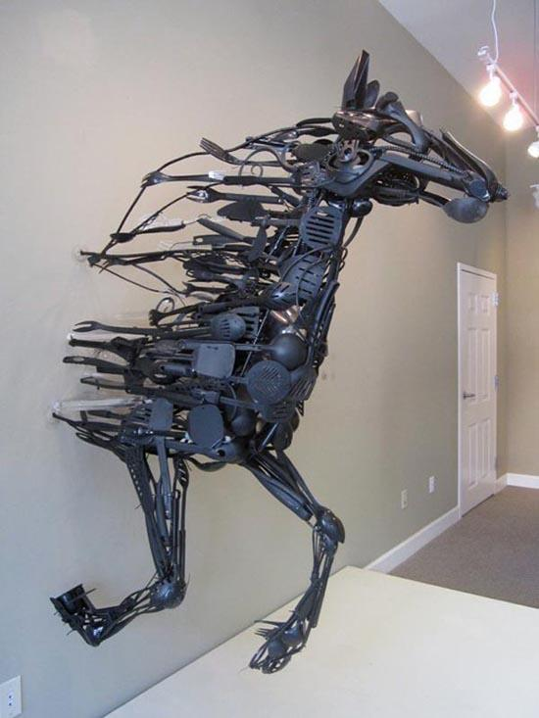

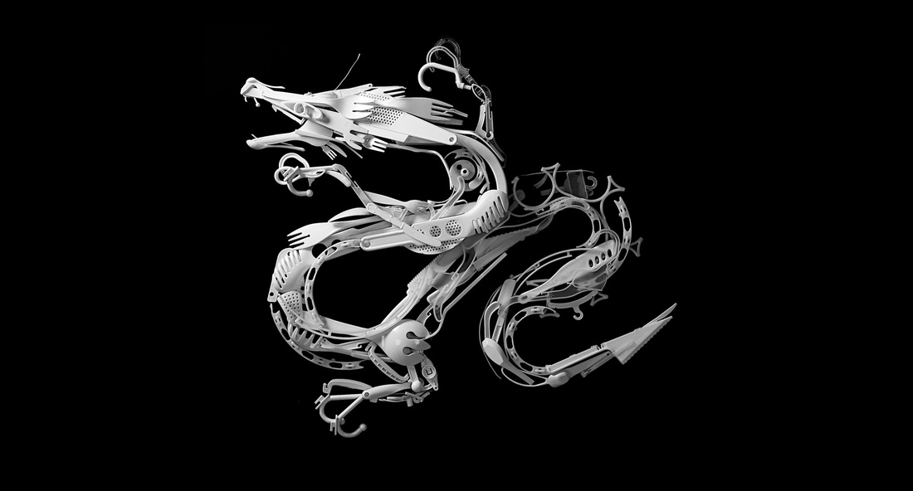

Joshua Allen Harris:
- A New York street artist who uses the vents of the city to bring to life regular recycled plastic bags.
- Using only tape and garbage he creates kinetic sculptures of animals and monsters.

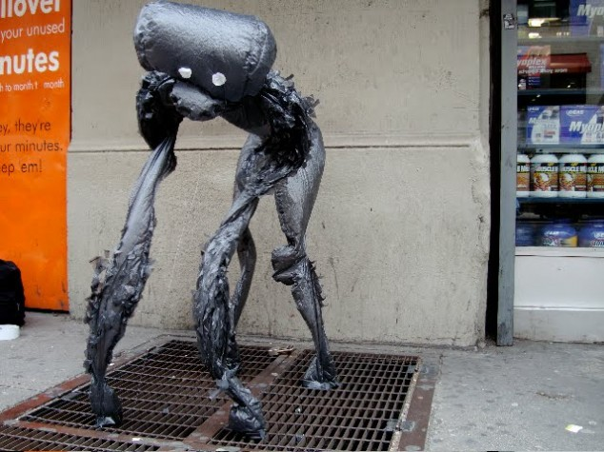

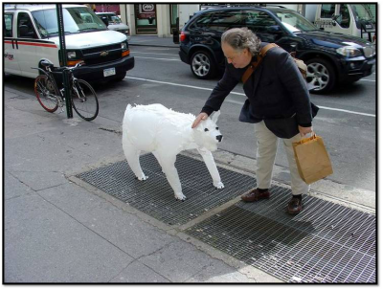

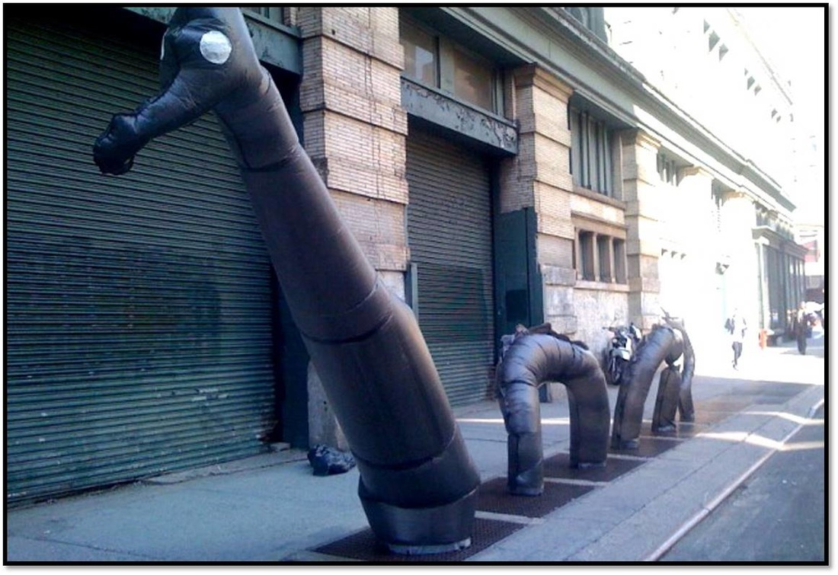

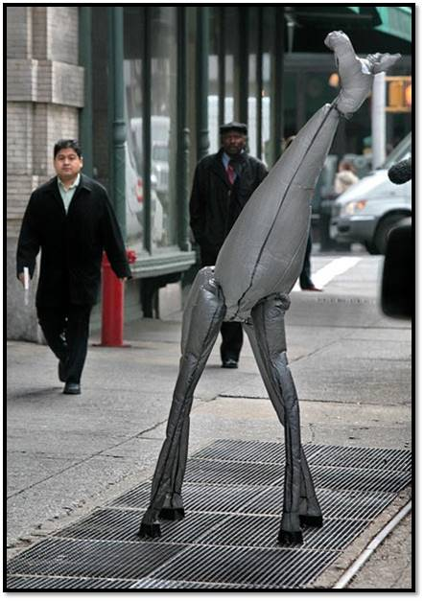

Khalil Chishtee's: Plastic Bag Sculptures
- Uses recycled plastic bags to create textures sculptures which represent the human figure.

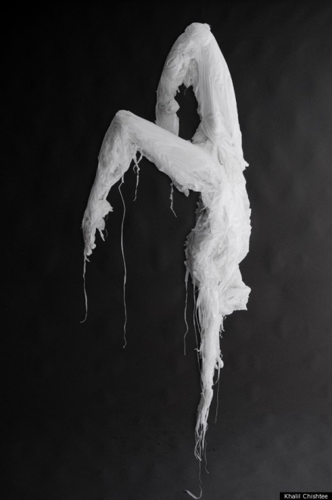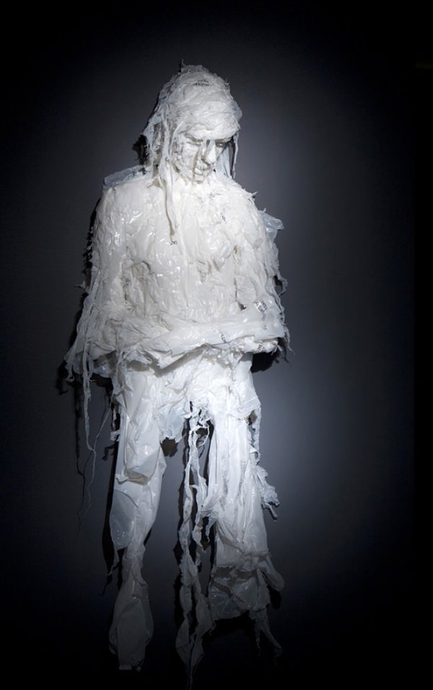

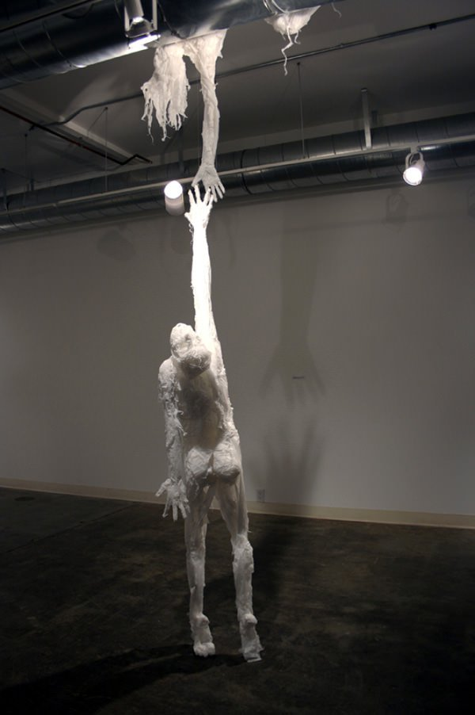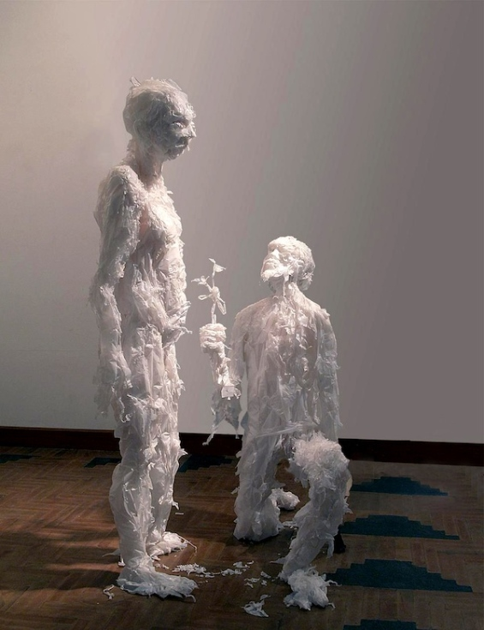
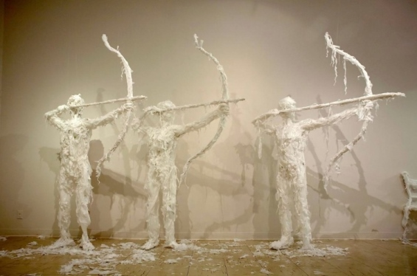

Vilde Rolfsen’s Plastic Bag Landscape
- Using plastic bags that she found in the street, the Norwegian photographer employs lights and colored backgrounds to create the illusion of a landscape.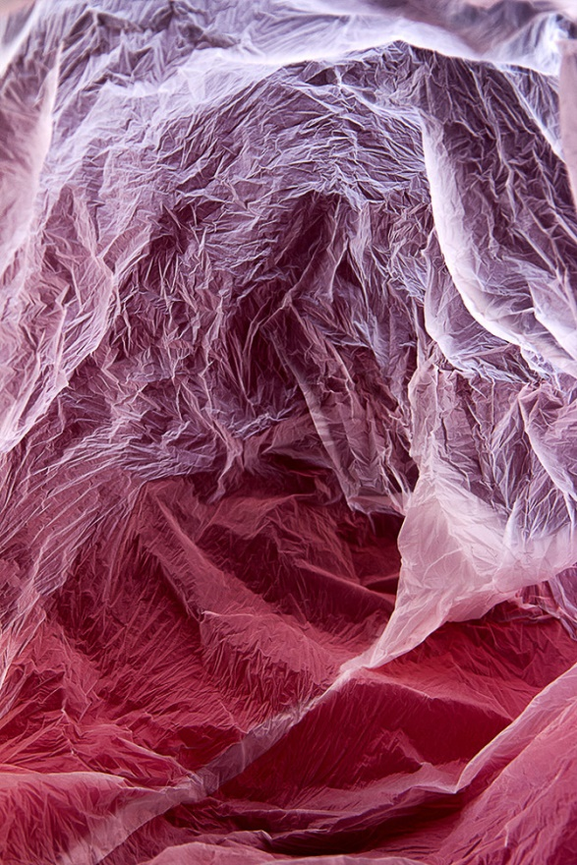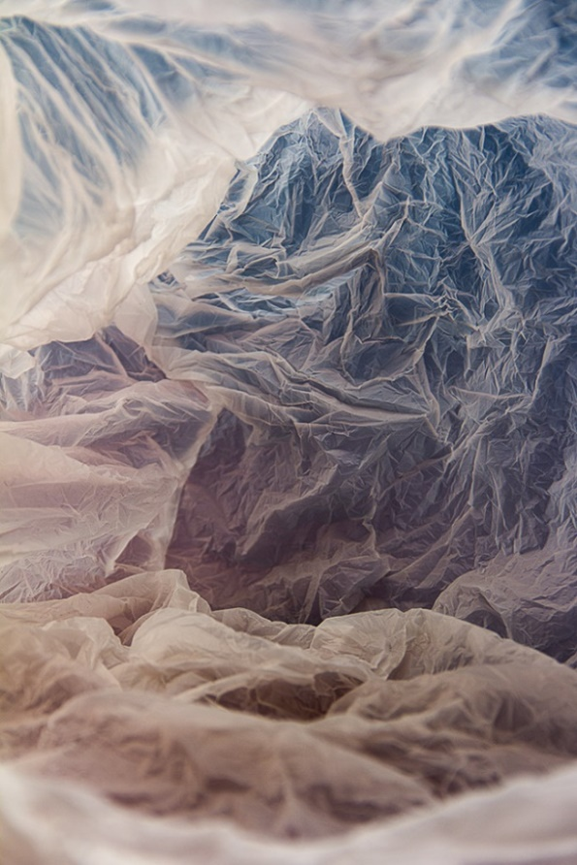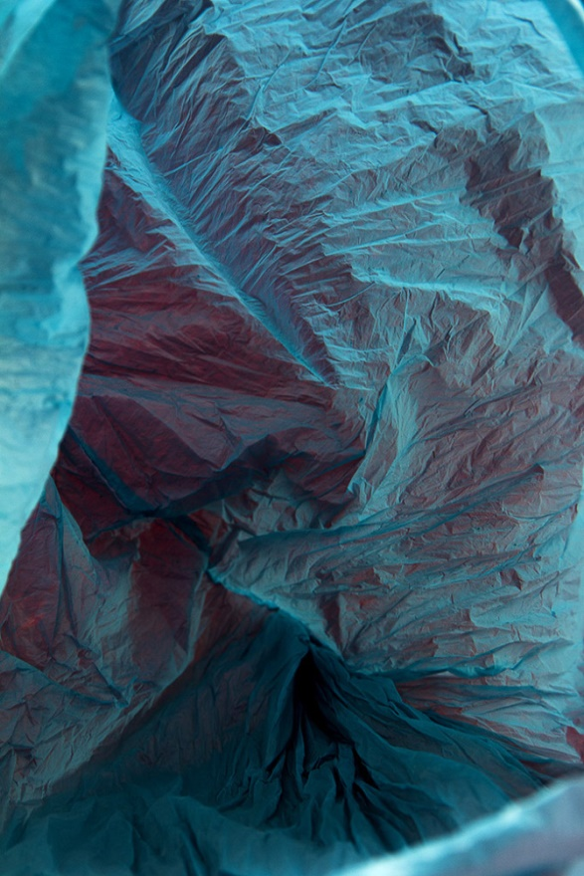 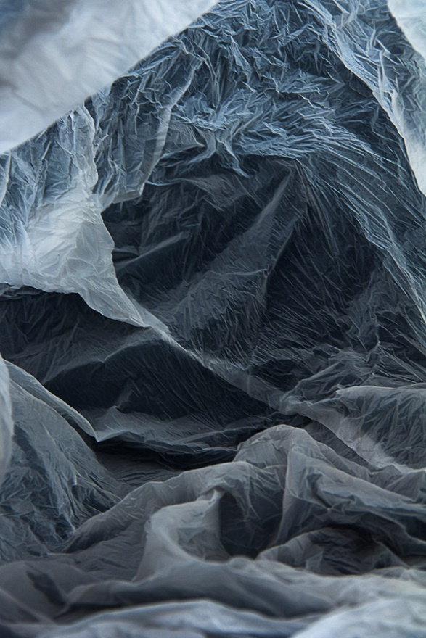

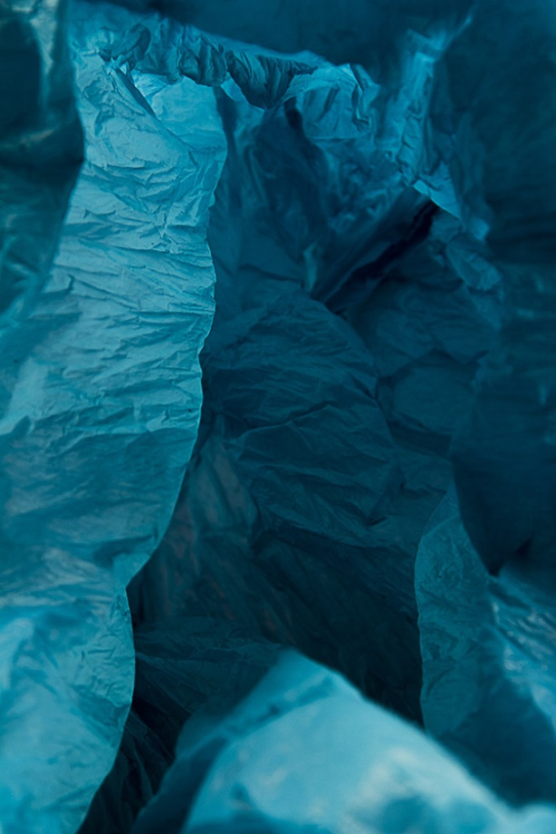

Schimmel Gold:
- Used junk mail and other paper waste to create art.
- Using postcards, brochures or any other paper people tend to throw away.
- This artist creates mosaic portraits using these papers and none toxic paints.

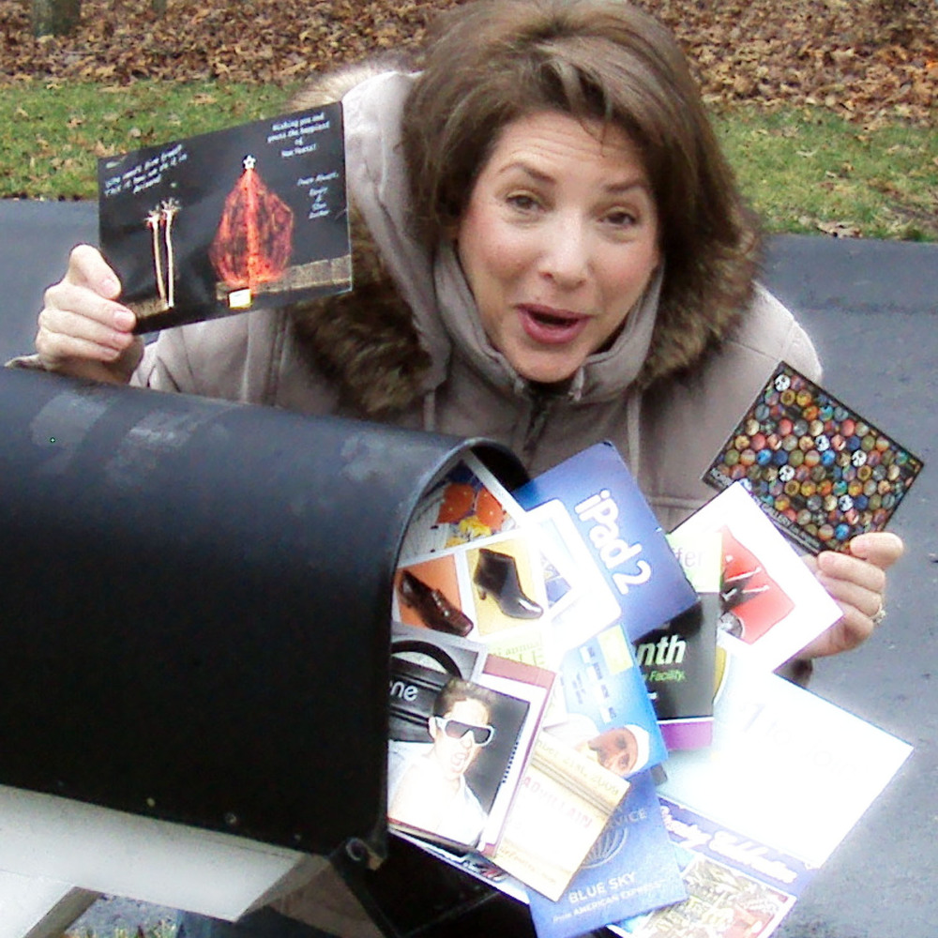

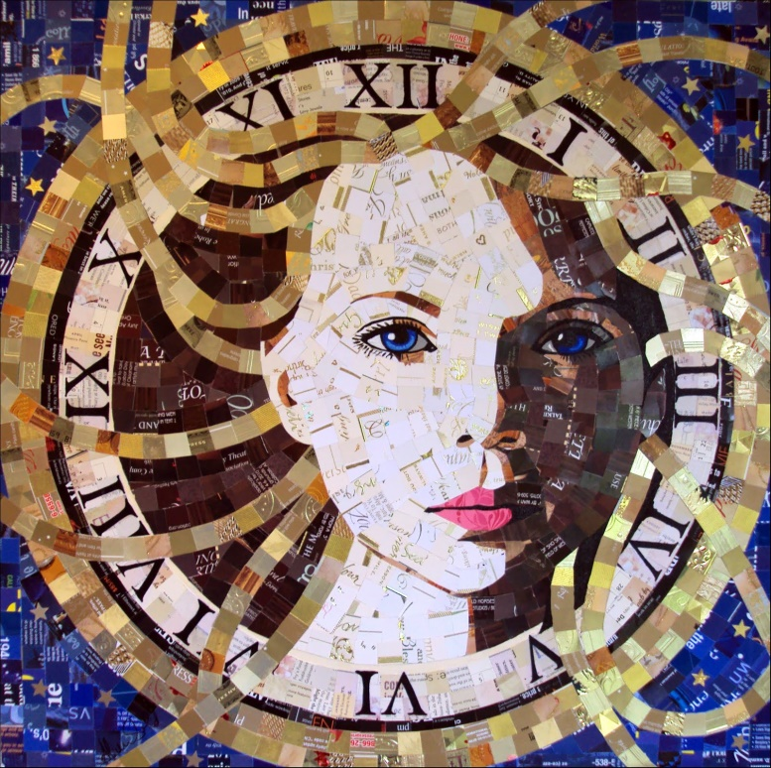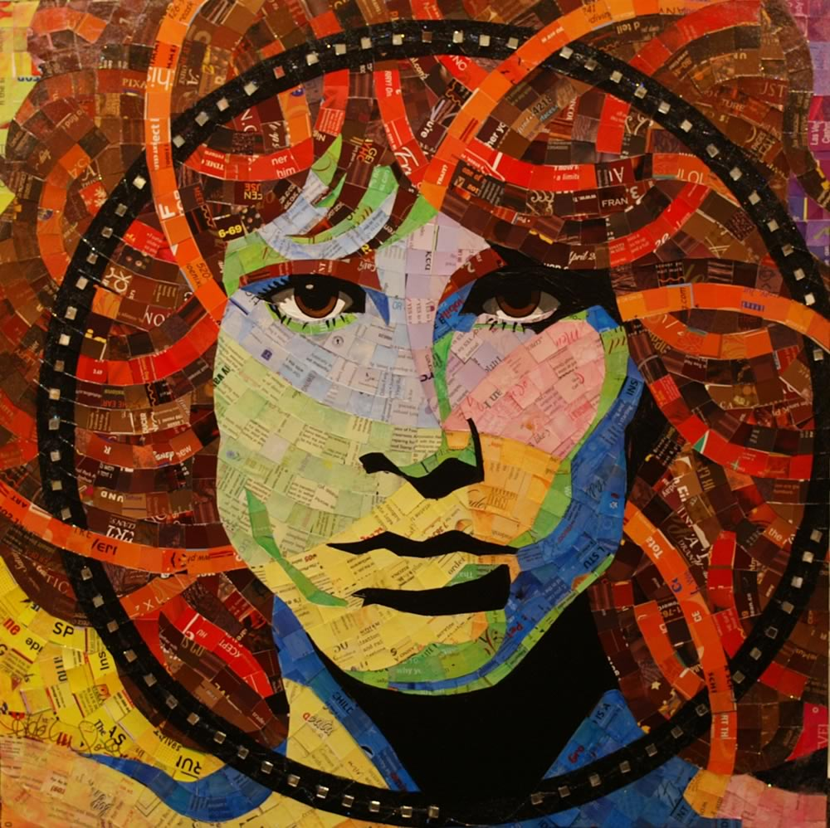

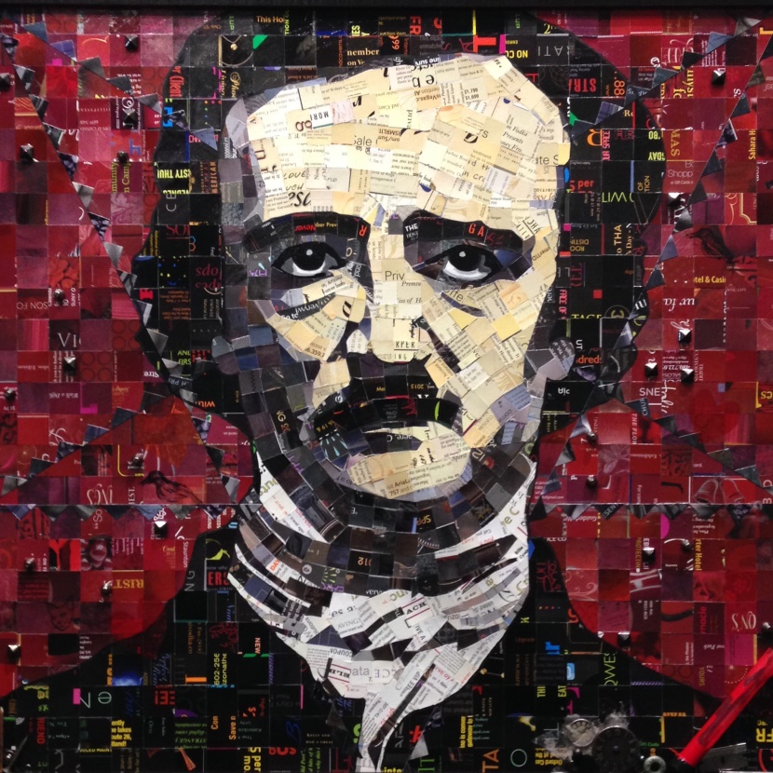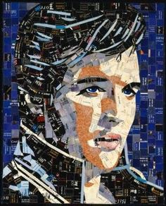

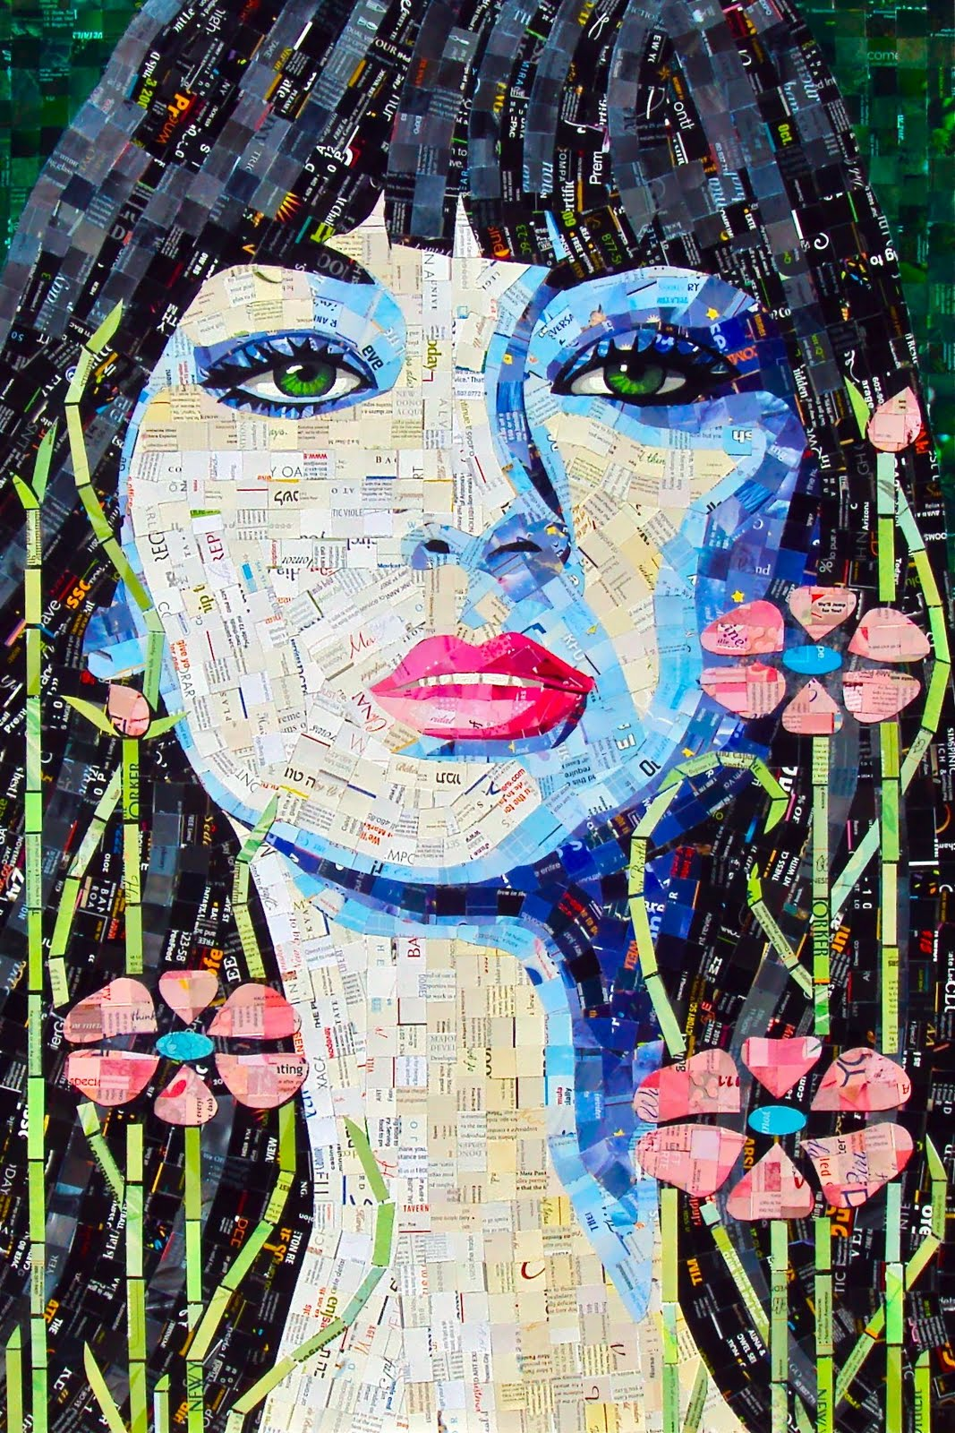

Uri Eliaz:
- An Israeli artist who creates sculptures using objects he found in the ocean.
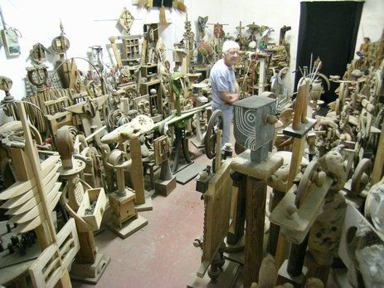
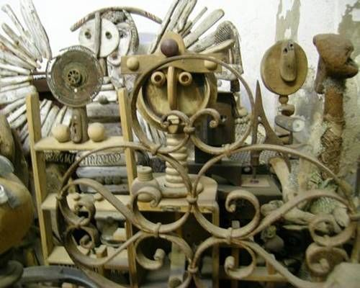

Bordallo II:
- A Portuguese artist who hopes to draw attention to our culture’s uncontrollable production of waste with his creation of animalistic trash sculptures.
- A street artist who uses trash found on the city streets and brings them to life with large mural sculptures.
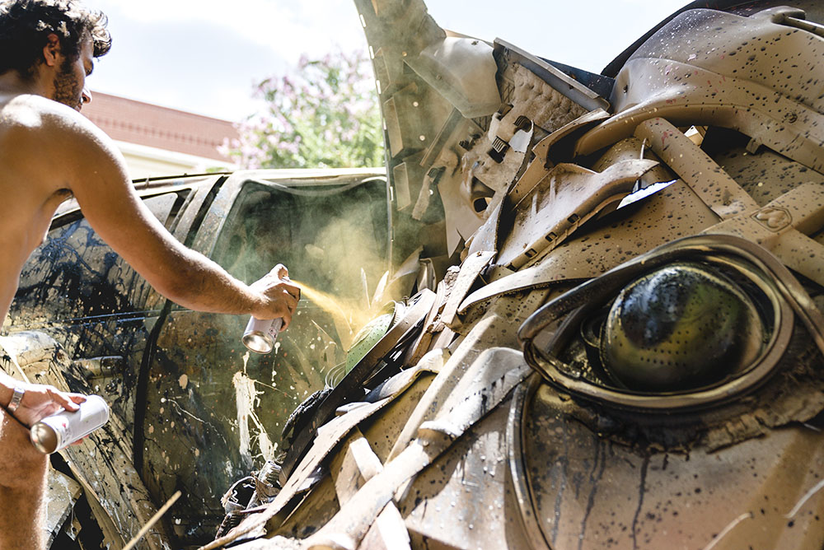
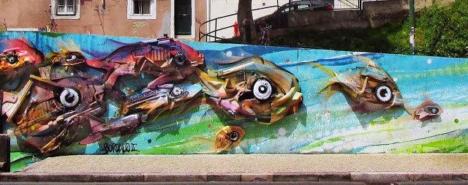
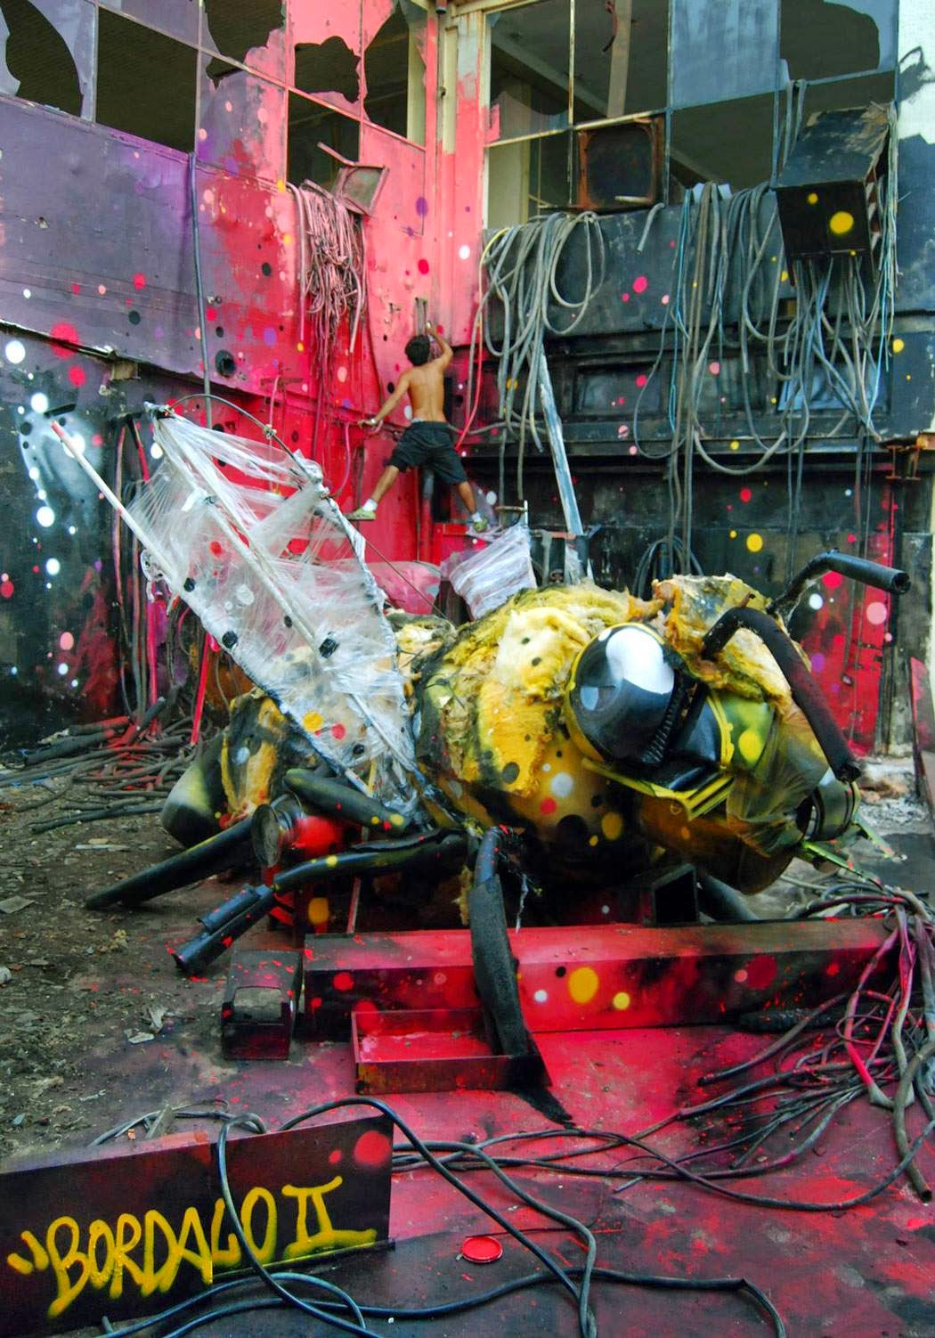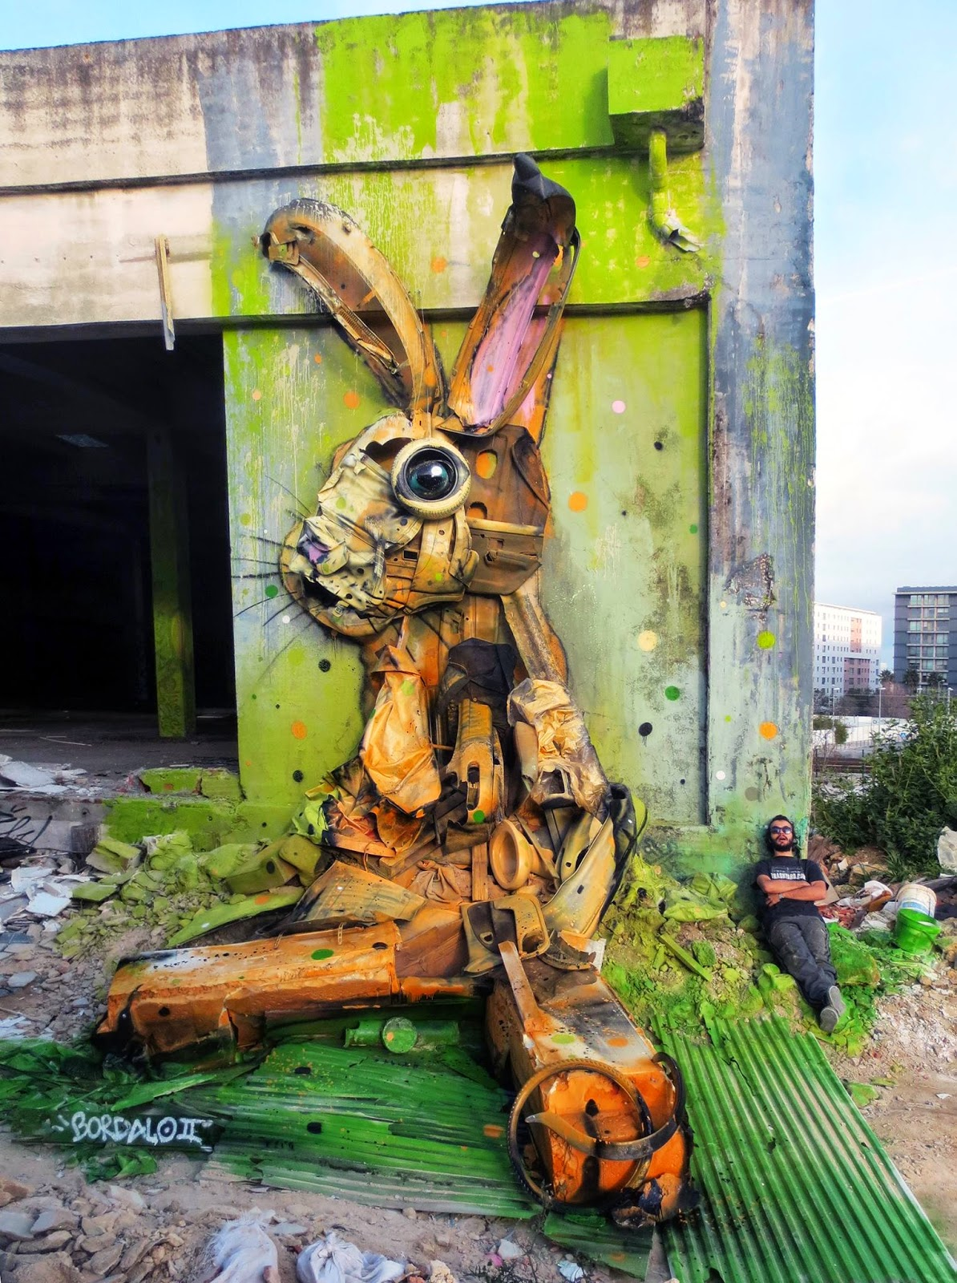
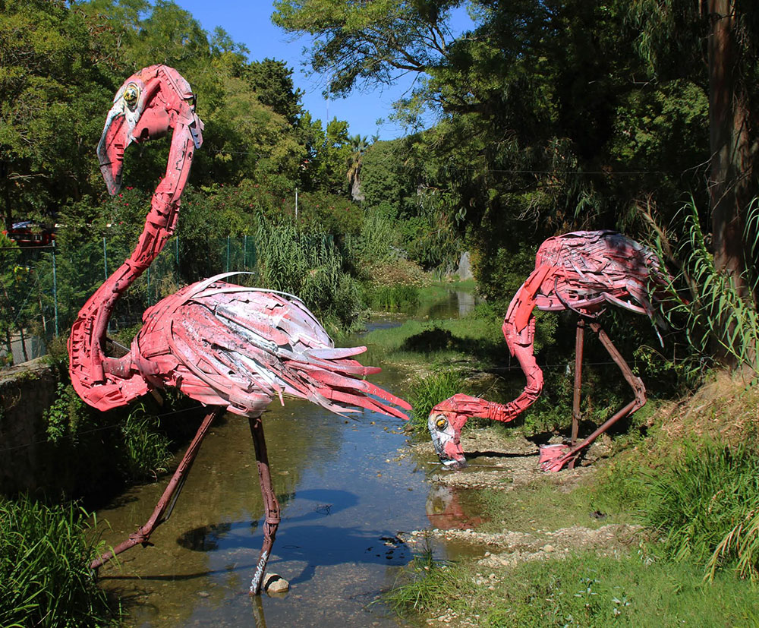

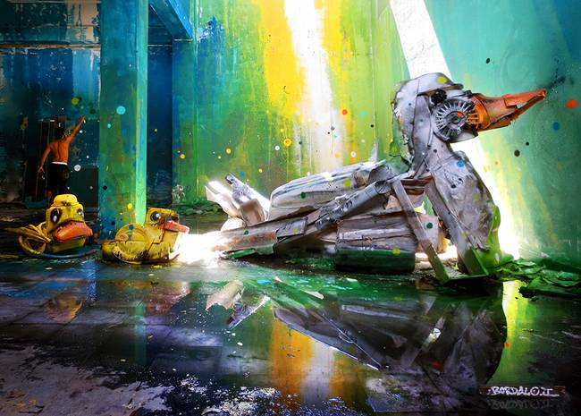
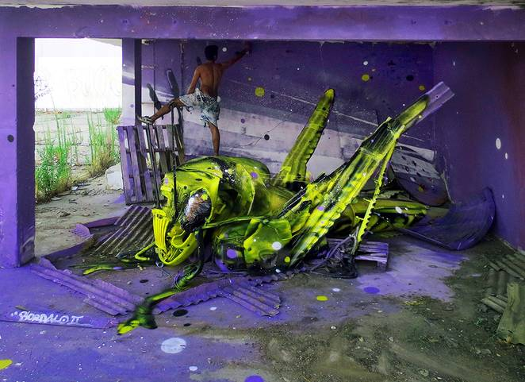

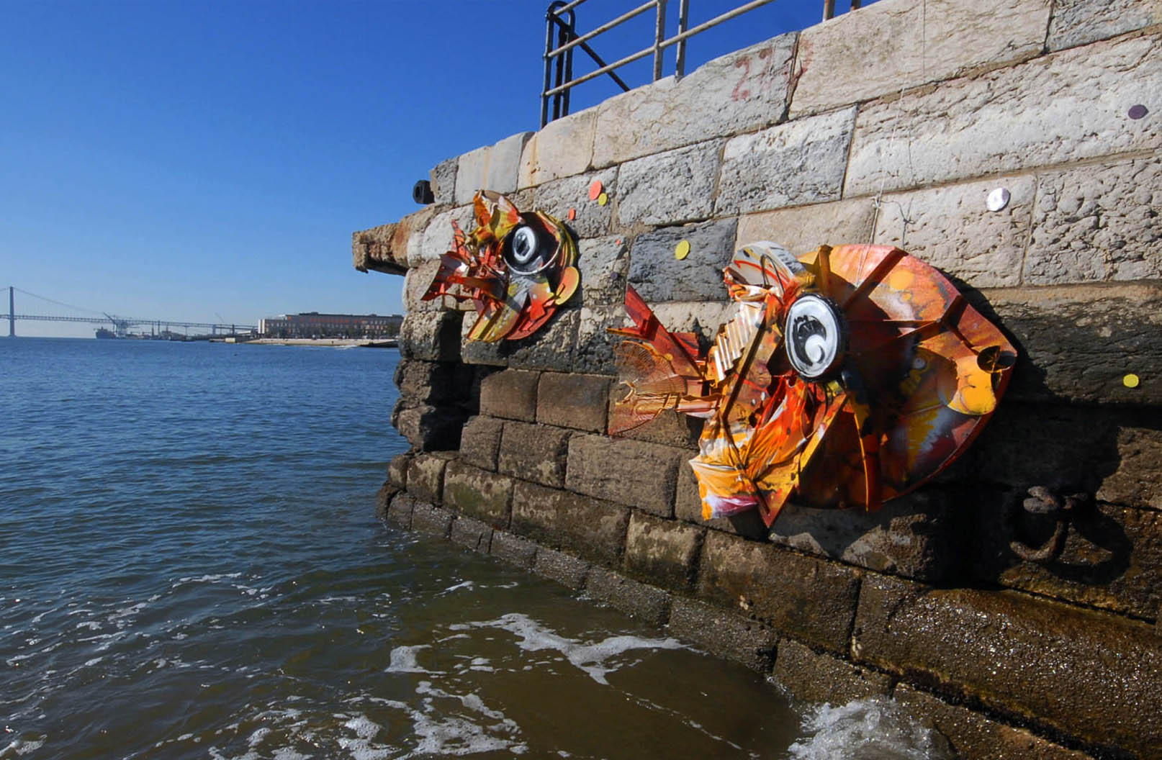
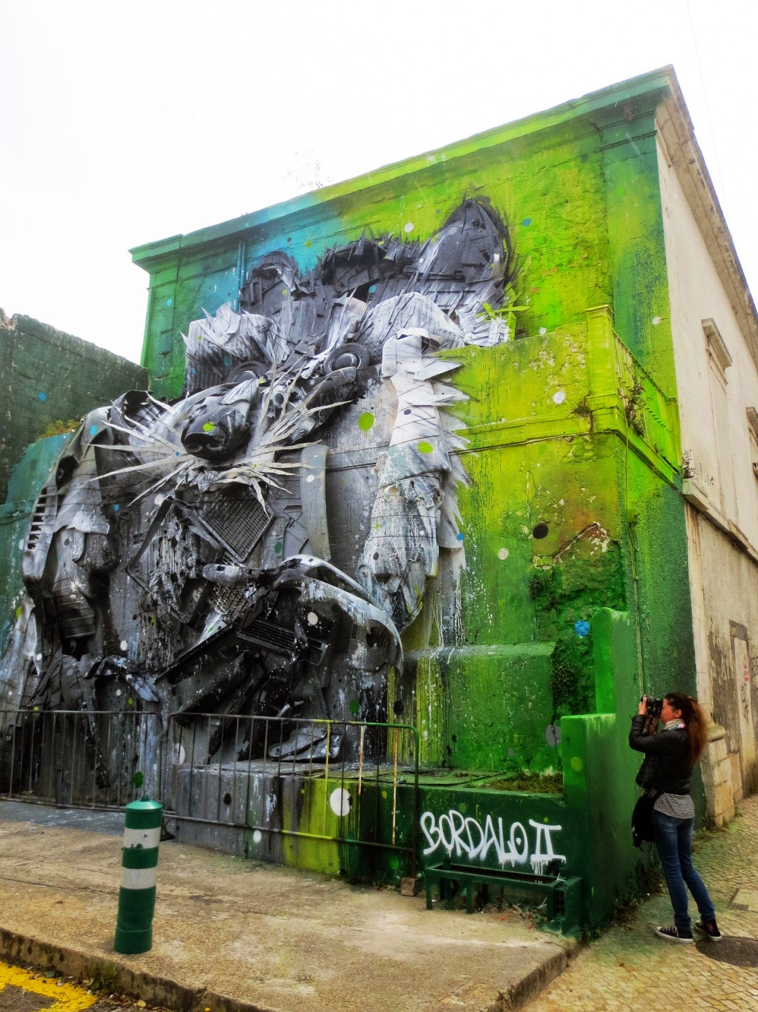
Eco Street Art
Ice Street Art
Néle Azevedo:
- “Melting Men” series by Brazilian artist who uses ice to bring attention to global issues.
- In 2009 she placed 1000 ice figures in a market Square in Germany to emphasise the human impacts of climate change.
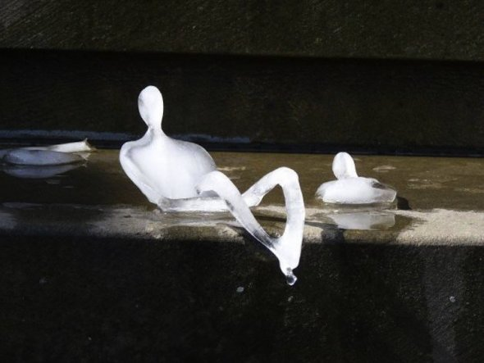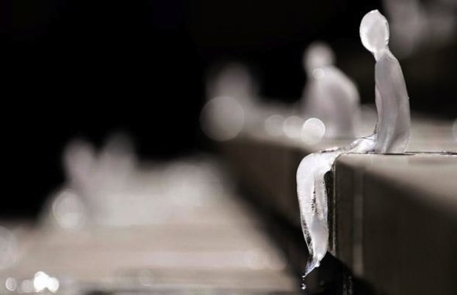
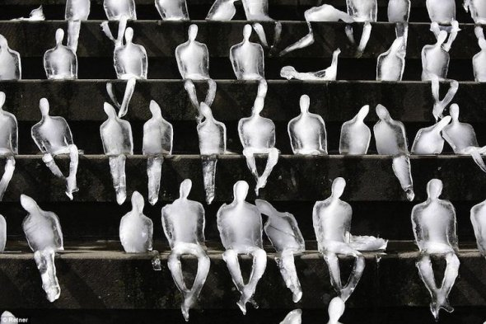

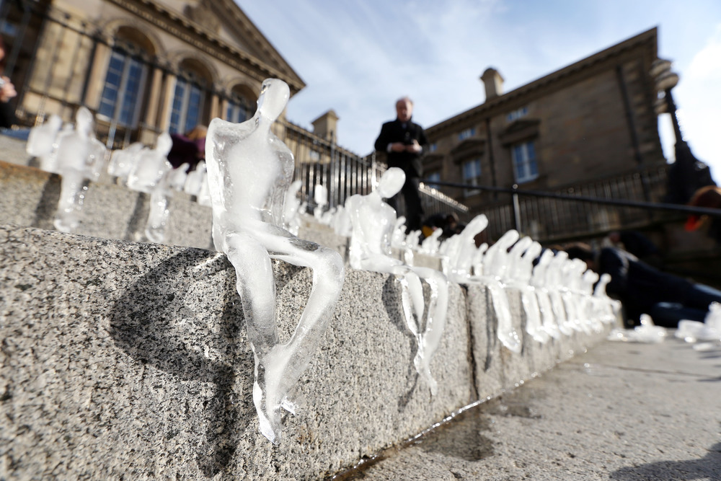
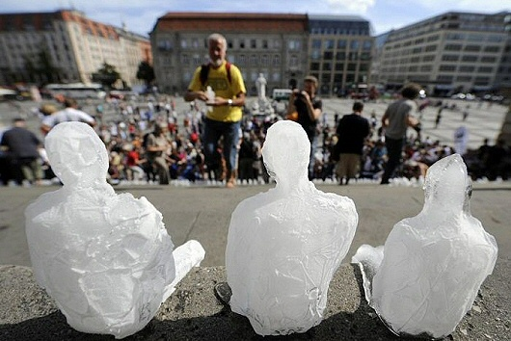
Moss Graffiti
- Moss graffiti is a recent trend in street art that uses living moss to write on the walls of public spaces. Replacing the harmful chemicals found in paints with plant matter, the artist can create art without damaging the environment.
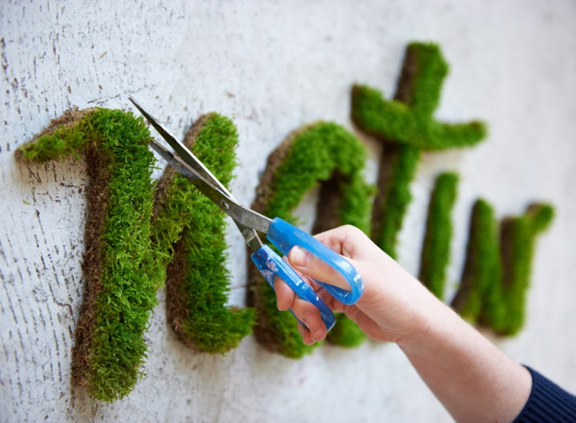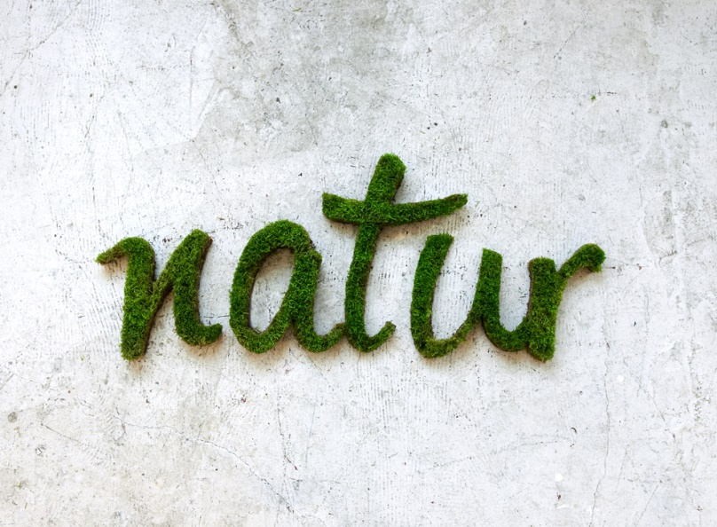
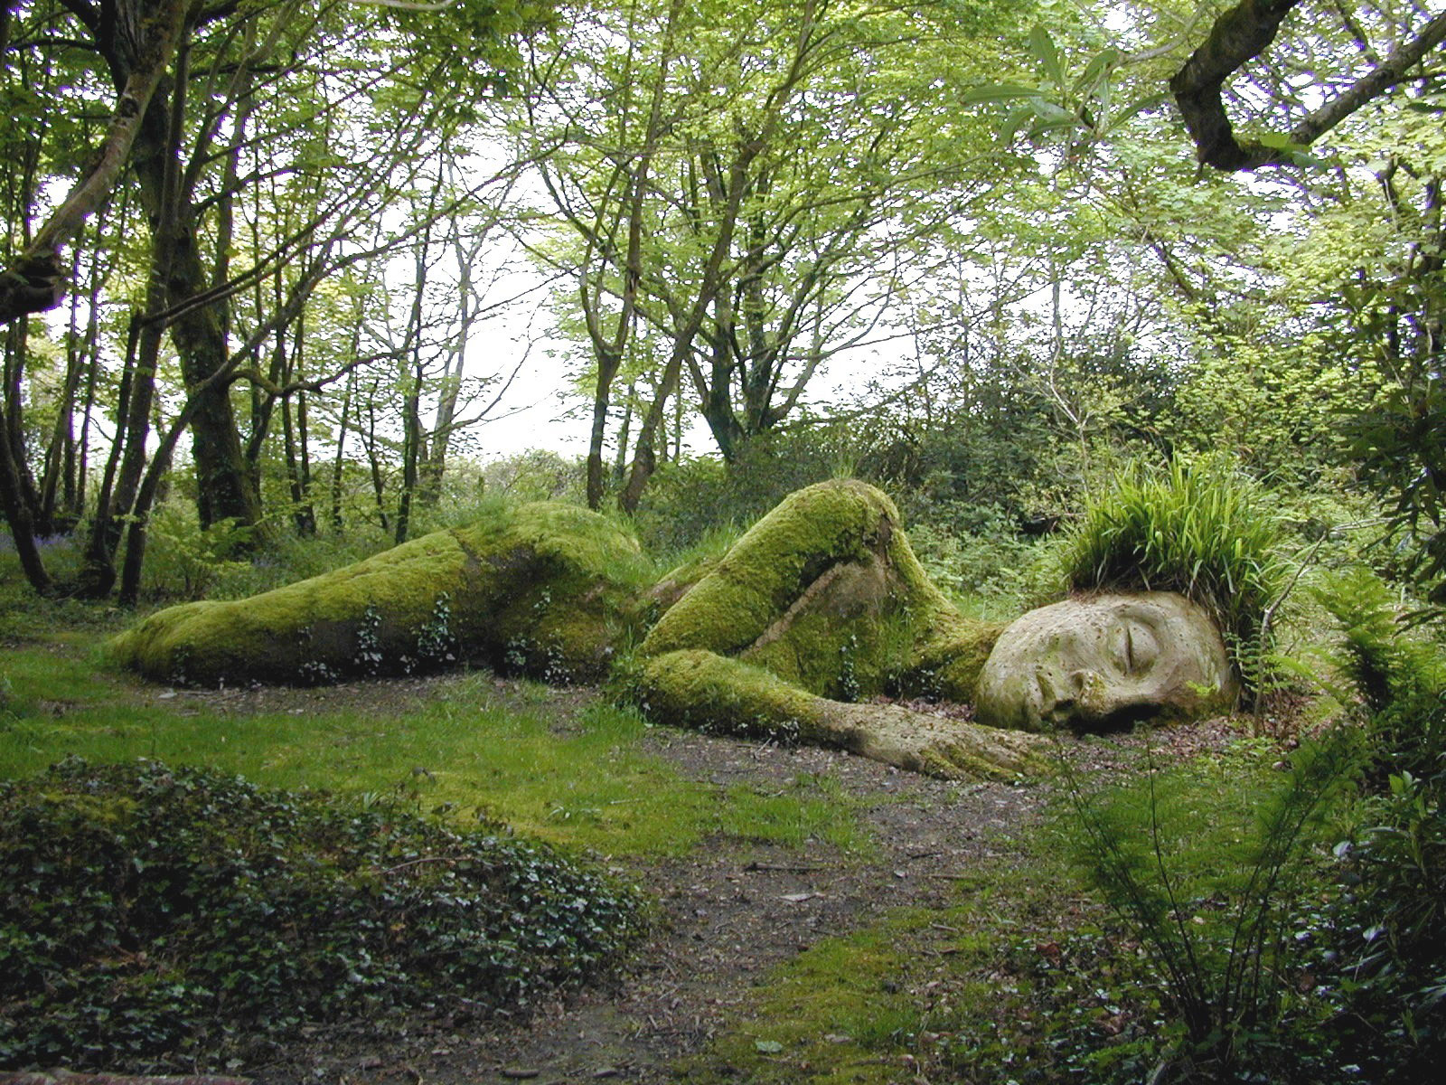

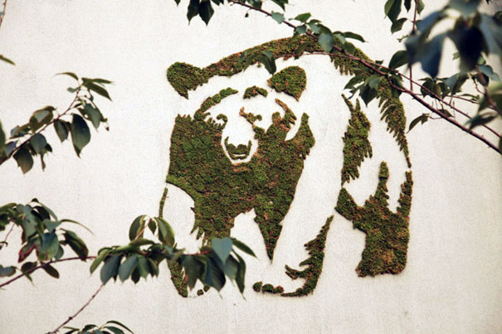
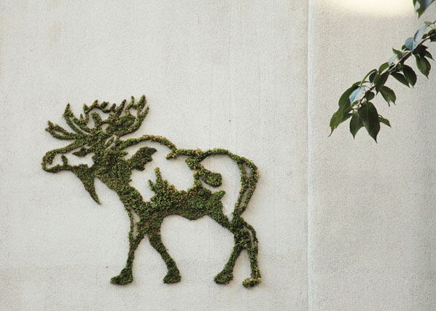

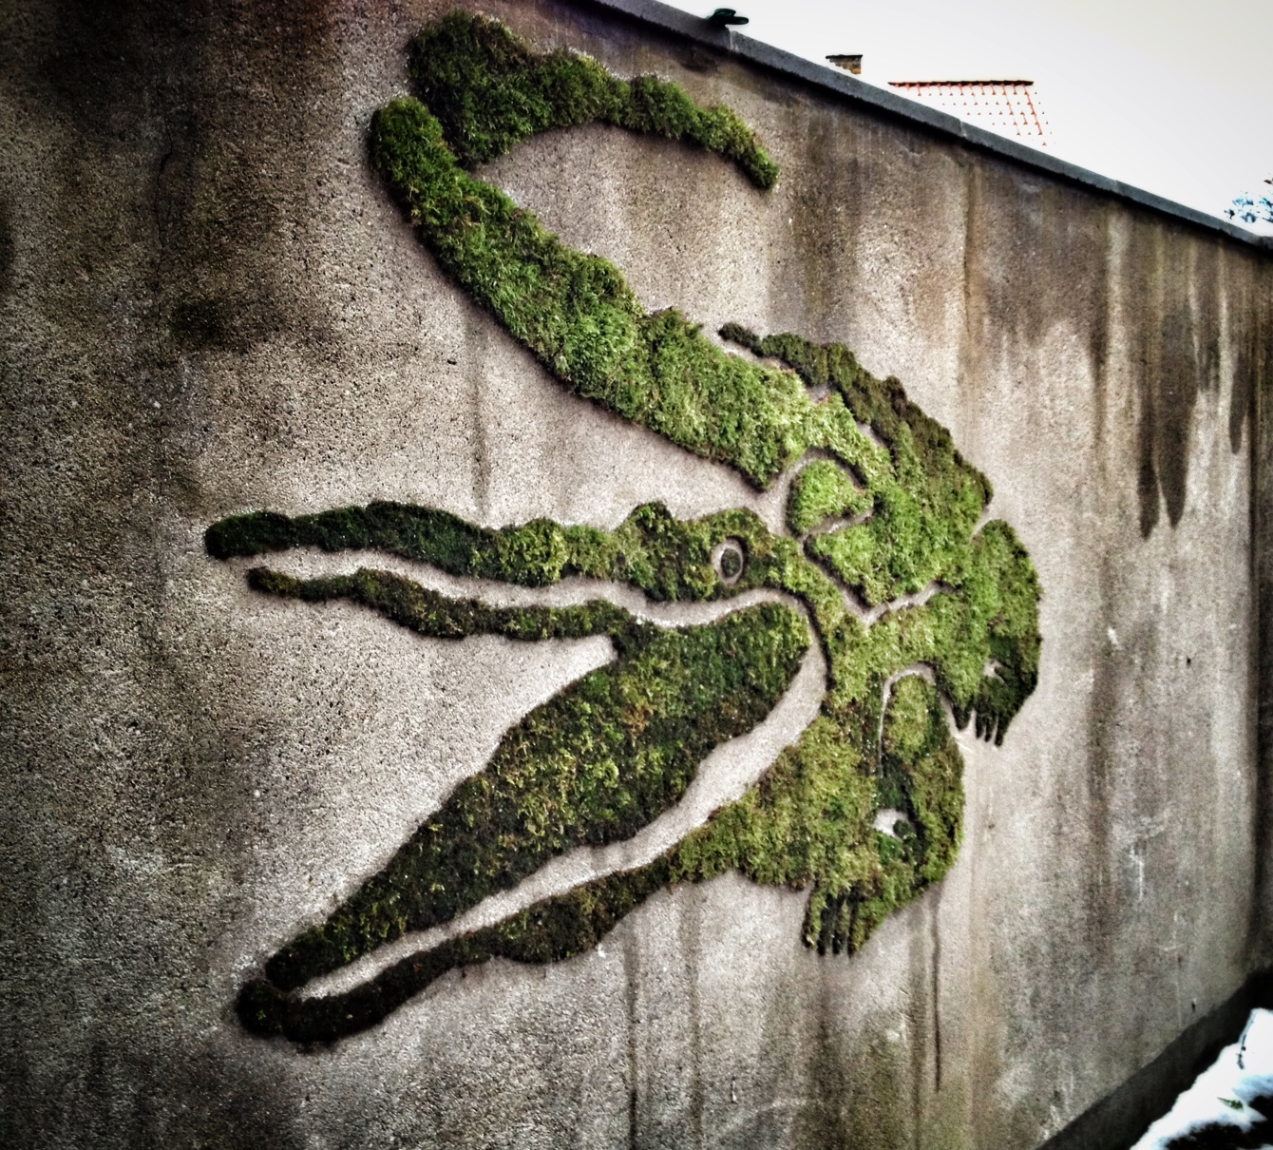
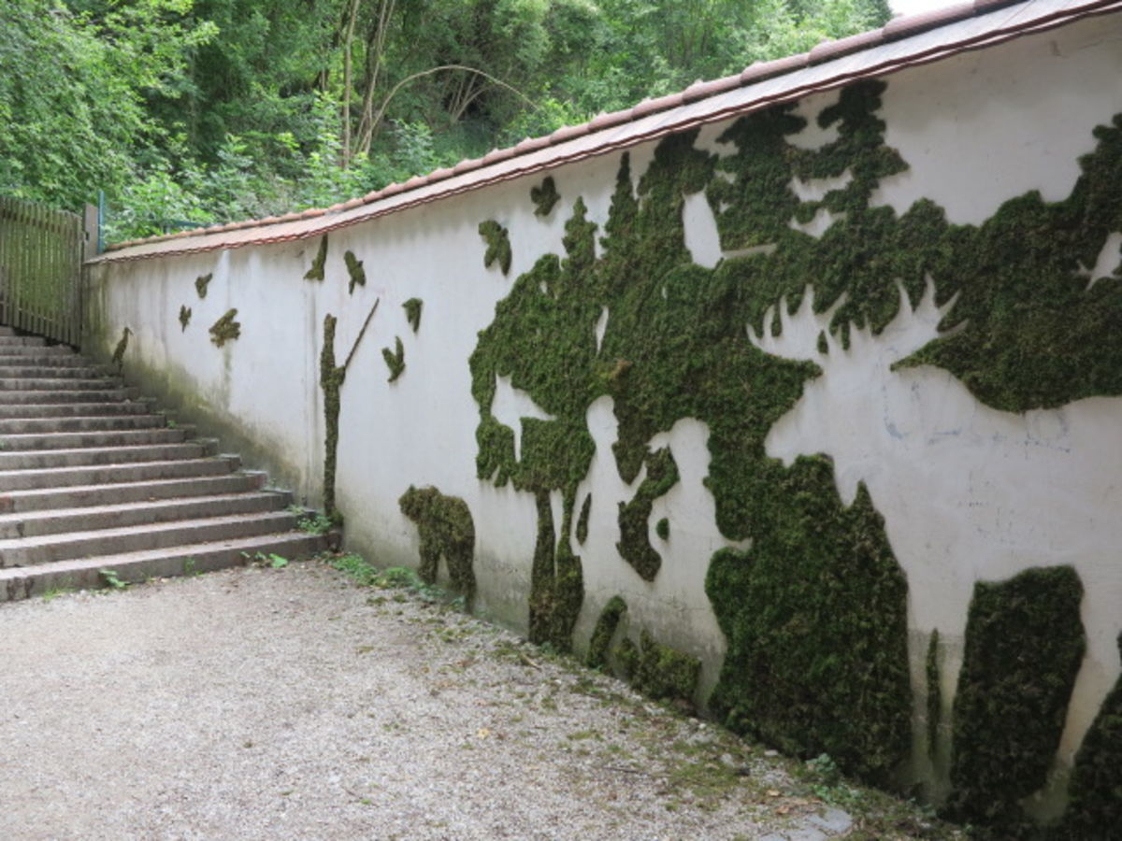
Street Art
“Urbanization is killing our Planet”
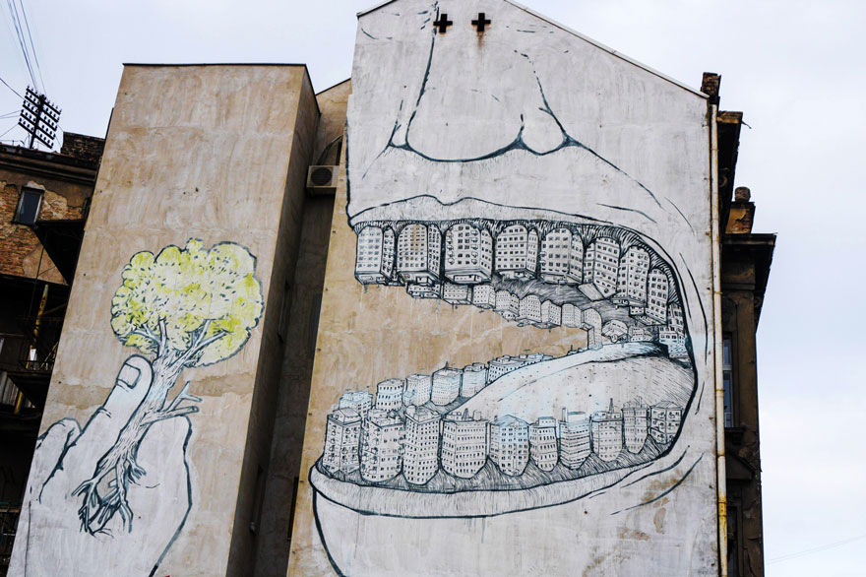
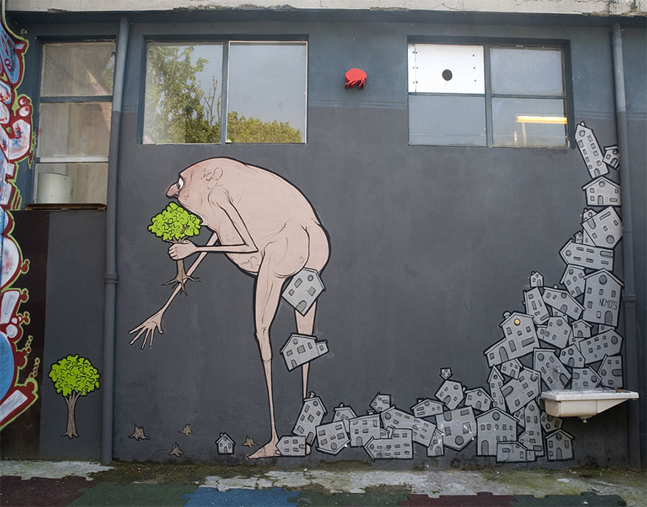

Banksy:
- An English graffiti artist and a political, environmental activist. His true identify remains unknown.
- Well-known street artist who uses the technique of stenciling to create powerful images.
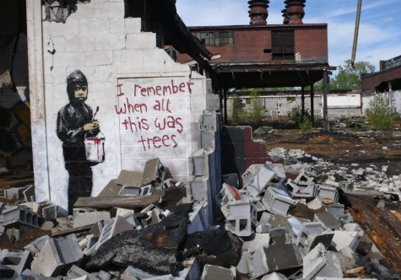
“I Remember when all this was trees” by Banksy, Detroit

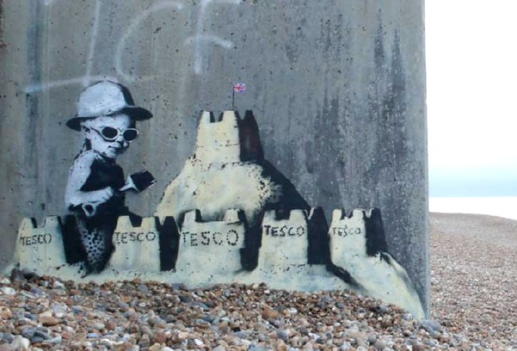
“Tesco Sand Castles” by Banksy
Playing with that which is transitory and volitile to our seas
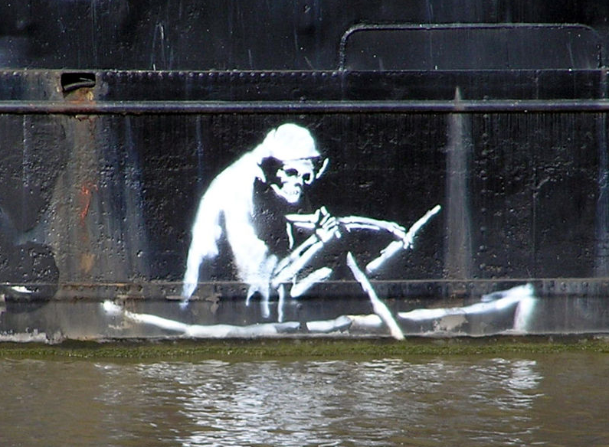
“The Death Boat” by Banksy
The Grim Reaper is steering this oil-filled vessel.

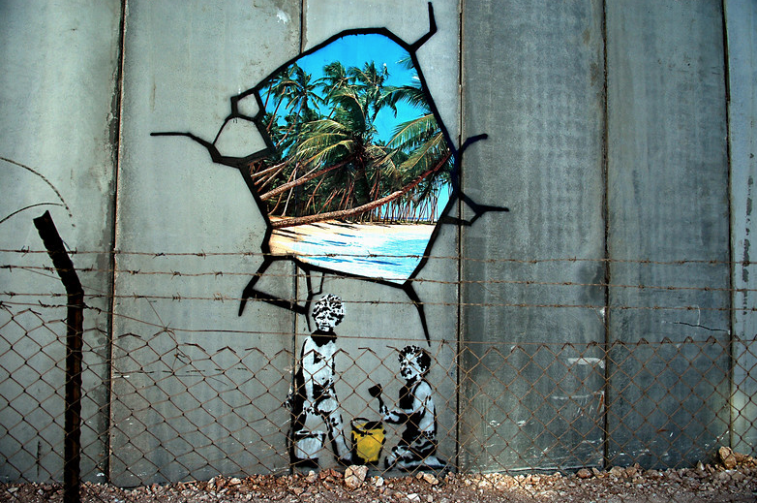
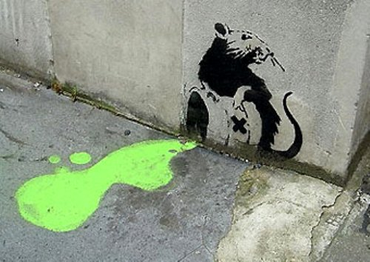
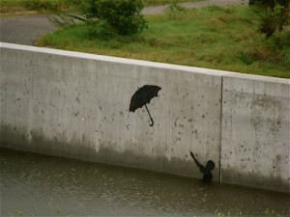
“World is going Down the Drain”
By Pejak, Spain
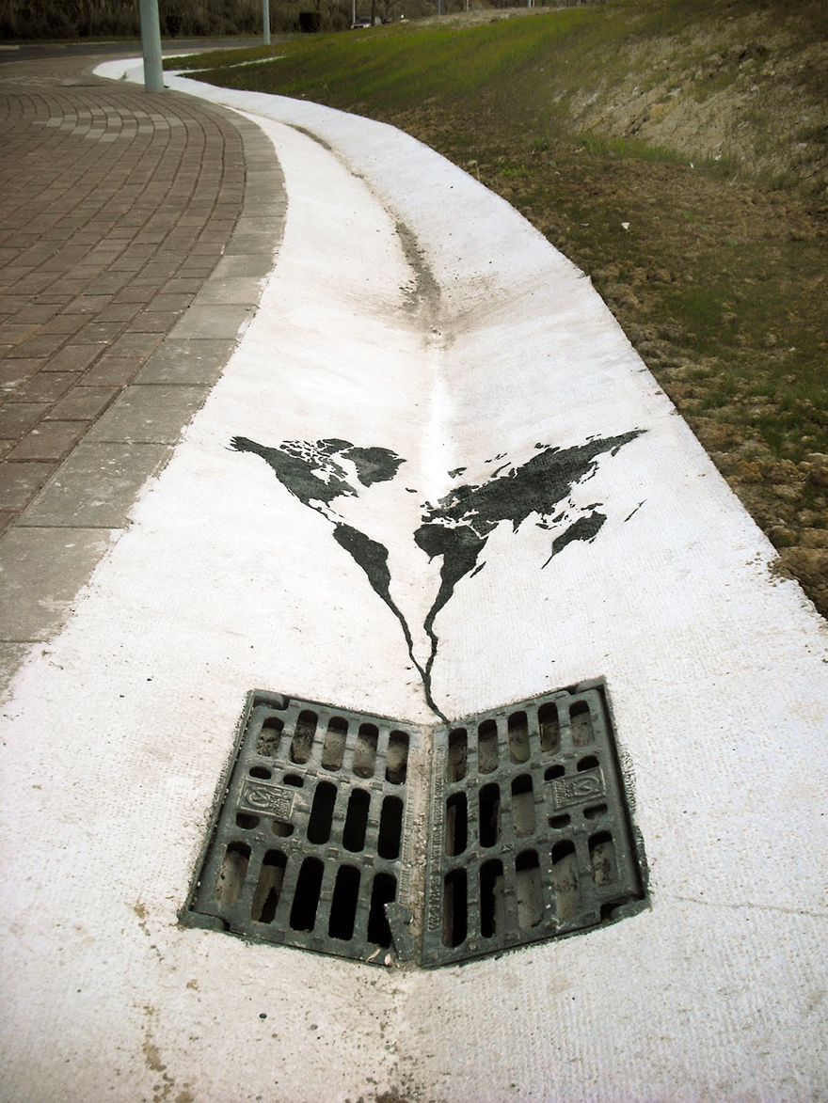
Digital Eco Art
- A public art project puts the environment on display in Rome while world leaders wrap up climate negotiations in Paris.

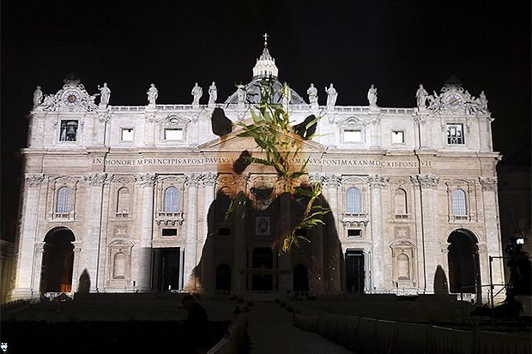
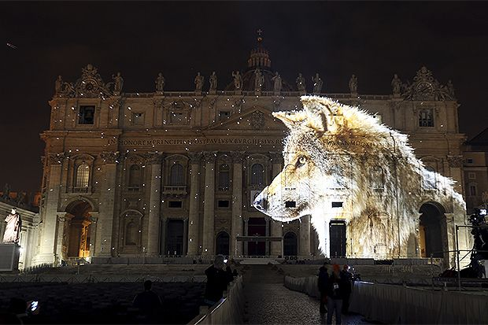

Chris Milk:

- “The Treachery of Sanctuary” an Interactive installation at the Barbican, London - July 2014.

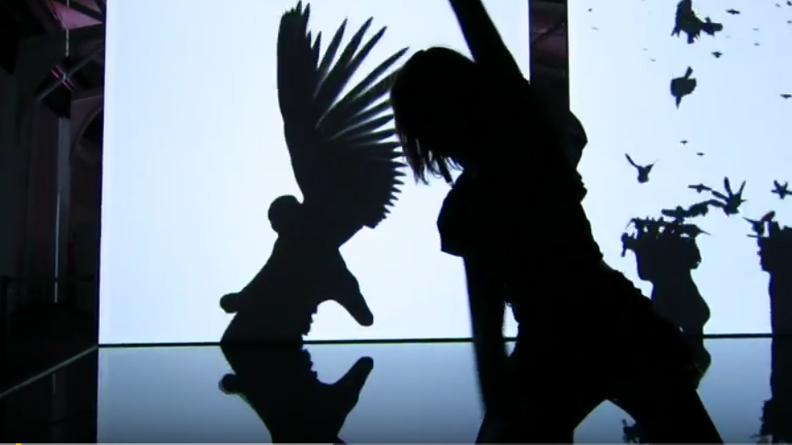
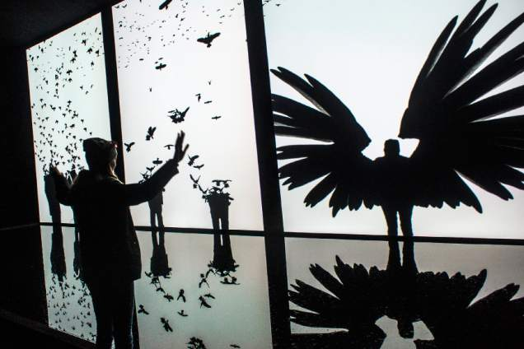

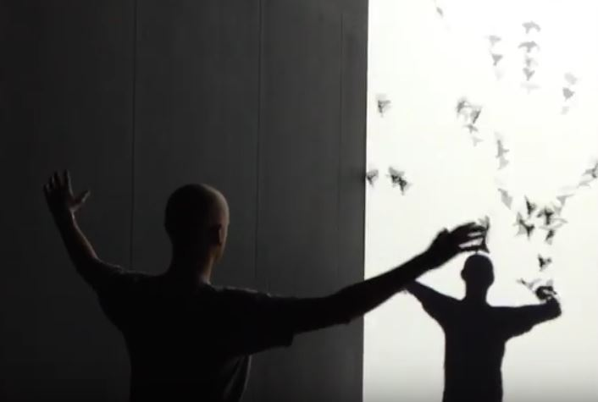
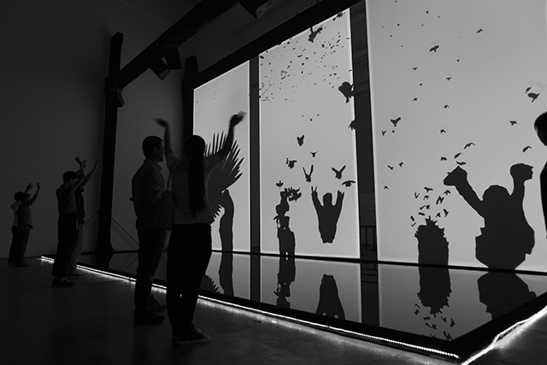

Naziha Mestaoui’s “Virtual Forests”
- Projects virtual forests onto city spaces, blurring the boundaries between the natural world and advancing technology.
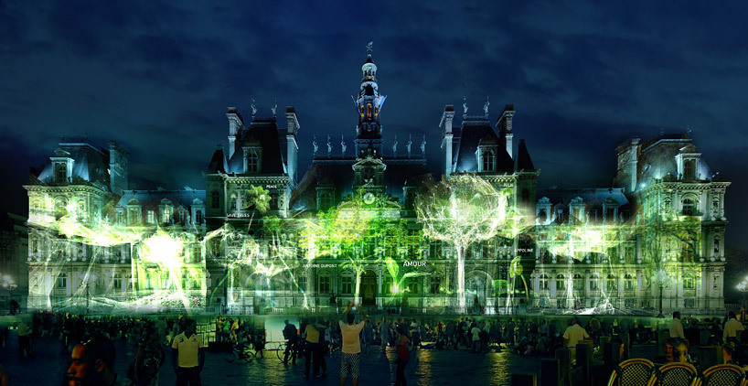

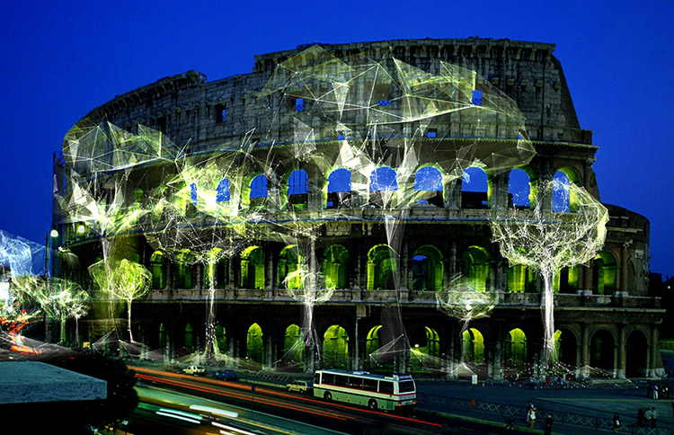

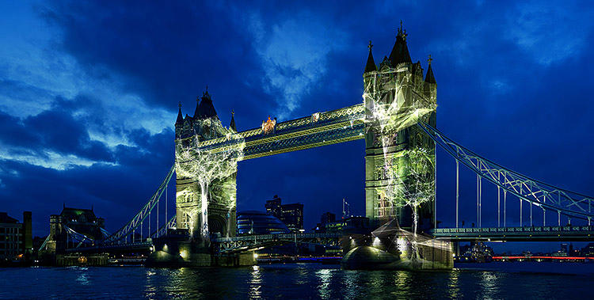
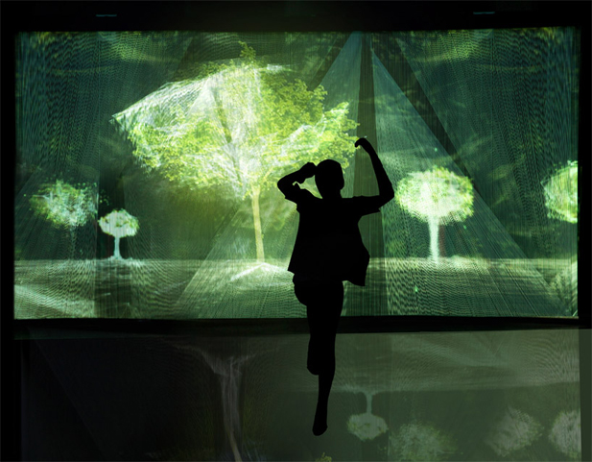

Barry Underwood: “Electric Landscapes”
- Combining elements of painting, photography, performance, cinema and land art, he renders environmental issues like light pollution and deforestation in electric splendor.
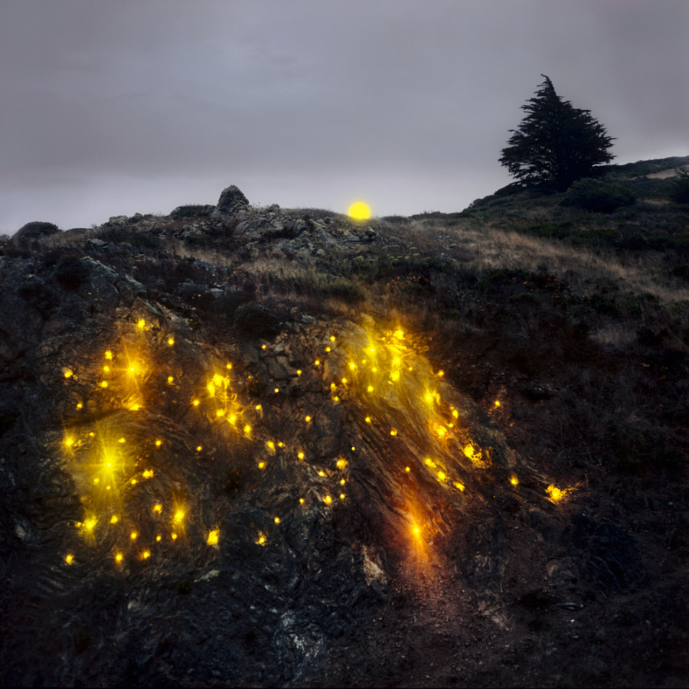

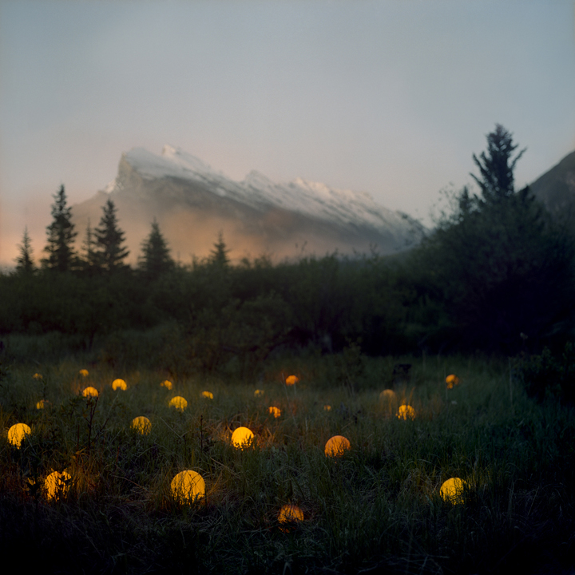
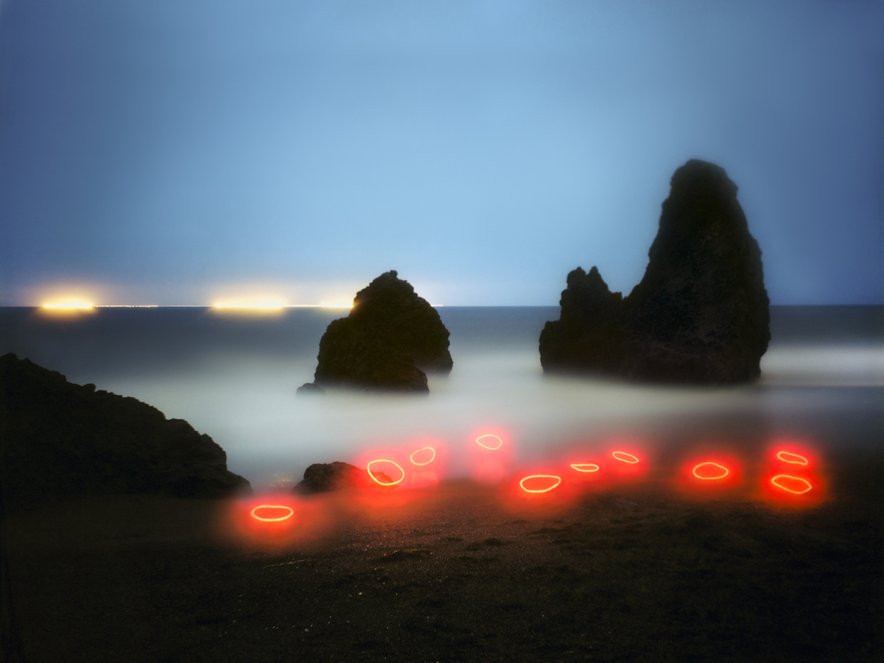

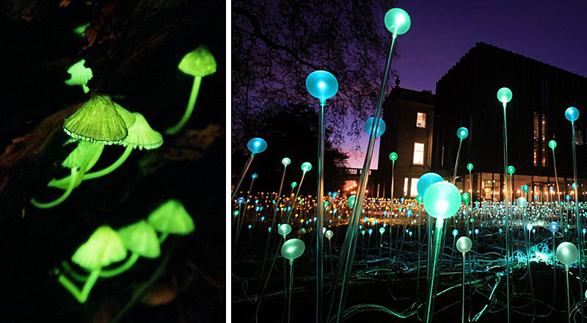
Examples of natural references
Mycena lux-coeli mushrooms / Light installation

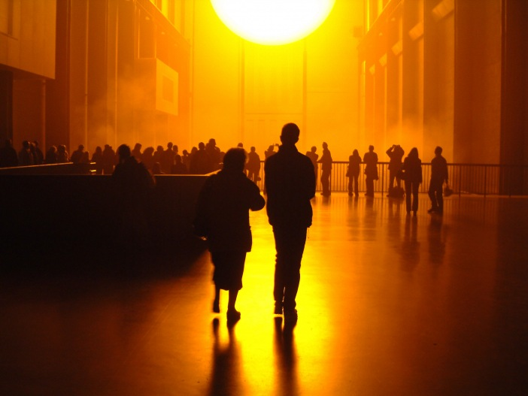
Light Installation project representing global warming

Digitally created posters to promote environmental awareness
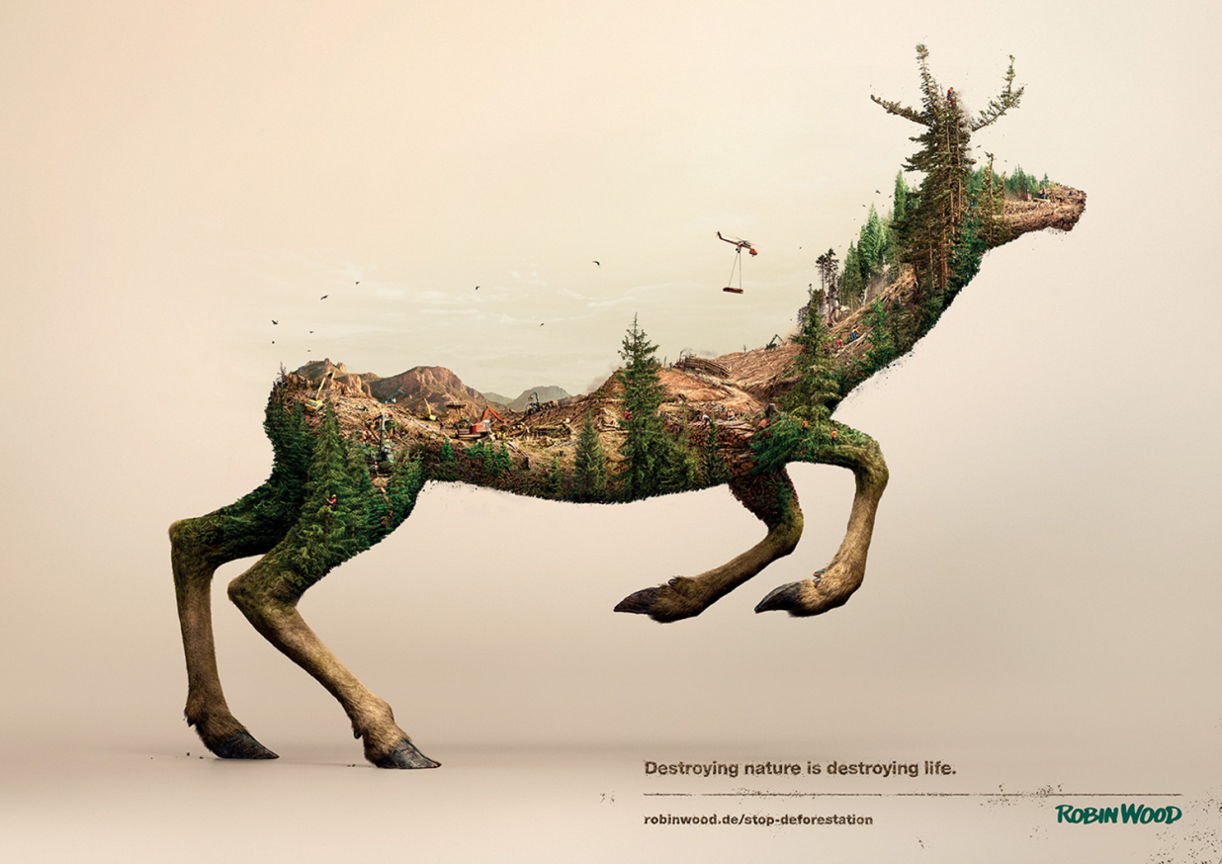
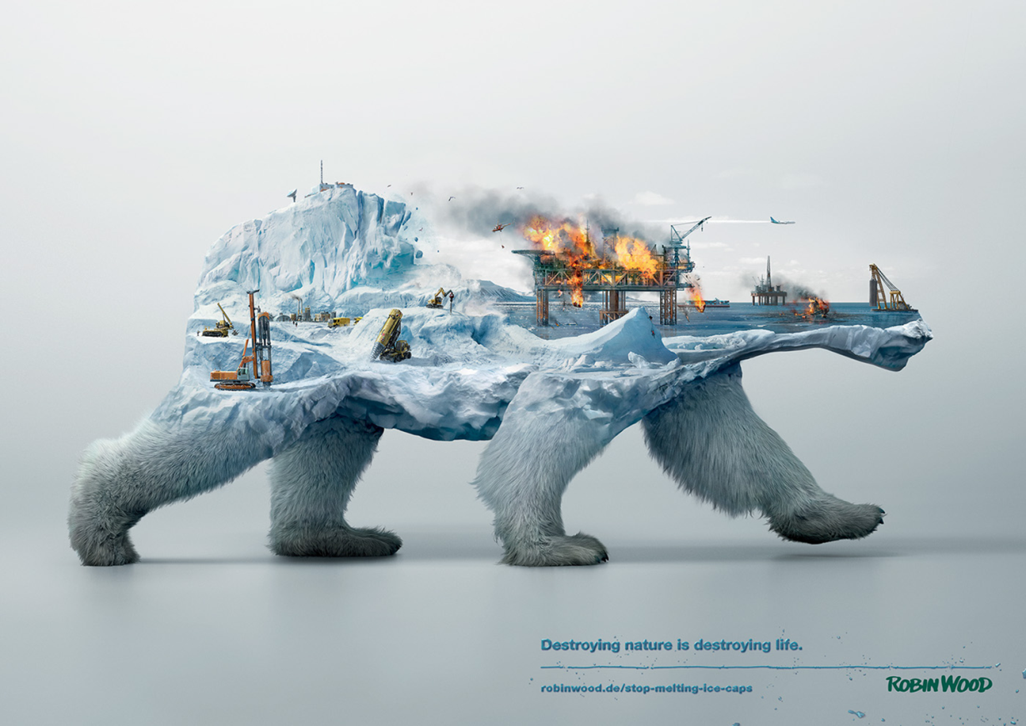

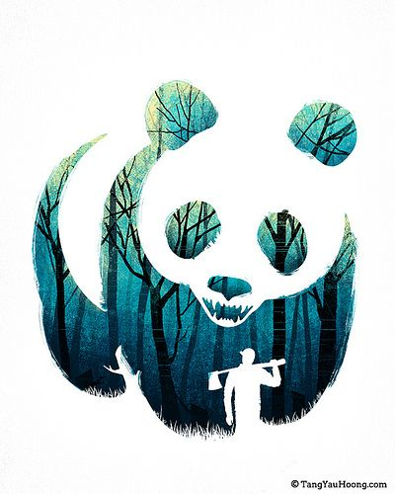
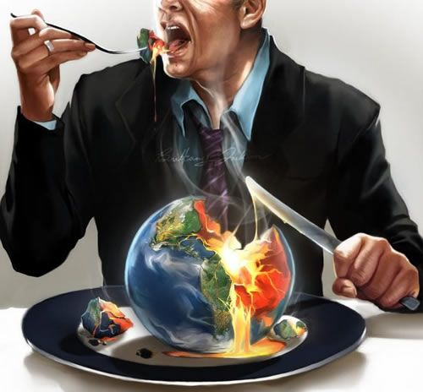

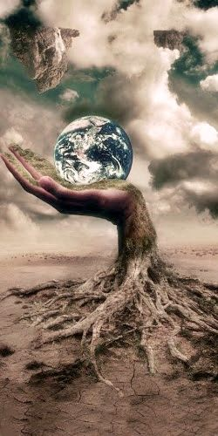

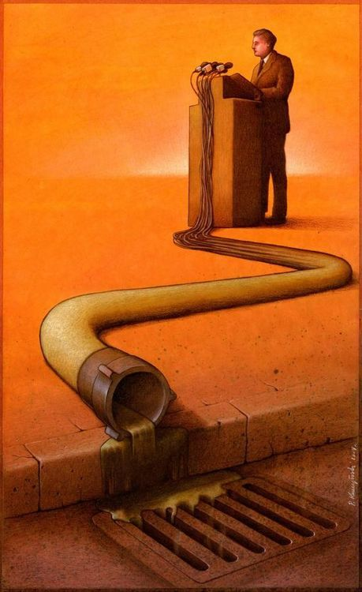

References
3 Types of Eco-Friendly Graffiti Art That Will Blow Your Mind:
http://www.greenpeace.org/new-zealand/en/blog/3-types-of-eco-friendly-graffiti-art-that-wil/blog/53107/

Eco Art: http://www.sinthiacousineau.com/eco-art.html

New Animalistic Trash Sculptures by Bordalo II Spring Up
Around the Globe:
http://www.thisiscolossal.com/2016/09/bordalo-ii-trash-sculptures/

Banksy’s Environmental Message:
https://www.niftyhomestead.com/blog/banksy-environmental-message/
18 Green Artists Who Are Making Climate Change And Conservation A Priority:
http://www.huffingtonpost.com/2014/07/15/environmental-art_n_5585288.html

