Motion Figures
Steps
Step 1: Select one motion silhouette from the images provided by the teacher.
Examples:
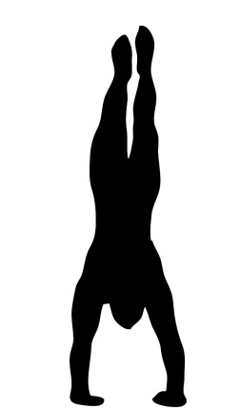
Step 2:
- Pick one black construction paper to be the background.
- Pick either 3 warm colors or 3 cold colors.
Step 3:
- Use the human figure template for inspiration when drawing and cutting out the parts for your human figure. You can also cut out the figure and glue the parts on the colored paper, and cut those parts out. Make sure to use all 3 colors you have chosen.
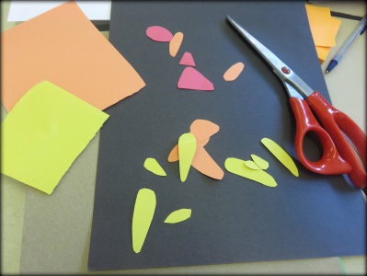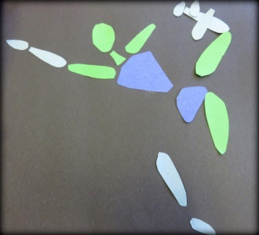
Step 4: Use the parts you made to recreate the motion of the figure on the silhouette.
Step 5: Glue the pieces on the black construction paper.
Step 6: Sign your name and give the project to the teacher.

