The Frog and the Ox
Warm & Cold Motion Figures

Art Educator: Cynthia Cousineau
School: Gardenview Elementary School
Grade Level: Grade 5 (Art & French)
Time Frame: 1:30 hours

Question of Inquiry: How to represent different motions with the human figure and explore the relationship between different colors?
“Project Prototype”
Rationale
Fables play an essential role in the art of story-telling for teaching children about morals. Fables involve themes and characters that appeal to children and the stories are often humorous. The characters are often played by animals that behave and talk like people, but maintain their animal traits thus display human-like behaviour. Through such stories and fables children develop there literary skills.
These stories were originally invented by a slave named Aesop, who was a famous story-teller in his time. Aesop lived in ancient Greece, and his stories were often used to entertain guests at parties. He was rumored to have a very ugly appearance, and he was often mistreated He would come up with stories that aimed to teach people a valuable lesson. His stories would eventually inspire Jean La Fontaine to also create children’s stories that aimed to teach morals.
In the story “The Frog and the Ox”, a frog encounters an Ox and wants to become as big and strong as that Ox. So the frog exercises to get bigger and stronger, but that was not good enough so he exercises some more. He exercised so much to the point where he became so big that he exploded. The moral of this story is that vanity may lead to self-destruction. The frog cared so much about how he looked; he eventually got so big he burst. He used different physical exercises to become bigger. Exercise involves motion, and students will explore the different types of motions by creating a colorful human figure to demonstrate a specific form of exercise. Students will familiarize themselves with representing figures using simple shapes.
Learning Objectives
- To become more familiar with the term “motion” and how to represent it through art.
- To explore the relationship between colors by learning about warm and cold colors.
- Students will become more familiar with the artistic elements of the human figure.
- Students will explore different artistic techniques for communicating motion.

Materials
For Educator:
- Examples of project prototype
- A human figure template to show the class
- A color Wheel
- Extra: Human Figure Model to demonstrate motion
For Students:
- Scissors
- Glue Stick
- One piece of black construction paper
- Colored construction paper of various colors
- A printed example of motion (silhouette or photograph)

Motion Figures
Steps
Step 1: Select one motion silhouette from the images provided by the teacher.
Examples:
Step 2:
- Pick one black construction paper to be the background.
- Pick either 3 warm colors or 3 cold colors.
Step 3:
- Use the human figure template for inspiration when drawing and cutting out the parts for your human figure. You can also cut out the figure and glue the parts on the colored paper, and cut those parts out. Make sure to use all 3 colors you have chosen.
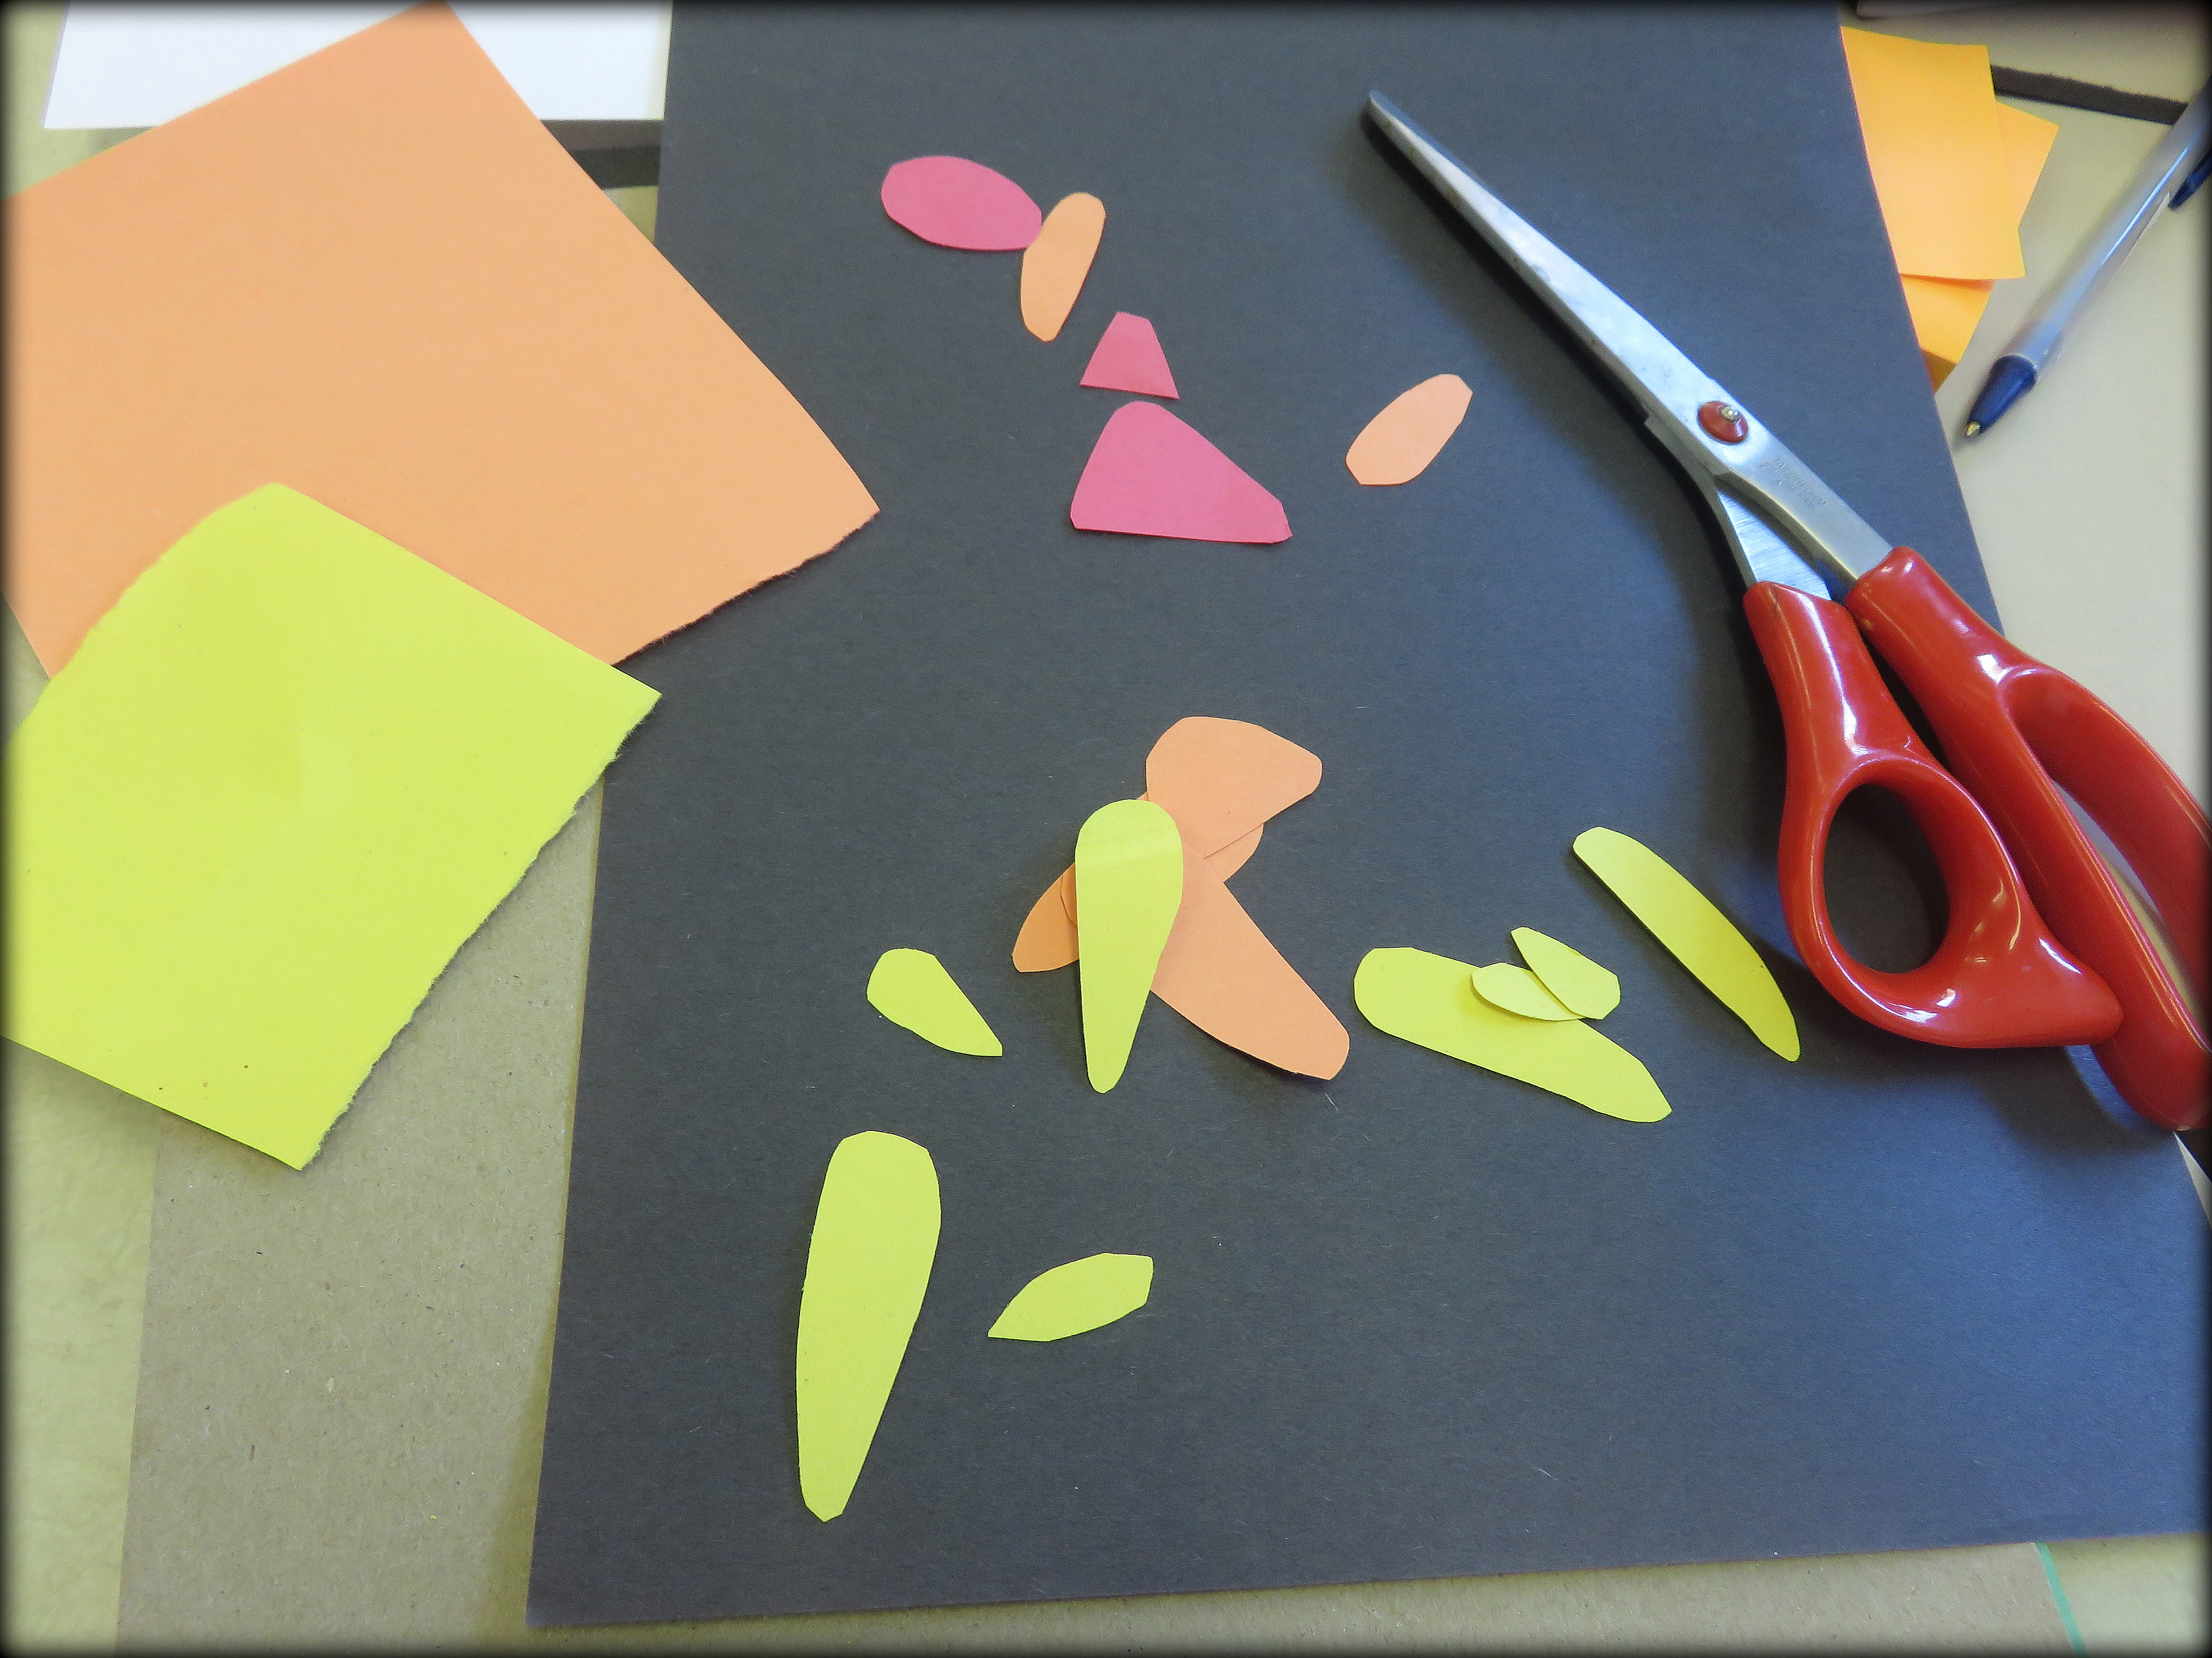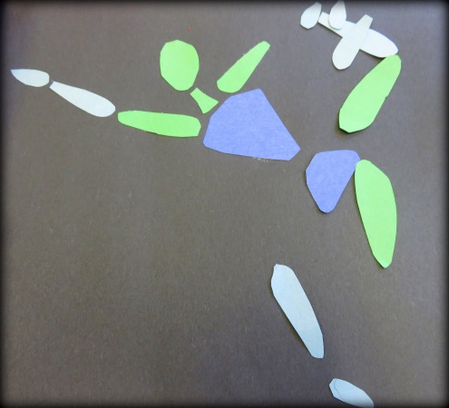
Step 4: Use the parts you made to recreate the motion of the figure on the silhouette.
Step 5: Glue the pieces on the black construction paper.
Step 6: Sign your name and give the project to the teacher.
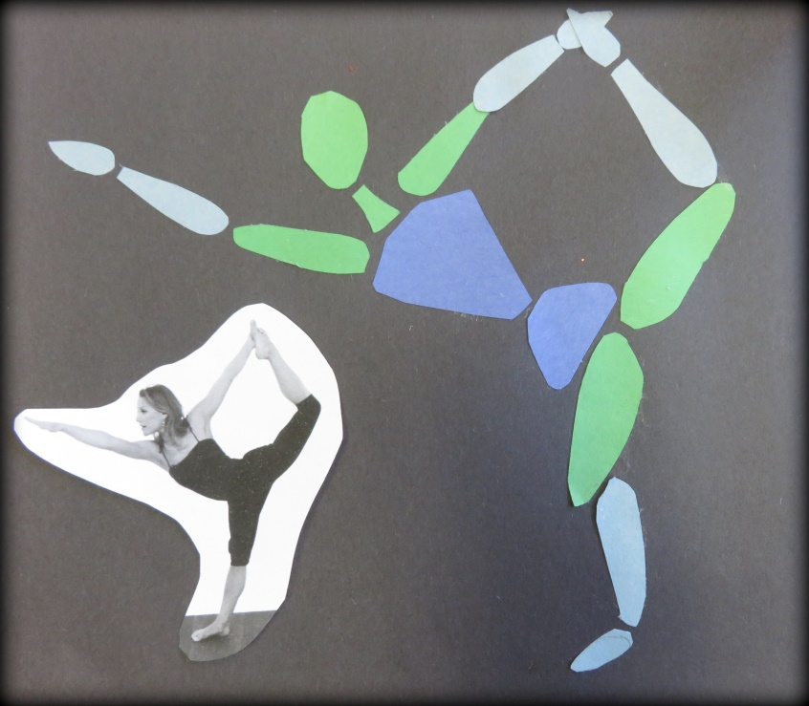
“Project Prototype”

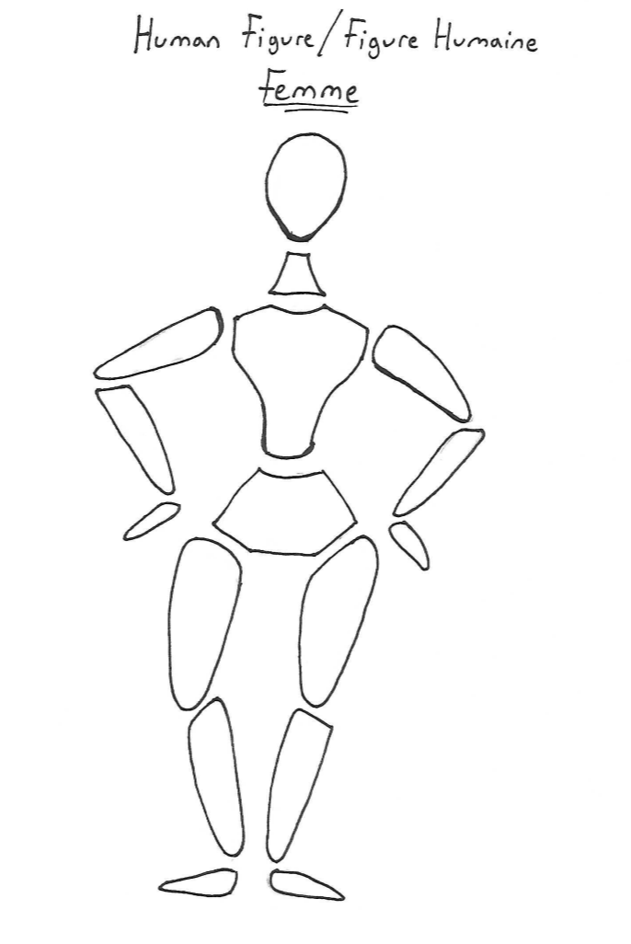
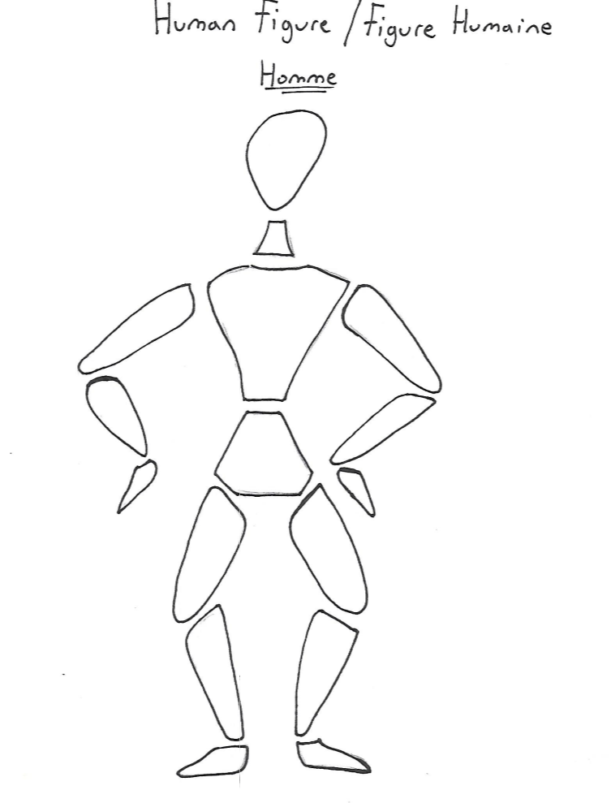
Vocabulary
Conceit: Too much pride in oneself
Color Wheel: A circular diagram showing the relationship between different colors. For example: primary, secondary and complementary colors.
Cool Colors: Colors associated with water, sky, ice, and colder temperatures. Colors include green, blue and violet.

Composition: The organization or arrangement of all of the visual elements in an attempt to develop a unity in the total work of art.
Figure: A person or animal that can be only seen as a shape or outline.
Motion: The action of moving
Silhouette: the dark shape and outline of someone or something visible against a lighter background, especially in dim light.

Warm Colors: Colors associated with fire, heat, sun and warmth. These colors include red, orange and yellow.
Vanity: Extreme pride in or admiration of one's own appearance or achievements

The Frog and the Ox
an Aesop Fable

One afternoon a grand and wonderful ox was on his daily stroll, when he was noticed by a small haggardly frog. The frog was too impressed with the great ox, impressed to the point of envy.

"Look at this magnificent ox!" he called to all his friends, "He's such a grand size for an animal, but he's no greater than I am if I tried."

The frog started puffing and swelled from his normal size.
"Am I as large as the wonderful ox?" he asked his friends.
"No, no, not near as grand as the ox," they replied.

So, the frog puffed himself up more and more, trying to reach the state of the ox.
"Now? now?" asked the frog.
"No, no. But please, don't try anymore," pleaded his friends.

But the frog continues to puff and swell, larger and larger until he finally burst.

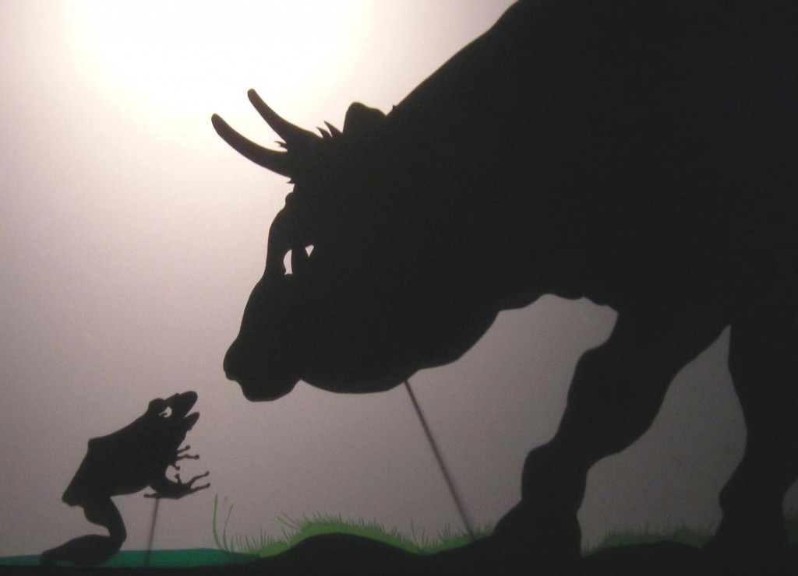

Morale of Story: “Self-conceit may lead to self-destruction.”

La Grenouille qui veut se faire aussi grosse que le Bœuf
Par Jean de la Fountaine

Une Grenouille vit un Boeuf
Qui lui sembla de belle taille.
Elle, qui n'était pas grosse en tout comme un oeuf,
Envieuse, s'étend, et s'enfle, et se travaille,
Pour égaler l'animal en grosseur,
Disant : "Regardez bien, ma soeur ;
Est-ce assez ? dites-moi ; n'y suis-je point encore ?
- Nenni. - M'y voici donc ? - Point du tout. - M'y voilà ?
- Vous n'en approchez point.". La chétive pécore
S'enfla si bien qu'elle creva.
Le monde est plein de gens qui ne sont pas plus sages :
Tout bourgeois veut bâtir comme les grands seigneurs,
Tout petit prince a des ambassadeurs,
Tout marquis veut avoir des pages.
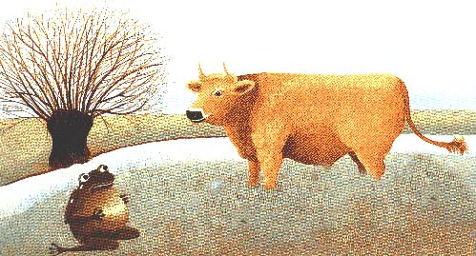
Morale de L’histoire : «Tout bourgeois veut bâtir comme les grands seigneurs, tout prince a des ambassadeurs, tout marquis veut avoir des pages.
References
La Grenouille qui veut se faire aussi grosse que le Bœuf : http://mistercarl.tripod.com/id8.html
-This site provides a written version in French of the Fable story “the fox and the ox”.
The Frog and the Ox: http://www.storyit.com/Classics/Stories/oxandfrog.htm
This site provides a written version in English of the Fable story “the fox and the ox”.

YouTube Vidéo on the Fable Story: La Grenouille qui veut se faire aussi grosse que le Bœuf
https://www.youtube.com/watch?v=7n7Kqr3AVYk
https://www.youtube.com/watch?v=Si1u3SDx9nQ
https://www.youtube.com/watch?v=Is47wPMfSHs

«

