[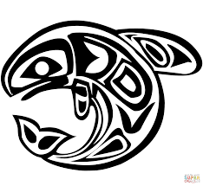](http://www.google.ca/url?sa=i&rct=j&q=&esrc=s&source=images&cd=&cad=rja&uact=8&ved=0ahUKEwjY4P3gm6DSAhVL0oMKHf2yAnUQjRwIBw&url=http://www.supercoloring.com/coloring-pages/arts-culture/canadian-aboriginal-art&psig=AFQjCNFg0seGJMmdpS5yOpkBHWi_tjZ4Tg&ust=1487733066106520)

[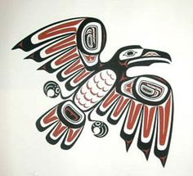](https://www.google.ca/url?sa=i&rct=j&q=&esrc=s&source=images&cd=&cad=rja&uact=8&ved=0ahUKEwichuqKnKDSAhVE4oMKHeYGCnoQjRwIBw&url=https://www.pinterest.com/pin/95138610849179612/&bvm=bv.147448319,d.amc&psig=AFQjCNGTgc7gWfSs03uFZVBpy8EgLXDcNg&ust=1487733166222944)

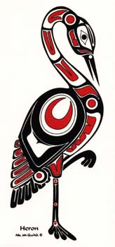

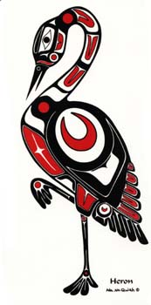

[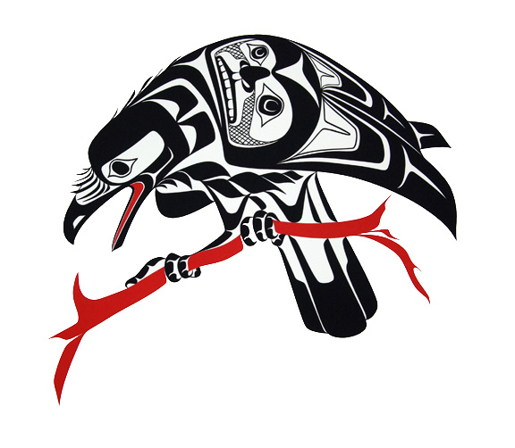](https://www.google.ca/url?sa=i&rct=j&q=&esrc=s&source=images&cd=&cad=rja&uact=8&ved=0ahUKEwj9i_L2nKDSAhVl_4MKHRZVC9kQjRwIBw&url=https://www.pinterest.com/cedarspirit22/pacific-northwest-coast-art/&bvm=bv.147448319,d.amc&psig=AFQjCNGTgc7gWfSs03uFZVBpy8EgLXDcNg&ust=1487733166222944)

[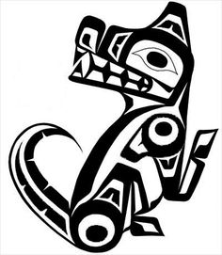](https://www.google.ca/url?sa=i&rct=j&q=&esrc=s&source=images&cd=&cad=rja&uact=8&ved=0ahUKEwj0_OmLnaDSAhUm0oMKHTWGCtoQjRwIBw&url=https://www.pinterest.com/pin/320811173430490126/&bvm=bv.147448319,d.amc&psig=AFQjCNGTgc7gWfSs03uFZVBpy8EgLXDcNg&ust=1487733166222944)

[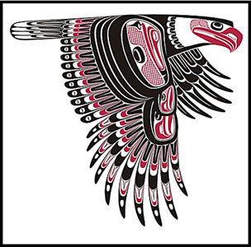](http://www.google.ca/url?sa=i&rct=j&q=&esrc=s&source=images&cd=&cad=rja&uact=8&ved=0ahUKEwjllMapnaDSAhVF9YMKHb0jAXIQjRwIBw&url=http://www.freespiritgallery.ca/nwprints.htm&bvm=bv.147448319,d.amc&psig=AFQjCNGTgc7gWfSs03uFZVBpy8EgLXDcNg&ust=1487733166222944)

[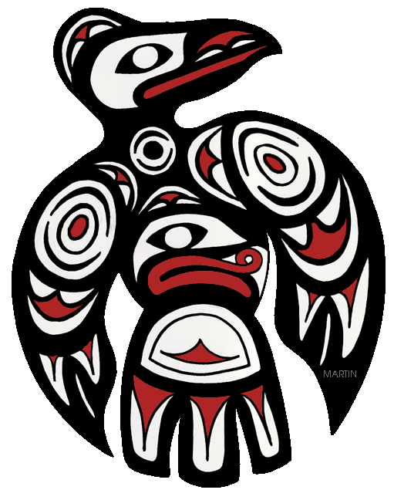](http://www.google.ca/url?sa=i&rct=j&q=&esrc=s&source=images&cd=&cad=rja&uact=8&ved=0ahUKEwiwtsG0naDSAhVIxYMKHbsxCSsQjRwIBw&url=http://nativeamericans.mrdonn.org/northwest/potlatch.html&bvm=bv.147448319,d.amc&psig=AFQjCNGTgc7gWfSs03uFZVBpy8EgLXDcNg&ust=1487733166222944)

[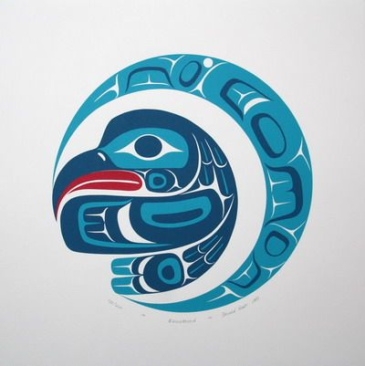](https://www.google.ca/url?sa=i&rct=j&q=&esrc=s&source=images&cd=&cad=rja&uact=8&ved=0ahUKEwiyh7rWnaDSAhXB6oMKHaeBD2UQjRwIBw&url=https://www.pinterest.com/klingercreative/northwest-native-american-masks/&bvm=bv.147448319,d.amc&psig=AFQjCNGP8JCQYviTqYf4jxaqv8-01Kc-Eg&ust=1487733594803306)