[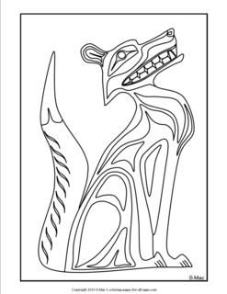](https://www.google.ca/url?sa=i&rct=j&q=&esrc=s&source=images&cd=&cad=rja&uact=8&ved=0ahUKEwjm7qqunL7RAhVJw4MKHb9JA8YQjRwIBw&url=https://www.pinterest.com/pin/390335492674567581/&bvm=bv.144224172,d.amc&psig=AFQjCNHqryeaWnmo4cQS5_obVzeHxJralQ&ust=1484365518077737)

[](http://www.google.ca/url?sa=i&rct=j&q=&esrc=s&source=images&cd=&cad=rja&uact=8&ved=0ahUKEwjF-qzBnL7RAhUm6YMKHQrfBcQQjRwIBw&url=http://www.vicartglass.com/sunshop/index.php?l%3Dproduct_detail%26p%3D1624&bvm=bv.144224172,d.amc&psig=AFQjCNHqryeaWnmo4cQS5_obVzeHxJralQ&ust=1484365518077737)

[](https://www.google.ca/url?sa=i&rct=j&q=&esrc=s&source=images&cd=&cad=rja&uact=8&ved=0ahUKEwit-PLMnL7RAhUj5oMKHd4zCbUQjRwIBw&url=https://www.pinterest.com/pin/324399979383295154/&bvm=bv.144224172,d.amc&psig=AFQjCNHqryeaWnmo4cQS5_obVzeHxJralQ&ust=1484365518077737)

[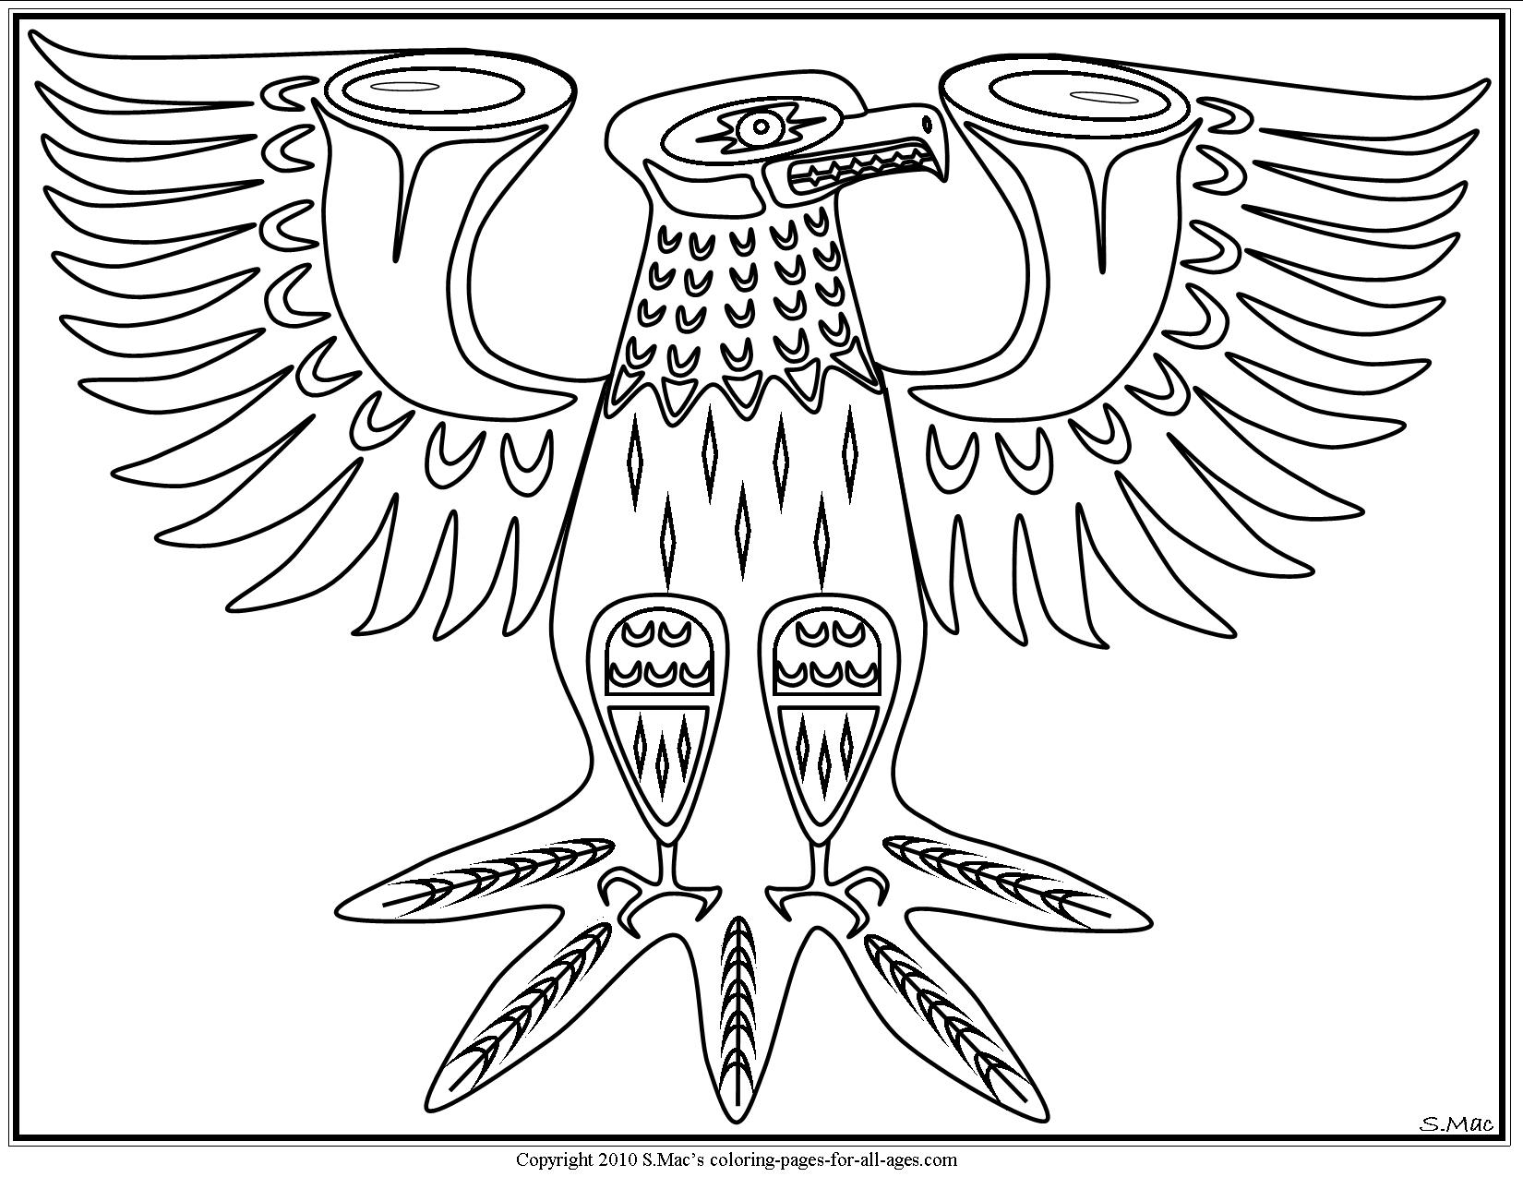](https://www.pinterest.com/scyeoman/coloring-pages/)

[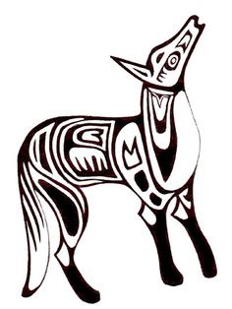](https://www.google.ca/url?sa=i&rct=j&q=&esrc=s&source=images&cd=&cad=rja&uact=8&ved=0ahUKEwi4-ZLinr7RAhWX3oMKHWjXDCkQjRwIBw&url=https://www.pinterest.com/pin/562598178423088852/&bvm=bv.144224172,d.amc&psig=AFQjCNHqryeaWnmo4cQS5_obVzeHxJralQ&ust=1484365518077737)

[](http://www.google.ca/url?sa=i&rct=j&q=&esrc=s&source=images&cd=&cad=rja&uact=8&ved=0ahUKEwjmnJHsnr7RAhVs_4MKHSYdBDoQjRwIBw&url=http://www.vicartglass.com/sunshop/index.php?l%3Dproduct_detail%26p%3D1622&bvm=bv.144224172,d.amc&psig=AFQjCNHqryeaWnmo4cQS5_obVzeHxJralQ&ust=1484365518077737)

[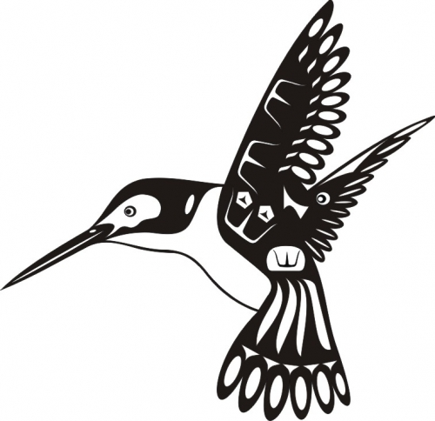](http://www.google.ca/url?sa=i&rct=j&q=&esrc=s&source=images&cd=&cad=rja&uact=8&ved=0ahUKEwi45smRn77RAhVE5YMKHdX0ACEQjRwIBw&url=http://www.vicartglass.com/sunshop/index.php?l%3Dproduct_detail%26p%3D1618&bvm=bv.144224172,d.amc&psig=AFQjCNHqryeaWnmo4cQS5_obVzeHxJralQ&ust=1484365518077737)

[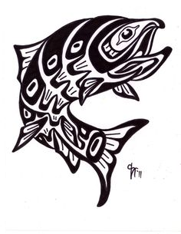](https://www.google.ca/url?sa=i&rct=j&q=&esrc=s&source=images&cd=&cad=rja&uact=8&ved=0ahUKEwjvwJ2dn77RAhUo74MKHTfDCkUQjRwIBw&url=https://www.pinterest.com/pin/285978645061742418/&bvm=bv.144224172,d.amc&psig=AFQjCNHqryeaWnmo4cQS5_obVzeHxJralQ&ust=1484365518077737)

[](https://www.google.ca/url?sa=i&rct=j&q=&esrc=s&source=images&cd=&cad=rja&uact=8&ved=0ahUKEwiykujGn77RAhVK7oMKHX48B4AQjRwIBw&url=https://www.pinterest.com/daveca83/pacific-northwest-indian-art/&bvm=bv.144224172,d.amc&psig=AFQjCNHqryeaWnmo4cQS5_obVzeHxJralQ&ust=1484365518077737)

[](https://www.google.ca/url?sa=i&rct=j&q=&esrc=s&source=images&cd=&cad=rja&uact=8&ved=0ahUKEwiPk8Pjn77RAhUq_4MKHRIAA6YQjRwIBw&url=https://www.pinterest.com/redhot1s/north-west-tribal-art/&bvm=bv.144224172,d.amc&psig=AFQjCNHqryeaWnmo4cQS5_obVzeHxJralQ&ust=1484365518077737)

[](https://www.google.ca/url?sa=i&rct=j&q=&esrc=s&source=images&cd=&cad=rja&uact=8&ved=0ahUKEwiY6KPIoL7RAhUF0YMKHUUqBG8QjRwIBw&url=https://www.pinterest.com/explore/haida-art/&bvm=bv.144224172,d.amc&psig=AFQjCNHqryeaWnmo4cQS5_obVzeHxJralQ&ust=1484365518077737)

[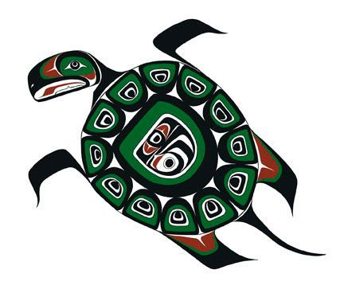](https://www.google.ca/url?sa=i&rct=j&q=&esrc=s&source=images&cd=&cad=rja&uact=8&ved=0ahUKEwjE9uDUoL7RAhXM7IMKHXs-CVIQjRwIBw&url=https://www.pinterest.com/daveca83/pacific-northwest-indian-art/&bvm=bv.144224172,d.amc&psig=AFQjCNHqryeaWnmo4cQS5_obVzeHxJralQ&ust=1484365518077737)

[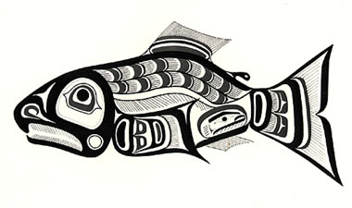](https://www.google.ca/url?sa=i&rct=j&q=&esrc=s&source=images&cd=&cad=rja&uact=8&ved=0ahUKEwiWr8OBob7RAhVq64MKHSLhAE0QjRwIBw&url=https://www.pinterest.com/michaelogden585/native-salmon/&bvm=bv.144224172,d.amc&psig=AFQjCNHqryeaWnmo4cQS5_obVzeHxJralQ&ust=1484365518077737)

[](https://www.pinterest.com/pin/503910645785713202/)

[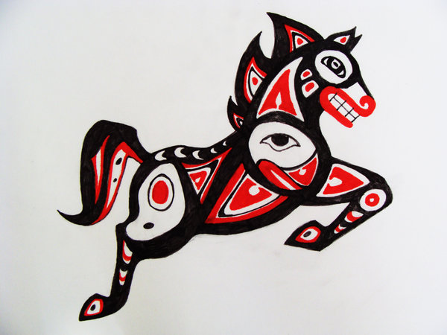](https://www.pinterest.com/amdresaguilera/haida-art-northwest/)

[](https://www.google.ca/url?sa=i&rct=j&q=&esrc=s&source=images&cd=&cad=rja&uact=8&ved=0ahUKEwjvwZDYob7RAhUn0oMKHfsGA2YQjRwIBw&url=https://www.pinterest.com/pin/493425702895208472/&bvm=bv.144224172,d.amc&psig=AFQjCNHqryeaWnmo4cQS5_obVzeHxJralQ&ust=1484365518077737)

[](https://www.google.ca/url?sa=i&rct=j&q=&esrc=s&source=images&cd=&cad=rja&uact=8&ved=0ahUKEwjbhun4ob7RAhXr6IMKHd_hAh4QjRwIBw&url=https://www.pinterest.com/pin/370561875565025139/&bvm=bv.144224172,d.amc&psig=AFQjCNHqryeaWnmo4cQS5_obVzeHxJralQ&ust=1484365518077737)

[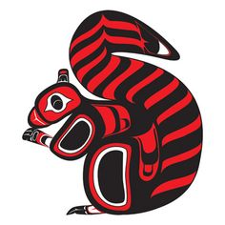](https://www.google.ca/url?sa=i&rct=j&q=&esrc=s&source=images&cd=&cad=rja&uact=8&ved=0ahUKEwjkgqeKor7RAhVr0oMKHSe0Ak4QjRwIBw&url=https%3A%2F%2Fwww.pinterest.com%2Fpin%2F6122149463268044%2F&bvm=bv.144224172,d.amc&psig=AFQjCNHqryeaWnmo4cQS5_obVzeHxJralQ&ust=1484365518077737)