[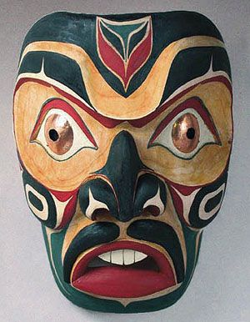](https://www.google.ca/url?sa=i&rct=j&q=&esrc=s&source=images&cd=&cad=rja&uact=8&ved=0ahUKEwioobaznIzSAhUj94MKHQ1UB-oQjRwIBw&url=https://www.pinterest.com/pin/108086459777878940/&psig=AFQjCNGVLc77DAWeH0rCnuLsnETqo1Yi1w&ust=1487046052577960)

[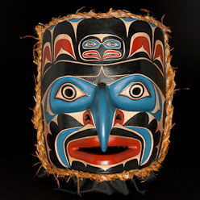](https://www.google.ca/url?sa=i&rct=j&q=&esrc=s&source=images&cd=&cad=rja&uact=8&ved=0ahUKEwjx8Mi6nIzSAhVh64MKHZaeADAQjRwIBw&url=https://www.tes.com/lessons/ruobHq8pEZK5OA/vaea-northwest-coast-art-overview&psig=AFQjCNGVLc77DAWeH0rCnuLsnETqo1Yi1w&ust=1487046052577960)

[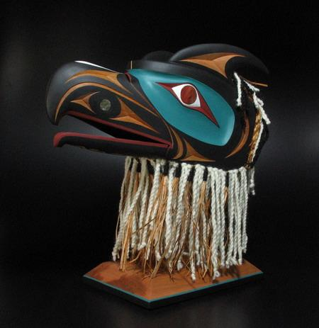](https://www.google.ca/url?sa=i&rct=j&q=&esrc=s&source=images&cd=&cad=rja&uact=8&ved=0ahUKEwixktu_nIzSAhWIzIMKHZpmBZwQjRwIBw&url=https://www.tes.com/lessons/FcAQG3AyJdn3bQ/3-4-5-northwest-coast-art&psig=AFQjCNGVLc77DAWeH0rCnuLsnETqo1Yi1w&ust=1487046052577960)

[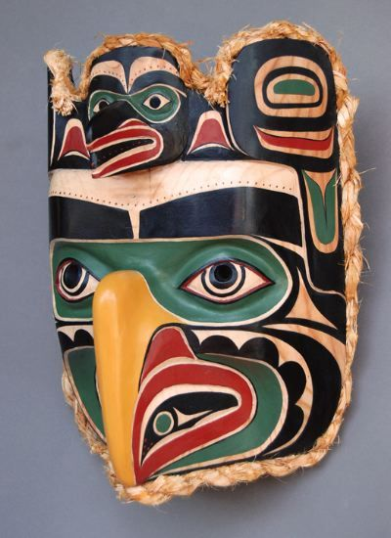](https://www.google.ca/url?sa=i&rct=j&q=&esrc=s&source=images&cd=&cad=rja&uact=8&ved=0ahUKEwjkhoLGnIzSAhVi7IMKHXn4A5wQjRwIBw&url=https://www.pinterest.com/pin/438749188679292371/&psig=AFQjCNFZ1I61T-xYmwIuWZdyjIYPNeqyDQ&ust=1487046098310824)

[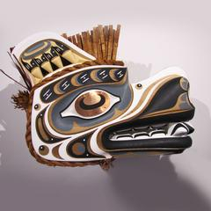](https://www.google.ca/url?sa=i&rct=j&q=&esrc=s&source=images&cd=&cad=rja&uact=8&ved=0ahUKEwjalMvhnIzSAhVr2oMKHa2VAtgQjRwIBw&url=https://spiritsofthewestcoast.com/collections/native-american-masks&psig=AFQjCNFZ1I61T-xYmwIuWZdyjIYPNeqyDQ&ust=1487046098310824)

[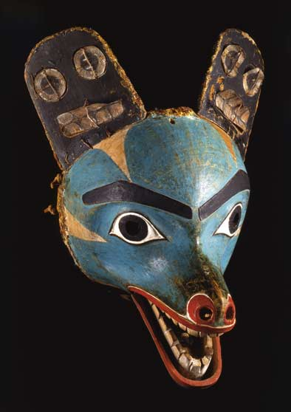](https://www.google.ca/url?sa=i&rct=j&q=&esrc=s&source=images&cd=&cad=rja&uact=8&ved=0ahUKEwin3vTonIzSAhXo7YMKHbZMDpgQjRwIBw&url=https://louiseaird.com/2013/06/12/down-from-the-shimmering-sky-masks-of-the-northwest-coast/&psig=AFQjCNFZ1I61T-xYmwIuWZdyjIYPNeqyDQ&ust=1487046098310824)

[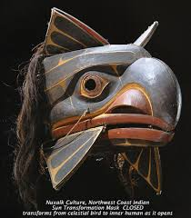](http://www.google.ca/url?sa=i&rct=j&q=&esrc=s&source=images&cd=&cad=rja&uact=8&ved=0ahUKEwiW3cPrnIzSAhUM74MKHYeLCWsQjRwIBw&url=http://thestorybehindthefaces.com/2011/09/12/812/&psig=AFQjCNFZ1I61T-xYmwIuWZdyjIYPNeqyDQ&ust=1487046098310824)

[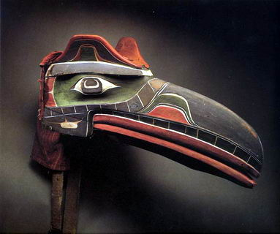](http://www.firstnations.de/fisheries/kwakwakawakw-kwakiutl.htm)

[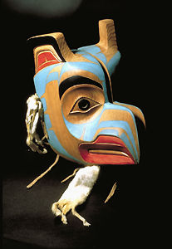](http://www.thecanadianencyclopedia.ca/en/article/northwest-coast-aboriginal-art/)

[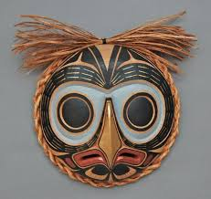](https://www.google.ca/imgres?imgurl=https://s-media-cache-ak0.pinimg.com/736x/58/e9/e4/58e9e45fabf687db1266e4a5c0a5d275.jpg&imgrefurl=https://www.pinterest.com/explore/native-american-masks/&docid=4uHqw0ytvK75IM&tbnid=mwdLnB66QIOPoM:&vet=1&w=650&h=612&bih=755&biw=755&q=northwest%20aboriginal%20masks&ved=0ahUKEwii7uzEnIzSAhVH1oMKHV0iAxIQMwhkKD4wPg&iact=mrc&uact=8)