Community Art Education
Individual Lesson
Activity: The Analogous Still-Life
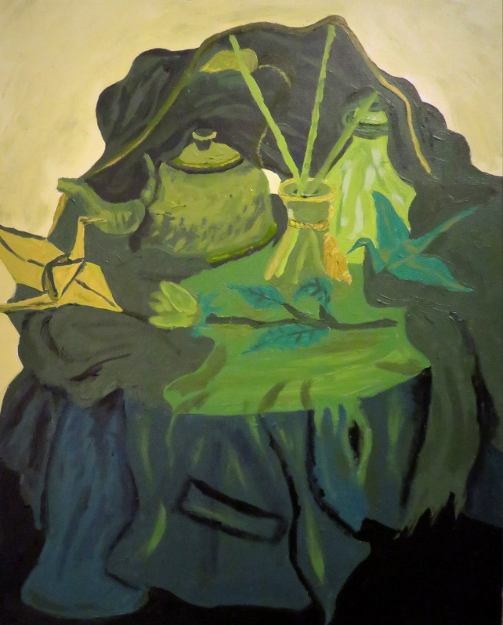
Art Educator: Sinthia Cousineau
Location: St. Margaret’s Day Centre
Population:
The population includes elderly adults who suffer from loss of autonomy, including cognitive loss such as Alzheimer, dementia and cognitive loss. The majority of participants are 70 years old or above. Each session contains approximately 8 participants.

Session:
Frequency: Every Wednesday morning
Length of session: One Hour (11am-12pm)
Activity: Creating a personal self-portrait using analogous colours
MEQ Competencies

Competency #1: “Creates personal images”

-Uses own ideas to create visual arts work.
-Organizes their visual arts production by picking appropriate colours to create an analogous still life.
-Shares their experience of visual arts creation by discussing their finished artwork and giving feedback on the works of their peers.

Competency #3: “Appreciates works of art”

-In this activity the participants will be introduced to the various works of art created by other still life artists, and will discuss these works and then use them as a source of inspiration.
-They will also appreciate the works of their peers as well as their own by discussing these works at the end of the activity.

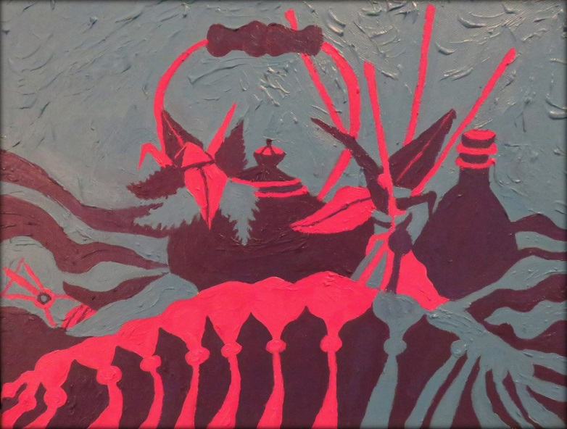
“Analogous Still-life by Sinthia Cousineau”

Rationale
The participants require an activity that involves using very little material, as they are limited in their mobility. Ideally the activity should be conducted from the participant’s seats, without them requiring getting up for the materials. Therefore the materials should be provided to the participants so that they can reach them. The activity is meant for them to examine the materials and express their ideas. The main role of art for these participants is to provide them with therapeutic means to express themselves and socialize with their peers. Considering that most of the participants suffer from cognitive or memory loss, this activity encourages them to use their imagination and challenge their cognitive abilities.
The participants need constant encouragement and motivation from student teachers and volunteers, who will assist them to produce their artworks. The participants require a calm and relaxing environment. The materials should be easy to manipulate and explanations should be brief but clear.
The main purpose of this activity is to allow participants to explore different ways of manipulating color, by having them produce a still life painting using analogous colors. The participant will learn how to use analogous colors through the selection of drawing tools offered to them.
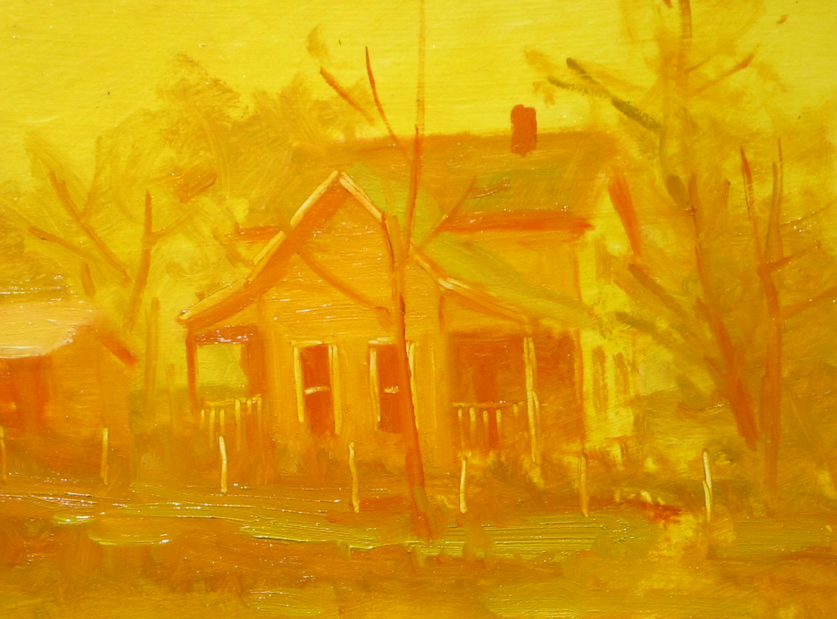
“Painting with the neighbours by John Pototschnik”

Objectives | Learning Objectives:  The participants will learn how to create a still life painting by observing the objects placed in front of them.  Art-making objectives:  Participants will be able to understand how they can use different colors, which are similar to each other to represent an image, which in this case is a still life.  They will explore the basic concepts of analogous colors. Each participant will be presented with a selection of 3 analogous colors already prepared by the instructor.  Art appreciation objectives:  Participants will be introduced to artworks of other artists, and be able to discuss how these artists used analogous colors. They will gain inspiration from these artists to use in their own works.  Example of an artist: Van Gogh (analogous sunflower)  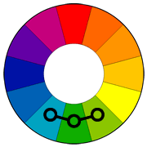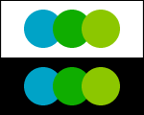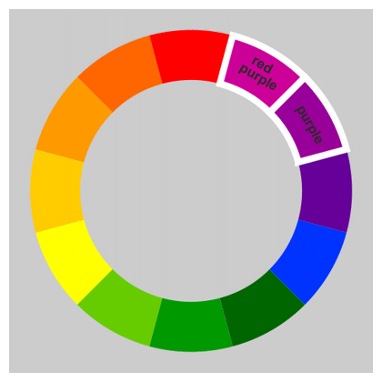  Social Objectives:  To enable participants to communicate with each other about their artwork as well as allow them to socialize during the art-making process.  -To experience a friendly environment  -To experience social connection with other participants  -To provide participants with an environment where they can respect each other’s company and art skills.  -To provide participants with an environment where they are able to express themselves and their emotions through art making.
Materials | All materials will be provided to the participants by the art educator.  Materials include:  -pencils  -10 x 10 inch canvas board  - paint  -black pen or marker (optional)  -examples of analogous artworks printed on paper to show the participants  -Prototype of a self-portrait of the art educator that shows the different steps of the project.  Note: colors should be divided into analogous colors at the start of the activity. Participants will choose the analogous colors they wish to use from the selection offered to them. Each participant will use 3 colors that belong to an analogous group.  Example: yellow, yellow-green, and green pastels
Equipment | The participants are not required to bring any equipment.  The art educator can provide a radio or other device to be used to play classical music to the class.

ACTIVITY PROCESSES |  | TIME
Motivation | Students will be shown works of art from other artists such as Vincent Van Gogh’s sunflower as an example of a work that uses analogous colours.  Questions to initiate discussion:  -What colours do you see in Van Gogh’s painting of a sunflower?  -Are these colours warm or cool?  -What are analogous colours?  -What analogous colours did he use?  Note: Due to the short attention span of participants the motivation will be short and go straight to the point. | 5 minutes
Media Exploration | Participants will explore paint and different ways of manipulating colours to represent an image. In this lesson they will focus on analogous colours, by gaining an understanding of how to manipulate colours that are close to each other on the colour wheel.  Optional: They will practice painting these colours of regular paper before moving on to the canvas board. | 5 minutes
Art Making | The participants will work from observation, using mirrors provided to them. They will work individually but sit next to each to each other. The art materials will be provided to participants in a way that will facilitate the art making process.  For this activity the tables will be divided into 3 separate groups, each containing their own objects to be used as still lives. | For art making & procedure  35 minutes
Procedure | Step 1: Observational outline of self-portrait (10mins)  -participants will be given canvas board and pen or pencil.  -They will be asked to draw the objects placed in front of them from observation.  Step 2: Adding analogous colours (20mins)  -They will pick a group of analogous colour to use from a selection of paints that was already divided into analogous colours by the art educator.  -They will add these colours to their observational drawing of their still life.  Step 3: Discussion of their still life in groups (5 mins)  -They will be given time to discuss their portraits with the group they are sitting with.  Step 4: Hand in their still life  -Once the discussion is over they will submit their drawing to the art educator before leaving, whom will later display it somewhere in the classroom.
Final  Response to Art | Questions to ask participants after they finish their work:  -Did you enjoy the activity?  -Do you like working with analogous colours. Why or why not?  -What did you like about drawing objects? | 5 minutes
Clean up | Due to the limited mobility of participants, they will not be required to help with the clean-up, unless they wish to assist.  They will be given a few minutes to wash their hands in the nearby sink. | 5 minutes
Closure | Once the lesson is completed, the art educator could ask the participants for feedback about what they thought about the lesson and whether or not they enjoyed it.  Afterwards the art educator could set up a display for all the still life paintings on the wall of the classroom to show participants for the next class. | 5 minutes

Vocabulary
Analogous Colour: These are colours that are next to each other on the colour wheel.
Example: red, red-orange, and orange.
Colour Wheel: A circular design that displays the colours, which is used by artists to help organize colours.
Still life: Is a name given to an artwork that depicts mostly inanimate objects as the subject matter. Examples: food, flowers, plants, shells, drinking glass, vases, etc.

References
Analogous colours
Color Terms. Color terms for art and design. Retrieved from http://www.artyfactory.com/color_theory/color_terms_1.htm
Color Harmonies. Tigercolor. Retrieved from http://www.tigercolor.com/color-lab/color-theory/color-harmonies.htm
What is an analogous color scheme? About home. Retrieved from http://interiordec.about.com/cs/colorindecor/f/faq_anaglous_co.htm
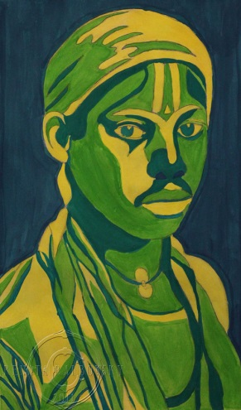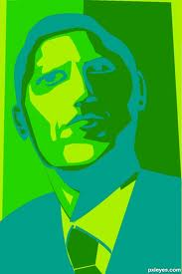
Sarah Sanford Robert Herse
Famous Analogous Art
The color wheel explained-Analogous Art. Design & New England construction. Retrieved from http://www.nedesignbuild.com/the-color-wheel-analogous/
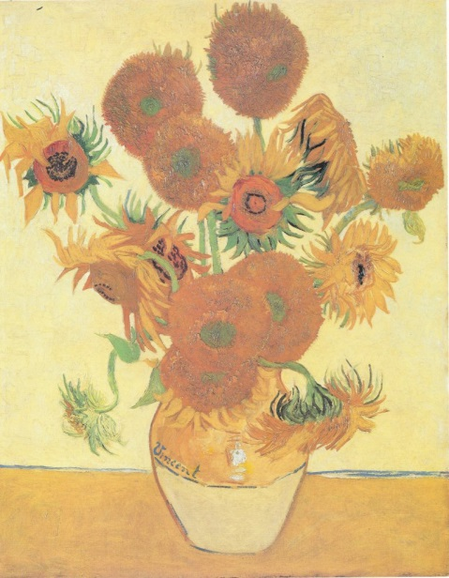
“Van Gogh’s Sunflower”
Articles
Freifeld, S. (2004). Color in art. Instructional program for grades K-4. Retrieved from http://gettingtoknow.com/wp-content/uploads/colorinartTG.pdf
Sale, T. (2007). Color Schemes. Drawing: A contemporary approach, 171-172.

