Lesson Plan
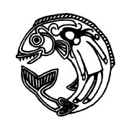

Animal Symbolism

Painting
Art Educator: Cynthia Cousineau
School: Concordia University
Topic: Storytelling & Animal Symbolism based on First Nations Culture, with the creation of cardboard paintings of specific animals.
Population: Age 7-11 Rationale: This lesson aims to foster cultural sensitivity in the students
Learning Objectives:

- To encourage natural storytelling and public speaking skills
- To gain a better understanding of Indigenous culture & foster cultural sensitivity
- To learn more about animals
- To foster independent research skills
- To practice painting and drawing skills

Materials for Teacher:

- Projector
- Laptop
- Radio (additional)
- Completed prototype of art project

Materials for Students (*=Bring to Class):

- Paintbrushes
- Cardboard paper
- Simple white paper
- Paint (black, white, and red)
- Scissors *
- Pencil *
- Glue *
- Images of Animals from Native Art

Art Form: Drawing & Painting
Technique: Contour Line drawing & Acrylic Painting
Vocabulary:
Indigenous: origination from a particular place; native
First Nations: The first people who lived in North America before the Europeans arrived
Symbolism: The use of symbols to represent ideas, emotions and states of mind.
-Motif: A decorative image or design, which could be repeated to form a pattern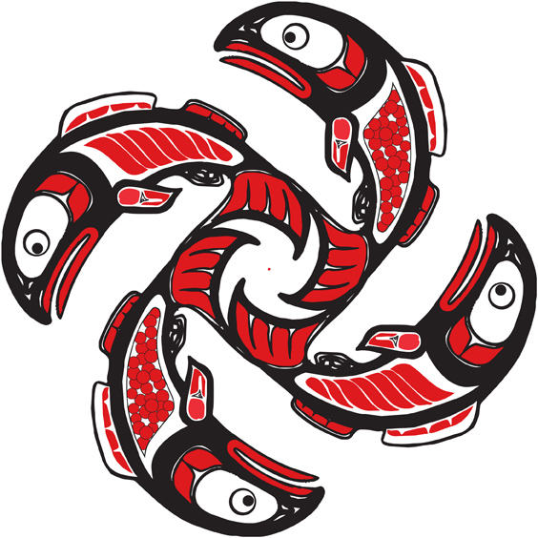
Visual Arts Competencies:
- To appreciate First Nations artworks
- To gain an understanding of the colors used in first nations art
- To draw animals as inspired by first nations art
Cross-Curricular Competencies:
- To learn about the First Nation Culture and history.
- To communicate a story appropriately.
- To use the resources available to them.
Lesson Sequences & Motivation:
Introduction:
- Show the class a short video about First Nation storytelling, followed about a PowerPoint on storytelling art.
- Introduce the topic to the students and discuss the needed materials.
- Inform the students about the techniques they will use for this project.
- Offer the students books or computer time to research an animal.

Demonstration:
- Using one of the templates with an animal form already on it, or picking a page from a book which features an animal show the class which animal you will create.
- Give the class an example of a mythological story with that animal and what the animal represents.
- One a piece of white paper to draw out the form of your animal and some basic motifs.
- Cut out the image and place it on a cardboard paper.
- Trace the image from the white paper to the cardboard paper.
- Cut out the cardboard paper to have the shape of your animal
- Paint the cardboard animal using the 3 colours of paint offered
- Show the entire class the finished animal, and leave it to dry
Work Time: 2 hrs
Clean-up: 10-15 minutes to put materials away and wash up.
Closure:
In the following class have students prepared to discuss their creation stories about the animals they constructed. Perphaps offer students a trip to a real gallary to see real works of First Nation Artists.
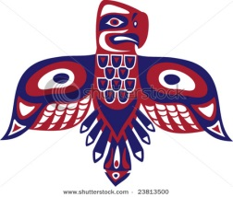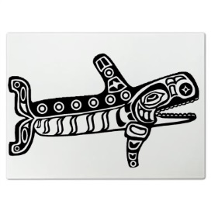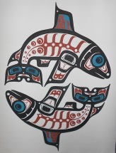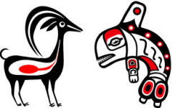
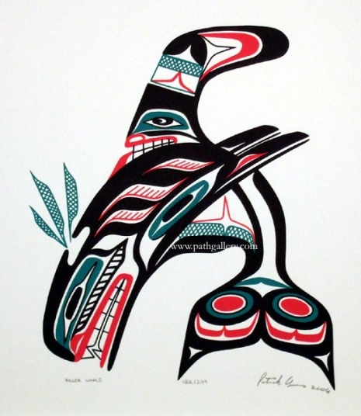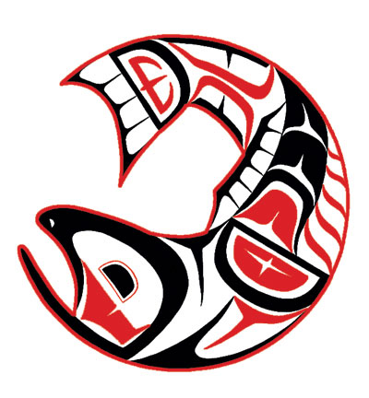
Adaptations for Diverse Learners:
-Adapt the time required for the progect to fit the needs of all students. If students finish early they could start working on their story telling presentation.
Assessment
-Students will be evaluated on:
- originality of their animal
- use of motifs and patterns
- diversity of use of the 3 colours
- their story
Resources:
Websites:
Animal Symbology: Shttp://shop.slcc.ca/node/5
First Nations Art Projects: http://www.ehow.com/info_7936841_first-nations-art-projects.html
Videos:
Pacific Northwest Native Indian Art Carvings: http://www.youtube.com/watch?v=NpqiPztQOY0
Story Telling: http://www.youtube.com/watch?v=wm9AZ3x5fpw
Teaching Story telling in the classroom: http://www.youtube.com/watch?v=JrZc6eztoH4&list=PL6C773AD48C214F81
Native American Relaxation Music: http://www.youtube.com/watch?v=kH8nsXpxlxU

