Narrative Comics Strips
Lesson Plan
Art Educator: Cynthia Cousineau
School: Gardenview
Grade level: grade 5, incorporated with French literature
Time Frame: Approximately 3 hours

Question of inquiry:
How to represent a story or fable using comic strip techniques?
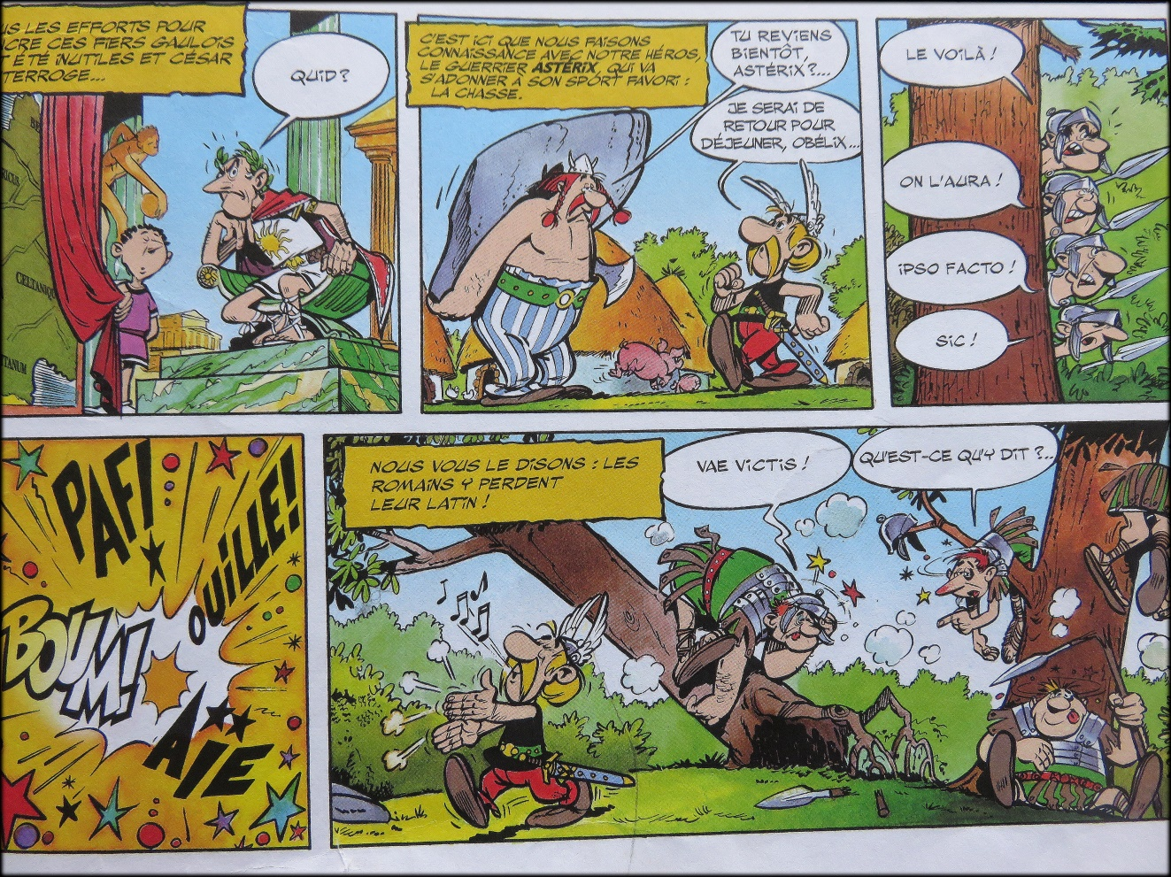
“Example of a comic strip from the series of Astérix et Obélix”

Overview
Comic strips bring life to drawings by simplifying the telling of a story. They are a useful form of artistic expression commonly used to tell stories with drawings that are accompanied by narratives. Comic strips contain multiple images that represent a story with a timeline. The history of comic strips began with Rodolphe Topffer in the 19th century who had the idea of adding a narration under drawings. Soon afterwards the French developed the first children’s newspaper which was entirely filled with comic strips. Comic strips are commonly used to express humor and bring motion to drawings as well as a sense of time.
This lesson is important because it allows students to develop their imagination and storytelling abilities by allowing them to invent their own characters and bring them to life when designing their comic strips. Students will learn the history of comic strips and explore different examples of popular comic strips from around the world, for example the manga a type of Japanese comic strips. However this lesson will mostly focus on learning the techniques involved in the creation of comic book stories inspired by Franco-Belgian comic strips such as Tintin and Astérix and Obélix.
In this lesson, students will develop their very own comic strip by inventing unique characters for their own story and by applying tradition comic strips techniques.
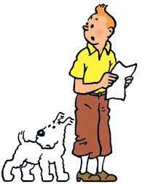
Visual arts competencies
Competency 1: “To create personal images”
- Uses ideas to design an original comic strip.
- Organizes their production in visual arts by choosing the materials they intend to use, and organizes their own story and ideas.
- Shares their experience in the creation of their own comic strips by discussing their story and characters with their peers.
- Produces a comic strip that is original and displays creativity.
Competency 2: “Appreciates work of art”
- Appreciates traditional artworks and media production involved in storytelling and fables, in particular comic books.
- Appreciate their own artworks and those of their peers by discussing their comic strips.
Cross-curricular competencies
Uses information: uses information on the techniques of comic strips and gains inspiration from reading comic books.
Uses creativity: expressing creativity by creating characters and stories in comic strips that display originality.
Uses efficient work methods: organizes their time to properly use the materials.
To communicate well: To properly express ideas through the creation of characters that display emotions. To create a narrative that is free of spelling or grammar mistakes.

Learning Objectives
- To appreciate comic book art by reading popular comic books from Franco-Belgian culture.
- To learn the history of comic books.
- To explore the artistic techniques used in the creation of comic strips.
- To create their own comic strip story.
- To develop a story and represent it through a series of narrative drawings.
- To represent different views by drawing characters from different perspective and distances.
Dissemination
Student work will be hung on a wall for all the school to see. The teacher will also photocopy each comic strip page and print out a book containing the work of every student. This book will then be put in the classroom or school library for students to read.
Le Prototype
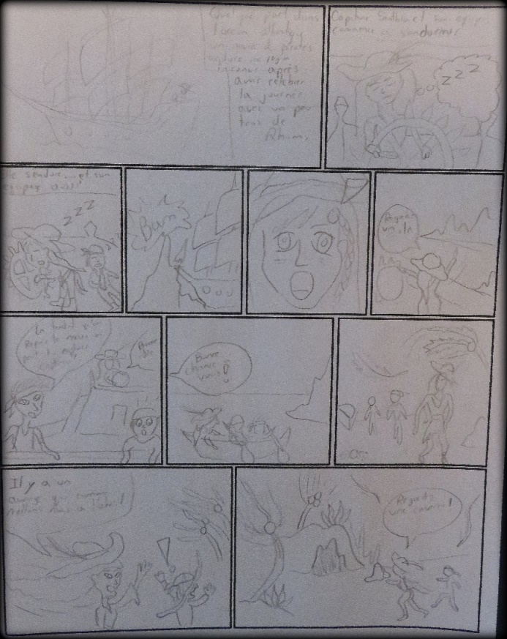
Example of the first step of the project, pencilling the story
Materials & equipment for educator

- Computer
- PowerPoint presentation on comics
- SMART board
- Examples of comic books
- Prototype of project at different steps

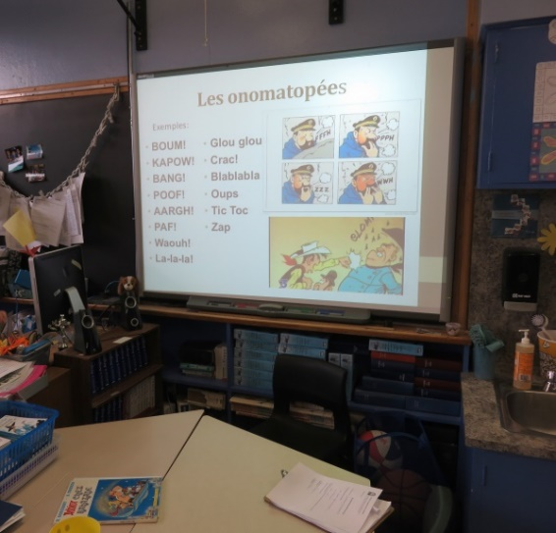
“SMART board with a PowerPoint presentation on comic strips”
Materials for students

- Black sharpies
- Color pencils
- Pencils
- Comic page template
- Eraser
- Comic books
- Guideline paper on steps and expectations of the project

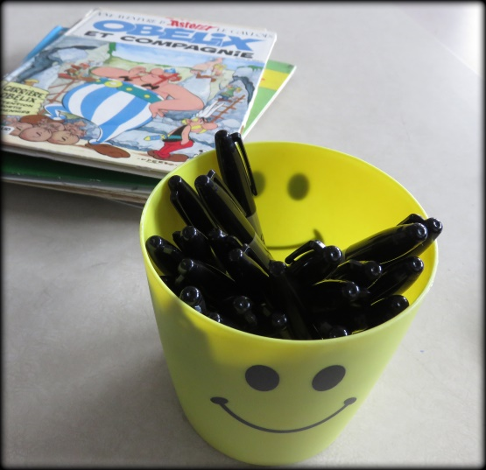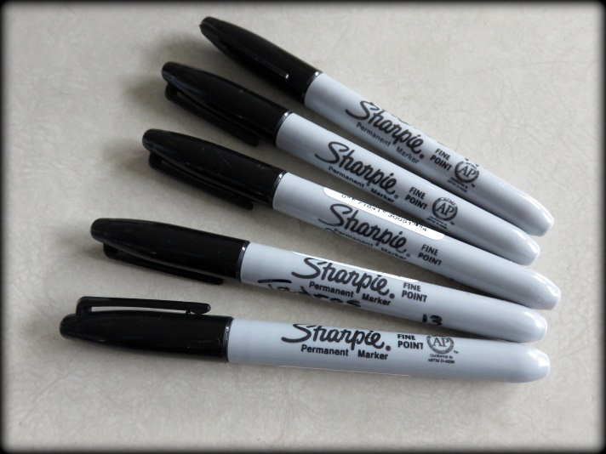

Vocabulary
Album: Comic books that are related to each other and contain a finished story or story to be continued; an album is part of a series.
Borderless panel: A comic panel that has no boarder or outline.
Caption: The words which appear in a yellow box which voices what the narrator of the comic story is saying.
Cartoonist: a title given to someone who designs comic strips.
Close-up shot: Isolating a part of the scene or the character by focusing on detail for example: an arm, a hand, or a face. Often it is used to show the expression of a face or to focus on a detail of a scene. Can also focus and places emphasis on small details, for example: an eye, a finger, a button.
Comic Strip: a sequence of drawings in boxes that tell an amusing story, typically printed in a newspaper or comic book.
Dialogue Balloon: A comic book technique used to express what the characters communicate to each other. These bubbles contain words or sounds used to express what the characters say, scream or think.
Drawing Board: The name given to each page of a comic book.
Gutter: The space between panels on a comic book page.
Inks: the final stage of a comics drawing (applying ink to the pencil).
Manga: A type of Japanese comic.
Medium Shot: In a comic book, when the character is represented from head to waist.
Long Shot: When we see all the character in a comic book story from head to toe. Focus is on the dialogue.
Onomatopoeia: A word that emits a sound. It represents the noises that take place in a comic story.
Overall plan: A plan in the comic book in which the characters are situated in the scene. It shows the scene of the story, focusing on the décor in which the characters are represented with little detail, since the main focus is on the décor.
Panel: The name given to one drawing on a comic book page. It is the single square on a drawing board of a comic. It contains the image with speech bubbles and narration.
Pencil: the first stage in drawing a comic book prior to the final inked stage.
Plan: The different ways of presenting the characters, as seen from different distances.
Storyboard: a sequence of drawings, typically with some directions and dialogue, representing the shots planned for a movie or television production.
Spiked balloons: A balloon that indicates what characters in comics are shouting.
Thought Balloon: A cloud balloon i that indicates what a character in comics are thinking.
Tier: A single row of panels on a comic book page.
Trace: copying a drawing by placing a piece of transparent paper on top of an image and copying the image
Zoom: The process of going from the ensemble plan to the big plan by getting progressively closer and focusing on more details.
Lesson Sequence
Introduction (25-30 minutes):
•Discus the history and technique of comic book art with a PowerPoint presentation.
•Ask the students: what is the definition of a comic book and comic strip?
• Discus the characters of comic books and how to represent them by using shots that show different distances.

Demonstration (5 minutes):
- Show the students the prototypes of comic book stories at different steps in the drawing process.
- Discuss the different steps of the project and the expectations of the project.
- Show students the material table, with the sharpies, templates and comic books.
- Tell students they are expected to represent different ways of drawing a character through different distances. Inform students that they need to create characters that are original.
- Remind students that they are expected to work in silence.
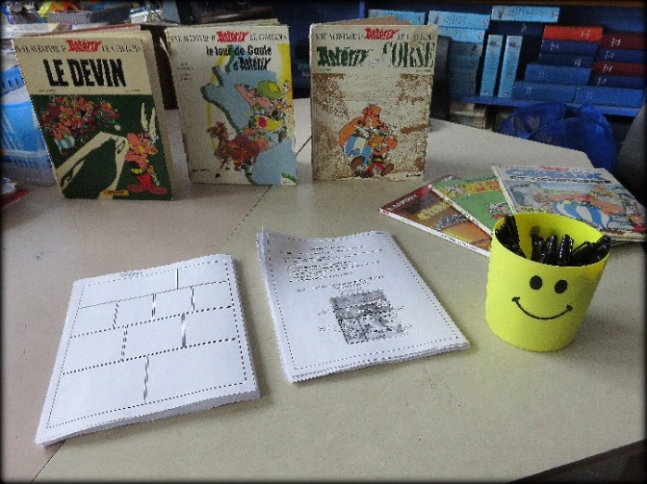
“Material table for the lesson on comic books”
Work time (2 hours):

- Students will work individually at their desks.
- Students are already assigned teams, and each team will be called in one after the other to come pick the materials they will need for their project.
- If a student finishes their comic book page early they can help clean the classroom, read, or work on their homework.
- During the work time the teacher can distribute comic books for the students to look at for inspiration for their own comic book art.

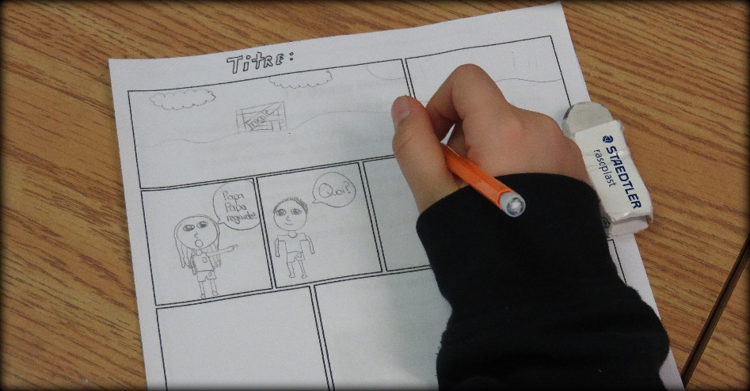
Student working on pencilling their comic story
Clean up (5 minutes):
- Five minutes prior to cleaning time, students will be reminded that they will begin cleaning soon and they need to finish up the part of the drawing they are currently working on.
- Ask students to bring back the books and sharpies to the materials table.
- Tell students to put their unfinished comic story back in their art folder. If they finished they can hand it in to the teacher.
Closure (10 minutes):
- Once all the comic stories are completed, the teacher will display all the comic book stories on the wall for the students to see and make comments on.
- The teacher will ask the students to give their opinion on the works of their peers. Which comic stories from their peers they like best and why. What did the students most enjoy about this art project? The students will be asked about their favourite part of the project.
- The students will be asked about what they learnt from this art project. What are the comic book techniques, what are the different types of shots, and about the history of comic books?
- Questions the teacher can ask the students:
-What is an overall plan?
-What is an onomatopoeia?
-What is the difference between a story board and a panel?
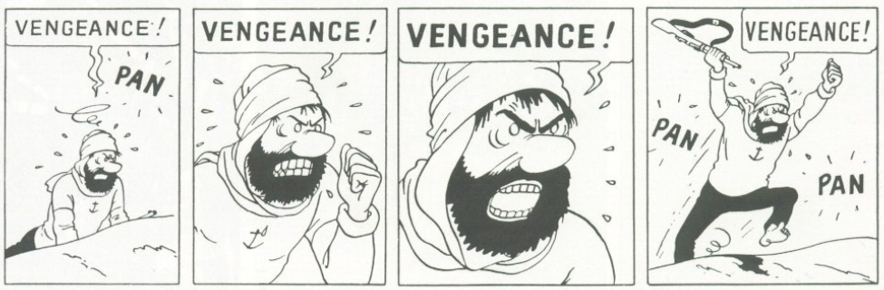
Hergé, Tintin : le crabe aux pinces d'or, Casterman

Adaptations for diverse learners
- Exceptional learners who finished earlier will have the option to create a second comic book story, read a comic book, catch up on other art projects or help clean the classroom.
- Students with learning disabilities will be given extra time to work on their project. They will have a clearer guideline to what is expected of them. They will have the option to go to the resource room to have someone assist them as they design their comic story. The resource room would provide them with a quiet place to help them focus more on their assigned task.
- Students with visual disabilities will be given a large paper, with larger panels to work on. They also won’t be required to use colours and can focus more on the story and narration.
- Students with auditory disabilities will be given a paper with more in depth explanation about the project with more detailed steps. The teacher will remain near those students as they explain the art lesson and will never turn their back to the student to ensure that the student can read their lips as they speak.
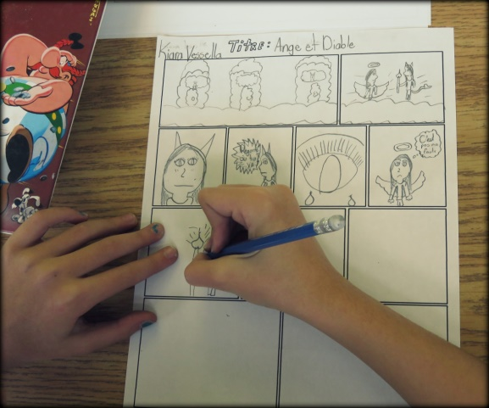
“Student working on their comic strip”
Bibliography / Resources
Websites | How it helps the lesson
http://biblio-finistere.cg29.fr/userfiles/File/techniques_bd_1_8_tpm.pdf | The history of comic books with examples.
http://www.les-onomatopees.fr/liste-onomatopees.php | A site that gives example of onomatopoeias.
http://ekladata.com/EYfssXEdWTVnOKb3Bw8lCdwC5UQ.pdf | A site that explains the vocabulary associated with comic books.
http://www.cbbd.be/uploads/fichiers/pages/invention-de-la-bd-web.pdf | Pedagogical information about comic books.
https://www.youtube.com/watch?v=vMefiAxpRKI | Introduction video about the adventures of Tintin.
https://www.youtube.com/watch?v=VnXmFpGZizA https://www.youtube.com/watch?v=0_As592BYWU https://www.youtube.com/watch?v=thBJzRydSlc https://www.youtube.com/watch?v=NQK59M8rAME https://www.youtube.com/watch?v=WLTtkFGC3dA | Videos about Astérix et Obélix that show how comic characters can inspire the creation of different movies.
https://www.youtube.com/watch?v=xz3j8gKRUTg | 2014 film by Steven Spielberg about the adventueres of Tintin.
https://www.youtube.com/watch?v=i5Bm_HZbVgE | Introduction to the cartoon of Lucky Luke

Steps
The creation of a comic book
Step 1: A good idea
- Think of a story or a funny scene.
- Think of two characters and how they would interact.
- Where is your story taking place?
- Are your characters indoors or outdoors?
- Think of an exciting event that would be the ending of your story.
- What type of story is it? Is it a mystery? An adventure? A comedy? A romance?
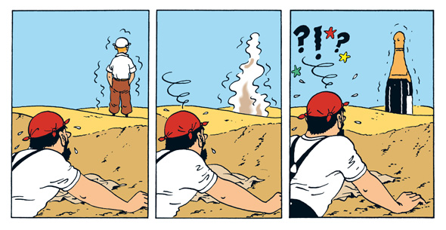
Step 2: Draw your comic story using a pencil
- On the comic page paper provided to you, draw in each box the images to represent the sequence of events taking place in your story.
- Think about the different balloons and words you will add to your drawings to clearly represent your story.
- Consider the different shots of your comic story; the different ways of viewing the characters from different distances.

Step 3: Trace over the pencil drawing with a black sharpie marker
- Take a sharpie marker and trace over all the lines you drew with the pencil. Once you are done tracing with the marker, erase all the pencil lines.

Step 4: Color in the drawing
Step 5: Write your name, give your story a title and hand in the project to the teacher.
Project
The Narrative Comic Strip
You will create a comic book story that must include the following:
- At least 5 dialogue balloons (5 points)
- At least one thought balloon to indicate what your character is thinking
(1 point)
- Two different onomatopoeias (2 points)
- A title for your comic book story (1 point)
- One panel that shows the overall plan of the story (1 point)
- At least two different characters (2 points)
- A creative idea for your story (1 point)

Note: Your comic must be clearly written and neat (2 points)
Total points = 15
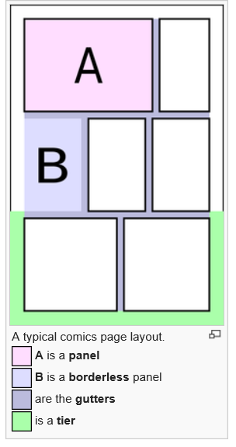
Evaluation Rubric
Narrative Comic Strips

Student’s name:

Task to be completed and value of points | Points earned
The comic contains 5 dialogue balloons
(5 points)
Contains one thought balloon
(1 point)
Contains two different onomatopoeias
(2 points)
The comic has a title
(1point)
One panel that represents the overall plan where the story is taking place
(1 point)
The story contains at least two different characters
(2 points)
The idea for the comic story is original and displays creativity
(1 point)
The comic is well written, clear to read and neat
(2 points)

Total Points: /15

Comments:

