Drawing an Invention Plan
Goal: You must design a scroll by drawing your idea for an original invention, and you must show different perspectives of this invention.
What you need to do:
- -Draw your invention (use your Think Like an Inventor Worksheet)
- -Label the 5 different parts of your invention
(order your parts using numbers, example: 1, 2, 3,4 & 5)
- -Show 3 different perspectives of your invention
- -Write the title & your name at the top
- -Draw a person using your invention

Pick 3 of these perspectives to when drawing your invention:

- Eye Level perspective: the height a viewer’s eyes are positioned in relation to the ground.
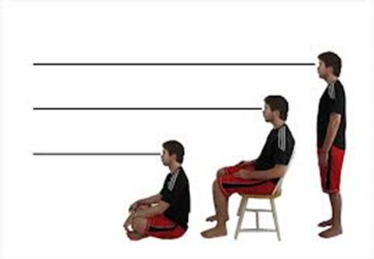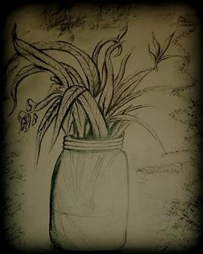
- Bird’s eye view perspective: A view of an object from above. Viewing the world as if you were a flying bird.
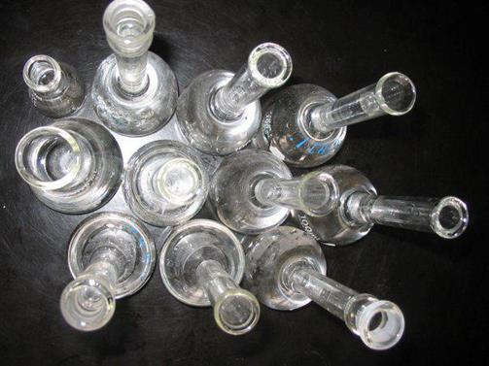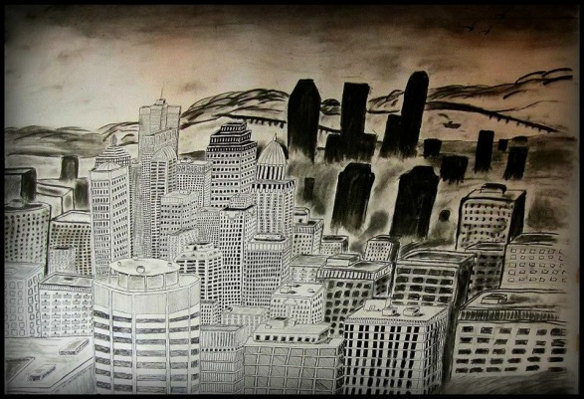

- worm's eye view: a view of an object from below, as if you were a worm looking up

- Side View

- Front View

- Back View

