Community Art Education
Collaborative Lesson
Project: Getting to know you

Ecological Paradise Collage
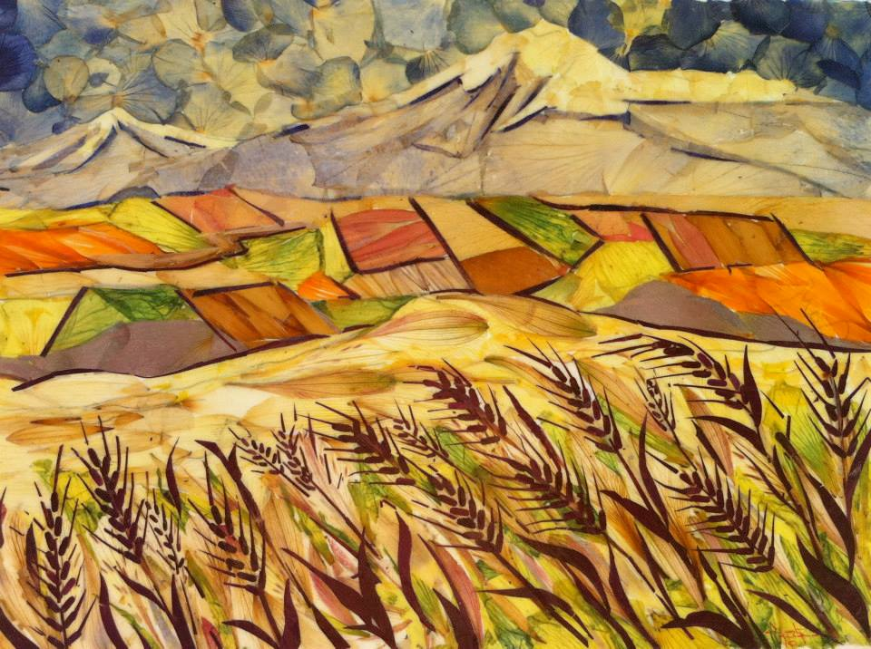
"WHEAT FIELD"
Flower petal collage
Artist Shogher Baghdoud

Art Educator: Sinthia Cousineau
Location: St. Margaret’s Day Centre

Population:
The population includes 6 elderly adults who suffer from loss of autonomy. They may have some physical disabilities and moderate to significant cognitive losses (Alzheimer and dementia).

Session:
Frequency: Every Wednesday morning
Length of session: One Hour (11am-12pm)
Activity: Creating a collage of your perfect place using flower petals or leaves. The aim is to see which materials the participants like and dislike as well as to learn a bit about each of the participants’ interest.

MEQ Competencies

Competency #1: “Creates personal images”

-Uses ideas to create visual arts work.
-Organizes their visual arts production, by choosing the materials they wish to use and how they will arrange them.
-Shares their experience of visual arts creation by discussing their finished collage and giving feedback on the collages of their peers.

Competency #3: “Appreciates works of art”

-In this activity the participants will be introduced to the various works of art created by other ecological artists, and will discuss these works and then use them as a source of inspiration.
-They will also appreciate the works of their peers as well as their own by discussing these works at the end of the activity.

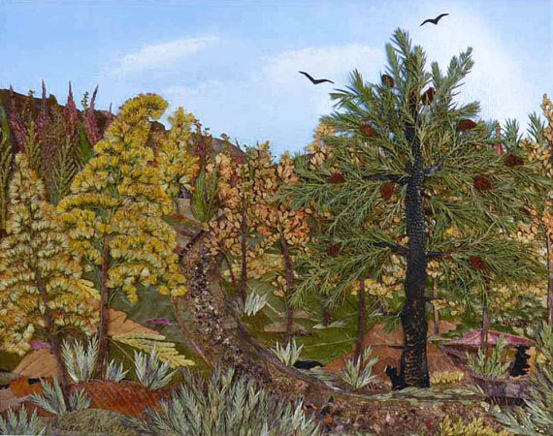

Example: A collage using organic materials

RATIONALE
Objectives | The participants require an activity that involves using very little material from, as they are limited in their mobility. The activity is meant for them to examine the materials and express their ideas. The main role of art for these participants is to provide them with therapeutic means to express themselves and socialize with their peers. As most participants suffer from cognitive or memory loss, this activity encourages them to use their imagination and reflect on themselves.  The participants need constant encouragement and motivation from student teachers and volunteers, who will assist them to produce their artworks. The participants require a calm and relaxing environment. The materials should be easy to manipulate.  From this art lesson, participants are expected to imagine their dream place, a personal paradise. They will have to think about themselves and what makes them personally happy, and incorporate these aspects of their happiness into a drawing of their perfect place using the contour line technique introducing the foreground, middle ground and background. Afterwards they will be introduced to ecological materials which they will use to create a collage using the same drawing.  The main objective is to enable the participant to think about themselves more deeply and about what makes them happy.  Art-making objectives: Participants will be able to understand how they can use natural materials which can be found in nature, and how they can add them to their own artworks to represent an idea.  They will create their ideal place by making a landscape collage using ecological materials.  These works will begin with the concept of foreground, middle ground and background. As well they will include the horizon line. Starry night by Van Gogh will be used as an example to demonstrate this.  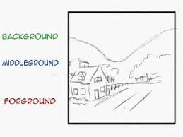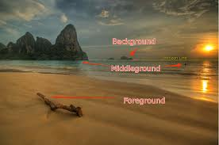  Art appreciation objectives: Participants with observe and discuss artworks created by other artists who use ecological materials and they will gain inspiration which they will apply onto their own works.  These artists will include:  - Grace Ciao: Creates fashion designs using flowers  - Hong Yo: an artist who creates birds using flower petals  - Lim Zhi Wei: An artist who creates images using flower petals  - Shogher Baghdoud: creates scenery using flower petals  - Omid Asadi: cuts images into leaves.  Social objectives: To enable participants to communicate with each other about their artwork as well as allow them to socialize during the art-making process.  -To experience a friendly environment  -To experience social connection with other participants  -To provide participants with an environment were they can respect each other’s company and art skills.  -To provide participants will an environment where they are able to express themselves and their emotions through art making.  Community objectives:  -To enable the participants to feel happier and more self-fulfilled with their home environment in the nursing home by allowing them to experience a place where they can benefit from the therapeutic and educational aspects that art making allows.  Other objectives include teaching the participants about how they could use elements of nature to create their collage.
Materials | All materials will be provided to the participants:  -Liquid glue  -Container to put glue in  -Brush to use with glue  -Pencils or pen  -White sheet of paper  -Flower Petals (Ideally 5 or more colors)  -Leaves (3 or more colors)  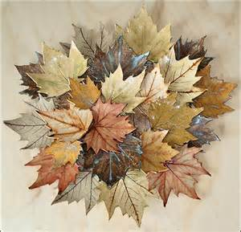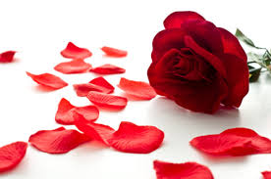
Equipment | -Books or magazines showing landscapes  -Music playing device (radio or iPod radio)  -I-pod with classical music or music suitable to seniors.  -Laptop to show slideshow images
ACTIVITY PROCESSES |  | TIME
Motivation | Participants will be shown books with images of landscapes, as well as images of artists who use natural materials to create works of art. These works are shown in the reference section of this lesson plan.  A prototype of the project created by the student teacher will also be shown to participants, so as to give them an idea of what s expected of them.  Question to ask participants:  -What would be your perfect place, and what would it look like?  -What do you like about this place and what makes it special?  -How can you represent this place using natural materials?  -In Van Gogh’s “Starry Night”, what is visible in the foreground? Middle ground? Background?  -What elements could be added to a background to give the perception of distance? | 5-10 minutes
Media Exploration | The student teacher will present the participants with the materials they will use, and will give a brief demonstration on how to use the materials.  They will use floral petals and leaves provided by the student teacher, because these are natural materials that can be found in nature.  The student teacher will demonstrate how these materials can be manipulated to help participants use them to create their landscape collage. | 5 minutes
Art Making | Participants will mostly rely on their imagination, but will be encouraged to examine art images of landscapes to help inspire them to design their own.  Participants will work individually but sit near other participants as to encourage light conversation and feedback from their peers. They will all be sitting at the same table.  While participants work, they will listen to classical or instrumental music which will provide them with a relaxing environment. | For art making & procedure  35 minutes
Procedure | List the steps of art-making by numbering the steps. Refer to specific materials used, review directions while learners work, and where learner artwork goes when finished. Procedure should be clear enough that another person could teach from your plan.  Step 1: Drawing out a simple landscape  -Participants will use a pencil to draw the shapes of their landscape on the white sheet of paper provided to them.  -They will draw the foreground, middle ground and background.  -They will draw basic shapes of trees and mountains.  Step 2: Choosing the materials  -Participants will choose the materials they wish to use from the bins in front of them  -They will have to select at least 3 different colours from the materials.  Step 3: Putting the collage together  -Participants will decide which colour to use for each part of their drawing, and try to arrange the materials to suit their idea  Example: blue petals for the ski, brown leaves for the mountain, and green leaves for the foreground  -Using the glue containers and brushes provided the participants will glue their materials to the paper, following the designed they have previously sketched out.  Step 4: Discussion  -Once they complete their collage the participants will be given time to discuss their own work and those of their peers.  Afterwards the collage will be given to the student teacher who will display it on the wall of the art room.
Final  Response to Art | Questions to ask participants:  -What materials from the environment could be used in making an artwork?  -Why did you create this specific landscape, and in what ways does it make it your perfect place?  -Why did you prefer to use a certain material over another (example: flower petals rather than leaves)?  Participants will be given the opportunity to discuss their own landscape collage as well as those of their peers.  Participants will be presented with works of art from artists who use ecological materials and will be asked to share their opinion about these works.  Examples:  -“What ecological material did the artist use?”  -How did the artist use this material in an original way?  -How could this inspire you to do something similar? | 5 minutes
Clean up | Due to the limited mobility of participants, the student teacher will do most of the cleaning.  However, participants will be given time to wash their hands at the nearby sinks and will be encouraged to place the materials back in the bins. | 5 minutes
Closure | Once the lesson is completed, participants would have acquired knowledge about how they could incorporate elements of the environment in their artworks.  They would have gained an understanding how to create their ideal landscape by using their own imaginations and applying the concepts of foreground, middle ground and background.  The student teacher will then ask them if they enjoyed the activity and what they have liked or disliked about it.  Participants will be asked to talk about their artworks and explain why they created their specific idea.  Note: the response is part of the closure | 5 minutes
BIBLIOGRAPHY / RESOURCES

Music from IPod
Classical:
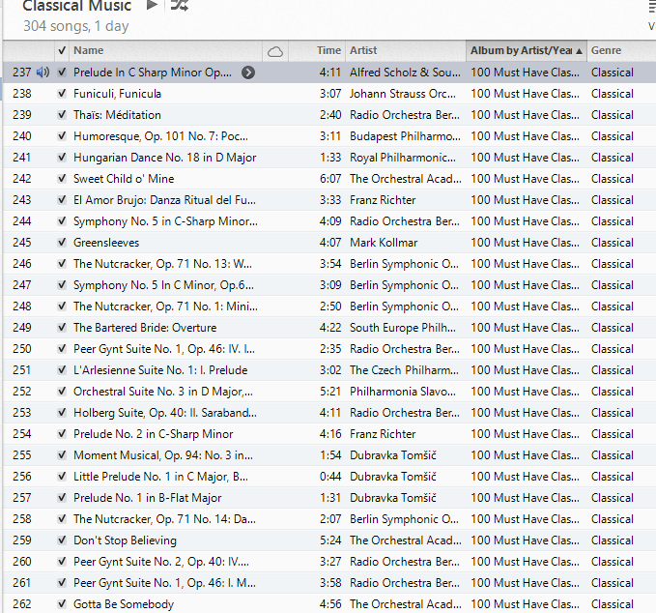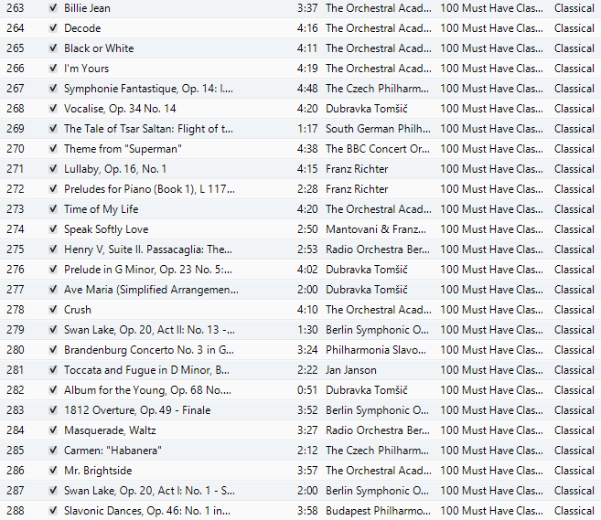
Websites

WEdesignstudios.com. A Lesson in: Outdoor Art. Retrieved from
……http://wedesignstudios.com/wp-content/uploads/2011/02/OUTDOOR-ART.pdf

Dugan, P. (2014). Flower Petal Creations. Retrieved from http://flowerpetalart.com/

Lushome. Amazing artworks and inspiring craft ideas, colourful birds designed with flower …...petals. Retrieved from http://www.lushome.com/amazing-artworks-inspiring-craft-ideas-.......colorful-birds-designed-flower-petals/118483

Artists Inspiration

Hong Yo (Red):
Lushome. Amazing artworks and inspiring craft ideas, colourful birds designed with flower …...petals. Retrieved from http://www.lushome.com/amazing-artworks-inspiring-craft-ideas-.......colorful-birds-designed-flower-petals/118483

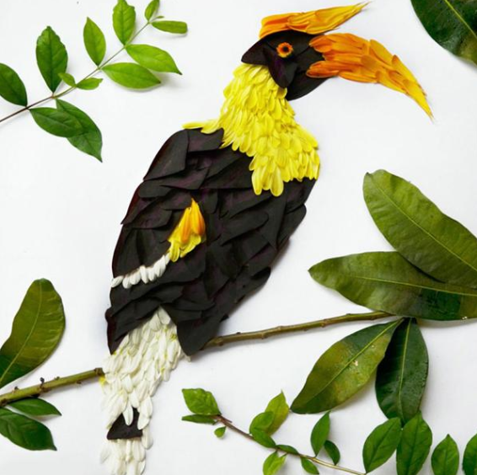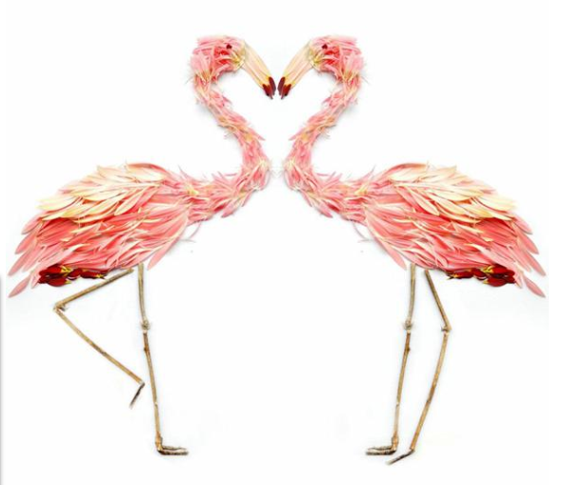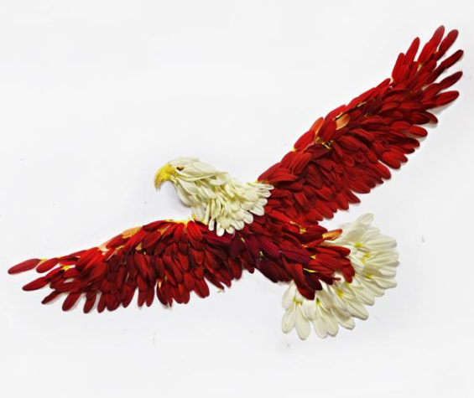

Lim Zhi Wei:
Cade, D. (2014). Artist shares beautiful illustrations created with flower petals and household …...objects. Retrieved from http://petapixel.com/2014/05/16/artist-shares-beautiful-.......illustrations-created-using-flower-petals-household-objects/

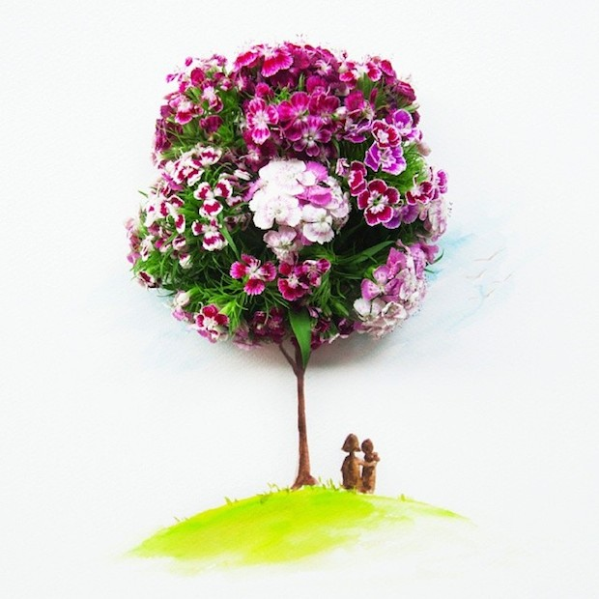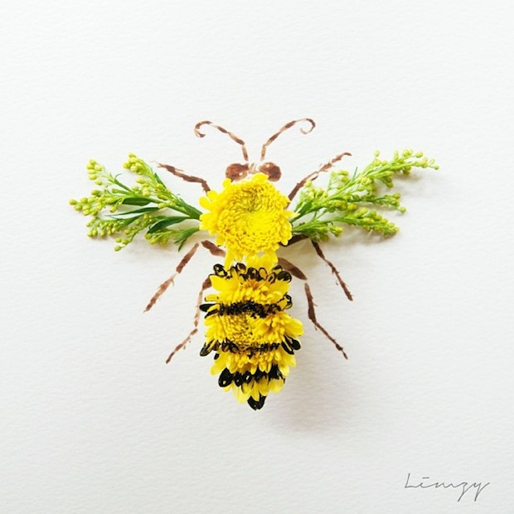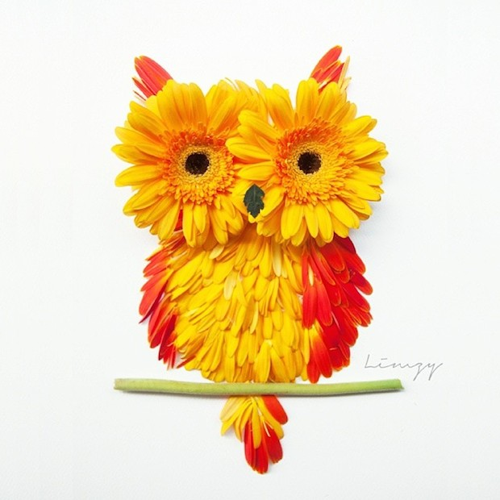

Shogher Baghdoud:
Baghdoud, S. (2014). The flower petal art gallery. Retrieved from …….http://www.shogher.com/petals.html

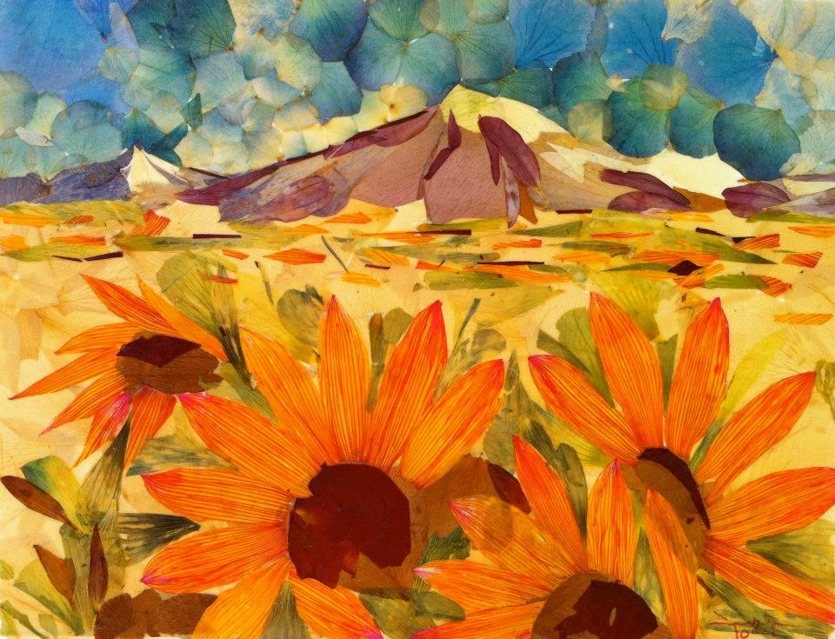

Omid Asadi:
Crone, J. (2014). Art that’s just a walk in the park: UnbeLEAFable designs of animals and …….iconic celebreties craved out of leaves. Retrieved from …….http://www.dailymail.co.uk/news/article-2722851/Artist-Omid-Asadi-creates-designs-using-leaves-scalpel.html

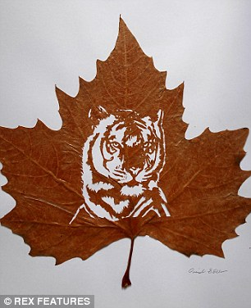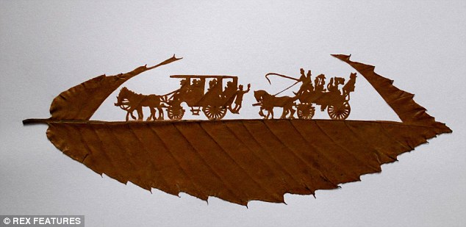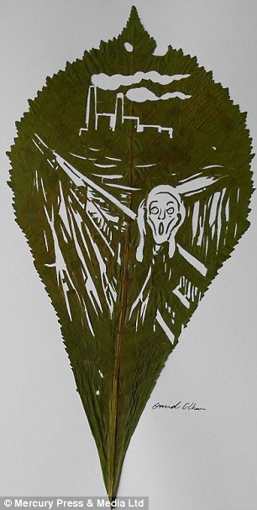

Grace Ciao:
Boredpanda. Artist turns real flower petals into fashion design illustrations. Retrieved from …….http://www.boredpanda.com/fashion-illustrations-flower-petals-grace-ciao/

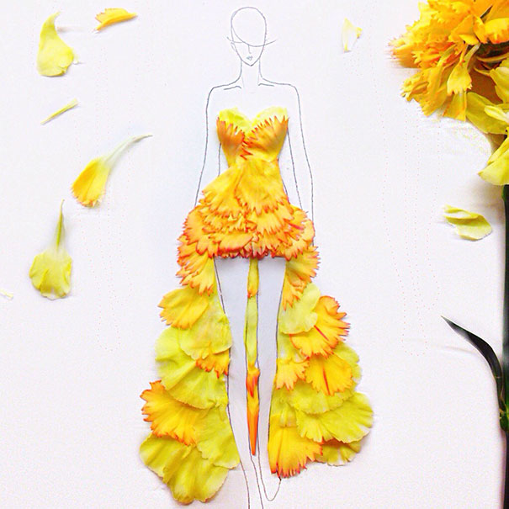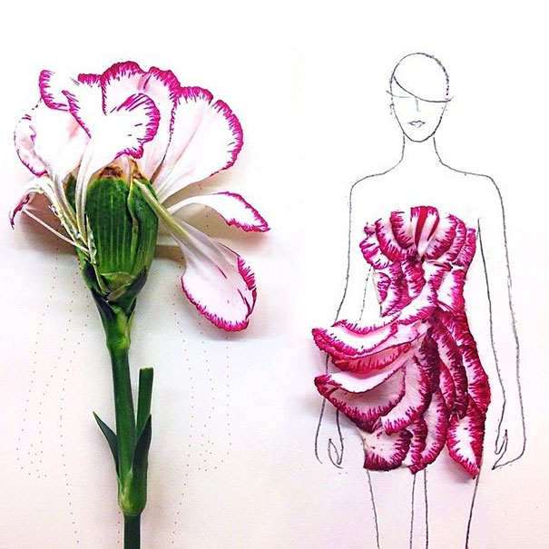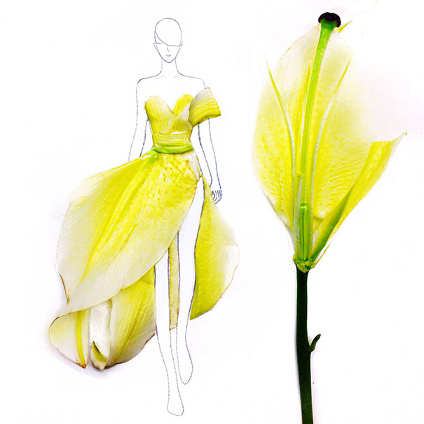

Van Gogh:
The Van Gogh Galalry. Van Gogh Landscapes. Retrieved from …….http://www.vangoghgallery.com/painting/landscapes.html



