**Sherlock Holmes**

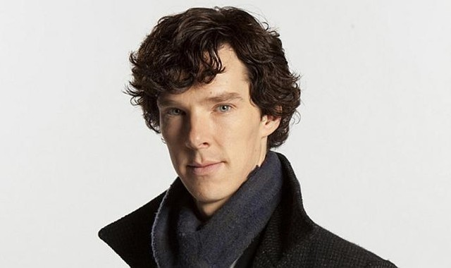[](http://www.google.ca/url?sa=i&rct=j&q=&esrc=s&source=images&cd=&cad=rja&uact=8&ved=0ahUKEwiKwNi6_tDPAhVIWz4KHXqwDjQQjRwIBw&url=http://quotesgram.com/sherlock-benedict-cumberbatch-quotes/&bvm=bv.135258522,d.cWw&psig=AFQjCNGPMxgvxzTvC9xgGiDE4TAMFM6hEg&ust=1476214674140944)

[](http://www.google.ca/url?sa=i&rct=j&q=&esrc=s&source=images&cd=&cad=rja&uact=8&ved=0ahUKEwi-4ICR_9DPAhUDOD4KHQT9ArkQjRwIBw&url=http://www.pbs.org/wgbh/masterpiece/programs/character-hub/series/sherlock-season-3/character/sherlock-holmes_s518/&bvm=bv.135258522,d.cWw&psig=AFQjCNGPMxgvxzTvC9xgGiDE4TAMFM6hEg&ust=1476214674140944)

[](http://www.google.ca/url?sa=i&rct=j&q=&esrc=s&source=images&cd=&cad=rja&uact=8&ved=0ahUKEwj54rSWgNHPAhVBNT4KHWdfAogQjRwIBw&url=http://hero.wikia.com/wiki/Spock&bvm=bv.135258522,d.cWw&psig=AFQjCNHYSbrluzwSY1MBM21ChKtBOB2b1w&ust=1476215159782317)

[](http://www.google.ca/url?sa=i&rct=j&q=&esrc=s&source=images&cd=&cad=rja&uact=8&ved=0ahUKEwiH04ujgNHPAhWHZj4KHUTbDLcQjRwIBw&url=http://crackerwax.com/2013/05/07/its-a-spock-off/&bvm=bv.135258522,d.cWw&psig=AFQjCNE1Surq6-en4rA9Pwk3azjo2ZcJhA&ust=1476215191080634)

[](https://www.google.ca/url?sa=i&rct=j&q=&esrc=s&source=images&cd=&cad=rja&uact=8&ved=0ahUKEwjiuKLogNHPAhXFbz4KHYMLB70QjRwIBw&url=https://quotesgram.com/jack-sparrow-confusing-quotes/&bvm=bv.135258522,d.cWw&psig=AFQjCNEeQ3MkzHQWXLqRJkquSVgrYgNnfA&ust=1476215322811802)

[](http://www.google.ca/url?sa=i&rct=j&q=&esrc=s&source=images&cd=&cad=rja&uact=8&ved=0ahUKEwid3MH0gNHPAhVMVD4KHebjALkQjRwIBw&url=http://www.mwctoys.com/REVIEW_110510a.htm&bvm=bv.135258522,d.cWw&psig=AFQjCNEeQ3MkzHQWXLqRJkquSVgrYgNnfA&ust=1476215322811802)

[](http://www.google.ca/url?sa=i&rct=j&q=&esrc=s&source=images&cd=&cad=rja&uact=8&ved=0ahUKEwiKqo_pgdHPAhWLND4KHdKaC88QjRwIBw&url=http://www.independent.co.uk/arts-entertainment/films/news/alan-rickman-dead-the-wonderful-story-about-how-he-hid-snape-s-story-arc-from-everyone-including-the-a6812031.html&bvm=bv.135258522,d.cWw&psig=AFQjCNFZJI2k409WxvzBAGSdJe1_4-1yew&ust=1476215460058703)

[](http://www.google.ca/url?sa=i&rct=j&q=&esrc=s&source=images&cd=&cad=rja&uact=8&ved=0ahUKEwji5s_ygdHPAhUBST4KHZWgBXUQjRwIBw&url=http://www.playbuzz.com/rachaeld11/a-harry-potter-who-said-it-severus-snape-or-harry-from-love-actually&bvm=bv.135258522,d.cWw&psig=AFQjCNFZJI2k409WxvzBAGSdJe1_4-1yew&ust=1476215460058703)

