Lesson Plan
Exploring Analogue and Digital Images
Playful Self-Portraits
Art Educator: Cynthia Cousineau
Target Audience:
Age: 14 to 17 years old
Group size: Small group of 15 students or less.
Formal Classroom situation: Takes place in lecture room, studio and darkroom.
Informal Situation: Museum visits, self-exploration of city, and online posting of information.
Course Description:
This is a studio course designed to teach students about analogue and digital photography. Students will be provided with a history of the different types of photography. The course will explore topics such as what makes an image meaningful? Students will be introduced to the darkroom, the digital camera, and the image-editing software, Photoshop. For the purposes of this course students will create multiple photographs of a playful nature. The course focuses on the playful elements of photography, in which students will have fun creating several images that display creativity and playfulness while also showing a strong understanding of how to manipulate the images they created. Students will become familiarize with the image editing techniques such as cropping, saturation, resolution, scare, the creation of file types, etc. The goal of this course is to teach students of the many creative possibilities that the photographic art creates. Students will learn how to create and manipulate their own images with several projects that involves incorporating the self with photographic images.
Playfulness is important when dealing with the creation of images, so through image manipulation the student will enter a new magical world where the possibilities are endless. Students will explore each technique and use their skills to show a playful side to their images.

Technical Facilities:
- Darkroom equipped with developer, water, and fixer.
- Photography Studio: for organizing, drying, cutting photos and class lectures.
- Computer Lab: Equipped with a scanner and photo- editing software such as Abode Photoshop and Illustrator.
Materials:
- Small objects to create patterns (Example: buttons, marbles, shells, nails, etc.…)
- 25-50 sheets of 8x RC (Resin Coated) Pearl Finish multi-grade photo paper
- A Digital camera or cellphone
- Portfolio, sleeves or folder to protect photos (8”x11”)
- A USB key
- A plastic bag for containing objects for photograms.
- Projector for PowerPoint presentation
Project Description:
Students will explore the techniques involved in the creation of photograms and digital photography by experimenting with the darkroom procedures. They will produce several photograms which they will scan to their computer. When creating their photograms they will also explore patterns. They will also use a digital camera or cellphone and take photos of local architecture and themselves. They will then combine their photograms with their digital photography to create a collage of themselves that incorporates both the photographs produced through analogue photography and digital photography.
Learning Objectives:
- To understand the different methods of capturing and manipulating an image
- To examine the meaning of images
- To gain an appreciation for the traditional photographic methods and incorporate them with modern digital methods.
- To become familiar with the darkroom and image editing software.
- To create playful self-portraits using images from both analogue and digital techniques.
- To understand the difference between analogue and digital photography.
- To develop vocabulary relating to the art of photography.
- To apply problem-solving skills to the creation of a playful self-portrait collage.
- To work collaboratively when exploring new techniques and share ideas
Lesson Sequence
Day 1: Introduction to Analogue Photography (3 hrs.)
- A presentation about the history of photography focusing on analogue photography.
- Explain how photograms are created.
- Show examples of photograms and artists.
- Give students time to brainstorm ideas.
- Discuss meaningful images.
- Tour the darkroom and explain the procedures.
Homework:
- Find an image that is meaningful and explain why?
- Collect small objects to use when creating photograms of patterns.
Day 2-3: Creating photograms (6 hrs.)
- For the first day, have students work in pairs. The first day is meant to familiarize with the techniques involved in the creation of photograms.
- Students will work individually on the second day.
- Students will create photograms of patterns and small objects.
- Students will produce 3 photograms of different patterns.
Homework: Finish 3 pattern photograms
Day 4: Introduction to Digital Photography (3hrs.)
- Show class a PowerPoint presentation about the history of digital photography
- Give examples of famous digital photography artists
- Explain the important parts of the digital camera
- Give tour of Computer lab
- Explain to students how to scan their photograms on to their computer and save them on USB
- Have students sit in pairs and explore the functions of the digital camera.
- Have students take pictures of each other.
Day 5: Field Trip around the city (2 hrs.)
- Take students outside to photograph the architecture of the city.
Homework: Take photographs or local architecture and interesting objects to incorporate in their self-portrait
Day 6: Exploring Photoshop, the surreal self-portrait (3 hrs.)
- Give time to students to scan and upload photos on to their computer.
- Students will save their digital photos taken in the previous classes to their computer and USB.
- Explain the functions of Photoshop with a brief PowerPoint presentation.
- Have students practice with Photoshop by working in pairs to create a surreal image featuring the two students. Students will use the photographs they took of each other and combine it with an image they downloaded from the internet.
Day 7: Mixing Pop Culture and Photoshop (2 hrs.)
- Students will create a self-portrait that features themselves mixed with an element of pop culture.
Day 8: Recreation of Famous Artwork
Day 9: Creation of a playful analogue-digital collage (2hrs)
- Students will create a collage on Photoshop which combines their pattern photograms, self-portraits and architecture photos in order to create a playful image.
Day 10: Exhibition of projects (1.5 hrs.)
- Class discussion about meaningful images.
- Each student will talk about their photographs and the process of creation.
- Students will comment on the work of their peers
Projects Produced in this Course:
- 3 Pattern Photograms of different objects
- 3-5 Good architecture photos in black and white
- 3 Different Self-Portraits
- A surreal self-portrait (Working in Pairs)
- A pop culture collage which features the self-portrait
- Recreation of famous artwork
- A final playful collage which includes a self-portrait mixing analogue and digital photography

Vocabulary
Analogue photography: Photography that uses a progressively changing recording medium, which may be either chemical process based or electronic. Refers to photography using an analogue camera and film and can be developed with the use of chemicals. This includes photograms and pin-hole photographs.
Digital Photography: A photographic method that stores the image digitally for later reproduction can be produced with a digital camera or scanning. With a digital format, a photograph can be manipulated with image enhancing software’s, such as Photoshop.
Photogram: Pictures produced without cameras. Images are created by placing various objects on the surface of a light-sensitive material, such as photographic paper and then exposing it to light, and developing it with the use of chemicals. This technique is also known as the camera-less photography.
Pixel: Dots that make up an image
Brightness: The measurement of a relative lightness or darkness of a color.
Saturation: The strength and purity of a color, representing the amount of gray in proportion to hue.
Crop: To cut off or remove a part of the image.
Layers: Parts of Photoshop files that keeps different parts of the design separate from each other.
JPEG: Joint Photographic Experts Group (jpg) is an image file that supports millions of colors and works best for photographs and other images with continuous tones.
PDF: Portable Document File, which enables the printing and viewing of documents.
Magnetic lasso: A selection tool that creates selections automatically by clinging to the edges of contrasting objects as you click the edges.

Prototypes
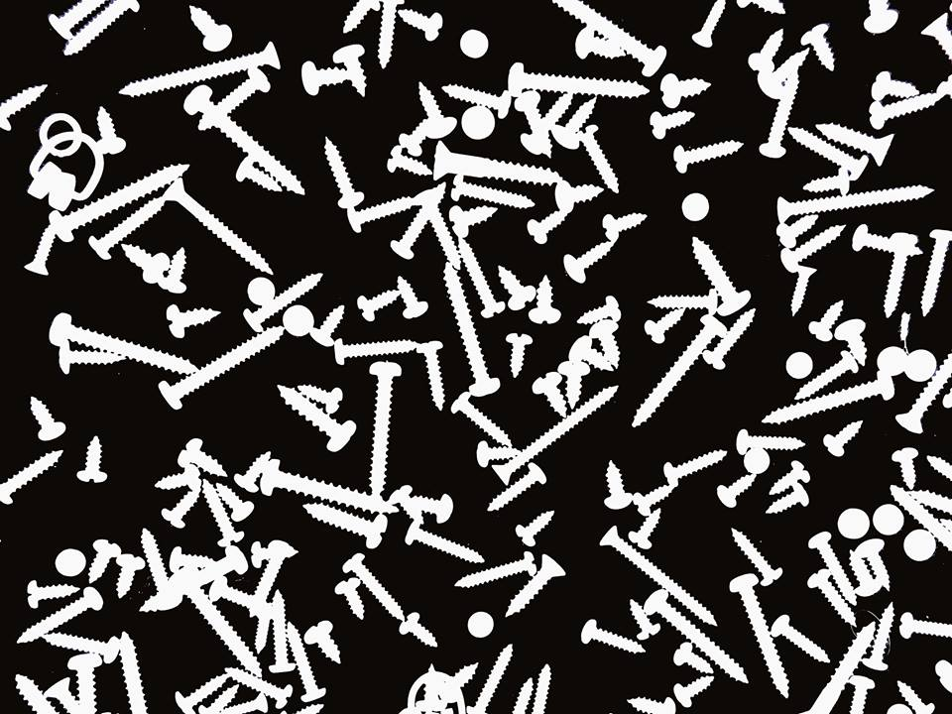
Project 1: Photogram of Nail Patterns
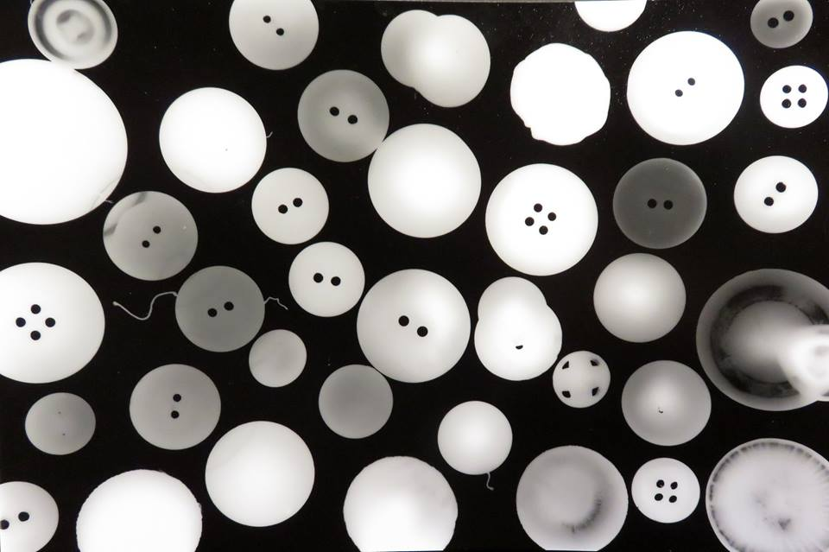
Project 1: Photogram of Button Patterns
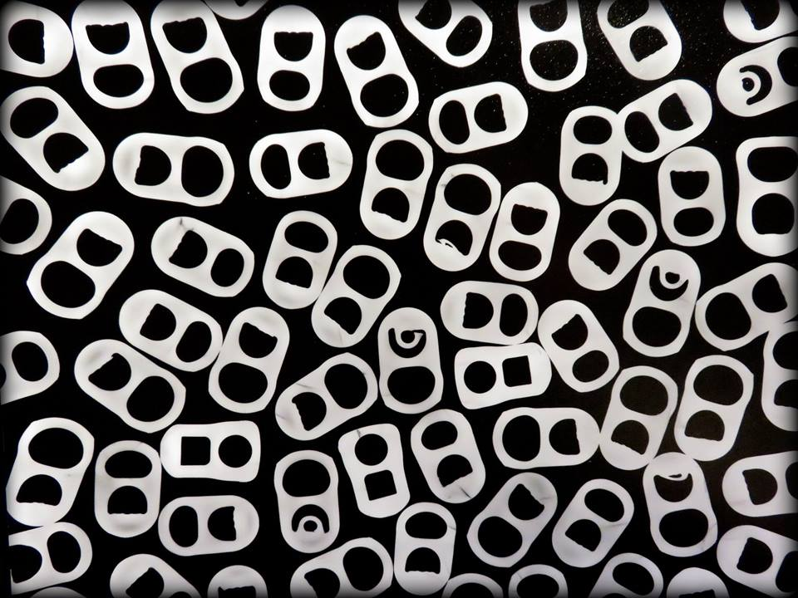
Project 1: Photogram of Can-opener Patterns
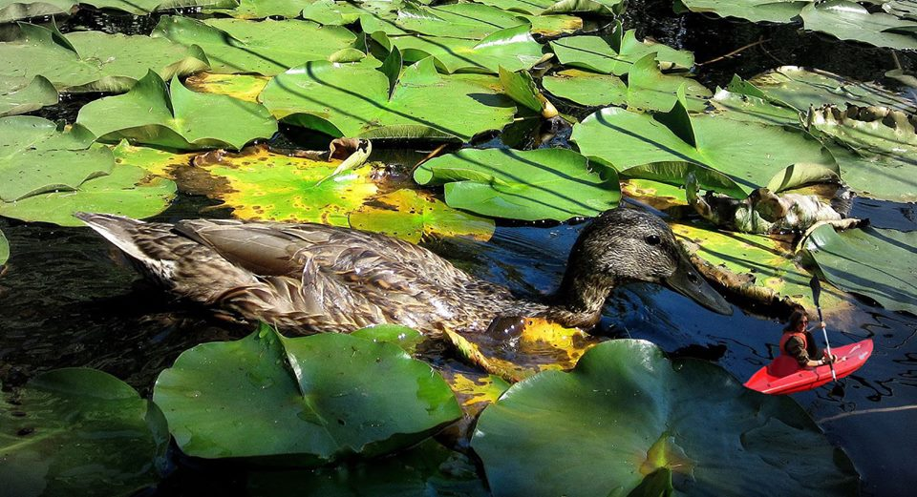
Project 4: Surreal Self-Portrait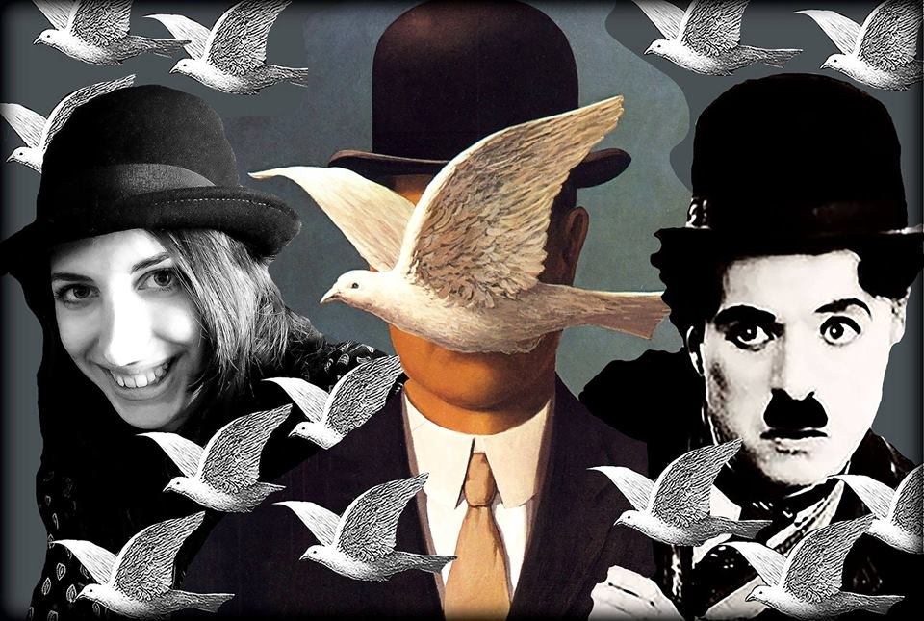 Project 8: Recreation of Famous Artwork

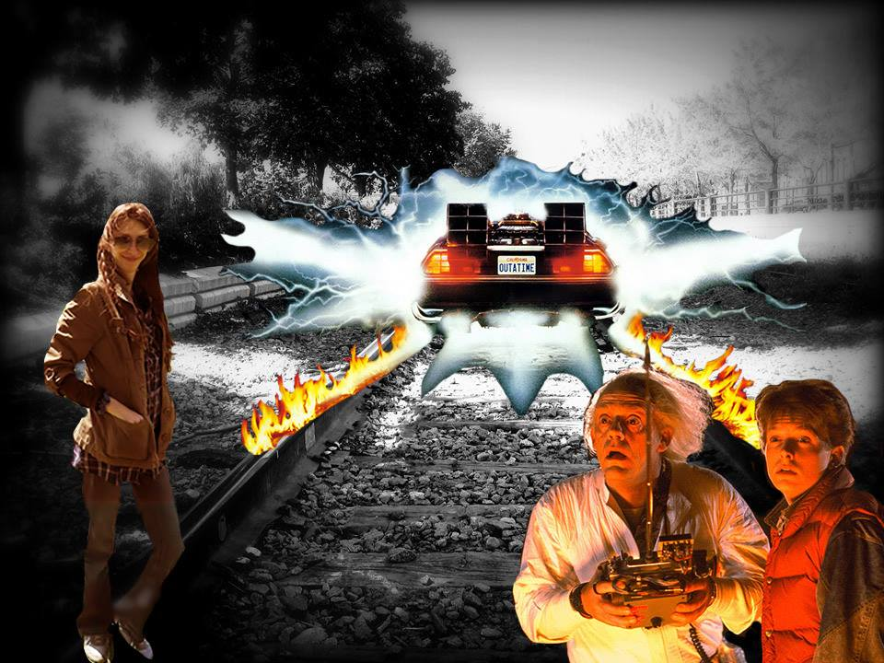
Project 5: Mixing Pop Culture and Photoshop
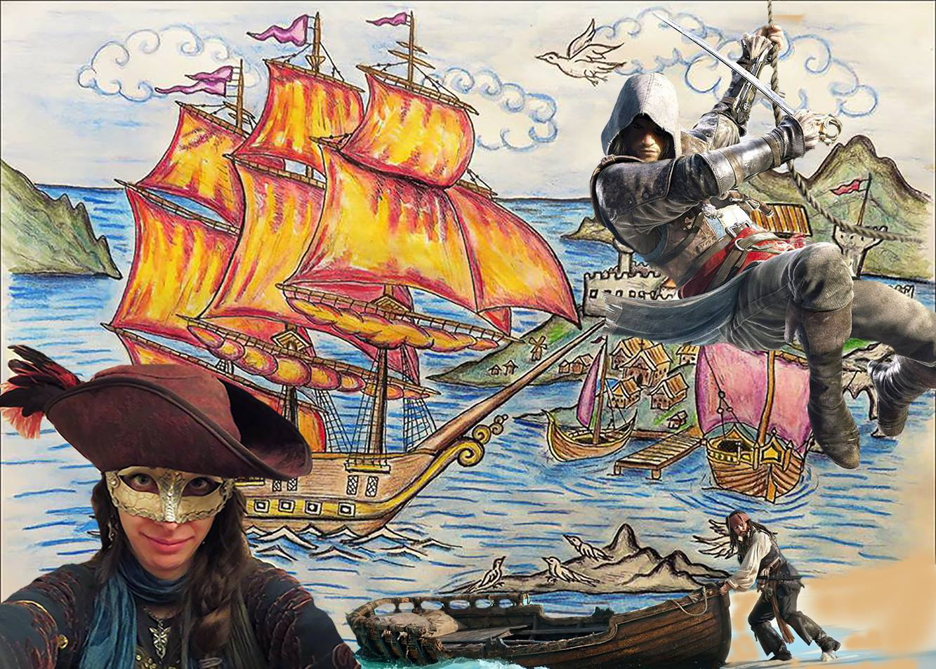
Project 5: Mixing Pop Culture and Photoshop

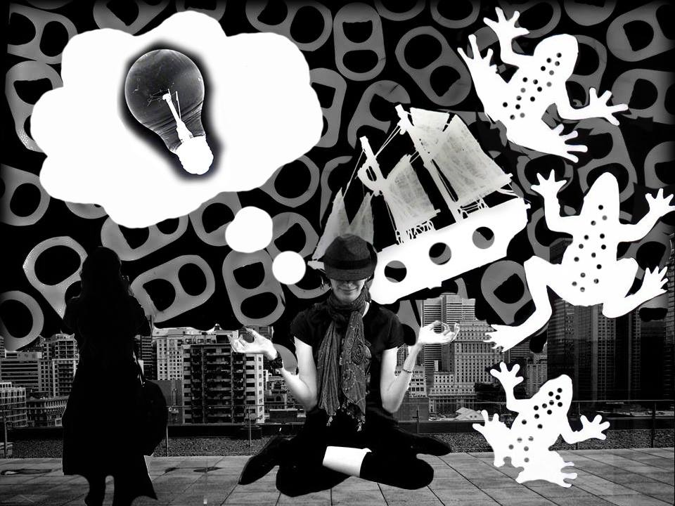
Project 7: Playful analogue-digital collage

References
Photograms
Photograms: http://www.photograms.org/
Making a photogram; Traditional darkroom ideas: https://www.ephotozine.com/article/making-a-photogram---traditional-darkroom-ideas-4688
Photogram Artists:
- Anna Atkins
- Christian Schad
- Ethan Jantzer
- Man Ray
- Lazlo Moholy-Nagy
Digital Photography
- Photography Tips for Beginners: https://photographylife.com/photography-tips-for-beginners
- Digital Photography Tips and Tutorials for Beginners: http://digital-photography-school.com/digital-photography-tips-for-beginners/
Photoshop
4 Creative Photoshop Artists who cleverly manipulate landscapes: http://www.hongkiat.com/blog/photoshop-expert-landscape-manipulation/
Beautiful Photoshop Illustrations by Artists Around the World: https://www.smashingmagazine.com/2009/11/100-photoshop-illustrations-by-artists-around-the-world/
Photoshop Artists:
- Andric Ljubodrag
- Erik Almas
- Erik Johansson
- Richard Roberts

Project 8
Recreation of Famous Artwork
For this project the goal is to transform an image of a famous painting with the use of Photoshop to include yourself in the scene. The idea is to playfully transform the famous painting into a new playful work of art, by applying several image-editing skills using Photoshop.
“Prototype of Project”
Your final project should demonstrate the use of the following:
- A reversed image of the original self-portrait or painting.
- The use of the lasso tool.
- An image of a famous painting.
- An image taken from the internet.
- The use of the “crop” tool.
- Change in the saturation of the image.
- An image of yourself that goes well with the scene of the painting.
- Working with at least 3 layers.
Poject Steps
Step 1 : Select 3 different images :
- A Famous artwork (Ex : Rene Magritte’s Man in the Bowler Hat)
- A photograph of yourself
- An an image from the internet (Ex : Charlie Chaplin)
Step 2: Go on Photoshop and click “file” then “new”.
- Change the resolution to 300
- Change the size to 8 x 11 inches
Step 3 : Download these images to photoshop
- Click “file” then “open” to select the images you which to use
- Use the famous artwork as the main background layer
Step 4: Using the photoshop tools, play around with the images to create your own playful version of the artwork.
Step 5: When finished save project as a JPEG & PDF file, on your USB.
- Title the saved project with your lastname then first name
Example: CousineauSinthia
- Include the 3 original images on the USB
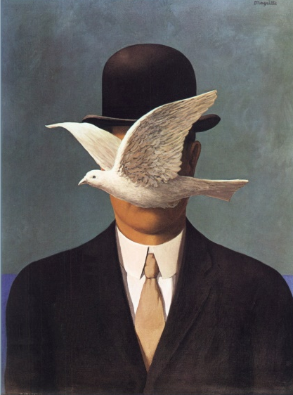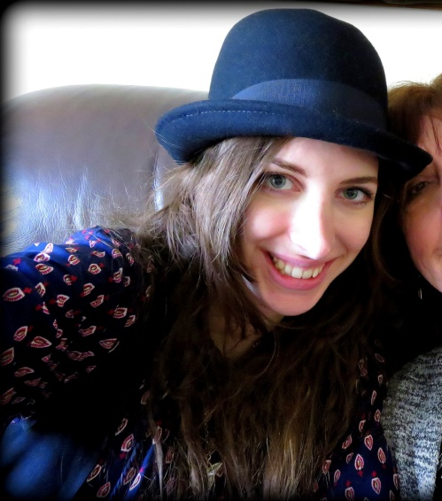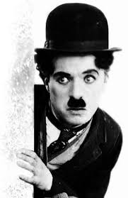

Saturation
Normal High Low
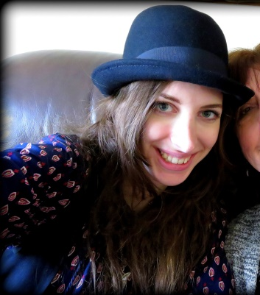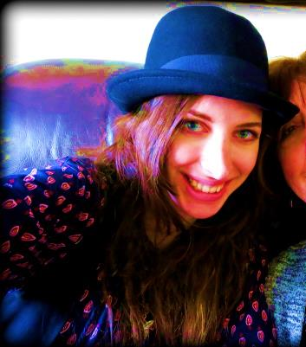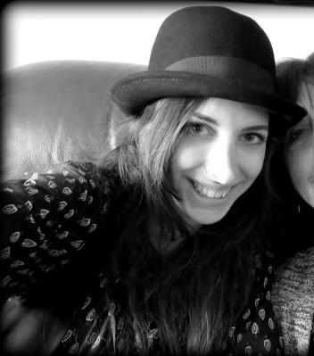
Reversing an Image
Cropping
