Art Educator: Cynthia Cousineau

School: John Grant Highschool

Grade Level: Cycle 2 Secondary (Grade 9-11)

Course: Visual Arts & Digital Media

Time Frame: 5-6 hours

Environmental Awareness
and
Nature Themed Animated Loop Film
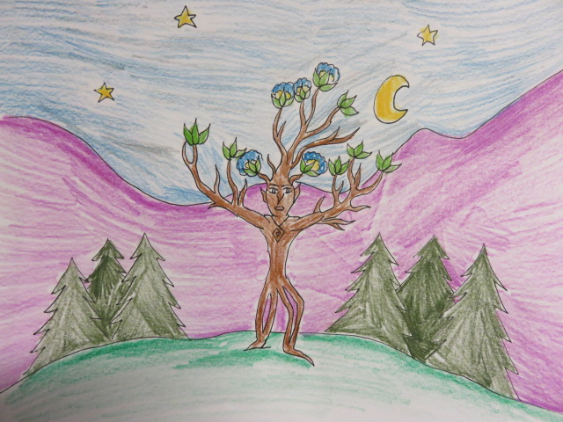
Example of a Drawing from Prototype Animated Film
Guiding Question
“How could new media art practices be used to foster environmental awareness and create a deeper appreciation for the natural world?”
Rationale
We live in a time where we consume irresponsibly without a concern for how it affects the natural environment. We destroy countless trees each day, we pollute the planet with fossil fuels, we throw away things that are still in good condition or buy things we do not need. It is therefore crucial to become more environmentally aware of ecological issues that threaten the planet and to gain a deeper appreciation of the natural world so that we could learn to live in harmony with it.
This lesson will teach students to incorporate elements representing the natural world into their artwork and to help them convey an important environmental message through that artwork with the creation of a short animated film.
Students will choose either a famous eco artist or a work of a well-known environmentalist which they believe conveys a strong environmental message. For example, the novels of J.R. Tolkien have strong environmental messages. They will aim to make an artwork that also addresses a key environmental issue or threat to the environment. For example, the deforestation of trees as a major environmental crisis and exploitation of natural resources, as was addressed in the stories of J.R Tolkien in his story “The Lord of the Rings”. Students will base their inspiration on examples of real environmental artists or environmentalists and create a work which addresses a similar theme to their source of inspiration.
Students will then proceed to think of an idea of an animation that would show a natural life cycle related to their chosen them and create an animated film that functions in a loop. Students will select an idea that interests them, and use sources of inspiration to eventually create an animated film that will convey a strong environmental message.
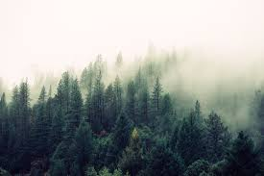
Lesson Objectives
- To create a short animated film based on a theme related to nature or the environment, which functions in a loop and successfully post the video on YouTube.
- To understand the value of eco art and to incorporate the environment into digital art media.
- To develop the basic skills involved in the creation of a short video.

Broad Areas of Learning

Environmental Awareness and Consumer Rights:
- Students will enrich their knowledge of the environment by research the key environmental issues that affect the planet’s ecological health.
- They will gain awareness how environmental artists have used artworks and new media technology to convey important environmental messages.
- They will gain a respect for the natural world, and realize how the cycle of life functions in a loop.
- They will gain awareness of the interdependence between the environment and human activity.
- They will enhance their knowledge or renewable and nonrenewable materials.
- Students will again a deeper appreciation for the natural world and realize that their actions affect the natural world, and that they could use their media art skills to help foster environmental awareness.

MELS Curriculum Competencies

Competency 1: Creates Personal Images

- Students will be able to design their own original idea in the form of several drawings using traditional drawing techniques.
- Students will create story boards with a basic representation of how they intend to animate their film.
- Students will come up with an original idea for a loop story that incorporates a theme related to the environment or nature.

Competency 2: Creates Media Images

- Students will be able to use tools, such as Photoshop to design their own animation. Students will also be able to manipulate a camera to photograph their drawings, if they choose to do the traditional drawing.
- Students will learn how to transform their animated video into a GIF.
- Students will explore the properties of Windows Movie Maker or iMovie, and learn how to upload their animated videos on YouTube.

Cross Curricular Competencies
- To use information:
- Consorting books and websites to help come up with a basic idea of how to draw an animation that has a good story and flows well as a loop.
- To become aware of key environmental issues affecting the ecological health of the planet, and to address these issues in their artwork for their animated films.
- To solve problems:
- Students will learn how to transform the end of their animation into the beginning, to form a loop with their story.
- Students will research their own source of inspiration for an environmental artist.
- Students will learn how to represent an environmental problem or message through new media drawings that mix traditional techniques.
- To exercise critical judgement:
- Students would have to think critically about how they are going to apply motion to their art.

- To communicate appropriately:
- To be able to clearly show a story with their animated film and GIF. To learn how to organize their ideas to create a narrative.
- To clearly convey the environmental message they wish to address.
Assessment
Each part of the lesson would be evaluated according to a 5 point scale grading rubric which will evaluate the art making process, the use of media technology and the final video product.

Lesson Sequence
Lesson 1: Introduction to Environmental Art (2hrs).
- Introducing Eco Art and New Media techniques
- Researching source of inspiration for conveying environmental message

Lesson 2: Story Board and Brainstorming Loop Idea (2 hrs.).
- Introducing Animation, storyboards
- Designing a character on a storyboard and creating a landscape for story

Lesson 3: Image editing of landscape and storyboard (3hrs).
- Using scanned image of landscape and storyboard and experimenting with image editing techniques. Using extra time to create 30 images for animation.

Lesson 4: Photoshop and work on 30 animated drawings (4hrs).
- Introducing Photoshop
- Time to finish working on images and scan or photograph to upload on computer

Lesson 5: Video Editing, publishing on YouTube and GIFS
- Using photo edited images of 30 drawings to create a video and then transform it into a GIF and upload video on YouTube.
Lesson 6: Class critique and presentations of animated loop videos. (2hrs)

Lesson 1: Introduction to Eco Art
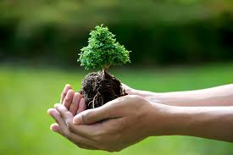
Guiding Question
“What is eco art? And how can we use technology to convey a message that promotes environmental awareness?”
Objectives
- To appreciate the artistic movement of environmental art and become familiar with the works of environmental artists.
- To learn how to represent environmental awareness or respect of nature through art, specifically new media art.
MEQ Competencies
To Appreciate Images:
- Students will learn about eco artists who use new media technology and make connections between technology and how it can convey a message.
Motivation (20 mins)
- Show students a PowerPoint presentation on Eco Artists and Eco Art and New Media
Show a YouTube video on a specific eco artist and discuss the environmental message they convey. Show examples of eco artists that use new media to convey environmental messages.
Discussion questions:
- What is eco art?
- What kind of works would you consider to be eco art?
- How would you use technology to create an enviormental message?
- How does eco art bring environmental awareness?
Activity: (1 hour)
- Research 3 inspiring eco artists or activists and pick one work that most inspires them.
- Brainstorm ideas for an animation the represents the cycle or nature or an environmental image and come up with a creative way of representing this idea in a loop.
Example: A sun setting and moon rising and then setting for the sun to rise again.
- Students will use computer technology to do their research and type their paper.
Closure:
- Summarize the main ideas of what encompasses eco art
- Gather students brainstorming and research sheets.

Assessment
Students will research & write 2 pages containing the following:
- Select a key environmental issue to focus on.
- Think of an important message you which to convey regarding that environmental issue.
- Find three examples of eco artists
- Pick eco artwork that they find most inspiring.
Students are to be graded on handing in 2 complete pages with their ideas for all these components.
Vocabulary
Eco Art:
- A term used for artwork that addresses an issue concerning the environment.
- It could either be an actual work or installation which is built using natural materials or a work that shows an element representing nature and aims to bring awareness about certain ecological issues.
Loop: A structure, series or process that has an end that links to the beginning.
Resource
A Guide to Eco Artists & PowerPoints on Eco Art: http://www.sinthiacousineau.com/eco-art.html
Lesson 2
Story board & Brainstorming Idea
Guiding Question
“What are the main components of a story and landscape and how would we represent a story using traditional drawing techniques mixed with new media?” 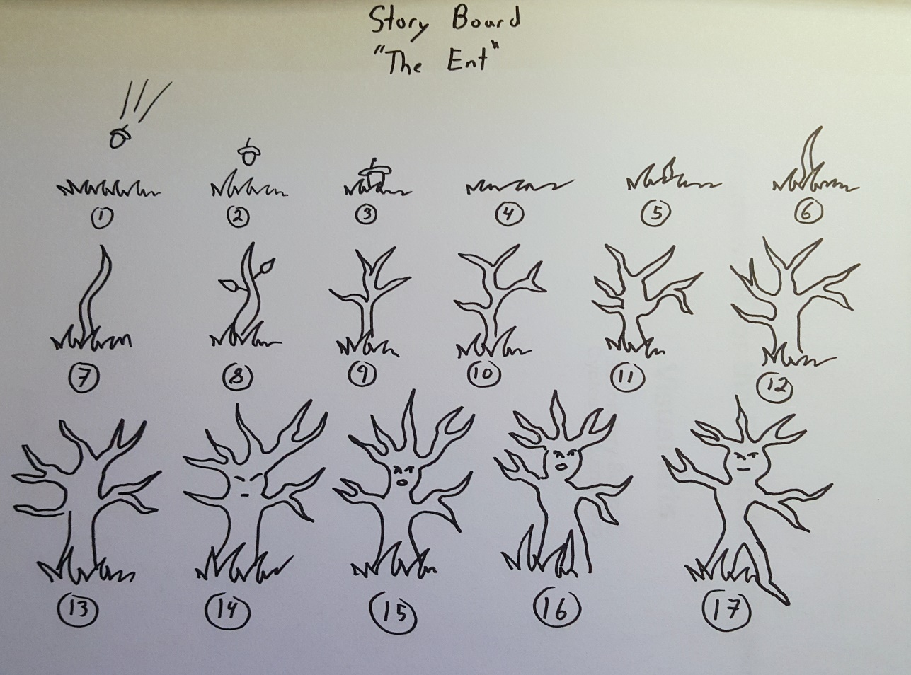
Prototype of a Storyboard for «The Ent”
Objectives:
- Come up with an original idea for a story that relates to the theme of environment or nature.
- To display creativity by coming up with an original idea for how this story could function in a loop.
- To create a sketch of the story with 30 different parts and scan on to a computer.

MEQ Competencies
To appreciate Art:
- To appreciate the components that makes a landscape by observing landscape art as seen through new media such as photography.
To produce individual works in the visual arts:
- Students will draw their own story board, design their own characters and create their own story that would function on a loop.
- Students will look for ideas related to the stimulus for creation while consulting sources of information.
- Students will make a pencil sketch of their idea and will experiment with transforming gestures by turning that idea into a color pencil or watercolor piece.

Assessment
- Students will be evaluated on their use of shape, line and spatial organization when submitting their storyboards.
- Students will be evaluated on the creativity of their idea and characters as well as on how the overall story functions as a loop.
- Students will be evaluated on how this story relates to the theme of the environment and which environmental message it conveys.
Motivation:
- Show prototype video of the Ent and then a prototype drawing for the storyboard for the Ent.
- Show students prototype of a storyboard for the Ent story.
- Show YouTube videos on how to create an animation with simple drawings.
Activity: Duration 2hrs.
- Students will be given a sheet of paper to do their storyboard drawings on and another to design character ideas. They will print sources they gathered from the internet to use as inspiration.
- Once the story board and landscape is completed they will photograph it or scan it on to a computer and save the file in their USB or email.
Closure:
- Students will hand in a printed copy of their storyboard and landscape design to the teacher.
Discussion Question:
- What are the basic components of a landscape design?
- What is a storyboard? How could you use a computer to make a story board?
- How can you capture an image from a traditional drawing and transfer it to computer technology?
Landscape Design
- Explain the concept of landscapes.
- Students will create a background design on a sheet of paper which incorporates elements of foreground, middle ground and background.
- They will then photograph their landscape using the camera of their cellphones (or scan it with a scanner if they have no cell phones).
Vocabulary
Animation: A technique of photographing two-dimensional drawings or the position of three-dimensional objects like puppets to create an illusion of movement as a film shown in sequence.
Animism: Bringing inanimate objects to life by giving them human characteristics.
Background: A flat setting for a moving character in an animated film, usually an artwork.
Foreground: The furthest part of a landscape
Frame: An individual still picture on a strip of film.
Loop: A structure, series or process that has an end that links to the beginning.
Middle ground: the part of the landscape between the foreground and middle ground
Script: the written story of a film.
Storyboard: A sequence of drawings, typically with some directions and dialogue, representing the shots planned for a movie or television production
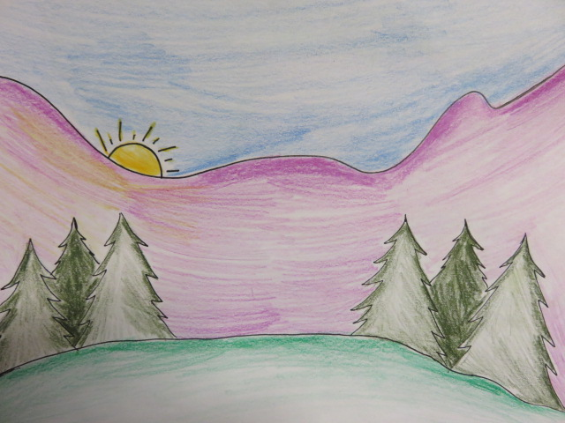
Lesson 2 Prototype: Simple Background Design for Animation
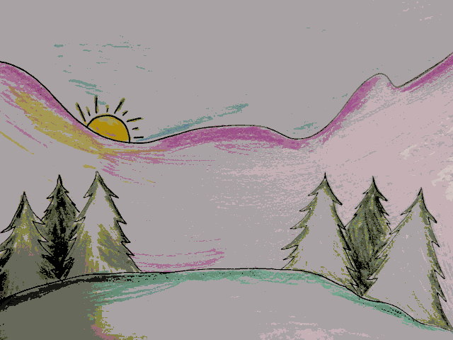
Lesson 3 Prototype: Posturized Landscape Background

Lesson 3: Image editing of landscape & Story board
Duration: 2 hrs.
Guiding Question: “How can you transform an image using image-editing software?”
Objectives
- To play with basic image editing techniques on windows photo gallery or Picassa to alter original landscape images and storyboard.
MEQ Competencies
Competency 1: Creates Personal Images
- Students will use image editing software to alter and transform the saturation and contrast of their original drawings.
Competency 2: Creates Media Images
- Students will use new media technology to transform their image into a new image.

Motivation:
- Introduction to Photoshop
- Using the filters on the cellphone or a computer image editing software (Photoshop) modify the image of your landscape drawing to make it appear more digital.
- Explain what is an animation and the concept of a loop. Introduce example of prototype of project.
Discussion Questions:
- What software could you use to edit an image?
- Using photo-editing software what changes could you make to an image?

Vocabulary
Hue: A color or shade.
Photo manipulation: involves transforming or altering a photograph using various methods and techniques to achieve desired results
Negative: is an image, usually on a strip or sheet of transparent plastic film, in which the lightest areas of the photographed subject appear darkest and the darkest areas appear lightest.
Negative Space: in art, is the space around and between the subject(s) of an image
Filter: In front of the camera lens filters are used to modify/colour the light entering the camera (photographic filters). In front of a light source filters modify or colour the light projected onto the scene (non-photographic filters).
Saturation: “Intensity” and “chroma.” It refers to the dominance of hue in the color.
Assessment
All assignments will be submitted to the teacher by email or printed copy. Students will be evaluated and graded on a checklist on their ability to do and submit the following:
- Students will photocopy of scan or photography their drawing of the storyboard and character design and use their previously landscape drawing.
- They will reverse the colors of the story board will exploring the “negative tool”.
- They will “posterize” their landscape drawing.
- They will do another alteration of their choice for their character design.
- They will explore the crop tool and saturation and create a new image using 8 different images of the different parts of their story and transform the saturation of each image to create a new image of a different color. Each of the 8 images must be a unique color.
- Students will also select another 8 images from their storyboard and created a black and white posturized storyboard.

Examples of Image Editing Transformations
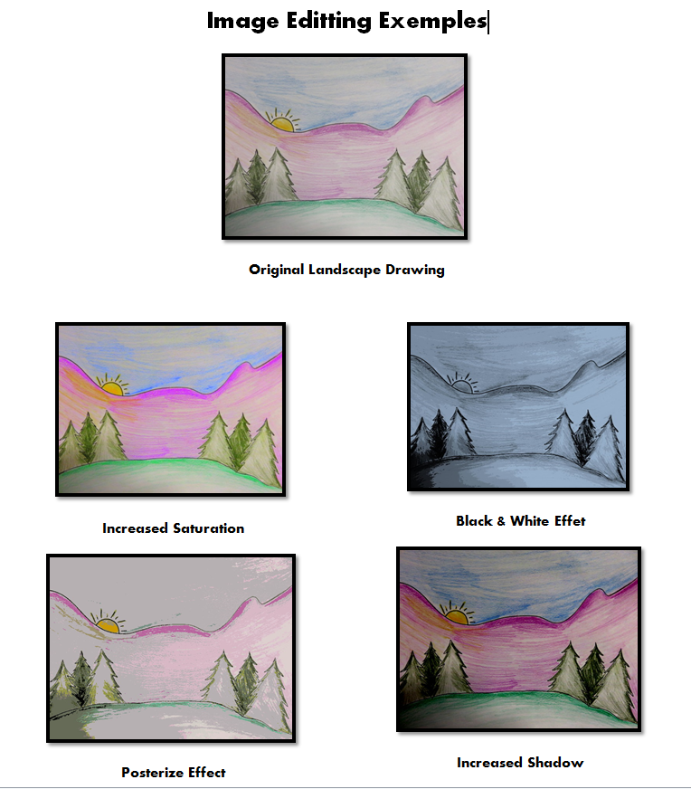

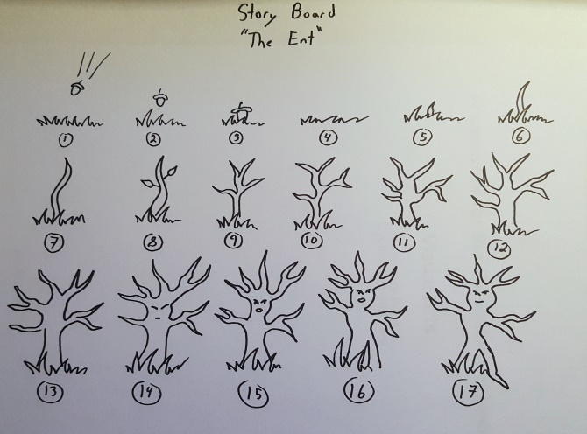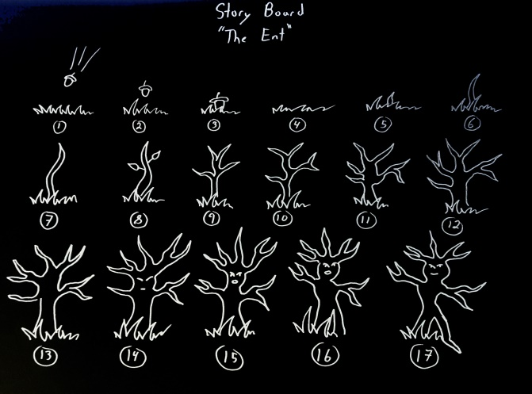
Prototype Example: Changing scanned storyboard into a negative

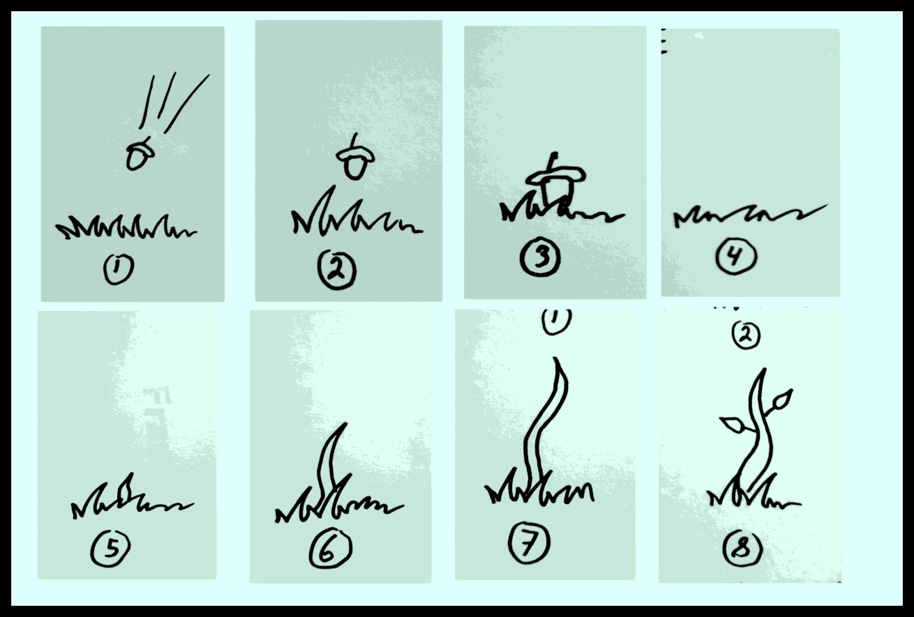
Prototype of Back and White Posterized Storyboard
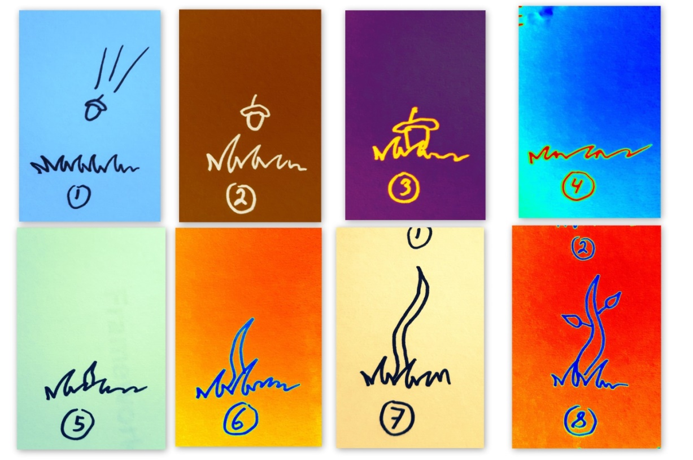
Prototype Example: Cropping and changing saturation of an image
Lesson 4: Photoshop & Work on animation drawings
Guiding Question
“How can we mix traditional drawing with new media alter an animation using Abode Photoshop?”
Motivation:
- Introduce Photoshop and its properties
- Show prototype of video once more and of image of the Ent at day vs night, showing how Photoshop was used to give the illusion of time of day.
Vocabulary
Photoshop: Image-editing software, which can be used when creating animations
Materials
Photoshop
Access to a computer
USB with 30 images on it
Activity (4hrs):
- Based on their storyboard brainstorming activity students will be given a story board paper to fill out a basic sketch of 30 images. They will use class time to do their drawings and scan or photograph them to their computer.
- Once drawings are completed students can alter elements of the drawings on Photoshop using the techniques learnt in previous lesson as well as some features of Photoshop.
Example: In “The Ent” prototype the saturation was changed as the sun set and the moon rises, for images that were at night had lower saturation and greater focus in an attempt to create a more realistic darkness.
Assessment
Students will be evaluated on their ability to manipulate images of their animation using Photoshop. Techniques that will be evaluated include changing the contrast, the saturation, sharpening an image or any alteration to an image. Emphasis is brought upon how the use of Photoshop helps enhance the quality of the animation or the loop idea.
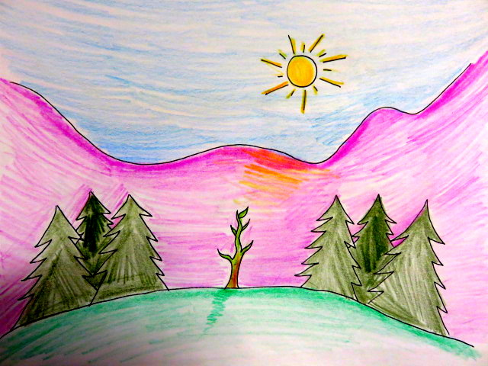
Day
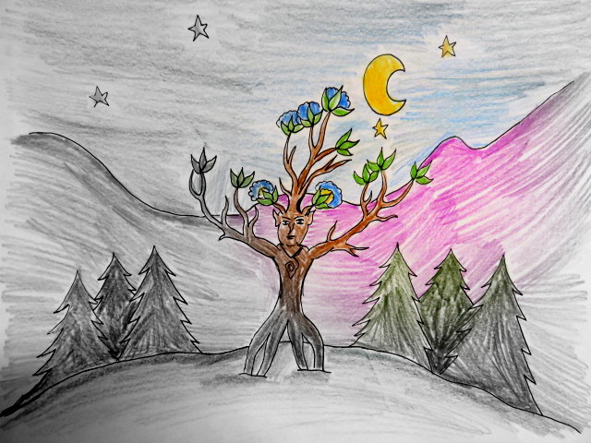
Night

Photoshop used to help enhance the loop of sun-moon rising and setting
Lesson 5: Video Creation & GIF
Guiding Question
“How can we turn images into an animation using video editing software and make it function as a loop?”
Objectives
- Successfully create an animated video that functions on a loop which repeats at least 5 times and publish that video on YouTube.
- Find and music suitable music of that video.
- Create a GIF of the animation that functions as a loop.
- Use video editing tools to make an animation video.

Vocabulary
Crop: To modify an image by selecting a certain part of it to focus on.
GIF: a technique for formatting images that supports both animated and static images.
Trim: To remove a part of a video clip to make it shorter.
Frame: An individual still picture on a strip of film.
Photoshop: Image-editing software, which can be used when creating animations.
MEQ Competencies
Competency 2: Creates Media Images
- Students will work with windows movie maker or iMovie to create an original animated video.
Materials:
- USB with finished edited images
- Access to a computer with windows movie maker or imovie
- Music files downloaded to email or USB
Assessment
Students will be evaluated on their ability to do the following:
- Create a video and successfully publish it on YouTube
- Successfully create a GIF animation.
- Use video image manipulation tools, such as manipulating the time, music, filters of a video.
Adding a title and credit to the video and mentioning their source of inspiration
Prototypes

- Video: ENT a very Short Animation by Cynthia Cousineau
https://www.youtube.com/watch?v=NxOfD8bdQAM

- Sequence of Images:

http://www.sinthiacousineau.com/animation--gifs.html

GIF: F:\Concordia\fall 2014\finalcynthia.cousineau[1].gif

Prototype of Video Sequence

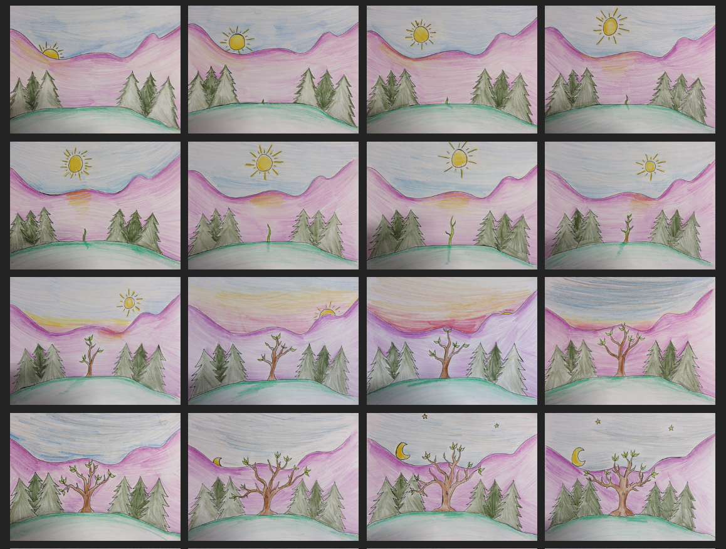
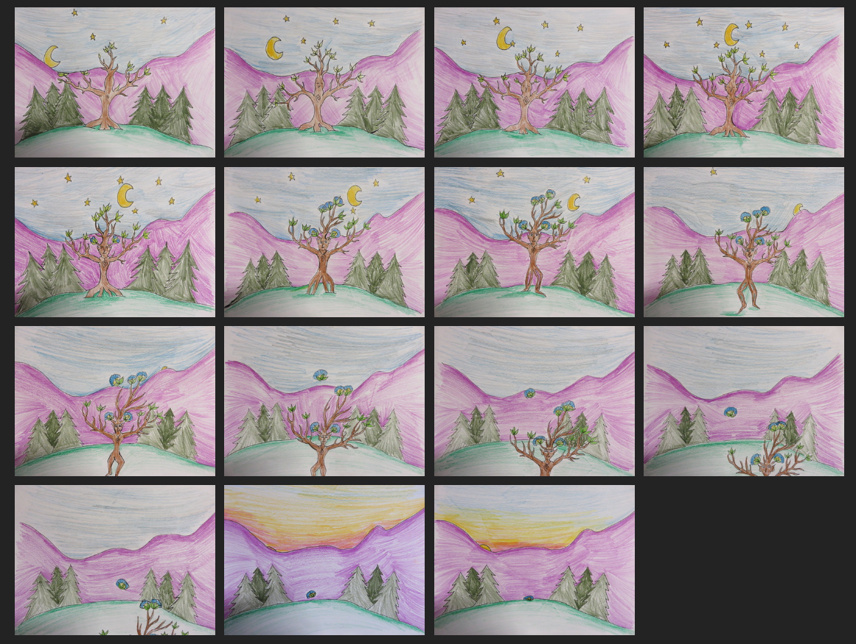

Lesson 6: Class critique and presentations of animated loop videos
- Students will present their source of inspiration and main message to the class.
- Students will critique each other’s work.
- Students will discuss which media technology they found most challenging in this project and what other media forms they would like to incorporate in future projects of a similar nature.
- Students will be evaluated on their participation in the critique discussion and the manner in which they present their animation.

Cross-Curricular Competency
To communicate appropriately:
- Students will communicate their source of inspiration and message to the class with a presentation of their short loop animation video.

Assessment

Students will be evaluated on the quality of their presentation and ability to convey an environmental message.

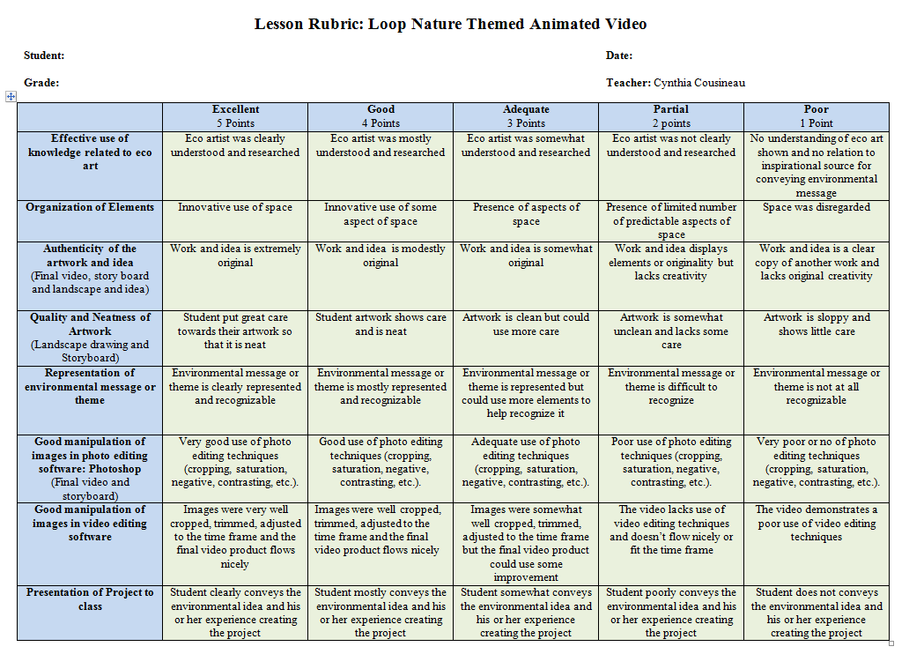
Diversity of Leaners

- More time would be given to students with special needs that restrict their learning abilities.
- If there are students with special needs that affect their intellectual capacities or mobility the buddy system may be applied in which these students could work in pairs.
- Students with hearing impairment will not be required to put music in their final video and will replace these criteria with a paragraph of self-reflection of their own learning process.
- Students will severe social anxiety can present project to the teacher rather than in front of the entire class, but their video will still be down to the class.
- Students with ADHD will be given time to meditate to help relax their mind and help them focus. Calming music will also be played in class so that all students could better focus.
Overall Project Process

Engage: Motivate students with prototypes and examples of artists and environmental activists.

Explore and investigate: Exploring photo editing skills on their story boards and landscapes.

Create: Creating an animated video and GIF that functions on a loop.

Share: Presenting their video and GIF to the class.

Resources for Animation

Gizmodo: http://gizmodo.com/5941436/how-to-make-a-gif-in-five-easy-steps
WikiHow: http://www.wikihow.com/Create-Animated-GIFs-Using-Photoshop
Main Media: http://www.mainemedia.edu/workshops/young-artists/young-animators?gclid=CLWJ6tLbjsECFWqCMgodciUAZw
Animated Stories: http://www.kidsworldfun.com/animated_stories_01.php
Animated Stories: http://www.highlightskids.com/story-player

Video: ENT a very Short Animation by Cynthia Cousineau
https://www.youtube.com/watch?v=NxOfD8bdQAM

A Guide to Eco Artists & PowerPoints on Eco Art:
http://www.sinthiacousineau.com/eco-art.html

