Reconstructing Scenery
Collage

Art Educator: Cynthia Cousineau
School: Garden view Elementary
Grade: 4-6
Time Frame: 2 sessions (1 hr. each)

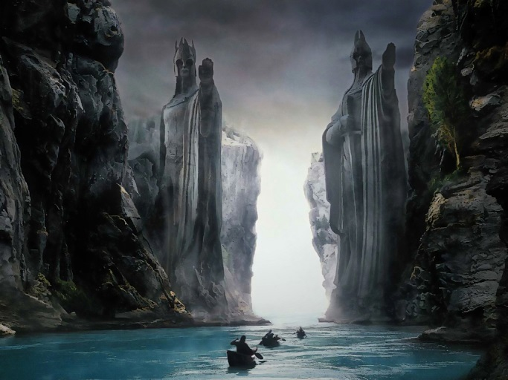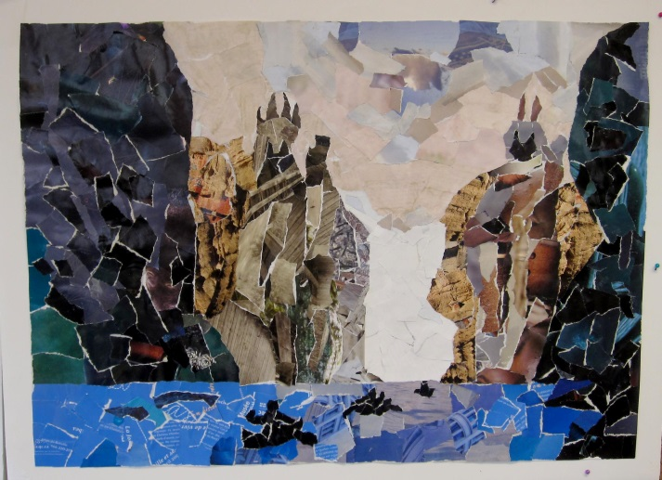
“Recreating the Scenery from Lord of the Rings: The Fellowship of the Ring”
By Cynthia Cousineau
Rationale: This lesson will enable children to practice their art skills by recreating their favourite sceneries from famous paintings, movies or photographs.
Specific Objectives:
- Students will learn how to recreate an image of a painting using the method of collage making.
- Students will produce original images inspired by another artwork (famous or not), thus also learning about that artist.
- Students will learn to recreate colors using magazine images to resemble the collages of the original image. They will use colors and composition that resemble the original.
- Students will research a painting of scenery or landscape of their choice using a computer to inspire their collage. Thus, they are incorporating technology with art.
- Students will be able to discuss the aspects that inspired them about their chosen painting & compare the original image to their recreation.
- Students will acquire a basic understanding of the composition of space within landscape art.
7) Students will produce an artwork that demonstrates foreground, middle ground and background.
8) Students will gain a better understanding of how to create depth in art.

Visual Art Competencies
- To Produce Individual Works in the Visual Arts
- To Produce Media Works in the Visual Arts
- To Appreciate media images & the works of classmates
Cross-Curricular Competencies
- To use Creativity
- To Adopt Effective Work Methods
- To use information and communication technologies (ICT)

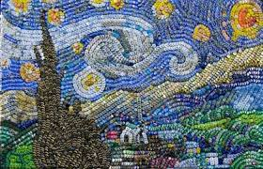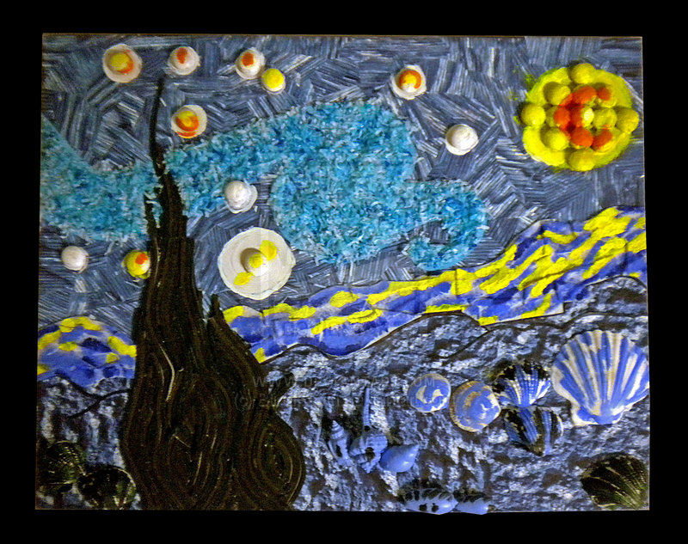

“Collage of a Starry Night

Visual Art Competencies
To Produce Individual Works in the Visual Arts
- Students will produce original images inspired by another artwork (famous or not), thus also learning about that artist.
To Produce Media Works in the Visual Arts
- Students will acquire a basic understanding of the composition of space within landscape art.
- Students will produce an artwork that demonstrates foreground, middle ground and background.
To Appreciate media images & the works of classmates
- Students will be able to discuss the aspects that inspired them about their chosen painting & compare the original image to their recreation.

Cross-Curricular Competencies
To use Creativity
- Students will learn to recreate colors using magazine images to resemble the collages of the original image. They will use colors and composition that resemble the original but maintaining the originality of their own work.

To Adopt Effective Work Methods
- Students will learn how to recreate an image of a painting using the method of collage making by choosing their image and visualising the colors they plan to use. The students will then plan the design of their artwork and manage their time appropriately to construct their work
To use information and communication technologies (ICT)
Students will research a painting of scenery or landscape of their choice using a computer to inspire their collage. Thus, they are incorporating technology with art.

Materials for students:

- Tracing Paper
- Scissors
- Glue (Stick or Liquid)
- Paint Bushes
- Pencil
- Magazines
- Construction Paper
- Tissue Paper
- Foam core board
- Regular Drawing paper
Materials for Teacher:
- Prototype
- Laptop
- PowerPoint Presentation on examples with mini lesson about Collage making

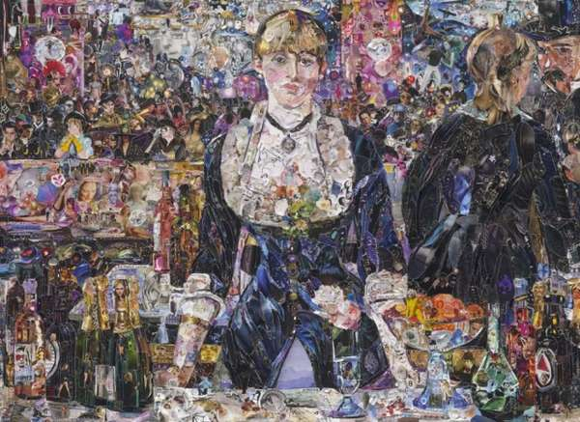
“A collage reproduction of a Manet’s Painting”

Vocabulary

Background: The part of a picture of scene that appears to be farthest from the viewer, usually near the horizon. It's the opposite of the foreground

Middle ground: The part of an artwork that lies between the foreground and the background

Foreground: The area of a picture of field of vision, often at the bottom, that appears to be closest to the viewer

Overlapping: When one thing lies over, partly covering something else. Doing this is one the best ways of creating an illusion of depth

Texture: An element of art which refers to the surface quality or feel of an object, its smoothness, roughness, etc. Texture may be actual or fake. Actual textures can be actually felt, while pretend textures are suggested by an artist in the painting of different areas

Composition: The plan, placement or arrangement of the elements and objects in a work of art
Horizon: The Line that separates earth from sky

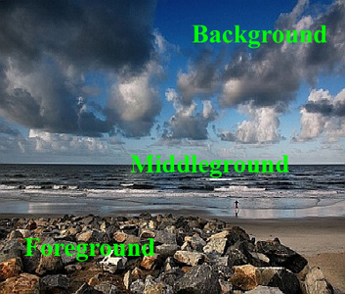
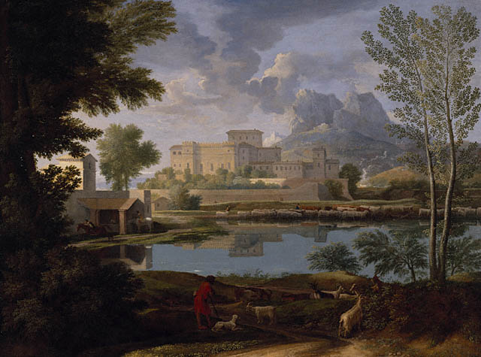
“Painting by Nicolas Poussin that shows the elements of foreground, middle ground and background”
Lesson Sequence
Introduction:
Day 1:
- Introduce the lesson with a PowerPoint presentation about scenery art which shows some of the famous landscape paintings. Towards the end of the presentation discuss the art of collage making & show some images of famous collage works (30 mins).
Day 2:
- Discuss with students the requirements of the project. Show them a prototype of the project. Discuss the materials which students are allowed to use for their collage making (5 mins).

Demonstration:
Day 2:
- Give a brief demonstration of the materials available to the class. Show students how to use these materials. Example: How to apply the liquid glue on tissue paper. Show them the different steps of the project (5-10 mins).
Example:
Step 1: Picking an Image you would like to reproduce
Step 2: Tracing the key elements of that image and drawing them on the large foam core board.
Step 3: Gluing the magazine paper, construction paper, tissue paper or other materials onto the foam core so that it resembles the original image.
Work-Time:
Day 1:
- Give students an opportunity to research their ideas after the PowerPoint presentation. Students could either use computers to research their images & print that image or take a photograph of it. Students could also look through art books and pick an image from there to photocopy (30 mins).
- If time allows students will trace their drawing onto a regular size paper & later recreate the image they drew onto the large foam core board.
Note: This could also be done for homework if the teacher runs out of time. Homework could also involve students gathering different kinds of paper materials to use for their collage project.
Day 2:
- Students will begin to glue and ensemble their collage ideas onto the foam core board. They will organize the paper materials they wish to use for their collages & share them among their peers. The entire class time will be dedicated to starting and finishing the collage. (40 mins).
Clean-up:
Students will recycle all unneeded paper materials which they have no used for their collage. They will clean the tables and return all art supplies to its proper place. They will give their finished collage to the teacher to display in front of the class on the wall (5mins).
Closure:
- All the students’ artworks will be displayed next to an image of the original artwork that inspired their collage, and students will be given time to observe the works of their peers. Then students will discuss why they picked the original artwork and compare what they like or dislike about their collage in comparison to the original work (15-20mins).
- By the end of this lesson students will have a clear understanding of the elements required to give depth to landscape art. They will also have acquired knowledge about the process of making collage art.
Adaptations for Diverse Learners
- Students with visual, motor or learning disabilities will be given extra time.
- Students who finish early can read books about famous landscape artists or collage artworks.
- Those students who finish early can also help their peers organize the materials needed to complete their collage, or can clean the classroom or help the teacher display the artworks.
Assessment
Students will be graded based on the rubric on displayed on the next page.
Optional: To incorporate a language arts element: Students can also be given a quiz about the artists discussed in the introduction PowerPoint or on the vocabulary covered in this lesson.
To include history: Students can research and write a mini essay on a landscape artist of their choice.
Resources
Websites
http://www.wikihow.com/Make-a-Collage
https://www.inspirationgreen.com/art-from-bottle-tops.html?start=80
http://quizlet.com/601629/collage-vocabulary-flash-cards/
Videos
http://www.youtube.com/watch?v=XMHJs5YIjtk
http://www.youtube.com/watch?v=ER9Lhgv5SxI&list=PLzRkz3UDnT-LR2RCGBoYINDm-Yf876u-T
http://www.youtube.com/watch?v=hY_neEhth8A
Evaluation
 | Minimal | Partial | Adequate | Through | Advanced
 | 0-1 | 2 | 3 | 4 | 5
Neatness of collage & drawing | The work is messy & falling apart | The work could have shown more care & shows some signs of sloppiness | The Collage is not perfectly neat but average | Work is mostly neat | The work is clean, no remains of glue showing, no pieces of paper sticking out of falling off
Demonstration of depth  (foreground, middle ground background & overlapping) | The work shows little or none of these components | The work shows only two components & it is not clear | The work is missing one component | The work demonstrates most of these components in a clear way | The work demonstrates all the components in a clear way
Variety of Colors & texture | Has no texture & only uses one color | Lacks color or texture | Uses adequate color and some texture | Has a good use of color and texture | Uses many colours & different shades & textures
Use & understanding of vocabulary | The student has no understanding of the meaning of the vocabulary | The student has a poor understanding of the vocabulary | The student demonstrates an average understanding of the vocabulary | The student mostly understand the vocabulary | The student demonstrates a perfect understanding of the vocabulary
Creativity & Originality of creating an image inspired by another | No use of creativity | Very little creativity in the work | Good use of creativity but could have used more thought | Good use of creativity but could use improvement | Very original transformation
Quality of Drawing of original painting & transferring that idea to the final collage | Drawing does not resemble the painting at all & neither does the collage | The drawing and collage somewhat resembles the original painting | Work resembles the original but has some differences | Original drawing is clear and resembles the painting * this is shown on the collage | Original drawing has details and clearly represents the painting & the collage demonstrates similar detail
Total Points= 30

