Roman Animal Mosaics
Lesson Plan

Art Educator: Cynthia Cousineau
School: Gardenview
Grade level: grade 5, incorporated with French literature & history
Time Frame: Approximately 4 hours

Question d'enquête:
How did the Romans represent stories or animals using the technique of mosaics?
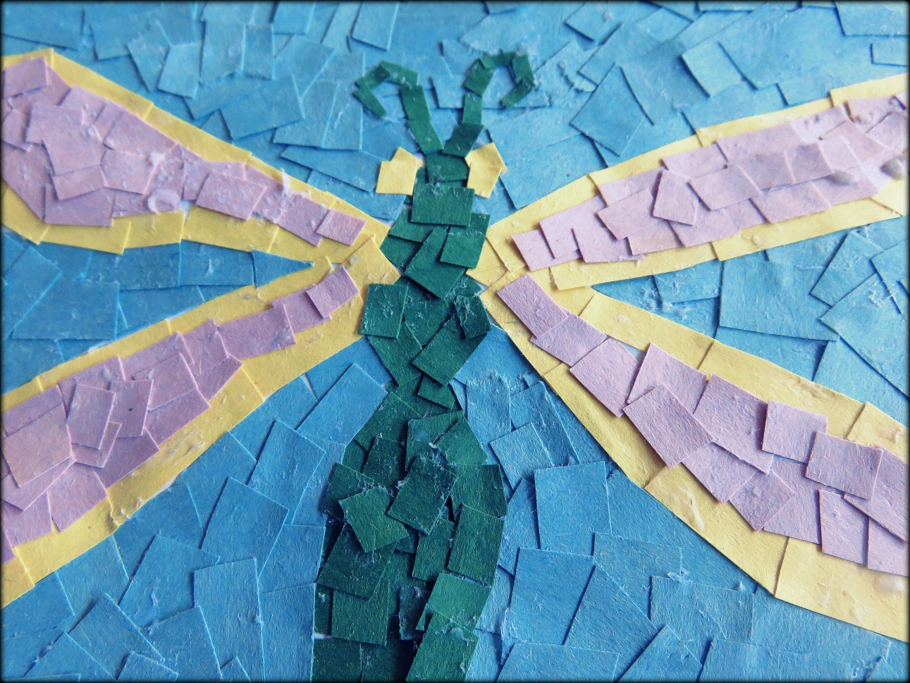
“Example of a paper mosaic representing a dragonfly”
Overview
According to Roman legend, Romulus was the founder of the city of Rome. Romulus and his twin brother Remus were the sons of the god Mars. When they were still infants, they were abandoned near the Tiber River. Luckily for the, they were found by a female wolf who had pity on them. She would watch over the two brothers and fed them her milk. The boys survived and one day they were found by a shepherd who adopted them. The boys grew up to be strong and intelligent men. They decided to build a city at the place where the shepherd found the. They called that city Rome, named after Romulus.
Back in the time of antiquity, ancient cultures like the Romans would use art as a way of communicating their stories by capturing scenes of their everyday life, such as scenes representing music, hunting, wars, or gladiator fights. They decorated their temples and houses with images that represented the mythology of their culture. The Romans are well known for their artistic abilities with mosaics, a technique were they would use small pieces or rock, marble or ceramic to create a motif and an image. These mosaics were mostly based on the themes of mythology of animals.
This lesson on paper mosaics is important because it will teach students patience when they create art. They will learn to appreciate the time and detail that are involved in the creation of a mosaic work. This lesson relates to the theme of fables because students will depict an animal from a fable story. In more advanced version of this lesson students can represent a seen from a story. This lesson can easily be adapted to the themes of fables, storytelling and mythology.
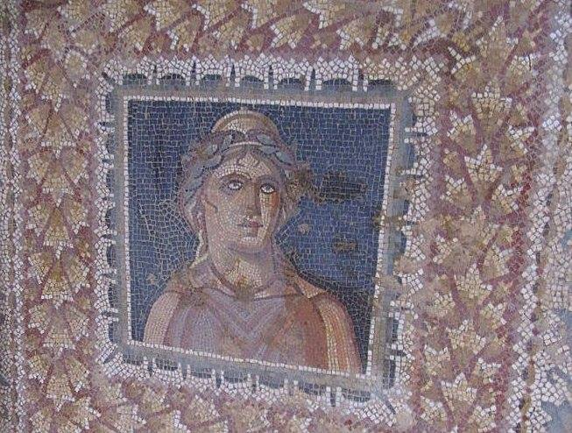
« Exemple de mosaïque romaine, en Tunisie (2011) »
Visual arts competencies
Competency 1: “To create personal images”
- Uses ideas to design their own paper mosaic.
- Organizes their production in visual arts by choosing the materials they intend to use, and organizing their own story and ideas.
- Shares their experience in the creation of their own mosaic by discussing how they represented their story or animal with their peers.
- Produces a paper mosaic that is original and display creativity.
Competency 2: “Appreciates work of art”
- Appreciates traditional artworks and media production involved in storytelling and fables, in particular mosaics representing mythology, Roman life and animals.
- Appreciate their own artworks and those of their peers by discussing their comic strips.
Cross-curricular competencies
Uses information: uses information on the techniques of mosaics and gains inspiration from the images of Roman mosaics.
Uses creativity: expressing creativity by representing animals or stories in mosaics that display originality.
Uses efficient work methods: Able to organize their time to properly use the materials.
To communicate well: To clearly represent their animal or story in a mosaic. To discuss their mosaic with their peers as well as give feedback on the mosaics of their peers.

Learning Objectives
- To learn to appreciate mosaics.
- To know the history of mosaics and the how they were important to Roman culture.
- To explore the different techniques involved in mosaics, such as the creation of motifs.
- To create their own paper mosaic with a geometric motif
- To represent a story or an animal with paper mosaics.
- To realise the value of patience involved in the creation of mosaics.
- To gain an appreciation for the small details in mosaics.
The Prototype
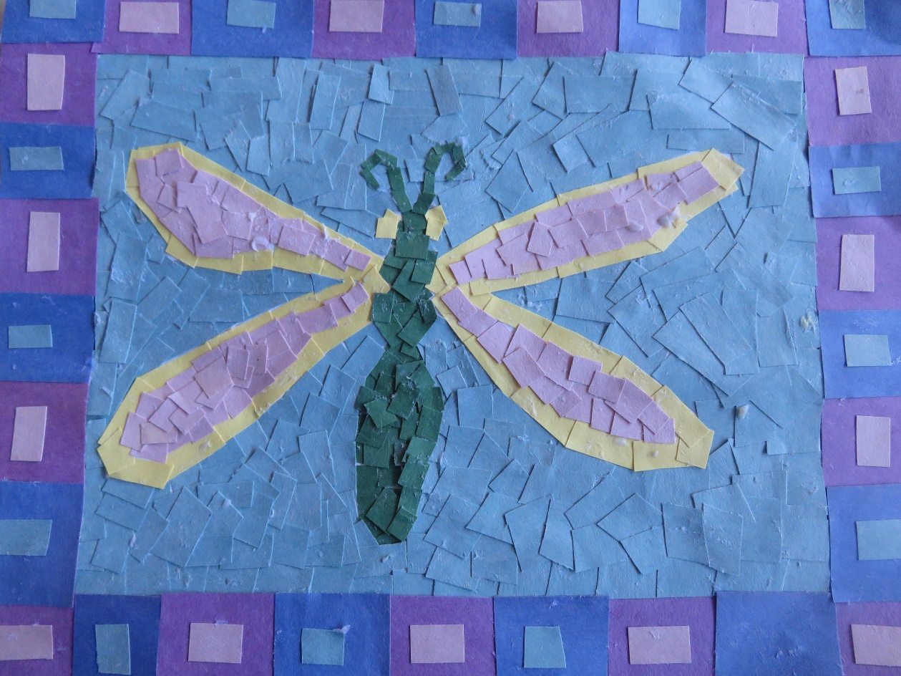
“Prototype of a paper mosaic of a dragonfly”

Materials & equipment for teacher:
- Computer
- PowerPoint presentation on Roman mosaics
- SMART board
- Books on Mosaics and the Romans
- Prototype of the project at different steps

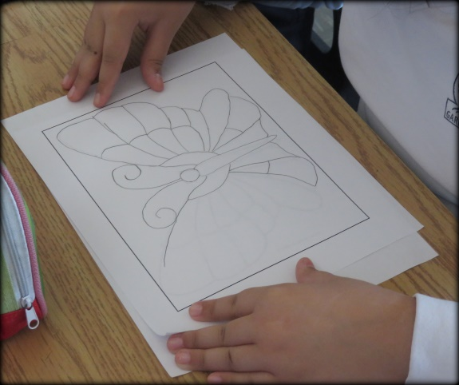

Materials for students:
- Black marker
- Pencil
- Glue stick
- Scissors
- Plastic bag
- Eraser
- Images of animals
- Paper explaining the different steps of the project
- Colored construction paper

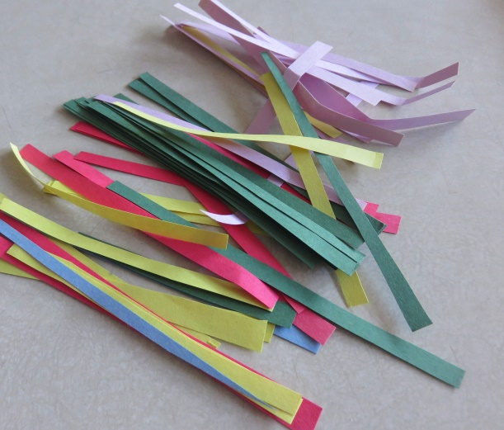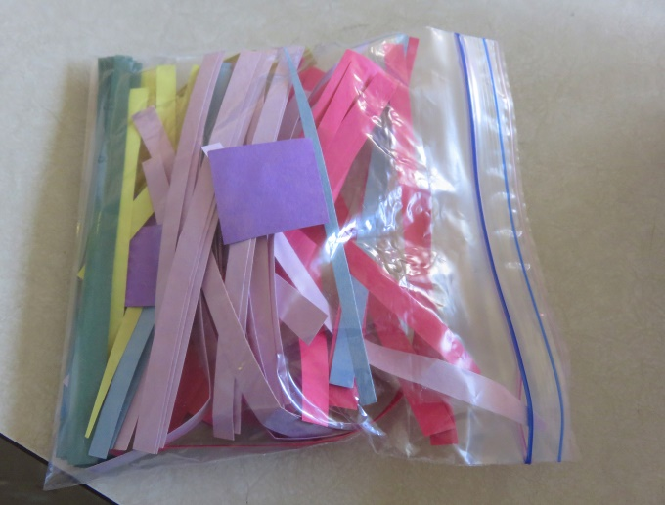
“Construction paper of various colors in a plastic bag”

Vocabulary
Frame: The bordure surrounding an image in a work of art.
Mosaic: Artistic technique in which small pieces of stone, marble, or ceramics are used to create a larger image or motif.
Motif: a drawing or dessin that is repeated to create a pattern.
Trace: To copy an image by placing a transparent paper on top of an image and copying the lines to recreate the same image.
Lesson Sequence
Introduction (duration 25-30minutes):
- Discuss the history of mosaics with a PowerPoint presentation.
- Ask students what is a mosaic?
- Discuss Roman history and art with students.
- Show students how the Romans represented their culture and history with mosaics that represented their mythology.
- Introduce the project of paper mosaics.
Demonstration (duration of 2-5 minutes):
- Show the students the different prototypes of the project. Each prototype representing a different stage of the project.
- Discuss the different steps of the project.
- Show students the materials they will be using for the project, which is available to them on the materials table.
- Tell students they will create a mosaic representing an animal from a fable story, or a scene from a story they have written.
- Remind students that they are expected to work individually and in silence.
Work time (3 hours):
- Students will pick an idea inspired by images of animals provided by the teacher.
- Students will trace the image to a white piece of paper with a frame.
- They will design a motif for their frame and draw their animal with either a pencil or black marker.
- On top of the image they have drawn they will glue tiny pieces of squared construction paper, to create an overall mosaic.
- Students are expected to work individually at their desks.
- Students are already divided into teams, and each time will be called one after the other to come to pick up the materials from the materials table.
- If a student finished early, they can help clean the classroom or work on other art projects.
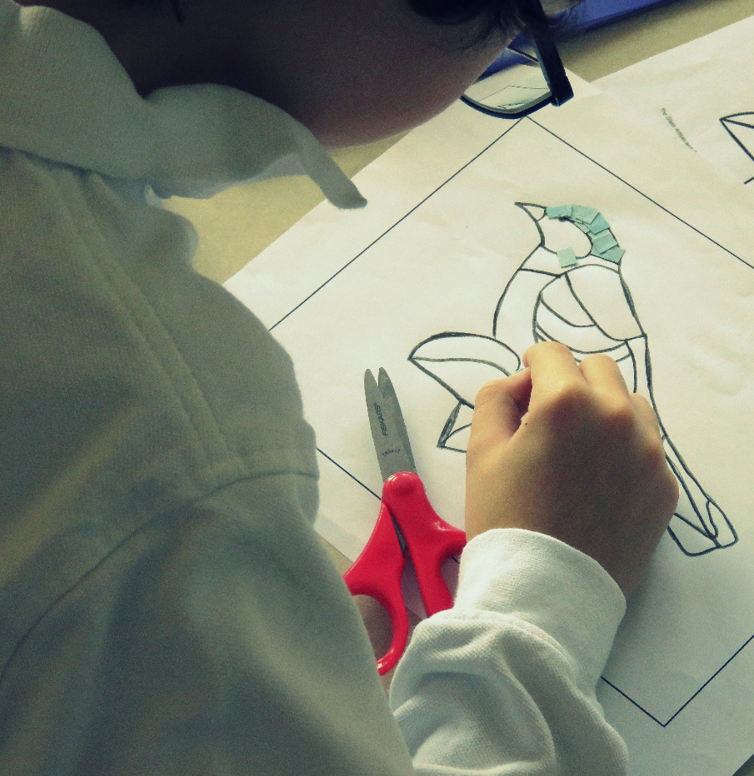
Student working on their paper mosaic

Cleanup (5 minutes):
- Five minutes prior to cleanup time, tell students they would finish the last detail they are working on, and start putting their things away.
- Mention to students that they need to put their small pieces of paper in the plastic bag provided to them, in order to avoid making a mess
- Tell students they should put their unfinished projects in their art folder, and hand in their finished projects to the teacher.
Conclusion (5minutes):
- Once all the work is finished, the teacher will display all the paper mosaics on the classroom wall so that the class can have a discussion about each other’s works
- The teacher will ask the students for their opinions regarding what the most and least enjoyed about this art project.
- The teacher will as students what did they learn from this activity?
- The teacher can ask the following questions:
-What is a mosaic?
-What is a motif?
-For what raison did the Romans create mosaics?
-What was the best part of the project in your opinion?
-Why did you choose to represent that particular animal?

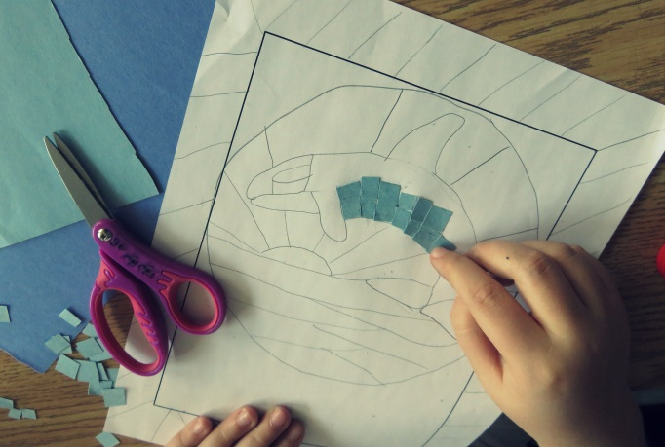
Student working on their mosaic
Adaptations for different learners

