Fable Stories in Motion
Optical Illusion with the Thaumatrope
Art Educator: Cynthia Cousineau
School: Gardenview Elementary
Grade Level: Grade 5, incorporated with French literature
Time Frame: This lesson lasts about 1:30 hours

Question of Inquiry
How can we use motion with two images to create an optical illusion that represents a story?

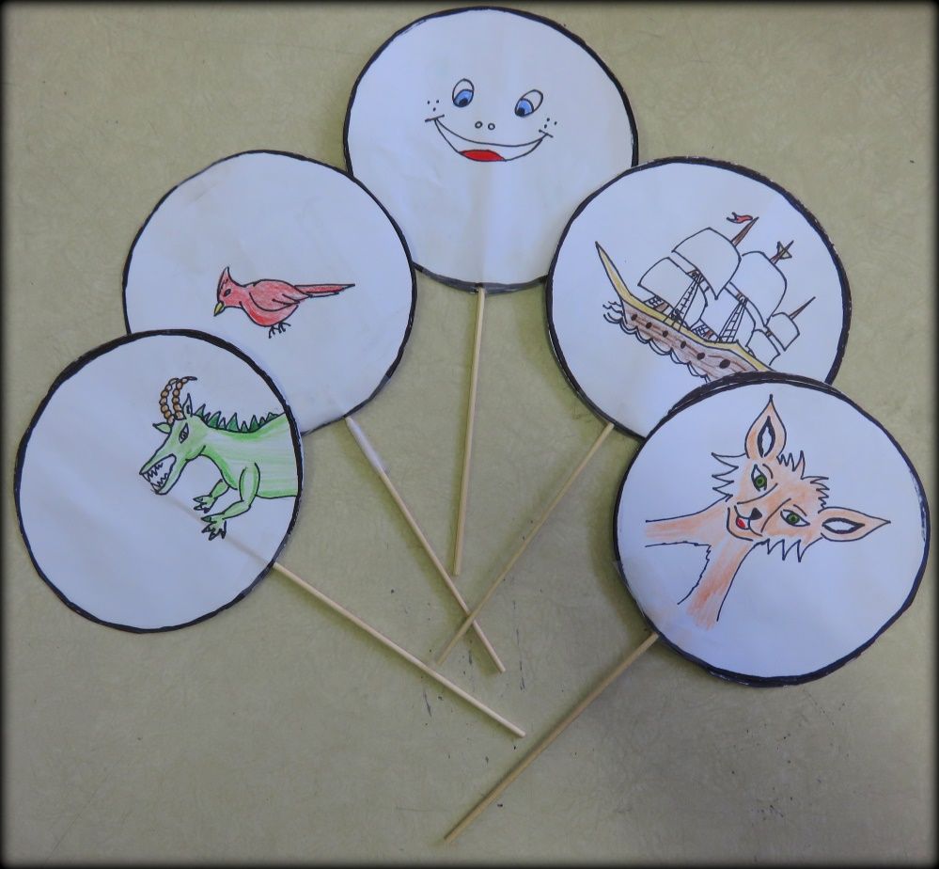
“Prototype Examples of Thaumatropes”

Rationale
Optical illusions are pictures that can be misleading. What we see with our eyes is communicated to our brain but sometimes what we see is different than what exists in reality, because of illusions in the visual system. Optical illusions occur when the brain tries to make sense of what our eyes see. An optical illusion is a trick of the mind in which our brain sees things that may or may not be real.
The thaumatrope was a popular children's toy in the 19th century. It is composed of a disc with an image on each side that is attached with two pieces of string or a stick. When the strings are twirled quickly between the fingers or the stick is turning fast enough it creates an illusion that two images seem to melt into one single image. The thaumatrope can be used to tell a story or display a particular motion.
In this lesson the students will experiment with motion and illusions. They will recreate a scene from a story or fable. For example, a fable is a story where animals are the main characters and they show certain human characteristics. In the example below we see prototype thaumatrope of a fox from the fable “The Fox and the Crow” who display human characteristics by wearing a top hat and bow tie. Students will be inspired by the stories of fables when creating their thaumatrope.
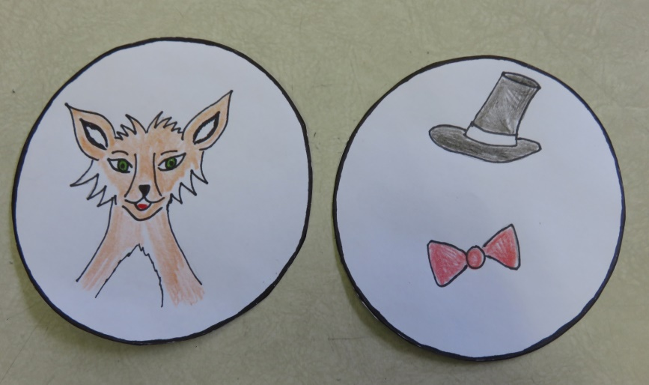
“Thaumatrope of the Fox from the Fable story of “”the Fox and the Crow”
Visual Arts skills

Competency #1: “Creates personal images”
• Uses ideas to create visual art that displays an illusion.
• Organizes visual arts production, choosing an idea they want to use and how they will organize it.
• Sharing their experience of creation of visual arts by discussing their thaumatrope with their peers.
• To produce individual and original works of art.
Competency #3: “Appreciates works of art”
• Enjoy the works of art, traditional artistic objects, media images, personal productions used in the narrative fables.
• Students will develop an appreciation for different types of art that are involved in the narration of fables.
• Students appreciate the works of other students as well as their own creation.

Learning Objectives
• Explore the use of motion and illusions in art.
• Acquire knowledge of how to incorporate optical illusions in an image
• Creates a thaumatrope which demonstrates an illusion and represents a fable story.
• Learning to combine two images to an illusion of a single image.
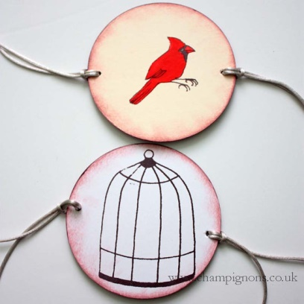
Cross-Curricular Competencies
- Uses Information:
- Uses fable stories as a source of inspiration when designing a thaumatrope.

- Solves Problems:
- Designing two images, that uses illusion and motion to give the perception of one single image.

- Displays Creativity:
- Creating a traumatrope that shows an original idea.

- Communicates well:
- Communicating their idea with the drawings and discussing with their peers how it relates to a fable story.
Adaptations for different Learners

For students who finish the project earlier they have a choice to make another thaumatrope, or finish their other art projects. They are also encouraged to help other students, especially students with special needs.

For students with disabilities the teacher may cut paper circles for them before the class. This student would be encouraged to ask questions and to seek help their friends and their teacher. They will also be given more time to complete the project.
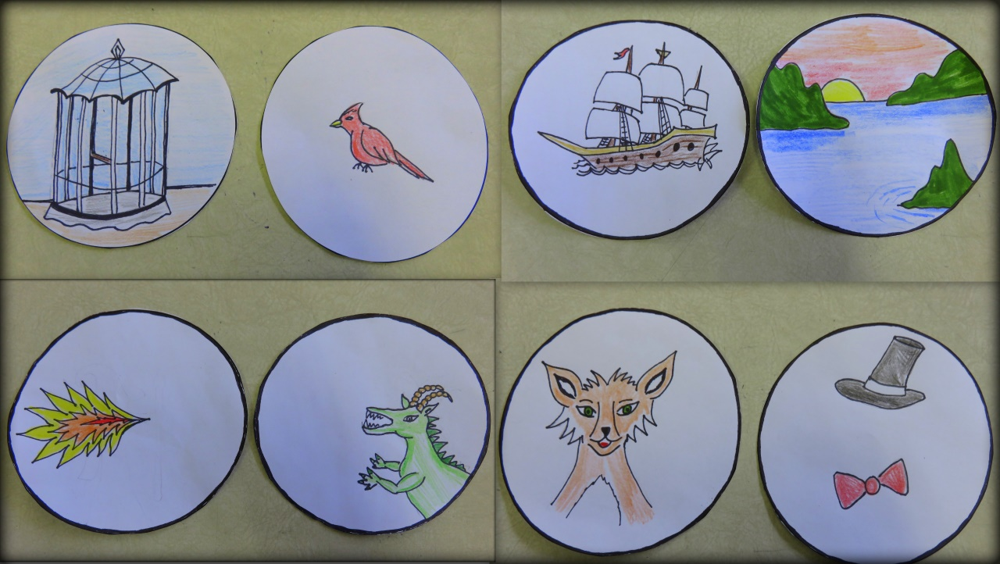
“Prototype thaumatropes that display a scene from a story”
Materials

For the educator:

• Project Prototypes: 5 examples different types of thaumatrope.
• PowerPoint presentation about illusions and thaumatrope.

For the students:

• Crayons or markers Colors
•Glue stick
• Wooden stick or straw
• Scissors
• Thaumatrope Template (two circles of the same cutting shape)
• Tape
Vocabulary

Fable: A short story, usually with animals as main characters, and teaches a moral.

Examples: The Crow and the Fox-The moral is, "Never trust a flatterer."

Story: An account of real or imaginary people and events told for entertainment.

Optical illusions (visual illusions):
• Are images perceived in a manner which differs from the reality.
• An illusion involving the human visual system (the eye to the brain).

Illusion a deceptive appearance recognized as a different perception of reality.

Motion: The design principles that deals with the creation of the action and movement.

Thaumatrope:

• A toy that was popular in the 19th century (Victorian era in England).
• A disc with a picture of each side is attached to two pieces of string.
• When the strings are twirled quickly between the fingers, the two images appear to merge into one because of the persistence of vision.
Lesson Process

Introduction: 10 minutes

- Give a PowerPoint presentation on optical illusions and thaumatrope.
- Have students create a thaumatrope with an idea based on a story or fable.
- Call each group one after another to get their materials.
Demonstration: 2-5 minutes

• The steps of the project have already been explained with the PowerPoint presentation.
• Show examples of the project (5 prototypes thaumatropes) for the students to play with to get a better idea of ​​how this works.
• Students will make a thaumatrope that:
1) Must be inspired by a story or fable
2) Must show a relationship between the 2 images

Work Time: 1 hour

• Call 2 volunteers to distribute sticks or straws and distribute a template sheet on which students will draw their thaumatrope.
• Students will work individually at their desks.
• If they finish early they have a choice to make a second thaumatrope, or work on other art projects.
Cleaning: 5 minutes

• Tell students when there is 5 minutes left before they start to clean.
• Remind students to recycle their paper and return the extra sticks or straws at the front of the class.
• Remind students to write their names on their thaumatrope stick or on a piece of tape that they will attach to their thauramtrope.

Closure: 5 minutes

• Ask students what is the definition of an optical illusion?
• Ask students to explain the story represented in their thaumatropes.
• Ask their opinions on the lesson.
• Tell students to share their thaumatropes with their friends and discuss their stories.
Steps Lesson

Step 1: Think of an idea for an optical illusion. In particular a story or fable with an animal.

Examples:

• A crow in a tree

• The Fox dressed like a human
• Fish and Aquarium
• Spider and web

Step 2: Cut out two circles from the template sheet which is where you will make your drawings.
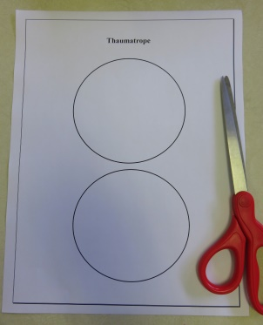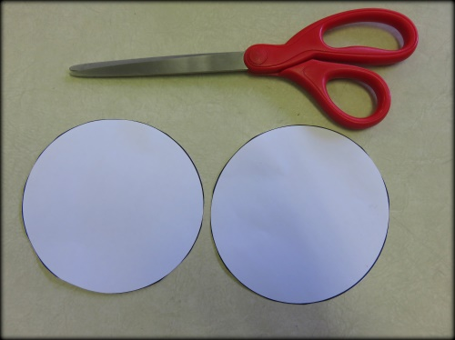
Step 3: Draw two different parts of your optical illusion in the circles.
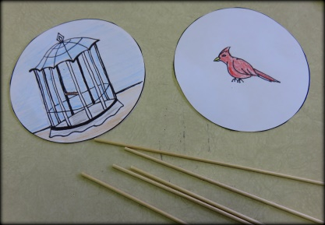
Step 4: Attach a straw or wooden stick to the back of one of your drawings using scotch tape.
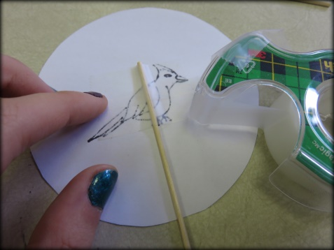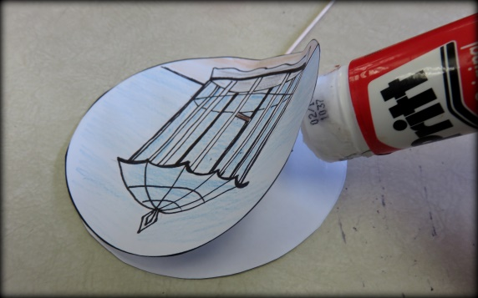
Step 5: Glue the other drawing on top of where you taped the stick.
Thaumatrope

Rubric for Evaluating Thaumatropes
Student Name:

Mark | 1 point | 2 points | 3 points
Project demonstrates care and effort | Project is messy, and shows little effort and planning | Project is neat, but could incorporate more detail and planning | Project is neat, detailed and well thought-out
Incorporates 2 images and demonstrates a good relationship between them to depict an optical illusion | Project is incomplete, lacks an image, and shows no relationship between images to depict an illusion | Project is incomplete, or lacks an image, and shows some relationship between images to depict an illusion | Project shows 2 clear images that blend well together to form an illusion of a single image
Represents a story or fable | Project has no relation to a story or fable. | Project somewhat relates to a fable story but needs to be more clear | Project clearly relates to a fable story by depicting a scene or character
Project demonstrates originality | Project is a copy of teacher’s porotype and shows little creativity | Project shows some originality | Project has original ideas and elements, and stands out compared to others

Total Points: /12

Comments:

References
Websites | How it helps the lesson
How to make your own thaumatrope http://thekidshouldseethis.com/post/17490881335 | A site that discusses the thaumatrope and how to build one.
Fancy Names & Fun Toys: http://www.mhs.ox.ac.uk/exhibits/fancy-names-and-fun-toys/thaumatropes/ | A useful website that talks about what a thaumatrope is and its history. It also provides ideas for other art forms that use motion and illusion.
Thaumatrope: http://courses.ncssm.edu/gallery/collections/toys/html/exhibit06.htm | Another site that describes the history and function of the thaumatrope.
Videos about the Thaumatrope:  https://www.youtube.com/watch?v=A_2TW5X4H6E  https://www.youtube.com/watch?v=yD0ovANHdqQ  https://www.youtube.com/watch?v=SivM3UVHMeg | Videos that provide examples of thaumatropes, how to make them, and how they look like with motion.

