Unit
Meaningful Images through
Stencil Art
“How can an image be meaningful and used to convey a powerful message to inspire positive change in the world?”

Art Educator: Cynthia Cousineau
School: John Grant Highschool
Grade Level: Cycle 2 Secondary (Grade 9-11)
Course: Visual Arts & Social Studies
Time Frame: 18 hour
Number of Lessons: 3

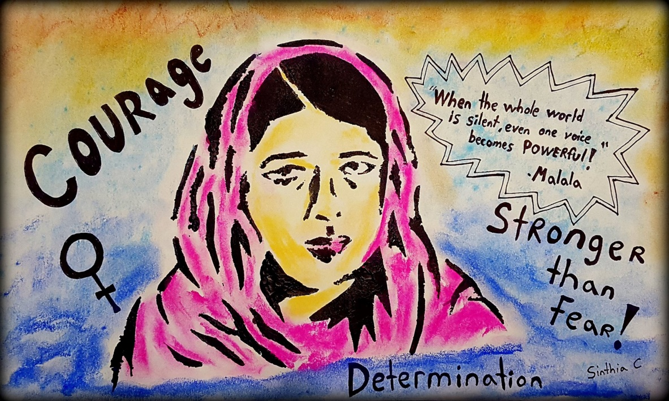
Prototype of Inspirational Activist Poster
Unit
Meaningful Images through
Stencil Art

Table of Contents:

Unit: Meaningful Images through Stencil Art 1
Table of contents 2
Unit Rational 3
Unit QEP Curriculum Competencies 4
Unit Lessons 5
Lesson 1 : Symbolic Tattoo 6
Lesson 2 : Symbolic Image Stencil …………………………………..19
Lesson 3: Inspirational Activist Poster Stencil 32
PowerPoint on Tattoo Art 47
Brainstorming Activity 1 51
Brainstorming Activity 2 52

Unit Rationale

Art is not just meant to be aesthetically pleasing to the eye, but it can also be used as a tool of self-expression to represent ones identity, to convey an important message and to inspire positive change in the world. This unit aims to inspire students to see the useful side of the world of art. To show them that through their artistic expression they could have a positive impact on the world by helping heal others around them, inspiring social change, and make the world a better place by raising awareness on major issues.
One of the main goals of this unit is to show students that an artist can also be an activist, hence the lessons in this unit mentions the works of famous artist activist such as street artist Banksy and illustrative artist Pawel Kuczynski. Through this lesson students will learn about various activist, such as Malala the young girl who was shot by the Taliban for standing up to women’s right to education. Another goal of this unit is to teach young people that they do indeed have power to make a difference.
The lessons in this unit will teach students various techniques for creating meaningful and symbolic images focusing primarily on stenciling techniques. They will produce designs of symbolic images, turn them into a tribal tattoo design and turn that into a stencil design to paint an image.
Unit Objectives
- To learn the technique of stenciling to create an image.
- To become familiar with street art techniques.
- To discover the meaning and symbolism behind images.
- To create images to inspire social or environmental change.
- To learn the transformative progression of a simple sketch towards the creation of a stencil poster, thus exploring different methods of evolving an image.
- To become familiar with activist art and activism.
Unit
QEP Curriculum Competencies
Visual Arts:
Competency 1: “Creates Personal Images”
- Students will draw their own ideas for a tattoo design creating a meaningful image that reflects an aspect of themselves.
- Students will seek inspiration from a word, animal or element that they find inspiring and meaningful to create an original design with symbolic value.
- Students will create their own stencils of their meaningful image.
- Students will also create a stencil of a powerful inspirational activist in the goal of communicating a message for change.

Competency 3: “Appreciate Images”
- Appreciate street art, tattoo art & activist art
- To appreciate the symbolism behind an image.
- To develop their own interpretation for the meaning behind an image.
- To see images as also serving a purpose rather than merely being aesthetically pleasing.
Appreciate the technique of stencil art and recognize its main artists. Example: Banksy.

Broad Areas of Learning
Environmental Awareness and Consumer Rights: This unit mentions the work of famous artist activists and environmentalists.
Citizenship and Community life: This unit inspires activism and improving the lives of the community.

Cross-Curricular Competencies
To use creativity: Students will develop an original idea for a symbolic image & stencil poster.
To construct their identity: Students will develop images that symbolize an important aspect of themselves and of a cause important to them.
To communicate appropriately: Students will produce art work with a clear symbolic meaning and message.
To use information: Students will be inspired by the work of famous activists and create an artwork that inspire the change that this activists attempts to bring awareness to.

Unit Lessons
Lesson 1: Exploring meaningful images through designing a symbolic tribal tattoo (5& ½ hrs.)
Summary:
- Analyzing the meaning of images related to modern society.
- Exploring Symbolism behind images by discussion on the history of tattoo art.
- Designing their tattoo idea for a symbolic image.
- Transferring that idea to a tribal style image and exploring different techniques for representing that idea.

Lesson 2: Symbolic Image Stencil (4 ½ hrs. to 5hrs)
Summary:
- Introduction to Street Art (20mins).
- Exploring how street artists have used murals to convey a message for environmental awareness (30mins)
- Using Banksy’s technique to create a stencil based on the tribal image they designed (3 hours)
- Applying paint to that stencil

Lesson 3: Inspirational Activist Poster Stencil (7½ hrs)
Summary:
- Introduction to the theme of activism with the story of Malala and viewing the works of street artist Banksy (30mins).
- Demonstration of Banksy’s stenciling technique (15mins).
- Discussion on how art has been used to change the world for the better (30mins).
- Picking an activist to research and draw a portrait of using the grid technique (3 hours).
- Making a stencil of the activist using tracing techniques to create an inspirational poster.

Lesson 1
Symbolic Tattoo
Design for Meaningful Image and Identity
“How can we create an image with powerful symbolic meaning that also represents our own identity?”
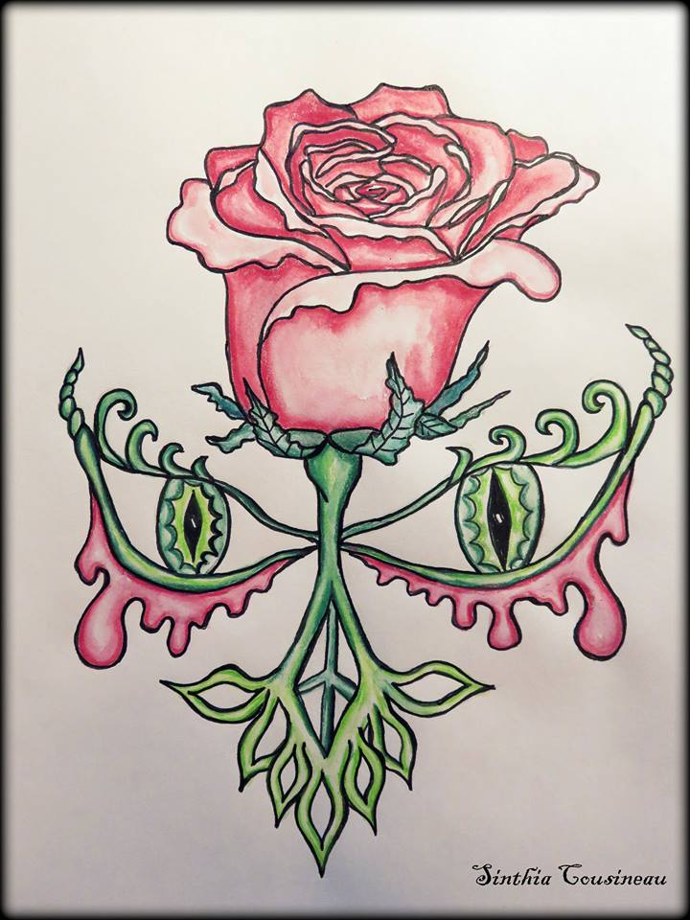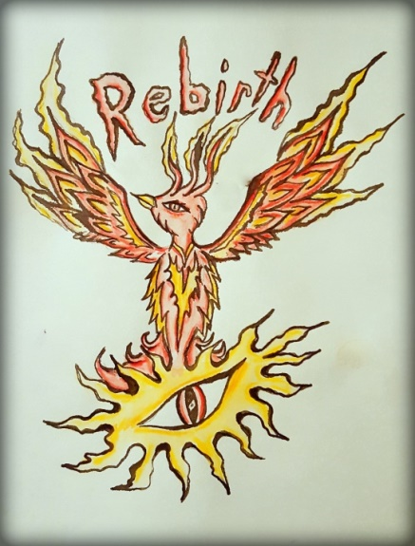
Prototypes Symbolic Tattoo

Main Objective
Design a meaningful image for a tattoo design which contains symbolic elements that represent your own identity.
Art Educator: Cynthia Cousineau
School: John Grant High School
Course: Visual arts & history
Grade Level: Cycle 2 Secondary
Time Frame: 5 hours

Rationale
An image can have a thousand words, and most images have a meaning behind them. This lesson will explore the concept of meaningful messages by exploring the history of tattoo art and how tattoos have always held various symbolic meaning. For example most tattoo images first began with spiritual meaning. They could also be used to help remember loved ones and to mark a certain status within a social group. Today the most common reason for why people get tattoos is as a means of communicating a symbolic message of their own identity. This lesson does not aim to encourage getting tattoos but rather how tattoo arts are known for their designs of images that hold high symbolic value. To each person an image could represent something unique. Through the use of symbolism an image can represent ones identity.
This lesson will focus on the creation of several meaningful images to represent a tattoo design reflecting one’s own identity using various symbolic elements. This lesson will focus also on the transformative process of drawing and the evolution of an image through the use of various techniques. By first designing an idea with a basic sketch, then applying calligraphy techniques to “ink” the drawing, and finishing by including values through watercolor painting students will produce an image that holds strong symbolic value to them. Then using this image student will explore the tribal drawing technique to transform their design into a tribal tattoo. This lesson is important for it shows that even a simple image could hold strong symbolic importance to a person and that they could be used as a valuable tool of showing a visual for one’s own identity.
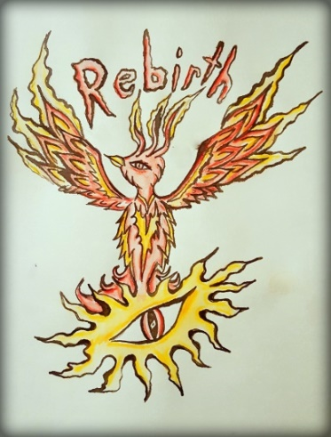
Symbolic Tattoo Design of symbolizing Inner strength through rebirth
Learning Objectives
- To understand the symbolism behind an image.
- Learn about the history of tattoos as a form of art.
- To learn how tattoo art can be used as a form of activism to heal people.
- To connect your identity with a symbolic image representing a meaningful aspect of yourself.

QEP Lesson Competencies

Visual Arts Competencies:

Competency 1: “Creates Personal Images”
- Students will draw their own ideas for a tattoo design creating a meaningful image that reflects an aspect of their identity.
- Students will seek inspiration from a word, animal or element that they find inspiring and meaningful to create an original design with symbolic value.
- Students will transform their symbolic image to an original tribal tattoo design.
- Students will develop several drawings using various techniques exploring an original idea for their drawings.
Competency 3: “Appreciate Images”
- Students will explore the meaning behind everyday images and examples of artworks that are meant to convey a message about today’s society.
- Student will gain a deeper appreciation for the symbolism used when creating an image.
- Students will gain knowledge of the history and purpose of tattoo art and acquire a deeper understanding of their symbolic value.
- Students will present their work and gain an appreciation the works of their peers’ trough a critique presentation.

Cross-Curricular Competencies
To use creativity: Students will develop an original idea for a tattoo as they explore different methods of representing their idea.
To construct their identity: Students will learn about how tattoos have been used to symbolize a person’s story, personality of values, and they will develop their own tattoo design for a meaningful image which represents their own identity.
To communicate appropriately: Students will produce artwork that clearly communicates a meaningful message about their identity using symbolic elements.
To use information: Students will use the knowledge they acquired from the discussion on the history of tattoo art and their various symbolic meaning to inspire the creation of their own tattoo design.

Diverse Learners

Visual Learners: They will have access to the prototype board, a visual PowerPoint of the steps of the project and an instruction sheet with images on them.

Auditory Learners: Recite the guidelines out loud twice; ask them to repeat the main steps of the project. Allow them to ask questions and when questions are asked the teacher will repeat the question before answer them.

Reading and writing learners: Provide written instruction to go along the visuals accompanying the PowerPoint Presentation and the instructional guideline handout. Provide students with brainstorming handouts and written quizzes to test their knowledge.
When giving oral instruction about lesson provide students with written instruction so they could read along.

Kinesthetic Learners: Allow students to physically engage with the materials by touching the tools and experimenting with them prior to the lesson.

Artwork to be created & evaluated
- Three ideas for a tattoo design in sketchbook.
- One ink & water color drawing of a tattoo design containing 2 symbolic elements and an element of nature with one word with an original font design.
- One final tribal design made using calligraphy ink.
- Practice sheet with hatching and cross-hatching techniques with ink.

Materials and Equipment

For Students

- Calligraphy Pen and nibs
- India Ink or other calligraphy ink
- Drawing pens
- Paper suitable for ink
- Watercolor paper
- HB pencils
- Water color pencils or paint
- Sketchbook
- Smudge stick
- Eraser or eraser pen

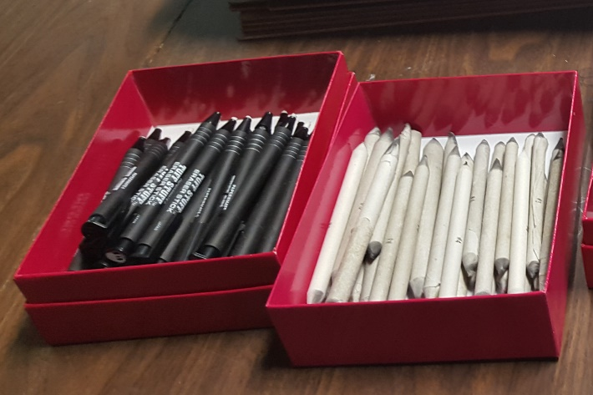

Teaching materials for Art Educator

- Prototype of a watercolor symbolic tattoo design
- PowerPoint on tattoo history
- PowerPoints on images with meaning
- Access to internet
- Computer
- Access to smartboard
- Prototype presentation board with the different steps of the project
- SMART Board

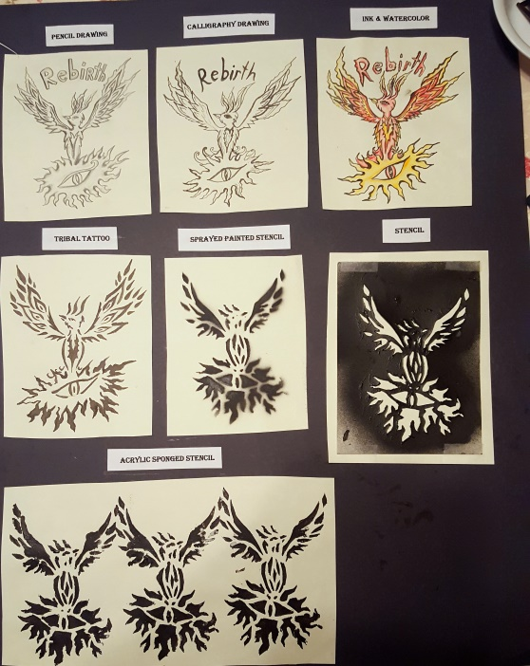

Lesson Sequence
Motivation to start lesson (35mins):
- Meaningful Images Discussion (15mins)
- What makes an image meaningful?
- What are examples of meaningful images in artwork?
- Present the works of activist artist Pawel Kuczynski and discus with students the meaning behind the images.
- Give students a Brainstorming worksheet like the one below this page.
- Show students prototype examples (5mins).
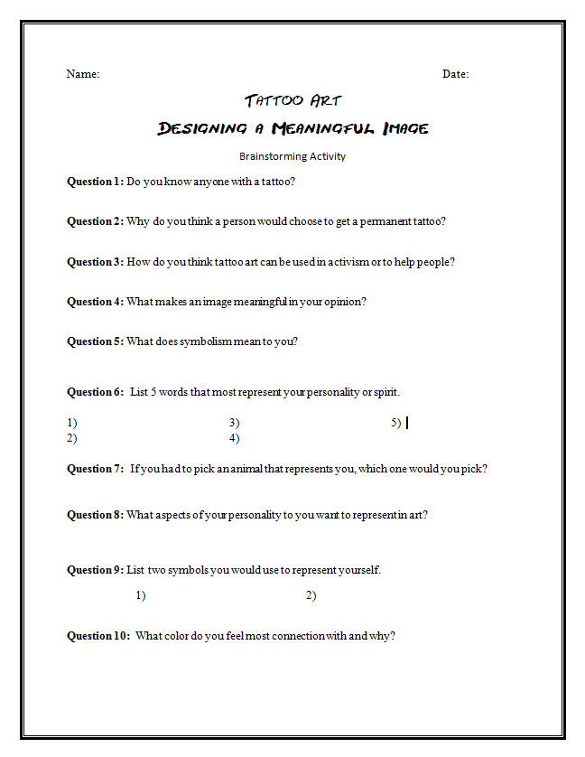
Meaningful Images Examples
Art works by Pawel Kuczynski
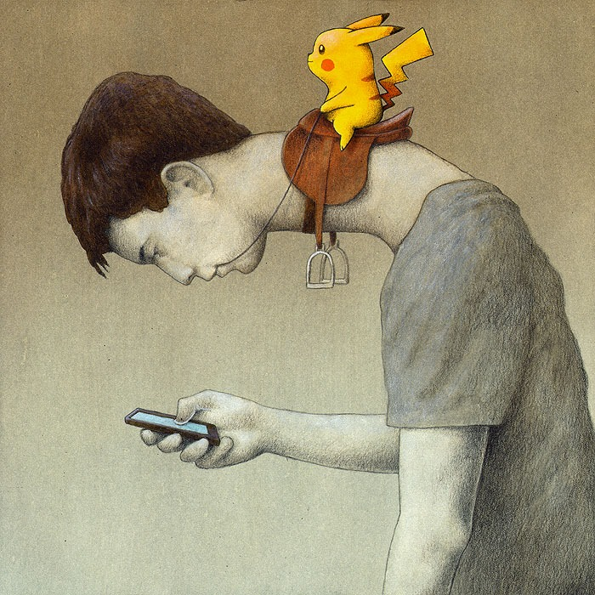
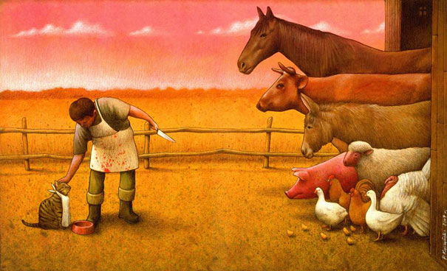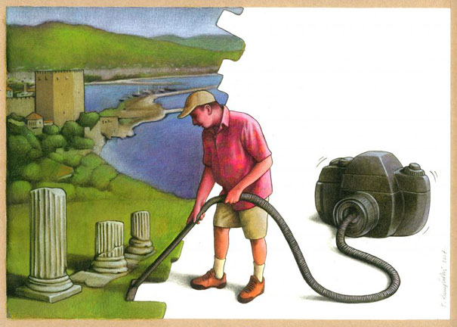
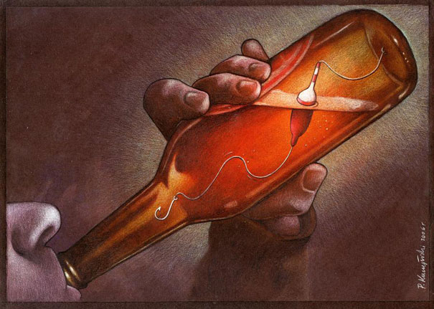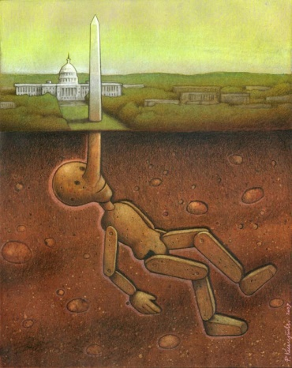
- Discussion & brainstorming questions on Tattoos & Symbolism (10 mins):
- Do you know anyone with a tattoo?
- Why do you think a person would choose to get a permanent tattoo?
- How do you think tattoo art can be used in activism or to help people?
- What does symbolism mean to you?
- Presentation on the history of tattoo art (15 mins):
Material Distribution (2mins) :
- Students will come select drawing material at the center of the table (pencils, calligraphy pens and nibs, watercolors etc.)
- India ink will be prepared before class by the art educator and distributed with the paper by the art educator.
Activity (4 & 1/2 hrs.)
Step 1: Fill out brainstorming sheet (20 mins)
Step 2: Using the brainstorming sheet as inspiration students will draw 3 designs for a tattoo in their sketchbook. This tattoo must contain 2 symbolic elements, and an element inspired by nature (1 hour).
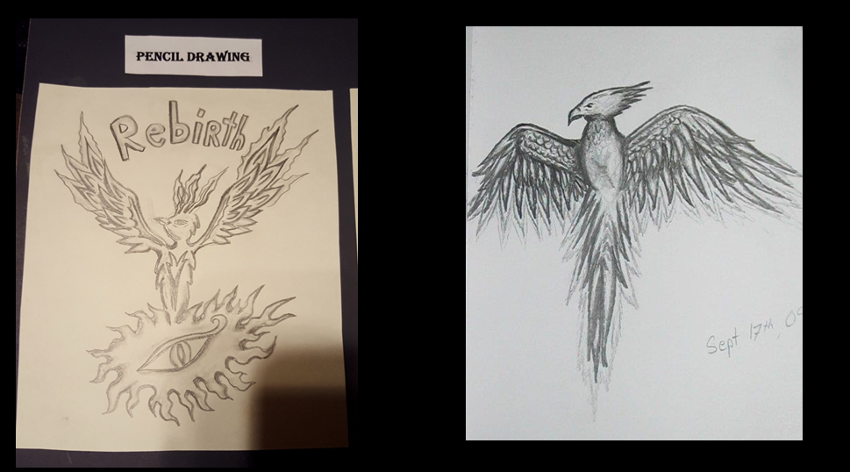

Step 3:
- Small demonstration of technique by art educator (5 mins).
- Students will practice making lines with calligraphy pens. They will represent hatching and cross-hatching techniques and the word to go with their tribal tattoo design (15mins).

Step 4: On a piece of water color paper students will select one of their previous 3 drawings and redraw one of the drawings using calligraphy ink. (1hr)
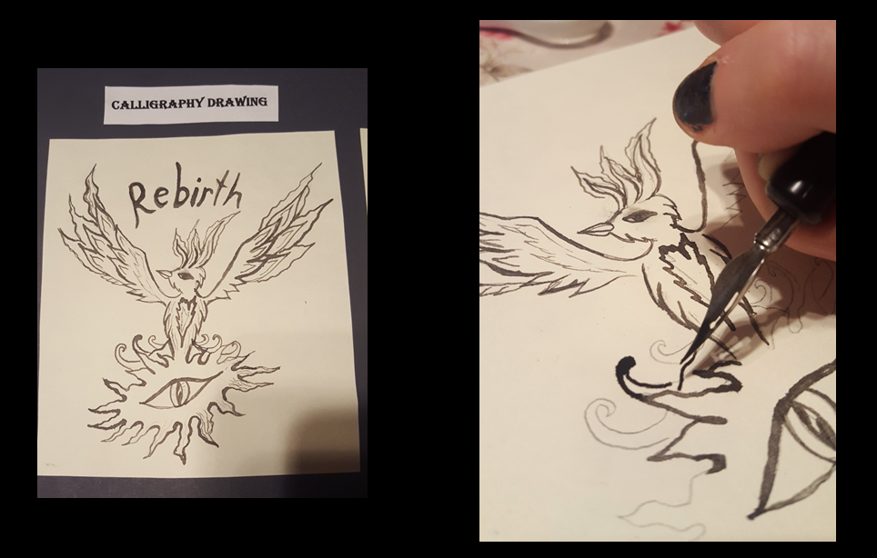
Step 5:
- There will be a small demonstration on how to blend water colors to form values (5mins).
- Once ink drawing is dry, students will apply watercolor to that drawing to create more value. While they wait for ink to dry it to dry they can practice their water coloring on small strips of paper. (1hr.).
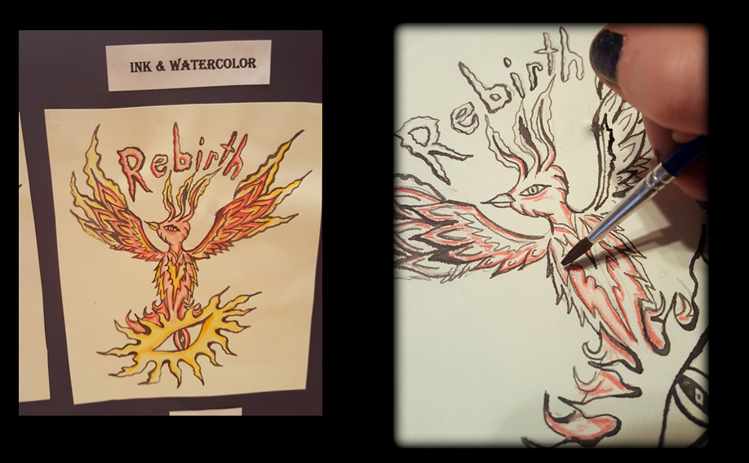
Step 6: Students will be given another piece of paper on which to design their tribal tattoo based on their previous design. They will use calligraphy ink to design their tribal tattoo (1hr).
Note: For special needs groups they would use black sharpies instead of calligraphy ink
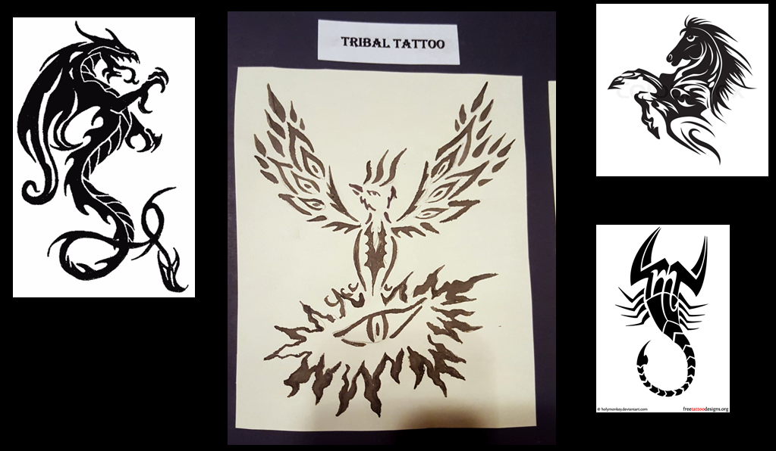
Cleanup (5mins)
- Students will be asked to sign their work.
- Students will put away all drawing materials and calligraphy ink.
- One person for each table is responsible to ensure that everyone in their table participates in the cleanup process and that there table is clean.
- All materials will be returned to the table in the front of the classroom.

Closure (15mins):
- Students will submit their watercolor and tribal tattoo designs.
- These drawings will be display on the wall.
- Teacher will ask students which part of the designing process they most enjoyed.
- All students will take one minute to talk about their artwork in front of the class.
- Teacher will ask students to explain to the class why their image is meaningful.
- Teacher will inform students that the next lesson involves transforming the tribal tattoo design made in lesson one, and students will be given a brainstorming sheet for lesson 2.

Vocabulary
Calligraphy: the art of producing decorative handwriting or lettering with a pen or brush.
Cross Hatching: Crosshatching is an extension of hatching, which uses is the use of fine parallel lines drawn closely together, to create the illusion of shade or texture in a drawing. Crosshatching is the drawing of two layers of hatching at right-angles to create a mesh-like pattern.
Inking: A drawing technique involving the use of black and other colored inks which are applied to a support (generally paper) with either a dip pen or a reservoir pen.
Hatching: an artistic technique used to create tonal or shading effects by drawing (or painting or scribing) closely spaced parallel lines.
Imagery: The use of expressive or evocative images in art.
Line: a long, narrow mark or band.
Pen Nibs: End points of calligraphy pens used for writing or drawing, different sizes and styles.
Pigment: Substance used as coloring. 2. Dry coloring matter, usually an insoluble powder, to be mixed with water, oil, or another base to produce paint and similar products.
Symbolism: the use of symbols to represent ideas or qualities. An artistic and poetic movement or style using symbolic images and indirect suggestion to express mystical ideas, emotions, and states of mind.
Tattoo: form of body modification, made by inserting ink, either indelible or temporary, into the dermis layer of the skin to change the pigment.
Tribal Tattoo: Tattoo designs that originated from Polynesian Islands which are characterized by Often identified by their curved lines, points and decorative patterns which are divided into parts that do not touch each other. Generally symbolizes something often an element of nature.
Value Scale: A scale that shows the range of values from lightest to darkest
Backup Activity
- Free drawing in their sketchbook or reading book on tattoo art
- Designing another tattoo idea in their sketchbook
- Cleaning up classroom and helping organize materials.
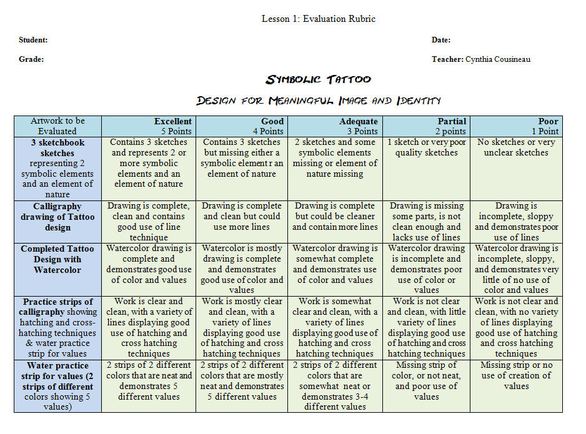

Teaching Resources
Websites:
- Meaningful Images: https://www.quora.com/What-are-some-pictures-without-text-with-deep-meaning-s
- Artist Activist Pawel Kuczynski: http://www.trueactivist.com/this-activists-artwork-speaks-volumes-about-present-day-society-must-see/4
- Airbrush Artist Applies Temporary Tattoos onto Sick Kids to Boost Their Self Esteem: http://mymodernmet.com/benjamin-lloyd-airbush-tattoos
Videos:
- Tattoo Artist Helps Victims of Domestic Violence and Self-Harm Reclaim Their Bodies: https://www.youtube.com/watch?v=TFkyGgC3FNs
- Tattoo Artists Cover Breast Cancer Survivors’ Scars With Beautiful Tattoos: https://www.youtube.com/watch?v=_OcXNn2emE0
- The Nipple Artist | The New York Times (6mins): https://www.youtube.com/watch?v=Egq2qnnXSPY
- Tattoos Help Breast Cancer Survivors Reclaim Their Lives After Mastectomy: https://www.youtube.com/watch?v=58eEF1GYl5M

Lesson 2
Symbolic Image
Stencils
“How can we transfer a drawing into a stencil that represents a symbolic idea?”
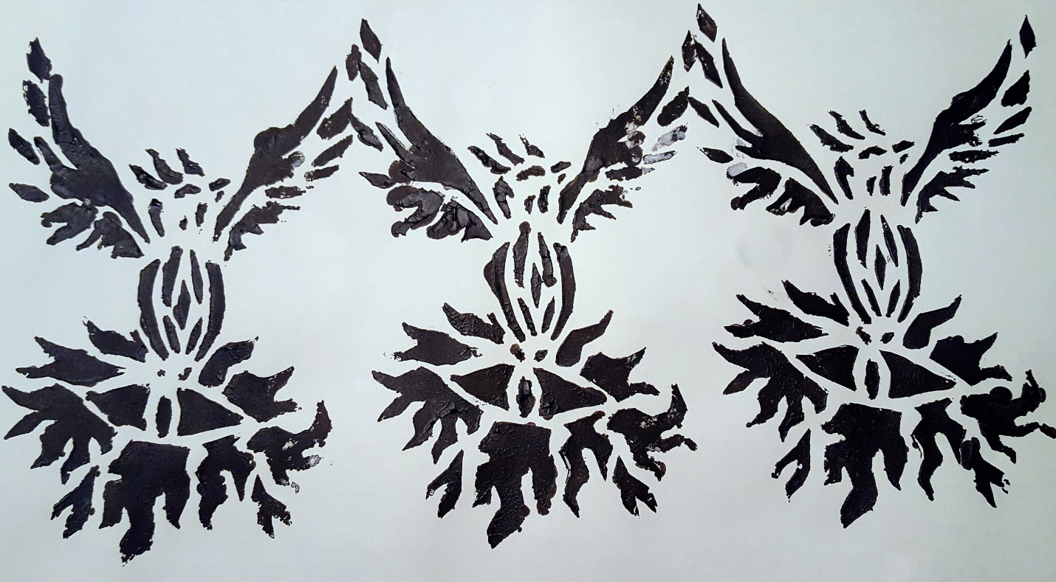
Prototype of Symbolic Phoenix Tribal-style Stencil
Main Objective
To create a single shaped stencil inspired by nature and a complex multi-shaped stencil inspired by a design of a tribal tattoo.

Art Educator: Cynthia Cousineau
School: John Grant High School
Course: Visual arts & history
Grade Level: Cycle 2 Secondary
Time Frame: 5 hours

Rationale
Creating artworks through stencil making is a very popular technique for representing an image. This technique began 35,000 years ago in Asia and Europe. The technique of stenciling has served many purposes in history. Stencils have been used in prehistoric painting, to color clothe, for book illustrations, wallpaper to label objects and for graffiti. This technique remains very popular with street artists like Sheperd Fairey and Banksy.
Students will explore the theme of meaningful images and symbolism through the creation of stencils that will evolve their tattoo designs to the next level. This lesson is important towards teaching students the progressive process of art and various techniques for representing an image.
Through this lesson students will learn about eco artists who used symbolism in their work to promote environmental awareness, and they will create an stencil that relates to the theme of the environment and nature. They will also create more complex stencils to represent their own identity by evolving their meaningful image.
Learning Objectives
- To learn about negative and positive space in order to create a stencil.
- To become familiar with stencil are by creating single-shaped and complex-shaped stencils.
- To involve a tribal style drawing into a stencil design
- To represent symbolic elements of nature and identity through making images with stencils

Artwork to be created & evaluated
- A single shaped stencil representing nature on acetate
- A complex multi-shaped self-identity stencil on cardboard
- Two separate paintings representing both these stencils through different ways of applying paint.
QEP Lesson Competencies

Visual Arts Competencies:

Competency 1: “Creates Personal Images”
- Students will create several stencils.
- Students will explore different techniques of making a stencil through the use of various materials and methods.
- .Students will design an image that relates to the environment and nature.
- Students will create an original image that is meaningful to represent their own identity.
Competency 3: “Appreciate Images”
- Students will appreciate the works of stencil artists like Shepard Fairey and Banksy.
- Students will become more knowledgeable about stencil art and the methods of creating stencils.
- Students will be more observant at detecting the use stencils in their everyday lives. For example: the wall papers of their room.
- Students will learn about how stencils could be used to raise awareness of an important message.

Cross-Curricular Competencies
To use creativity: Students will develop an original idea for a meaningful image as they explore different methods of representing their idea through stencil art.
To construct their identity: Students will design an image that represents their own identity through stencil art.
To communicate appropriately: Students will produce artwork that clearly communicates a meaningful message about their identity using symbolic elements and clearly represent an element of nature.
To use information: Students will learn from observation and videos how to create a stencil and apply that information when making their own stencils.

Materials
materials for Students

- Exacto knife or knife pen or scissors
- Cutting board or cardboard to cut on
- Black sharpie
- Acetate sheets
- Cardboard sheets
- HB pencils
- Guideline paper with instructions for project
- Their drawings of a tattoo design
- Water-Acrylic paint mix in a spray bottle
- Sheets of paper for acrylic

Teaching materials for Art Educator

- Access to a smartboard and computer
- PowerPoint presentation on the steps of the project
- Porotype explanation board
- Examples of the prototype at different steps

Diverse Learners

Visual Learners: They will have access to the prototype board, a visual PowerPoint of the steps of the project and an instruction sheet with images on them.

Auditory Learners: Recite the guidelines out loud twice; ask them to repeat the main steps of the project. Allow them to ask questions and when questions are asked the teacher will repeat the question before answer them.

Reading and writing learners: Provide written instruction to go along the visuals accompanying the PowerPoint Presentation and the instructional guideline handout. Provide students with brainstorming handouts and written quizzes to test their knowledge.
When giving oral instruction about lesson provide students with written instruction so they could read along.

Kinesthetic Learners: Allow students to physically engage with the materials by touching the tools and experimenting with them prior to the lesson

Coded learners or students with cognitive disabilities: Allow them to design a simpler stencil with less complex shapes, just as a one shaped symmetrical stencil. Give them paper instead of cardboard to make it easier to cut. Instead of an exacto knife give them ball-point pens to use to cut through the paper by applying pressure.

Vocabulary
Critique: evaluating someone’s art work, discussion of art work
Contour: outline of a shape, type of drawing style
Contrast :difference, usually a difference between light and dark
Ecological art (eco art): Artwork created by an artist concerned with the state of our environment.
Graphic Design: the art or skill of combining text and pictures in advertisements, magazines, or books.
Negative Space: the space around and between the subject(s) of an image. Negative space may be most evident when the space around a subject, not the subject itself, forms an interesting or artistically relevant shape, and such space occasionally is used to artistic effect as the "real" subject of an image.
Positive Space: the space an object takes up.
Stencil: A thin sheet of material, such as paper, plastic, wood or metal, with letters or a design cut from it, used to produce the letters or design on an underlying surface by applying pigment through the cut-out holes in the material.
Symmetry: Equal balance on either side of a point

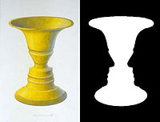
Negative vs Positive Space

Lesson Sequence

Introduction (10 mins)
Introduce the topic of stencil art with discussion:
- What is a stencil?
- What can you make with a stencil?
- What are some famous artists who use stencils?
- In what ways are stencils useful?

Motivation (15mins)
- Show prototypes of lesson at different steps.
- Demonstrate how to cut a stencil and show a video on how to create simple stencils
- Show videos on street artist who create works to promote environmental awareness and tell students they will create a symmetrical stencil inspired by the environment and nature.
- Show works of street artists, mention Banksy.

Material Distribution (5 mins)
- Teacher will prepare each’s students desk with a cutting board.
- Once lesson is explained and student know what is expected of them they will be given the acetate paper and cardboard to do their stencils. They will also be given an exacto knife and expected to return it before leaving the class.
- Drawing materials will be on a table in the front of the class for students to borrow.
Activity
Part 1: Simple one shaped symmetrical stencil on acetate.
(40-60 mins)
Step 1: Drawing a design that is inspired by nature and symmetrical. It has to be a one shaped design.
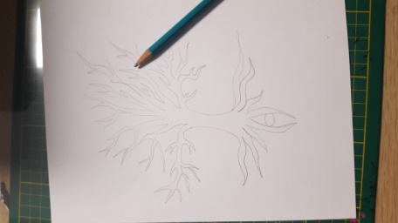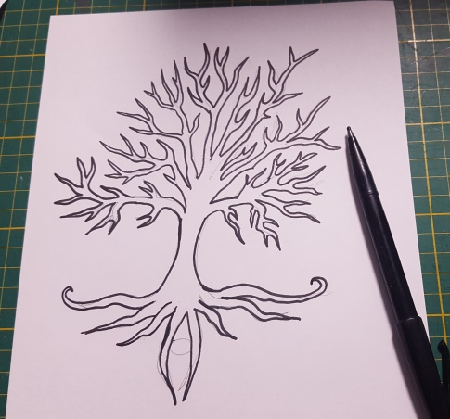
Step 2: Redrawing their idea on acetate with a black sharpie by tracing over the original image
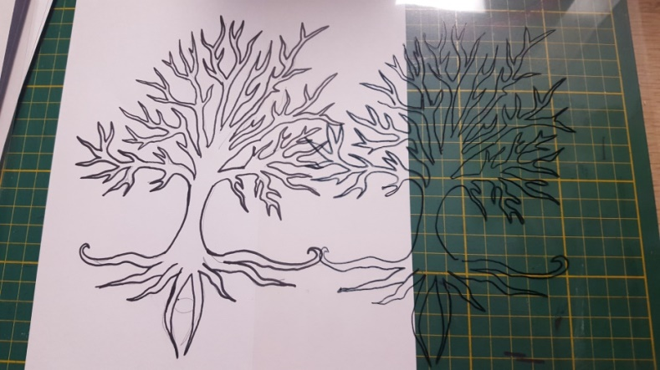
Step 3: Cutting out the stencil using scissors or an exacto knife and then placing tape on the stencil to fix the incision where the original cut began.
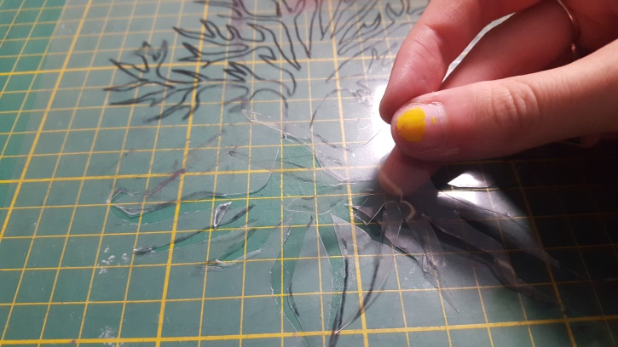
Step 4: Place the stencil over a piece of paper and using a sponge dabbed in acrylic paint, paint over the stencil. When painting, mix two different colors of paint, make 3 different copies of the image.
Part 2
The complex multi-shaped tribal stencil (2 & 1/2 hrs.)
Step 1: Using your tribal tattoo design from lesson 1, redrew or trace the tribal tattoo on a piece of white cardboard.
Step 2: Use a sharpie to fill in the positive space of the image.
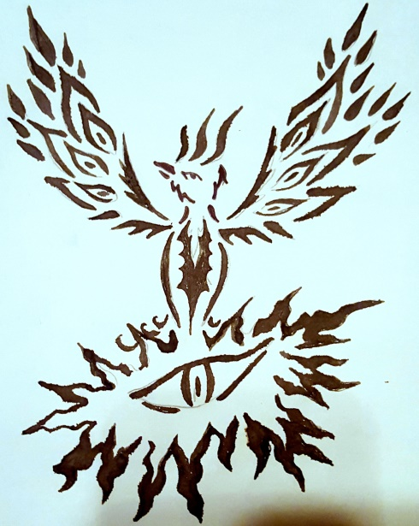
Step 3: Place the cardboard on a cutting board and use an exacto knife to carve out the part of the image filled in with the black sharpie.
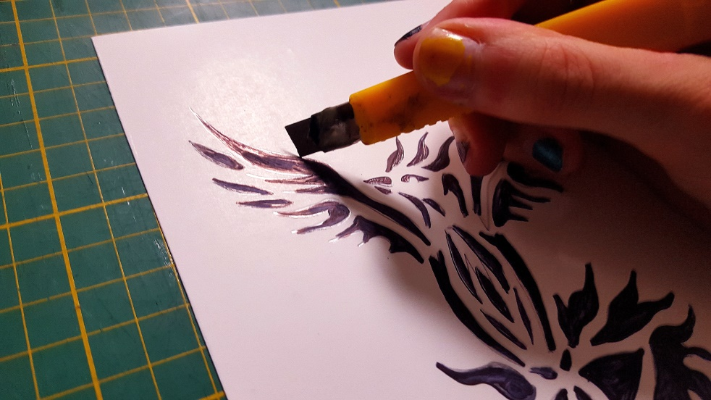
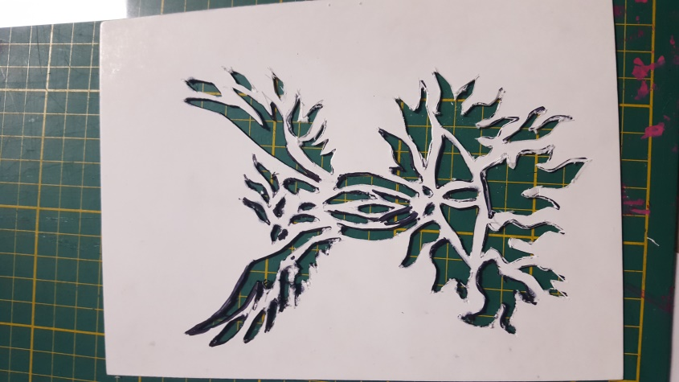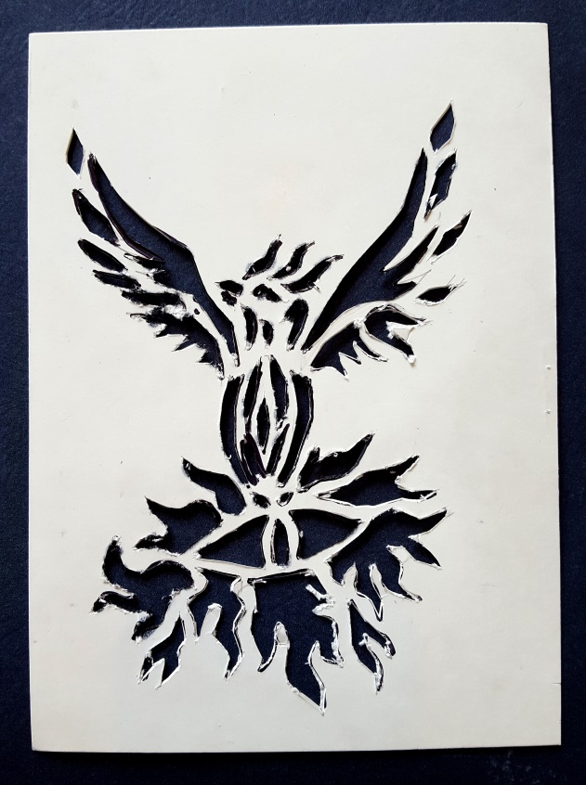
Step 4: After making sure that all the liens are neatly cut, place the stencil over a piece of paper and spray paint it using the mixture of water and acrylic paint in the spray bottles. Make three copies of the image using different colors.
Step 5: Place of the drying rack to dry
Backup Activity
- Free drawing in their sketchbook or reading book on stencil art
- Designing a stencil for a word which closely relates to their own identity that could be incorporated with their painting or adding a pastel background to the dried stencil paintings.
- Cleaning up classroom and helping organize materials.

Cleanup (10mins)
- Students will be told 10 mins before the bell that they need to start cleaning up their materials.
- Students are expected to return the exacto knifes and cutting boards to the front of the class and any other material they borrowed.
- One student per table group is expected to make sure that their teammates all contribute to the cleanup.
- Students who finish early can start cleaning up the classroom.

Closure (10 mins)
- Ask students if they enjoyed the lesson what they found challenging and what they most liked about it.
- Student works will be displayed on the wall for them to admire.
- If many students finish early the class could engage in a critique on each other’s work.

Project Prototypes
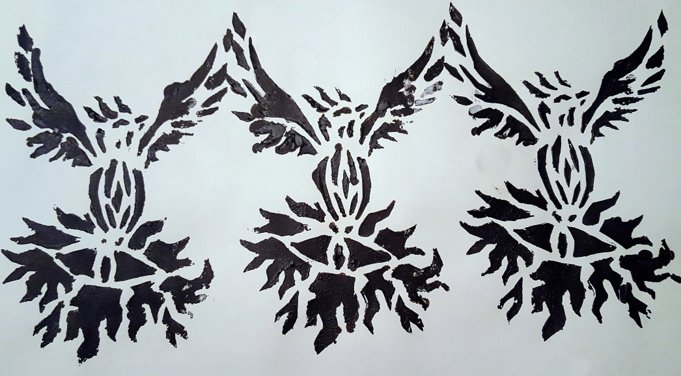
Three copies of the stencil using black acrylic paint, however for this project students will use a variety of colored paints
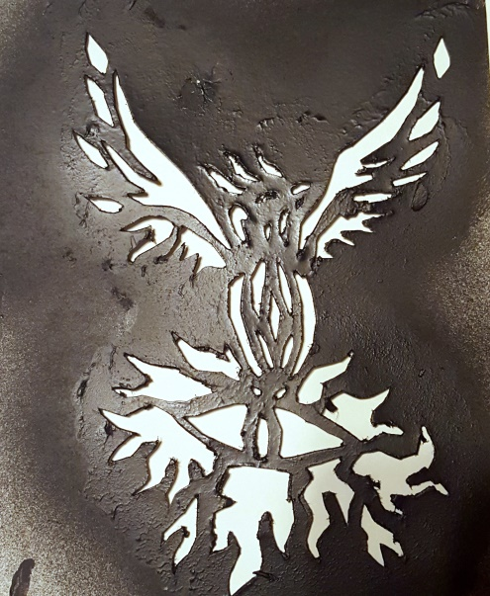
Stencil after application of paint

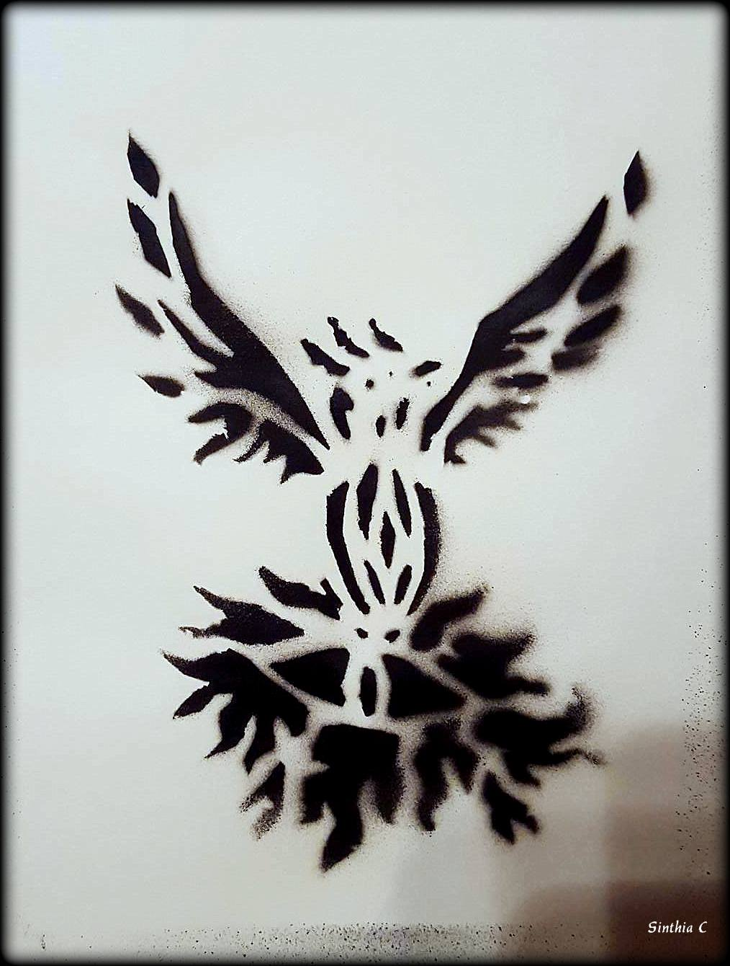
Example of stencil with application of real spray paint

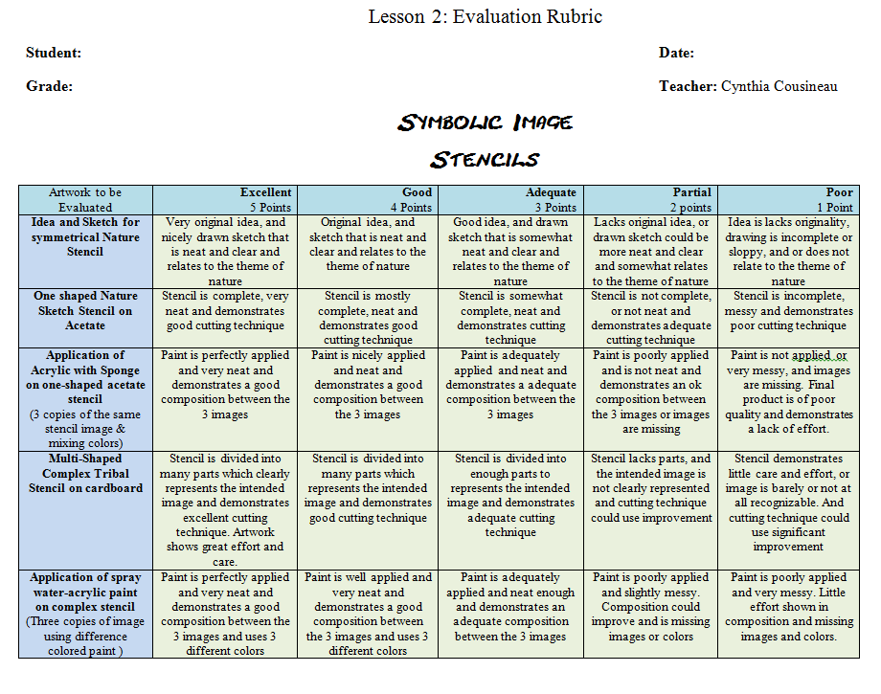
Teaching Resources
Making a simple stencil:
- https://www.youtube.com/watch?v=BzQ38ER3aSg
- https://www.youtube.com/watch?v=yHsojM5d5no
Creative Street Art: https://www.youtube.com/watch?v=2PaPNWVQcco
Environmental Awareness:
- Man vs Earth (6mins): https://www.youtube.com/watch?v=VrzbRZn5Ed4
- Artist: Bordalo II and environmental awareness: From trash to art (4:30mins): https://www.youtube.com/watch?v=qSJEuF7OYhU&list=PLYo23ehe8h36GSzI_9YSJP5ixuyhQdT-8&index=22

Lesson 3
Street Art & Stenciling
The Inspirational Activist Poster
Question of Inquiry
“Street art has often served to promote awareness about social, political and environmental issues, therefore how could we create an art work inspired by street art to promote activism?”
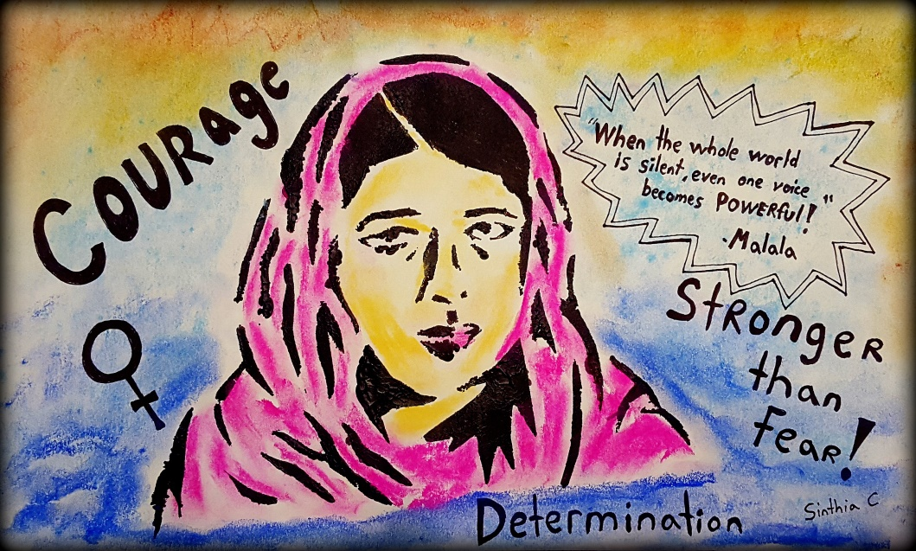
Project Prototype Poster
Main Objective
- To create images which inspire social change by representing an activist through the creation of a stencil, inspired by the famous street Banksy.

Art Educator: Cynthia Cousineau
School: John Grant High School
Course: Visual arts & history
Grade Level: Cycle 2 Secondary
Time Frame: 7 hours

Rationale
Street art is a popular trend in urban environments which consists of visual artworks created within a public location. These artworks are produced outside of traditional art venues such as the typical art museum, and are feathered outside on public buildings. This artistic movement began its popularity in the 1980s.
Street art consists of graffiti, sticker art, warn bombing and stenciling. Other names for street art can be “urban art” or “guerrilla art”. Spray paint art is not considered to be vandalism or territorial graffiti if it is created by an artist that aims to communicate a message directly with the public. Street artists are often known to show works that present socially relevant messages mixed with esthetic value.
This lesson will focus on the artworks of famous street artists such as Banksy, Shepard Fairey, and Bordalo II all of whom are also well-known activists who address important social or environmental issues. This lesson will teach students about the technique of stenciling and how they can create images that invoke awareness of a key social issue. It relates to the theme of this unit, which is activism, for it will allow students to see that they can use art to unable positive change in this world by bringing to light important issues.
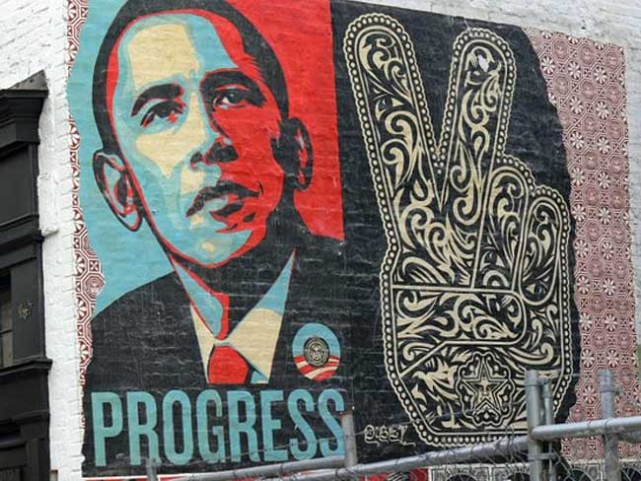
Street art by Sheperd Fairey
Inspiring Artists for Project
Shepard Fairley, Invader & Banksy

QEP Lesson Competencies

Visual Arts Competencies:

Competency 1: “Creates Personal Images”
- Students will create several stencil images representing an activist of their choice.
- Students will explore different techniques of making a stencil through the use of various materials and methods. They will also explore techniques involved in tracing an image
- .Students will design an image that aims to inspire activism.
- Students will create an original image that is meaningful and represents a cause they support.
Competency 3: “Appreciate Images”
- Students will appreciate the works of stencil artists and activists like Shepard Fairey and Banksy.
- Students will become more knowledgeable about stencil art and the methods of creating stencils and how these can be used in activism to represent social, environmental or political issues.
- Students will be more observant at detecting the use stencils in their everyday lives. For example: the wall papers of their room.
- Students will appreciate and discus the works of their peers.

Cross-Curricular Competencies
To use creativity: Students will develop an original idea for a meaningful image for representing an activist as they explore different methods of representing their idea through stencil art.
To construct their identity: Students will design an image that represents their own identity through stencil art by creating an image that brings awareness to a cause important to them.
To communicate appropriately: Students will produce artwork that clearly communicates a meaningful message about their identity using symbolic elements and clearly represent an element of nature.
To use information: Students will learn from observation and videos how to create a stencil and apply that information when making their own stencils. They will research their activists and use the knowledge they gain from that research to make their posters more inspiring.

Materials & Equipment

Teaching Materials for Art Educator:
- PowerPoint presentation
- Project Prototype & link to prototype video on the Malala Stencil
- Access to a smartboard & Computer
- Guideline of assignment to distribute to class
- Images of activists for class to pick from

For Students:

- Brainstorming Activity
- Cutting board
- Exacto knife
- Pencil
- Black Sharpie
- White Cardboard
- Tracing paper
- Charcoal or graphite stick
- Black acrylic paint
- Sponges for applying acrylic paint
- Container to hold acrylic paint

Diverse Learners

- Visual Learners: They will have access to the prototype board, a visual PowerPoint of the steps of the project and an instruction sheet with images on them.

- Auditory Learners: Recite the guidelines out loud twice; ask them to repeat the main steps of the project. Allow them to ask questions and when questions are asked the teacher will repeat the question before answer them.

- Reading and writing learners: Provide written instruction to go along the visuals accompanying the PowerPoint Presentation and the instructional guideline handout. Provide students with brainstorming handouts and written quizzes to test their knowledge. When giving oral instruction about lesson provide students with written instruction so they could read along.

- Kinesthetic Learners: Allow students to physically engage with the materials by touching the tools and experimenting with them prior to the lesson.

- Coded learners or students with cognitive disabilities: Allow them to design a simpler stencil with less complex shapes, just as a one shaped symmetrical stencil. Give them paper instead of cardboard to make it easier to cut. Instead of an exacto knife give them ball-point pens to use to cut through the paper by applying pressure.
Lesson Sequence
Introduction (20 mins):
- Fill out Brainstorming activity.
- Discussion: What is an artist, and the purpose of art?
- What is street art?
- Is street art Vandalism?
- How can art, in particular street art be used to make the world better?

Motivation (30mins):
Intro to Activism Art:
Possible videos:
- Video: Make good art: https://www.youtube.com/watch?v=OiO586RmgBk
- Video to encourage living life and taking risks and following your dreams:
Why most people die before age 25 (4 mins): https://www.youtube.com/watch?v=oKAmujgS4mo
- Activism and changing the world:
Things in the world that activists aim to change: Video (9mins) “The Lie we Live”: https://www.youtube.com/watch?v=ipe6CMvW0Dg

Intro to street Art:
The Questions we never ask (5mins): https://www.youtube.com/watch?v=e6N_LlNQQ5Y
- Artist: Shepard Fairey & anti-war activism:
Videos activist street artists: https://www.youtube.com/watch?v=9QrKhZ6aF_g&list=PLYo23ehe8h36GSzI_9YSJP5ixuyhQdT-8&index=30
https://www.youtube.com/watch?v=8_8_rk4cRj4&list=PLYo23ehe8h36GSzI_9YSJP5ixuyhQdT-8&index=31
- Palestinian refuge & empowering women: https://www.youtube.com/watch?v=SUHkKwCoxEo
Introduce Prototypes of Project
Material Distribution (5mins)
- Students will bring their own information gathered on the activist that inspires them.
- Cutting boards will be prepared by art educator prior to the lesson so when students walk in the classroom each seat will have its own board.
- Exacto knives will be handed out after the lesson is explained and they will also be returned to the teacher before the end of the lesson.
- All other materials will be located on the material table in the front of the classroom.

Demonstration (10mins)
- Show the how to make a Malala stencil video
- An actual demonstration will be down by the art educator for the creation of a grid and for showing students how to trace an image using charcoal.

Activity
Day 1: Introduction to Activism Image Project (1.15hrs)
- Discuss the term activism (5 mins)
- Show videos on Malala, the young teenage activist who fought for women’s right to education:
- He Named Me Malala Official Trailer 1 (2015) - Documentary HD: (3 mins)
- https://www.youtube.com/watch?v=vE5gSHJkusU
- He Named Me Malala I Opening Animation | FOX Home Entertainment: (2 mins) https://www.youtube.com/watch?v=PS-572B4HUs
- Malala's story - BBC News: https://www.youtube.com/watch?v=FnloKzEAX7o (3 mins)
- Diane Sawyer Sits Down With the Inspirational Malala Yousafzai: https://www.youtube.com/watch?v=ev-jPT5M9cU
- Show prototype of the inspirational activist stencil poster (Example: Malala)
- Tell students that for their project they will research and pick a famous activist to inspire their stencil art.

Examples of Activists:

- Women’s Right Movement
- Black Lives Matter Movement
- PrayForParis (JeSuisCharlie)
- Worldwide Refugee Crisis
- Rosa Parks
- Martin Luther King Jr.
- Wangari Maathai
- Malala

Day 1(1 hr.):
Step 1: Tracing an image of Malala or an activist of their choice with tracing paper. Select one of the following images
Step 2: Flip the tracing paper over, and using a piece of compressed charcoal redraw over the previously traced lines of Malala or other activist. Then flip the tracing paper and using a pencil retrace over the original liens you traced while playing the tracing paper over a white cardboard paper.
Step 3: Use a black sharpie to draw over the lines on the cardboard, and create the different parts of the stencil
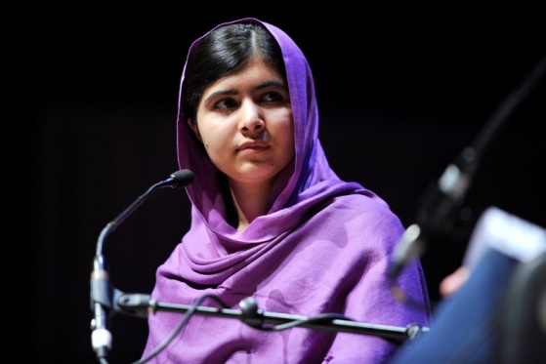
Optional Activity: Applying the Grid technique (2 hrs.)

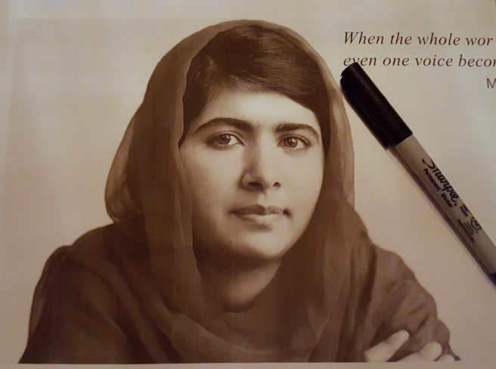
Day 2: Making the activist Stencil (2 hrs.)
- Using the cardboard with the traced image of Malala
- Show YouTube video of how to make the Malala stencil (4 mins)
https://www.youtube.com/watch?v=i6g8DeZ1p_E&feature=youtu.be
- Follow the steps shown on the video for tracing and coping an image

Day 3: Finishing the stencil and applying paint and words. Make several copies of the stencil. (2hrs)
Day 4: Decorating the dry stencil with pastel, adding inspirational words and symbols with black sharpie. Displaying the finished artworks on the wall (1hr.).
Cleanup (10 mins)
- Students will be told 10 mins before the bell that they need to start cleaning up their materials.
- Students are expected to return the exacto knifes and cutting boards to the front of the class and any other material they borrowed.
- One student per table group is expected to make sure that their teammates all contribute to the cleanup.
- Students who finish early can start cleaning up the classroom.

Closure (15 mins)
- Ask students if they enjoyed the lesson what they found challenging and what they most liked about it.
- Student works will be displayed on the wall for them to admire.
- Class critique of student work with feedback from teacher.
- If many students finish early the class could engage in a critique on each other’s work.
- Each student will talk about why they chose that particular activist and what the activist fights for.

Vocabulary
Activist: A person who campaigns for some kind of social change. Someone who's actively involved in a protest or a political or social cause.
Activist art: a term used to describe art that is grounded in the act of ‘doing’ and addresses political or social issues
Banksy: An artist from the UK, a known graffiti artist, political activist and painter. Creator of many satirical street art combining dark humour with graffiti.
Graffiti: Writing or drawings scribbled, scratched, or sprayed illegally on a wall or other surface in a public place.
Grid: a scale of squares that are used to enlarge an image for drawing or painting
Installation: Any type of 3D sculpture put on the street. Example: Space Invader
Monochromatic: Using only one color.
Murals: is any piece of artwork painted or applied directly on a wall
Propaganda: information, ideas, or rumors deliberately spread widely to help or harm a person, group, movement, institution, nation, etc.
Protest art: is a broad term that refers to creative works that concern or are produced by activists and social movements.
Stencil: tool that is traced to make a shape or letters, can be used with different drawing
or painting media
Street Art: Street art is any visual art developed in public spaces - that is, "in the streets". Art done with permission.
Vandalism: action or art involving deliberate destruction of damage to public or private property
Prototypes
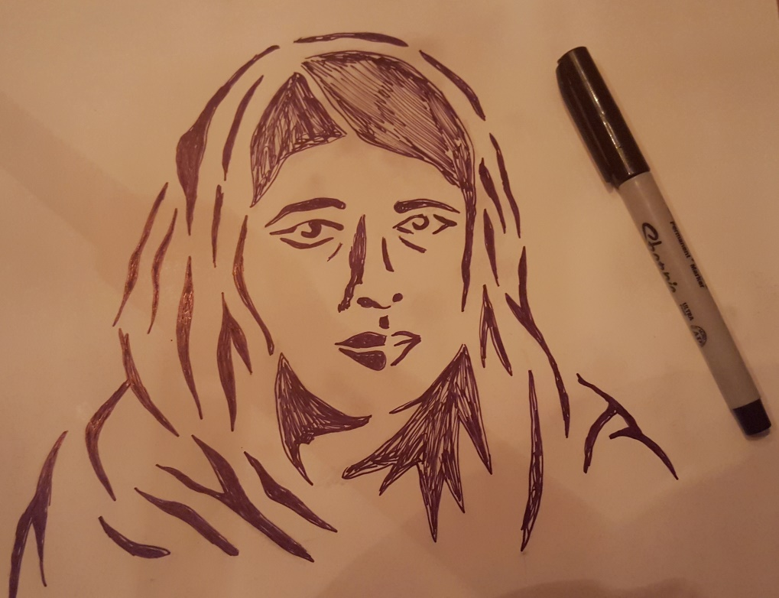
Drawing the parts of the stencil with a black sharpie
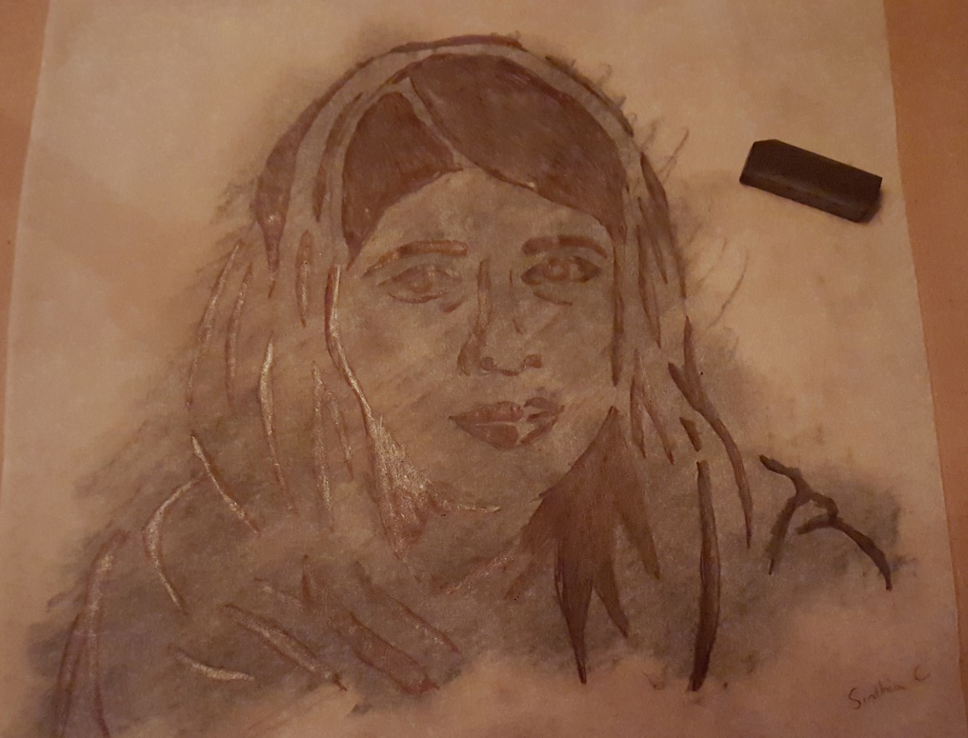
Applying Charcoal to the stencil prior to tracing

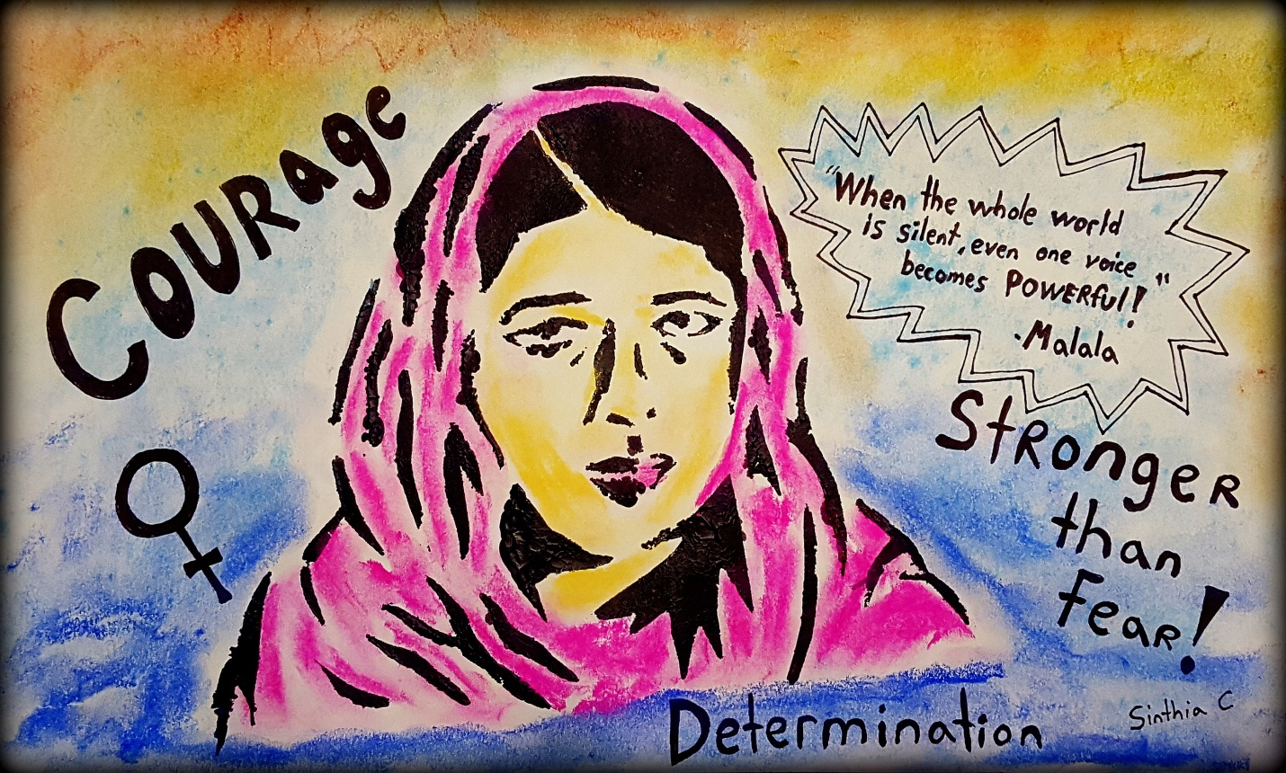
Example of the finished Malala Activism Poster

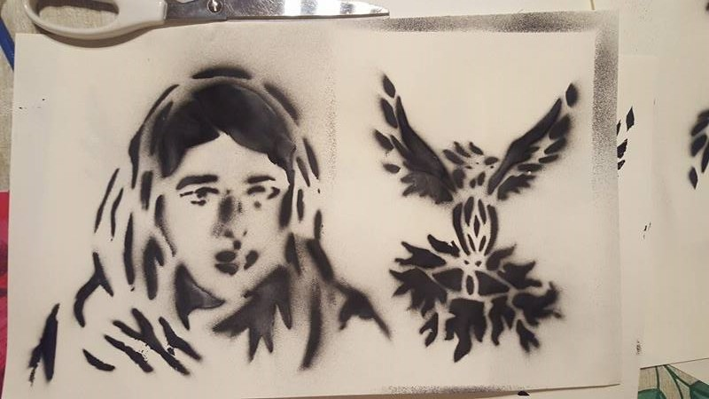
Examples of images created with a stencil and spray can
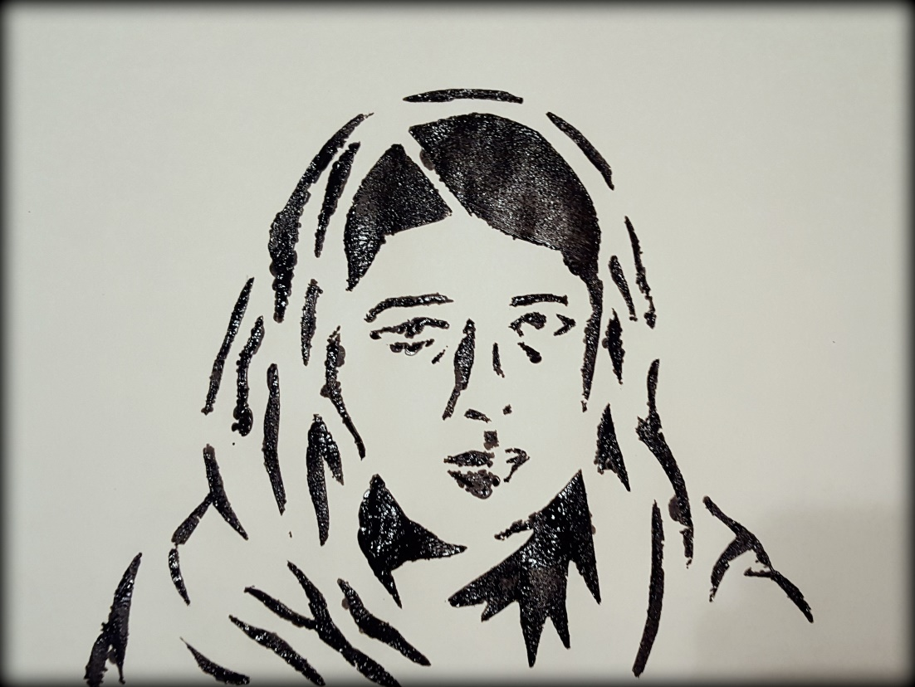
Stencil of Malala, created using sponges & acrylic paint
Artwork to be created & evaluated
Final Stencil Poster of an activist

Backup Activity
- Free drawing in their sketchbook or reading book on stencil art or a drawing of their activist. Perhaps a grid portrait of their activist displaying use of values.
- Designing a stencil for a word which closely relates to their activist to be added to their stencil.
- Cleaning up classroom and helping organize materials.

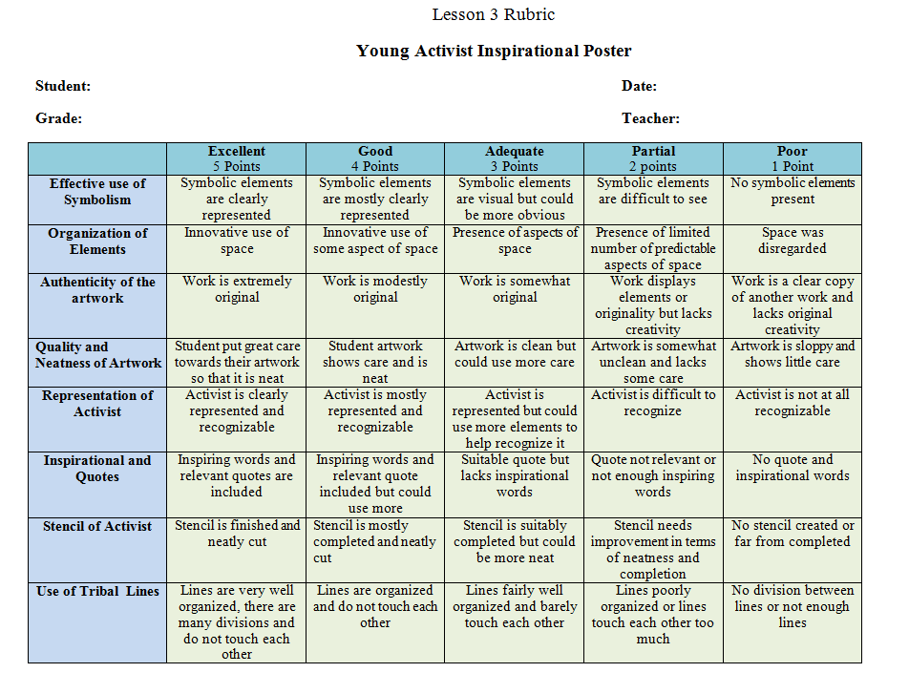

Teaching Resources
Websites
- STREET ART / MURALS / GRAFFITI: http://www.henry4school.fr/Art/art/street-art.htm
- Street Artists: http://www.sinthiacousineau.com/street-art.html
- Street art and activism: http://www.trueactivist.com/these-30-street-art-images-testify-uncomfortable-truths/
- Images with messages about todays society : http://www.espacebuzz.com/ces-15-dessins-denoncent-parfaitement-le-monde-moderne-et-ses-nombreuses-derives.html
- Activism art & todays society: http://www.trueactivist.com/this-activists-artwork-speaks-volumes-about-present-day-society-must-see/
Street Videos
- Is graffiti art? Or vandalism? - Kelly Wall: https://www.youtube.com/watch?v=4GNoUYZhrT0
- Banksy Simpson video: https://www.youtube.com/watch?v=DX1iplQQJTo
- Stencil Graffiti Art: https://www.youtube.com/watch?v=BNfqdcRVnoM
- Making a stencil:
- https://www.youtube.com/watch?v=DVbC3EGk_K4
- https://www.youtube.com/watch?v=jifPspz-k9g
- Banksy Art: https://www.youtube.com/watch?v=Qkc921anMBw
- Spray painting a stencil: https://www.youtube.com/watch?v=nAV97nwXvl8&t=6s
Malala videos
- He Named Me Malala Official Trailer 1 (2015) - Documentary HD: (3 mins)
- https://www.youtube.com/watch?v=vE5gSHJkusU
- He Named Me Malala I Opening Animation | FOX Home Entertainment: (2 mins) https://www.youtube.com/watch?v=PS-572B4HUs
- Malala's story - BBC News: https://www.youtube.com/watch?v=FnloKzEAX7o (3 mins)
- Diane Sawyer Sits Down With the Inspirational Malala Yousafzai: https://www.youtube.com/watch?v=ev-jPT5M9cU
Activism Videos
- “The Lie we live” (9mins): https://www.youtube.com/watch?v=ipe6CMvW0Dg
- The Questions we never ask (5mins): https://www.youtube.com/watch?v=e6N_LlNQQ5Y
- Artist: Shepard Fairey & anti-war activism:
https://www.youtube.com/watch?v=9QrKhZ6aF_g&list=PLYo23ehe8h36GSzI_9YSJP5ixuyhQdT-8&index=30 (3mins)
https://www.youtube.com/watch?v=8_8_rk4cRj4&list=PLYo23ehe8h36GSzI_9YSJP5ixuyhQdT-8&index=31 (5mins)
- A Refugee Uses Street Art to Change the World (3mins): https://www.youtube.com/watch?v=SUHkKwCoxEo
- Video: Fur Hurts—Art and Activism Collide (3mins): https://www.youtube.com/watch?v=3yl7j7wOPZw
- Sewing Teddy bears for sick kids-meet 12 yr. old Campbell (6mins): https://www.youtube.com/watch?v=quHdFGV94OM
- 17 Syrian boy uses clay to fight back Isis and restore cultural heritage: http://edition.cnn.com/2016/11/17/middleeast/nimrud-iraq-mosul-artifacts/index.html

Prototype Demo Video
- How to make a stencil: Malala Activism Theme (4mins): https://www.youtube.com/watch?v=i6g8DeZ1p_E

