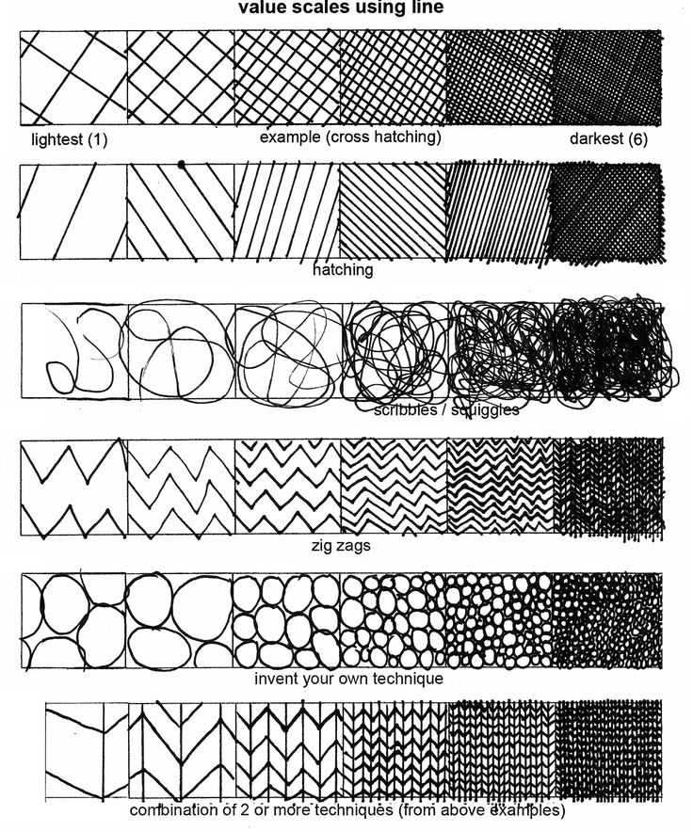

Name:
Values and Shading Assignment

Lightest Darkest
Hatching

Cross Hatching

Scribbling

Smudging

Color 1

Color 2

