**Zentangle Patterns**

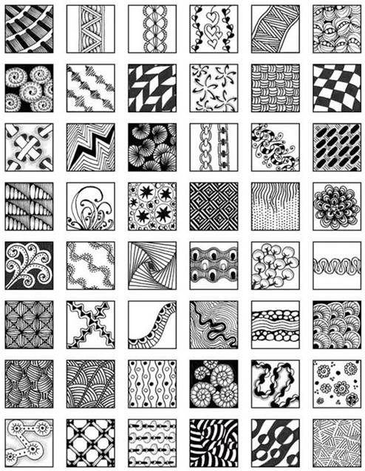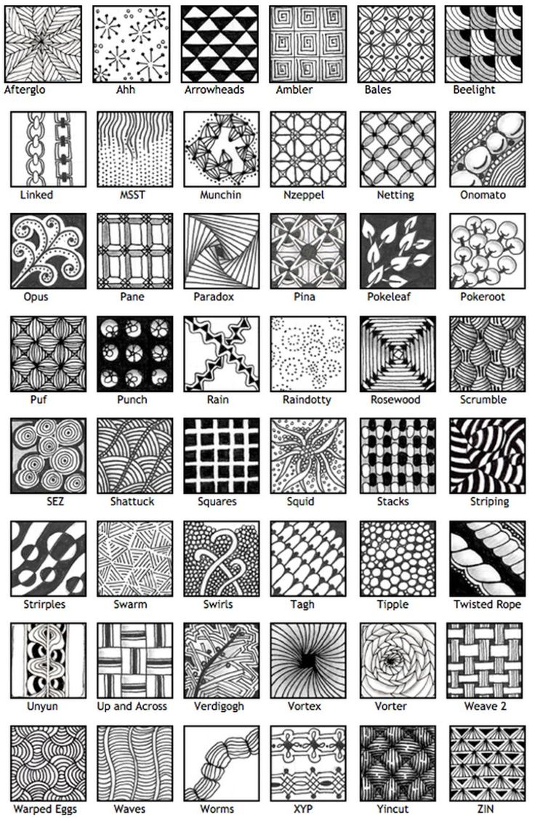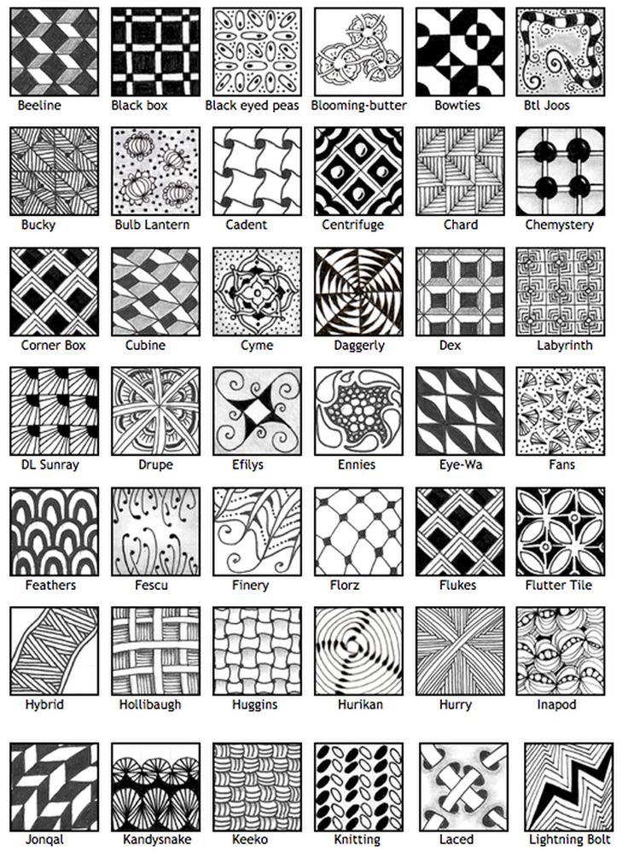

[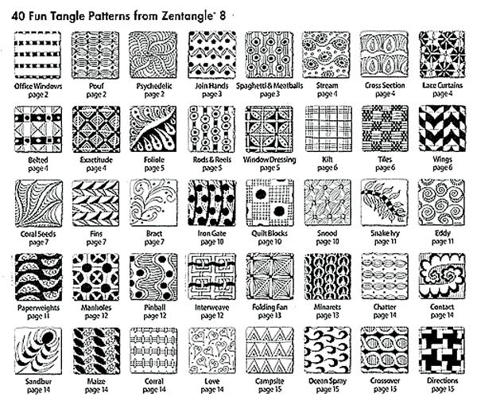](https://www.google.ca/url?sa=i&rct=j&q=&esrc=s&source=images&cd=&cad=rja&uact=8&ved=0ahUKEwjn04PknqvXAhUHPBoKHaD1Am0QjRwIBw&url=https://www.softexpressions.com/software/books2/4L0348.php&psig=AOvVaw2ZOyIHH5a-GUTSVQJuCWUT&ust=1510102077639640)